COVID-19 detection from chest X-ray Images using Deep learning

Introduction
COVID-19, first identified in Wuhan, China, in December 2019, is a highly contagious coronavirus with severe health implications, including fatalities. Its global impact has underscored the urgent need for effective diagnostic methods to curb its spread and manage its effects. Current diagnostic techniques, such as nasal and throat swabs, are widely used but suffer from variable sensitivity, leading to false negatives. Early and precise detection of COVID-19 is crucial for isolating suspected cases promptly and minimizing the risk of transmission to healthy individuals.
Background and Motivation
Since the outbreak, the World Health Organization (WHO) has reported nearly 700 million confirmed COVID-19 cases and 7 million fatalities globally (as of July 2023). Although most patients experience mild symptoms and recover without intensive treatment, severe cases often require medical attention, particularly in individuals with underlying health conditions such as cardiovascular diseases, diabetes, or chronic respiratory illnesses.
While RT-PCR tests remain the gold standard for COVID-19 diagnosis, their sensitivity is highly variable. In cases of severe respiratory symptoms, imaging techniques such as chest X-rays and CT scans play a crucial role in diagnosis due to their ability to detect lung abnormalities caused by the virus. Among these methods, chest X-rays are more accessible and cost-effective, making them a preferred choice in resource-limited settings.
Despite their advantages, interpreting chest X-rays requires expert radiologists, whose availability is often limited during pandemics. This has led to the exploration of automated methods, such as deep learning-based solutions, to support radiologists by providing accurate and efficient image analysis.

To address these challenges, this research introduces a comprehensive framework for classifying chest X-ray images to aid in the early detection of COVID-19. The framework leverages state-of-the-art deep learning (DL) techniques and focuses on optimizing performance by employing a two-phase approach:
- Preprocessing Phase
  - Various image enhancement techniques are applied to both full and segmented chest X-ray images to improve the quality and features of the images, ensuring more accurate classification.
  - A novel segmentation method is utilized, where each original X-ray image is multiplied by a lung mask derived from the ground truth dataset. This approach isolates the lung region, reducing noise and highlighting relevant features for diagnosis.
- Classification Phase
  - Pre-trained convolutional neural networks (CNNs), specifically VGG19 and EfficientNetB0, are employed for image classification.
  - Transfer learning is used to fine-tune these models, taking advantage of their pre-learned weights from large-scale datasets (e.g., ImageNet) to improve performance on smaller, domain-specific datasets.

Experimental results demonstrate that the proposed framework achieves remarkable performance, particularly in binary classification tasks (COVID-19 vs. Normal), using VGG19 with enhanced full X-ray images. The model achieved:
- Sensitivity: 0.96
- Specificity: 0.94
- Precision: 0.9412
- F1 Score: 0.9505
- Accuracy: 0.95
In multi-class classification (e.g., COVID-19, Non-COVID pneumonia, Normal), the framework also performs exceptionally, achieving an accuracy of 0.935.

Contributions of the Proposed Research
- Framework Development
  - Designed a framework to diagnose COVID-19 using both full and segmented chest X-ray images.
  - Integrated novel preprocessing techniques to enhance image quality and isolate relevant features.
- Image Enhancement and Segmentation
  - Applied image enhancement techniques to improve the contrast and clarity of X-ray images.
  - Introduced segmentation using lung masks to focus on critical regions, reducing the influence of extraneous features.
- Transfer Learning for Classification
  - Utilized pre-trained CNN models (VGG19 and EfficientNetB0) to leverage knowledge from large datasets, enabling high performance on smaller medical image datasets.
  - Demonstrated the efficiency of transfer learning in reducing computational costs and training time while maintaining high accuracy.
- Promising Results
  - Achieved state-of-the-art performance in binary classification tasks, significantly outperforming traditional methods.
  - Showed robustness in multi-class classification, highlighting the framework's versatility in detecting COVID-19 and other lung diseases.

Related Work
This study builds on a growing body of research that employs deep learning techniques for COVID-19 detection using medical imaging. Below is a summary of key contributions from prior work:
- Nishio et al.
Developed a VGG16-based system to classify chest X-rays into healthy, COVID-19 pneumonia, and non-COVID pneumonia categories. The system achieved an accuracy of 83.6% and sensitivity of 90.9% on a dataset of 1248 images.
- Minaee et al.
Applied transfer learning with four CNN models (DenseNet-121, SqueezeNet, ResNet50, and ResNet18) to classify COVID-19 cases. Using augmented data, the best model (SqueezeNet) achieved a sensitivity of 98% and specificity of 92.9%.
- Sahin
Proposed a CNN model and pre-trained ResNet50 and MobileNetv2 for binary classification. The models were evaluated on a dataset of 13,824 images, with the CNN model achieving an accuracy of 96.71%.
- Wang et al.
Introduced COVID-Net, a CNN designed for multi-class classification. The model achieved 93.3% accuracy using the COVIDx dataset of 13,975 images.
- Chow et al.
Evaluated 18 CNN models, with VGG-16 achieving the highest accuracy (94.3%) on a dataset of 700 images. Majority voting across models yielded competitive performance.
- Panwar et al.23 developed a deep learning model called nCOVnet for detecting COVID-19 based on X-rays. A dataset of 284 X-ray images was used of which 142 images are normal cases and 142 images are COVID-19 cases. The model achieved an accuracy of 88.1%.
- Nigam et al.24 used transfer learning to utilize 5 pre-trained models which are DenseNet121, NASNet, Xception, VGG16, and EfficientNet to classify Coronavirus suspected cases as normal, COVID-19 positive cases, and other classes. The used dataset contains 16,634 X-ray images, 6000 normal images, 5634 COVID images, and 5000 imges for others.

Proposed Framework for COVID-19 Diagnosis Using Chest X-ray Images
This section provides an in-depth explanation of the proposed framework. It describes the dataset utilized, followed by the two primary phases of the framework: preprocessing and classification using CNN models with transfer learning. The framework adopts two distinct approaches for training CNN models: the first employs the entire chest X-ray images, while the second uses segmented images of the lung region.

Dataset Details
The study uses the COVID-19 Radiography Database as the primary dataset for implementing the proposed framework. This publicly available benchmark dataset comprises thousands of X-ray images along with their corresponding lung masks. The images are provided in PNG format with a resolution of 299 × 299 pixels. The dataset includes the following categories:
Class | Number of Cases
Normal | 10,192
Positive COVID-19 | 3,616
Lung Opacity | 6,012
This dataset was developed collaboratively by researchers from Qatar University, Dhaka University (Bangladesh), and contributors from Malaysia and Pakistan, including medical experts. Sample images from the dataset, representing the different classes, are illustrated in Figure 1.

Preprocessing Phase
The preprocessing phase prepares the X-ray images for classification by enhancing image quality and ensuring consistency in input dimensions. The key steps include:

Classes | Normal | Positive COVID-19 | Total
Number of cases | 10,123 | 10,200 | 2,323

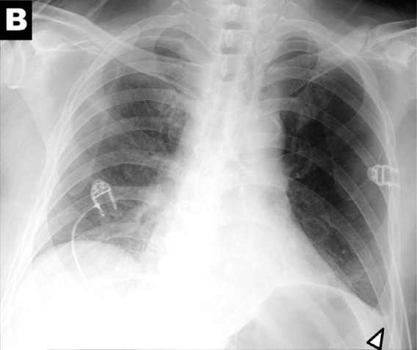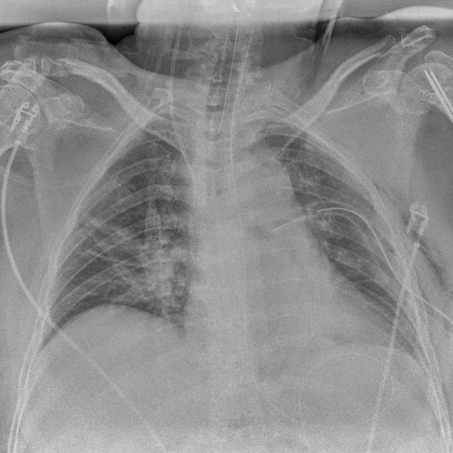
COVID positive

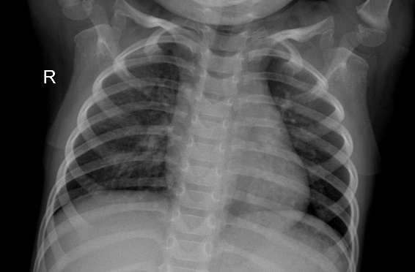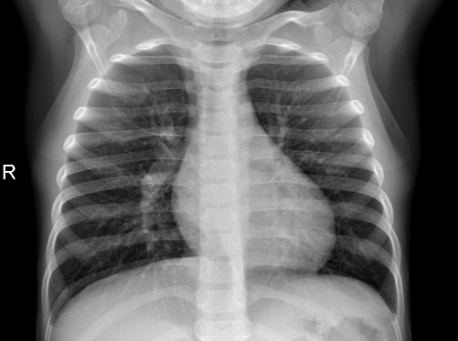
Nornal

- Image Enhancement
Various enhancement techniques were applied to improve image clarity and contrast, facilitating better feature extraction and classification. These methods include:
  - Histogram Equalization (HE): This technique redistributes the gray levels in the image, adjusting brightness and contrast to enhance visual quality.
  - Contrast Limited Adaptive Histogram Equalization (CLAHE): CLAHE improves local contrast by dividing the image into smaller regions and applying histogram equalization within these regions, preventing over-enhancement.
  - Image Complement: This process inverts the intensity levels of the image, turning dark areas lighter and vice versa. This transformation mimics practices used by radiologists and may enhance the deep learning model's ability to identify patterns.
Figure 2 showcases an original X-ray image alongside its enhanced versions (HE, CLAHE, and complement) and their corresponding histograms.
- Segmentation
The lung region (Region of Interest) is isolated from the X-ray image using ground truth lung masks provided by the dataset. The authors of the dataset applied a modified U-Net model to generate these masks. Each X-ray image was multiplied with its corresponding lung mask to extract the segmented lung region. Enhanced images (HE, CLAHE, complement) were also segmented similarly, creating multiple variations for training. Figure 3 illustrates this segmentation process.
- Resizing Images
CNN models require input images of a uniform size. For this research, all X-ray images (full and segmented) were resized to 224 × 224 pixels to match the input requirements of the pre-trained CNN models, VGG19 and EfficientNetB0. Additionally, resizing to 112 × 112 pixels was tested to accelerate training without compromising classification performance.

Classification Phase
The classification phase involved training pre-trained CNN models with transfer learning using both full and segmented X-ray images (including enhanced versions). Two pre-trained models, VGG19 and EfficientNetB0, were fine-tuned for binary and multi-class classification tasks.
- VGG19 Model
  - Developed by the Visual Geometry Group (VGG) at Oxford University, VGG19 features 16 convolutional layers, 5 max-pooling layers, and 3 fully connected layers.
  - The convolutional layers use 3 × 3 filters, with a stride and padding of 1 pixel. The fully connected layers include 4096 channels each, followed by a softmax activation layer for classification.
- EfficientNetB0 Model
  - Designed by Google Research, EfficientNetB0 is part of the EfficientNet family, optimized for performance by balancing width, depth, and resolution.
  - Its architecture uses MBConv blocks and employs a scaling method to achieve better efficiency and accuracy.
The pre-trained models were fine-tuned with a modified architecture to adapt to the dataset and classification tasks (binary or multi-class). Softmax activation was applied to the final layer for classification into two or four categories, depending on the task.

Experimental Setup and Training Details
The experiments were implemented using Python’s Keras deep learning library with TensorFlow as the backend. The hardware setup included:
- Processor: AMD Ryzen 5 5500U with Radeon Graphics 2.10 GHz
- RAM: 8 GB
- GPU: AMD Radeon Graphics Processing Unit
The training employed the following configuration:
- Optimizer: Adam
- Learning Rate: 0.001
- Batch Size: 32
- Epochs: 10–30
- Dropout: 0.3 (to prevent overfitting in fully connected layers)
The weights of the pre-trained models were frozen to retain their ImageNet-learned features, and only the top layers were fine-tuned for this specific dataset. Figure 4 summarizes the proposed methodology.
Extensive experiments evaluated the impact of preprocessing techniques, segmented images, and different CNN architectures on classification performance, leading to the selection of the optimal model configuration.

Dataset and Evaluation Setup
To validate the proposed framework, a benchmark dataset was utilized for binary classification. A subset of 1,600 X-ray images was selected, evenly split between the two classes (800 images per class). The data was divided into training, validation, and test sets to ensure effective model training and evaluation. Specifically:
- Training Set: Used for learning and parameter optimization.
- Validation Set: Monitored the model's performance during training for fine-tuning.
- Test Set: Assessed the model's final performance.
For binary classification, 25% of the dataset (400 images: 200 from each class) was allocated for testing. The remaining 75% was further split into training and validation sets (80% and 20%, respectively). For 4-class classification, a total of 3,200 X-ray images (800 per class) were used, following a similar split and preprocessing approach.
Evaluation Metrics
The framework's performance was measured using the following metrics:
- Sensitivity (Recall): Sensitivity=TP/ TP+FN
- Precision: Precision=TPTP+FP\text{Precision} = \frac{\text{TP}}{\text{TP} + \text{FP}}
- Specificity: Specificity=TNTN+FP\text{Specificity} = \frac{\text{TN}}{\text{TN} + \text{FP}}
- Accuracy: Accuracy=TP+TNTP+FP+TN+FN\text{Accuracy} = \frac{\text{TP} + \text{TN}}{\text{TP} + \text{FP} + \text{TN} + \text{FN}}
- F1 Score: F1 Score=2⋅TP2⋅TP+FP+FN\text{F1 Score} = \frac{2 \cdot \text{TP}}{2 \cdot \text{TP} + \text{FP} + \text{FN}}
Where TP, FP, TN, and FN denote true positives, false positives, true negatives, and false negatives, respectively.

Model Architecture
VGG19 Fine-Tuned Architecture
For binary classification, the VGG19 model's top layers were fine-tuned to adapt the ImageNet-trained weights to the new dataset. The architecture included:
- Dense layers with 1,024, 512, and 256 neurons.
- A dropout layer (rate = 0.3) to prevent overfitting.
- A final dense layer with 2 outputs for binary classification using SoftMax activation.
EfficientNetB0 Fine-Tuned Architecture
Similarly, EfficientNetB0 was fine-tuned with the following structure:
- Dense layers with 1,024, 512, and 256 neurons.
- A dropout layer (rate = 0.3).
- A final dense layer with 2 outputs for binary classification using SoftMax activation.
Experimental Results
VGG19 Performance
- Full Images:
The classification accuracy for the original dataset was 91.3%, improving with enhanced versions:
  - Histogram Equalization (HE): 94.0%
  - CLAHE: 95.0%
  - Complement: 94.75%
- Segmented Images:
The original dataset yielded an accuracy of 88.7%, which improved to:
  - HE: 91.0%
  - CLAHE: 90.49%
  - Complement: 90.75%
CLAHE yielded the best overall results for full images, with notable improvements across metrics.
EfficientNetB0 Performance
- Full Images:
The original dataset achieved 91.5% accuracy, with enhancements improving performance:
  - HE: 94.0%
  - CLAHE: 93.8%
  - Complement: 94.0%
- Segmented Images:
The accuracy improved from 88.5% (original) to:
  - HE: 90.5%
  - CLAHE: 90.5%
  - Complement: 90.75%

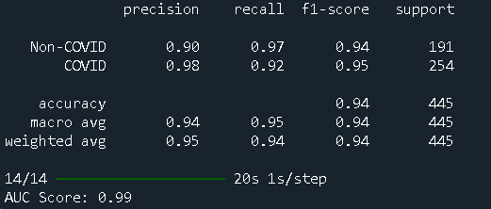
Both models demonstrated superior performance with enhanced image versions compared to their original counterparts.
Comparative Analysis of CNN Models
The comparison between the two CNN models, VGG19 and EfficientNetB0, reveals that while both achieve comparable results, VGG19 slightly outperforms EfficientNetB0 across key metrics.
Best Achieved Performance
The top-performing configuration utilized the CLAHE-enhanced full X-ray images with the VGG19 model for binary classification of chest X-ray images into COVID-19 or normal cases. The results include:
- Sensitivity (Recall): 0.96
- Specificity: 0.94
- Precision: 0.9412
- F1 Score: 0.9505
- Accuracy: 0.95
Figures accompanying the study illustrate the training and validation accuracies, training and validation losses, ROC curve, and the confusion matrix, further validating the model’s effectiveness.

Discussion
Importance of COVID-19 Classification
Classifying COVID-19 cases effectively is crucial in mitigating the pandemic’s impact. The proposed framework focuses on differentiating COVID-19 cases from normal cases. Through a combination of preprocessing techniques and segmentation, the framework enhances the quality of input images and improves the classification performance of CNN models.
Dual-Approach Training
Two distinct training approaches were adopted:
- Full Chest X-ray Images
- Lung-Segmented Images
Experiments demonstrated that full images consistently produced better results compared to segmented images. Additionally, the application of enhancement techniques improved the performance of all models, reinforcing the value of preprocessing.

Comparison with Related Work
The proposed framework was evaluated against state-of-the-art studies, as summarized in Table 6. Key observations include:
- The framework outperforms most related studies, achieving 95% accuracy and 0.9505 F1 Score, except for one study【21】, which achieved 96.71% accuracy and 97% F1 Score. Notably, the competing study used imbalanced data with significantly more normal cases (10,198) than COVID cases (3,626).
- The proposed framework employs balanced datasets and rigorous preprocessing, ensuring generalizability and fairness.

Multi-Class Classification
To further evaluate its robustness, the framework was extended to 4-class classification, introducing additional categories:
- COVID-19
- Normal
- Viral Pneumonia
- Lung Opacity
A dataset of 3,200 X-ray images (800 per class) was utilized for training. The highest accuracy was achieved by:
- EfficientNetB0: 93.5% accuracy with the Histeq-enhanced full images.
- VGG19: 93.375% accuracy with CLAHE and Complement-enhanced full images.
These results demonstrate the framework's scalability and effectiveness in handling multi-class tasks, making it suitable for diverse real-world applications.

