PRELIMINARY DATA: Real-time SRWC Redd Dewatering Estimates

BDO Science Division

12 October, 2022

This script constructs real-time winter-run redd dewatering estimates based on most recent data available from CDFW (October 5, 2022). Data are also available in the YYYY Winter-run Data file.xls online at [calfish.org](https://gcc02.safelinks.protection.outlook.com/?url=https%3A%2F%2Fwww.calfish.org%2FProgramsData%2FConservationandManagement%2FCentralValleyMonitoring%2FCDFWUpperSacRiverBasinSalmonidMonitoring.aspx&data=05%7C01%7Clelliott%40usbr.gov%7C689ebb9a6c8243b4f96c08da90f5c542%7C0693b5ba4b184d7b9341f32f400a5494%7C0%7C0%7C637981682646098788%7CUnknown%7CTWFpbGZsb3d8eyJWIjoiMC4wLjAwMDAiLCJQIjoiV2luMzIiLCJBTiI6Ik1haWwiLCJXVCI6Mn0%3D%7C3000%7C%7C%7C&sdata=A1eQkWPxbkXxnzEvc2K8%2FTmslZ8H8zvxdks3%2F78Yrvw%3D&reserved=0), but these may not reflect the most recent updates.

Please note that all data are preliminary until data collection is finalized. Likewise, there are uncertainties with forecasts which may lead to changes in proposed operations.

##   
## Attaching package: 'lubridate'

## The following objects are masked from 'package:data.table':  
##   
## hour, isoweek, mday, minute, month, quarter, second, wday, week,  
## yday, year

## The following objects are masked from 'package:base':  
##   
## date, intersect, setdiff, union

# Current Redd Count

As of September 28, 2022, the unexpanded redd count is **1059** Winter-run redds. It is important to note that until data collection is completed for the year this is the **minimum** number of possible redds. This number will always expand upon final analysis but gives an in-season guard rail of the minimum number of redds this year. From 2018-2021, female expansion has ranged from 0.31 to 1.31 with a 0.7 average, thus we may expect the final number of redds to be closer to 1800 redds using average expansion on data this year, and using this value, 18 redds dewatered would be at the 1% take level.

As of October 5, 2022, **36** Winter-run redds have **emerged** and **3** have been **dewatered**. This leaves **13** shallow water redds of concern.

In addition, **79** wild adult female WRCS were collected for hatchery broodstock to meet increased production goals this year.

# Table

**Table 1.** Average September Keswick (KES) Flow, monthly flows for September and October (in cfs), total Sept-Oct volume (in TAF), estimated numbers of SRWC redds dewatered, and percent of population that would be lost under each of the proposed alternatives. Redd dewatering is considered at the actual or estimated dewatering flow and with a 100 cfs buffer applied to the actual/estimated dewatering flow.

| Metric | Alt7 | Alt8 | Alt9 |
| --- | --- | --- | --- |
| Avg Sept Flow (cfs) | 4150 | 4150 | 4150 |
| Avg Oct Flow (cfs) | 3779 | 3921 | 3868 |
| Total Sept-Oct Flow (TAF) | 479 | 488 | 485 |
| Redds dewatered | 5 | 3 | 4 |
| Percent Lost | 0.5 | 0.3 | 0.4 |
| Redds dewatered (w/ 100cfs buffer) | 6 | 5 | 5 |
| Percent Lost (w/ 100cfs buffer) | 0.6 | 0.5 | 0.5 |

# Plots

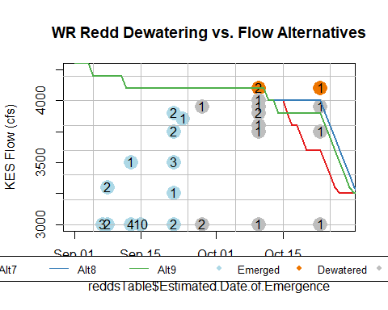

**Figure 1.** Actual or estimated emergence dates of SRWC redds and actual or estimated dewatering flow for the September-October estimated redd emergence dates as compared to Keswick flow (in cfs) of proposed management alternatives. Points represent emerged, dewatered, or remaining redds. Numbers inside of points indicate how many redds share that estimated emergence date and actual/estimated dewatering flow. Points that fall above/to the right of a flow alternative line are expected to be dewatered given that management alternative is followed. Points that fall below/to the left of/on a flow alternative line are not expected to be dewatered, given that management alternative is followed.