- A virtual machine having the centos OS was created
Iptables was found to be already installed on Centos whose status was found by

iptables -L

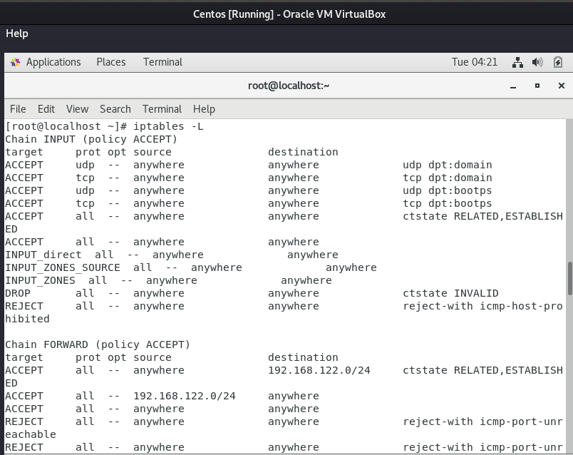

b. A subnet range was blocked by using the command in firewalld

firewall-cmd --permanent --add-rich-rule=”rule family=’ipv4’ source
address=’192.168.56.0/24’ reject”

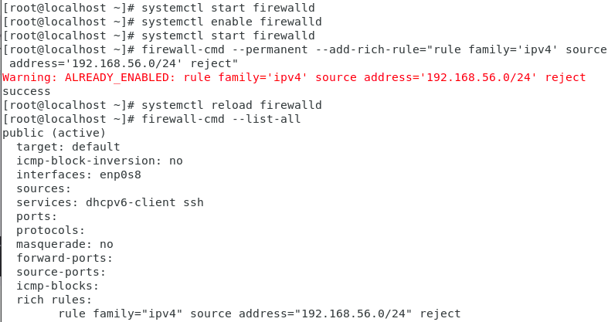

c. ssh, Http and Https were allowed using iptables as follows:

Iptables -A INPUT -p tcp --dport portnumber -j ACCEPT

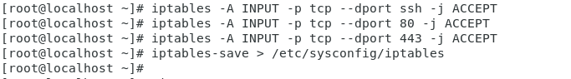

d. After blocking the ip of my Host machine using firewalld the response was shown as destination port unreachable when I tried pinging the centos system from my host system.

