2.The centos VM was to be configured as a router and the medium through which ubuntu VM gets access to the internet.
For this,
- Two network interfaces were configured for centos namely enp0s3 as the bridged adapter(WAN interface whose ip was 192.168.0.4) and enp0s8 as the Host only adapter(LAN interface whose ip was 192.168.56.101).
-Only one Network interface was configured for Ubuntu namely enp0s3 as the Host only adapter(LAN interface whose ip was 192.168.56.102).

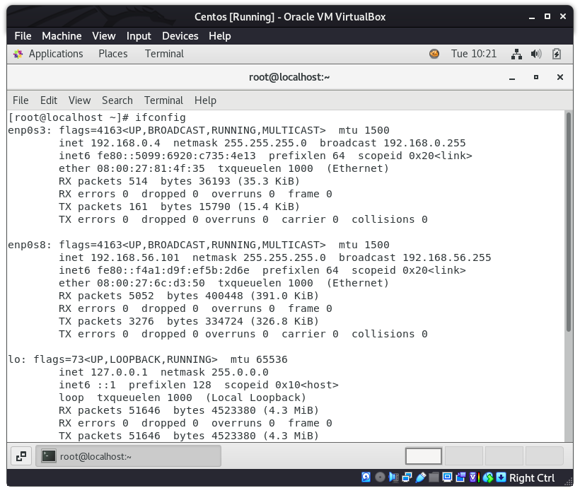
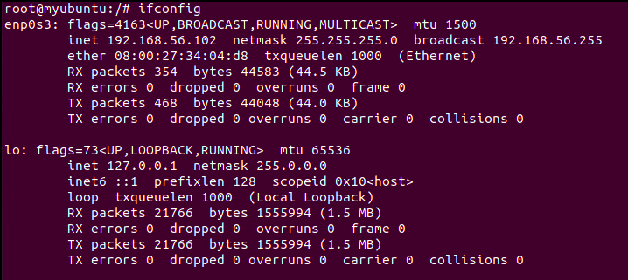

Since the only gateway through which ubuntu was able to access the internet was through the centos system because their Host only addresses were in the same network i.e. 192.168.56.0/24 , The centos system was set up as the default gateway for ubuntu

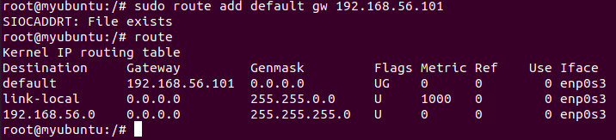

The Centos system was configured as follows to allow internet connectivity to the ubuntu system.
Masquerade allows internal IP addresses to operate through one external IP address (which is the enp0s3 interface ip address i.e. 192.168.0.4)
The below screenshot shows how the centos server accepts requests at enp0s8 interface(192.168.56.101) and allows them to connect to the internet via the WAN interface(192.168.0.4)
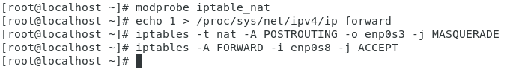

The name server was also configured for Ubuntu as the nameserver for Centos as follows
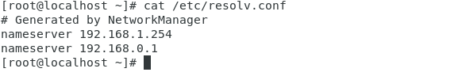
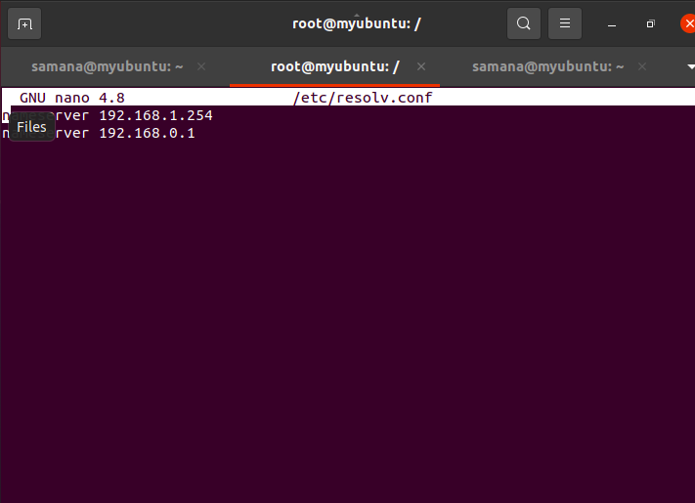

After the configuration our ubuntu system was able to connect to the internet through centos system which can be verified by the image below.
