Q1
yum install firewalld (pre-installed in centos 7)
systemctl enable firewalld
firewall-cmd –state

firewall-cmd --permanent --add-rich-rule="rule family='ipv4' source address='180.76.15.0/24' reject"
firewall-cmd –reload

firewall-cmd –zone=public–add-service=ssh --permanent//(pre-allowed)
firewall-cmd --zone=public –add-service=http --permanent
firewall-cmd --zone=public –add-service=https --permanent
firewall-cmd --reload
firewall-cmd –zone=public--list-all

firewall-cmd --zone=public –add-service=samba –-permanent
firewall-cmd --reload
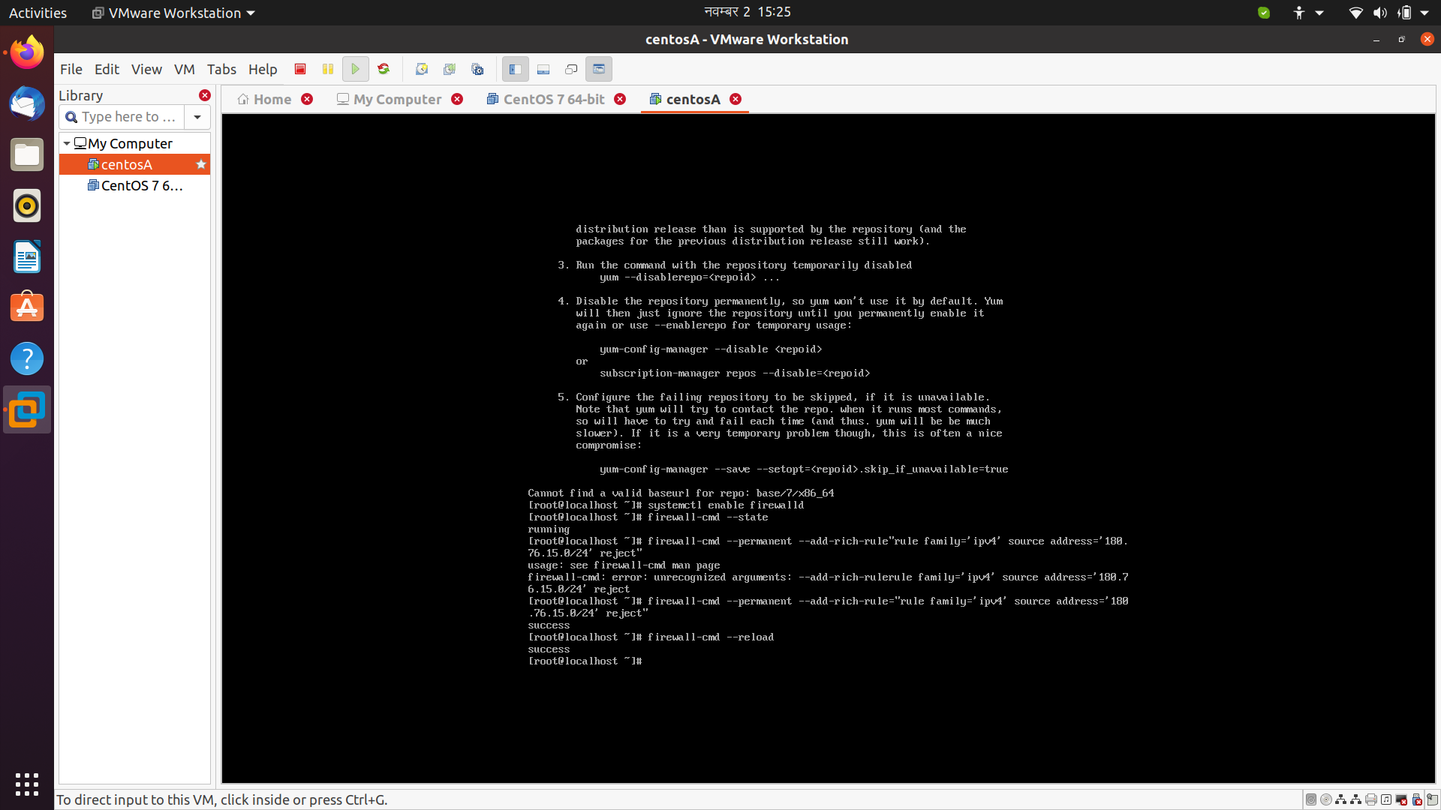

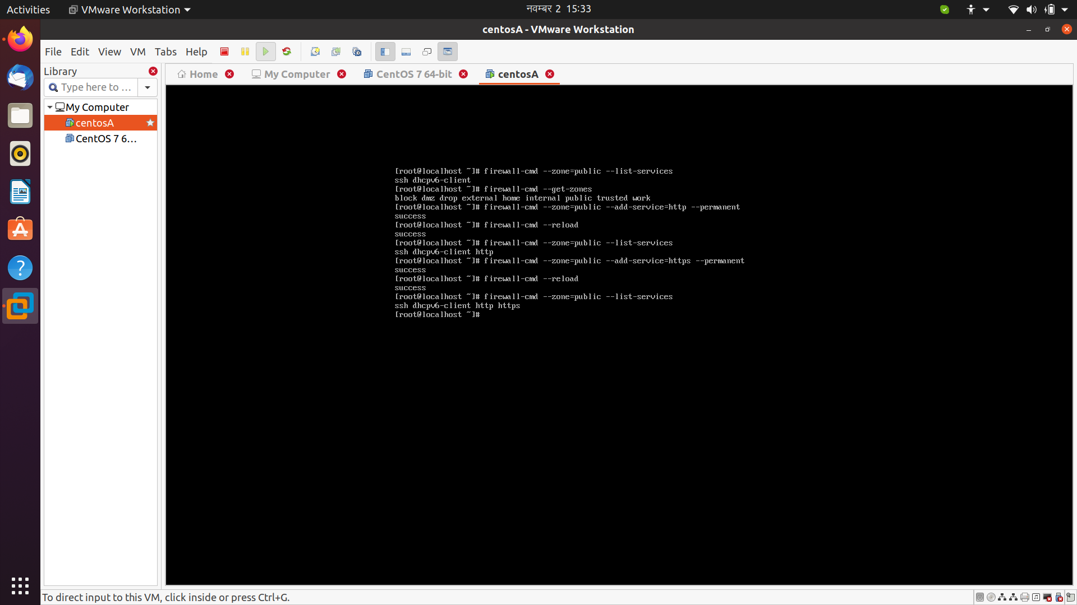
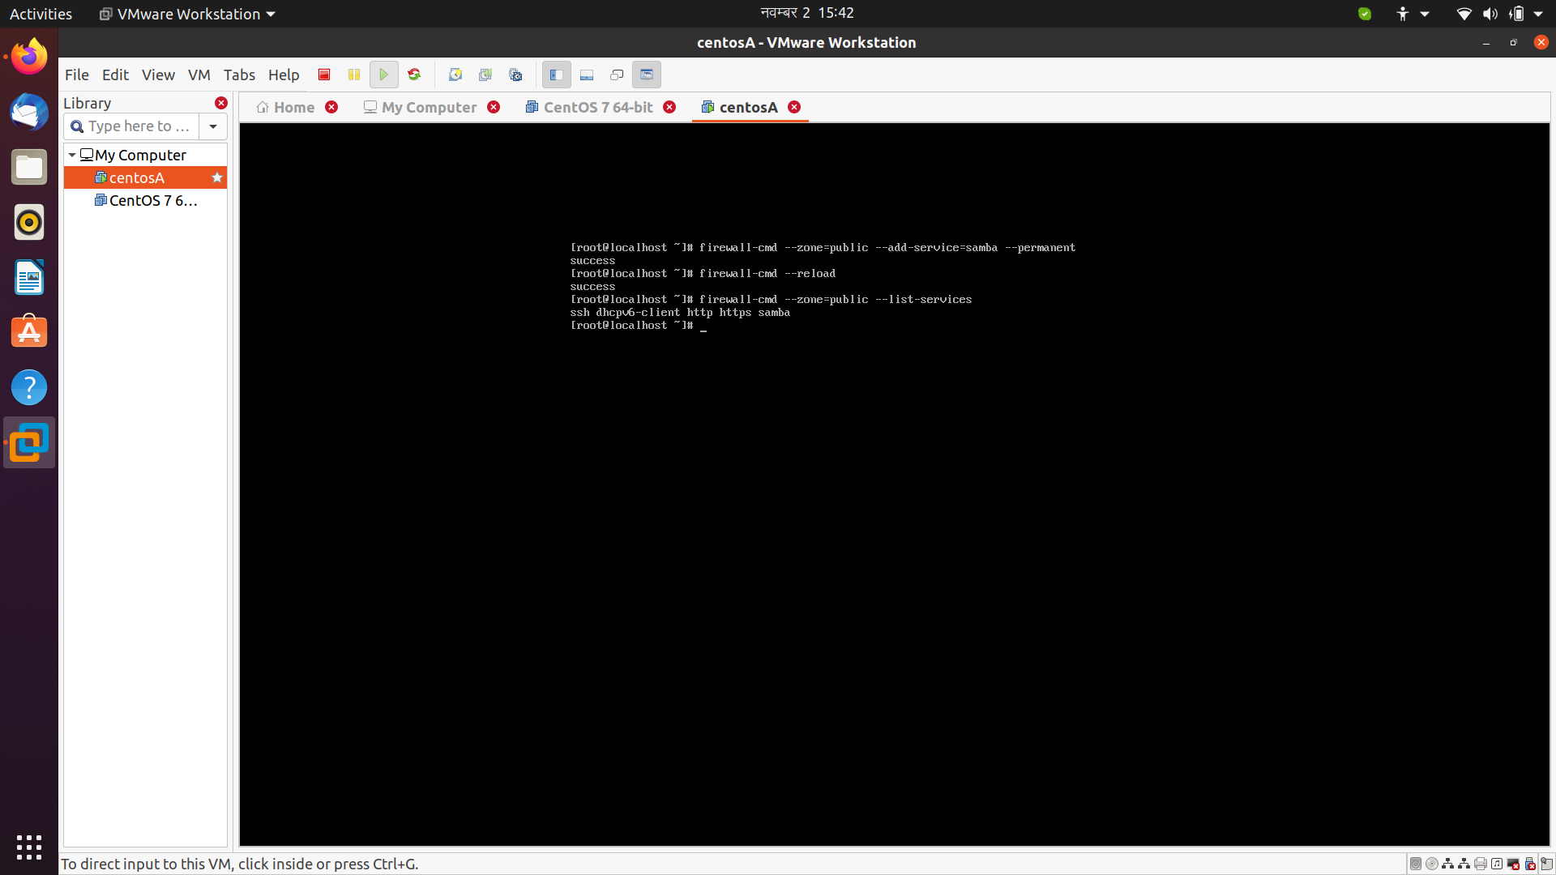

Q2..

##in cetnos A
created two network interface one to wan and other for lan
ifup ens33 (NAT)
ifup ens36 (Host only)172.16.5.129

uuidgen ens36
cd /etc/sysconf/network-scripts
cp ens33 ens36
vi ens36
change the change uuid, name and device in conf file

systemctl restart network

##in centosB

ip a
ifup ens33 (Host-only)
vi /etc/sysconf/network-scripts/ifcfg-ens33
Add
IPADDR=172.16.5.130
NETMASK=255.255.255.0
GATEWAY=172.16.5.129
ZONE=public

systemctl restart network

######In centos A

echo 1 > /proc/sys/net/ipv4/ip_forward

echo "net.ipv4.ip_forward = 1" >> /etc/sysctl.conf

sysctl -w net.ipv4.ip_forward=1

firewall-cmd --permanent --direct --passthrough ipv4 -t nat -I POSTROUTING -o ens33 -j MASQUERADE -s ens36

