Q1 A)
ip a
ifup ens33
ip a
ping google.com
ip a
hostname
vi /etc/host
vi /etc/hosts
vi /etc/hostname
reboot
vi /etc/default/grub
grub2-mkconfig -o /boot/grub2/grub.cfg
reboot
ip a
cd /etc/sysconfig/network-scripts/
ls
mv ifcfg-ens33 ifcfg-eth0
ls
cat ifcfg-eth0
ls
vi ifcfg-ens34
mv ifcfg-ens34 ifcfg-eth1
ls
cat ifcfg-eth1
vi ifcfg-eth0
systemctl stop NetworkManager
systemctl disable NetworkManager
systemctl restart NetworkManager
reboot
ip a
ping google.com
yum install epel-release -y
systemctl stop firewalld
systemctl disable firewalld
yum install iptables-services -y
systemctl enable iptables
systemctl start iptables
systemctl status iptables
systemctl stop iptables
systemctl status iptables

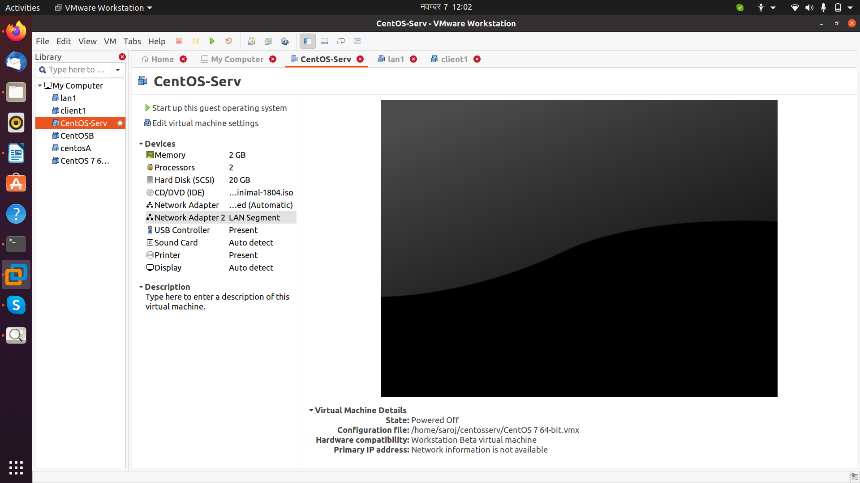

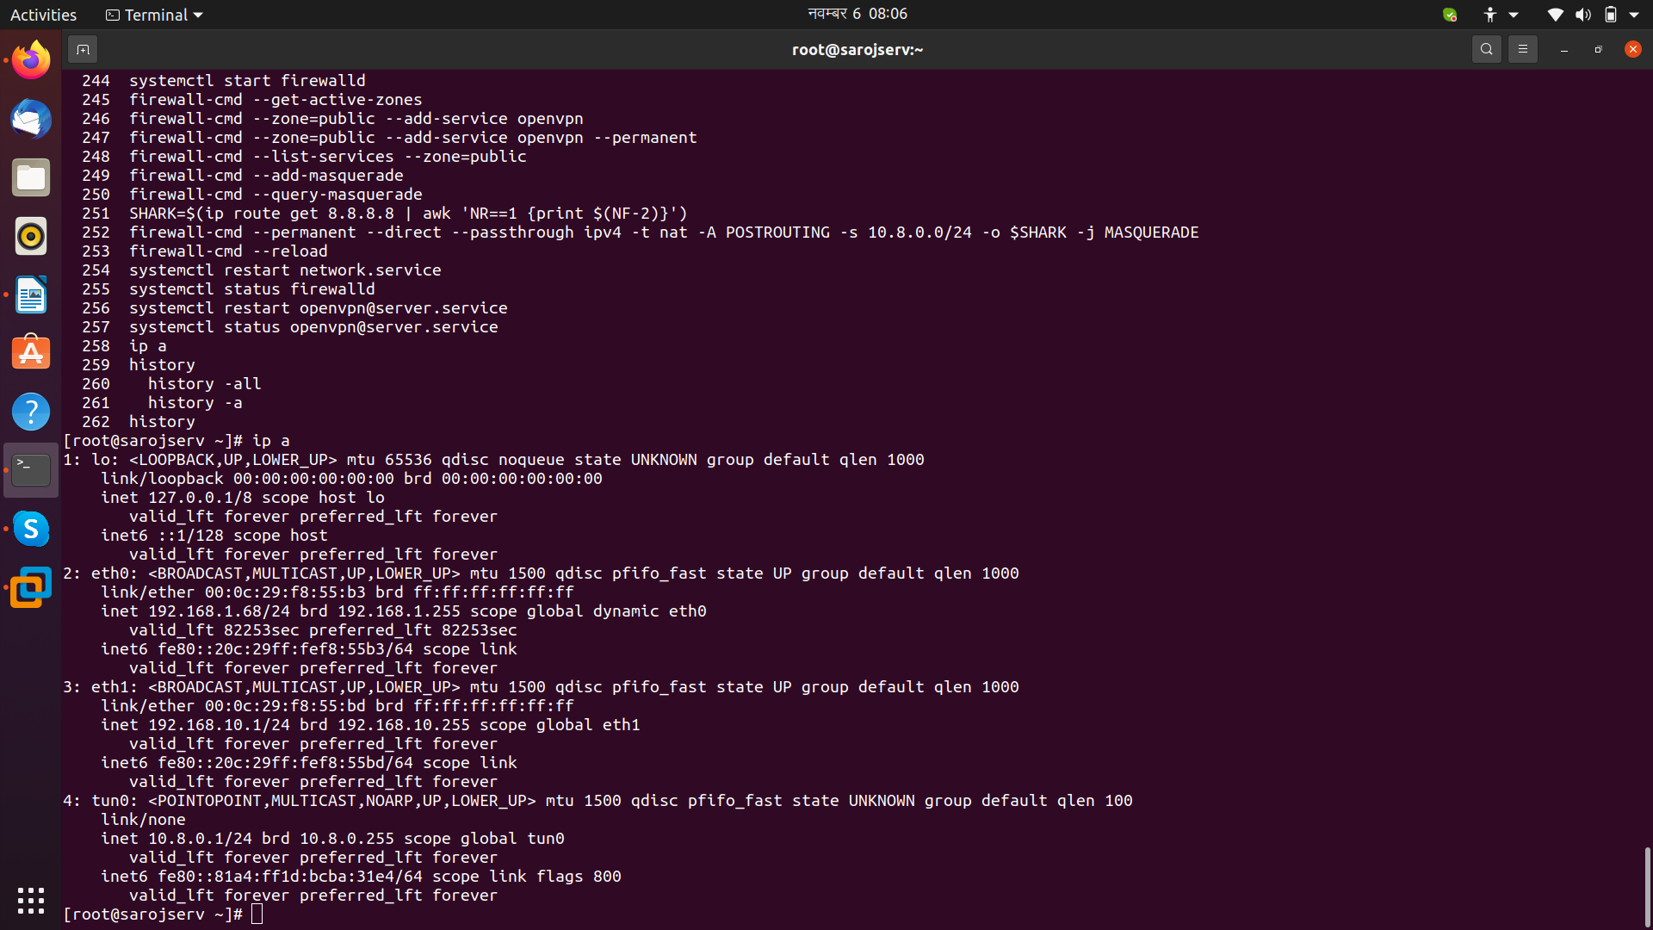

Q1 B)
yum install openvpn -y
cd /usr/share/doc/openvpn-2.4.11/sample/sample-config-files/
pwd
ls
cp server.conf /etc/openvpn
cd /etc/openvpn
ls
vi server.conf
yum install easy-rsa -y
mkdir -p /etc/openvpn/easy-rsa/keys
ls
yum install wget -y
wget -O /tmp/easyrsa https://github.com/OpenVPN/easy-rsa-old/archive/2.3.3.tar.gz
tar xfz /tmp/easyrsa
cd /tmp/easyrsa
cp -rf easy-rsa-old-2.3.3/easy-rsa/2.0/* /etc/openvpn/easy-rsa
pwd
ls
vi vars
source ./vars
./clean-all
./build-ca
./build-key-server $( hostname )
cd keys
ls
./build-dh
cd ..
source ./vars
./clean-all
./build-ca
./build-key-server $( hostname )
./build-dh
cd keys
ls
cp ca.crt sarojserv.crt sarojserv.key dh2048.pem /etc/openvpn
cd ../..
ls
restorecon -Rv /etc/openvpn
ln -s /lib/systemd/system/openvpn\@.service /etc/systemd/system/multi-user.target.wants/openvpn\@server.service
ls
vi server.conf
ls
vi server.conf
ls
systemctl -f enable openvpn@server.service
systemctl -f start openvpn@server.service
systemctl start openvpn@server.service
systemctl status openvpn@server.service
vi server.conf
openvpn --keygen --secret /etc/openvpn/ta.key
openvpn --keygen --secret /etc/openvpn/easy-rsa/keys/ta.key
pwd
cd easy-rsa/
ls
cd keys/
ls
systemctl start openvpn@server.service
systemctl status openvpn@server.service
cd ../..
ls
vi server.conf
openvpn --genkey --secret /etc/openvpn/sarojserv.tlsauth
systemctl status openvpn@server.service
systemctl restart openvpn@server.service
systemctl status openvpn@server.service
ip a
source ./vars
pwd
cd easy-rsa/
pwd
ls
source ./vars
./build-key myclient1
cd keys
ls
ip a
ls
ls -l
cd
cd /home/
ls
cd saroj
ls
mkdir
mkdir client1key
ls
cd /etc/openvpn/
ls
cd easy-rsa/keys/
ls
cp ca.crt myclient1.crt myclient1.key /home/saroj/client1key/
cd /home/saroj/client1key/
ls
ll
chmod 644 myclient1.key
ll
scp ca.crt root@192.168.1.168:/home/saroj
scp myclient1.crt root@192.168.1.169:/home/saroj
ip a
scp myclient1.key root@192.168.1.69:/home/saroj
vi /etc/sysctl.conf
ls
sysctl -p
vi /etc/pam.d/openvpn
vi /etc/openvpn/server.conf
systemctl stop openvpn@server.service
systemctl start openvpn@server.service
systemctl status openvpn@server.service
systemctl stop firewalld
cd /etc/openvpn/
ls
scp sarojserv.tlsauth root@192.168.1.69:/home/saroj/
ls
ll
cp sarojserv.tlsauth /home/saroj/
cd /home/saroj/
ls
mv sarojserv.tlsauth client1key/
ls
cd client1key/
ls
ll
chmod 644 sarojserv.tlsauth
ll
scp sarojserv.tlsauth root@192.168.1.69:/home/saroj/

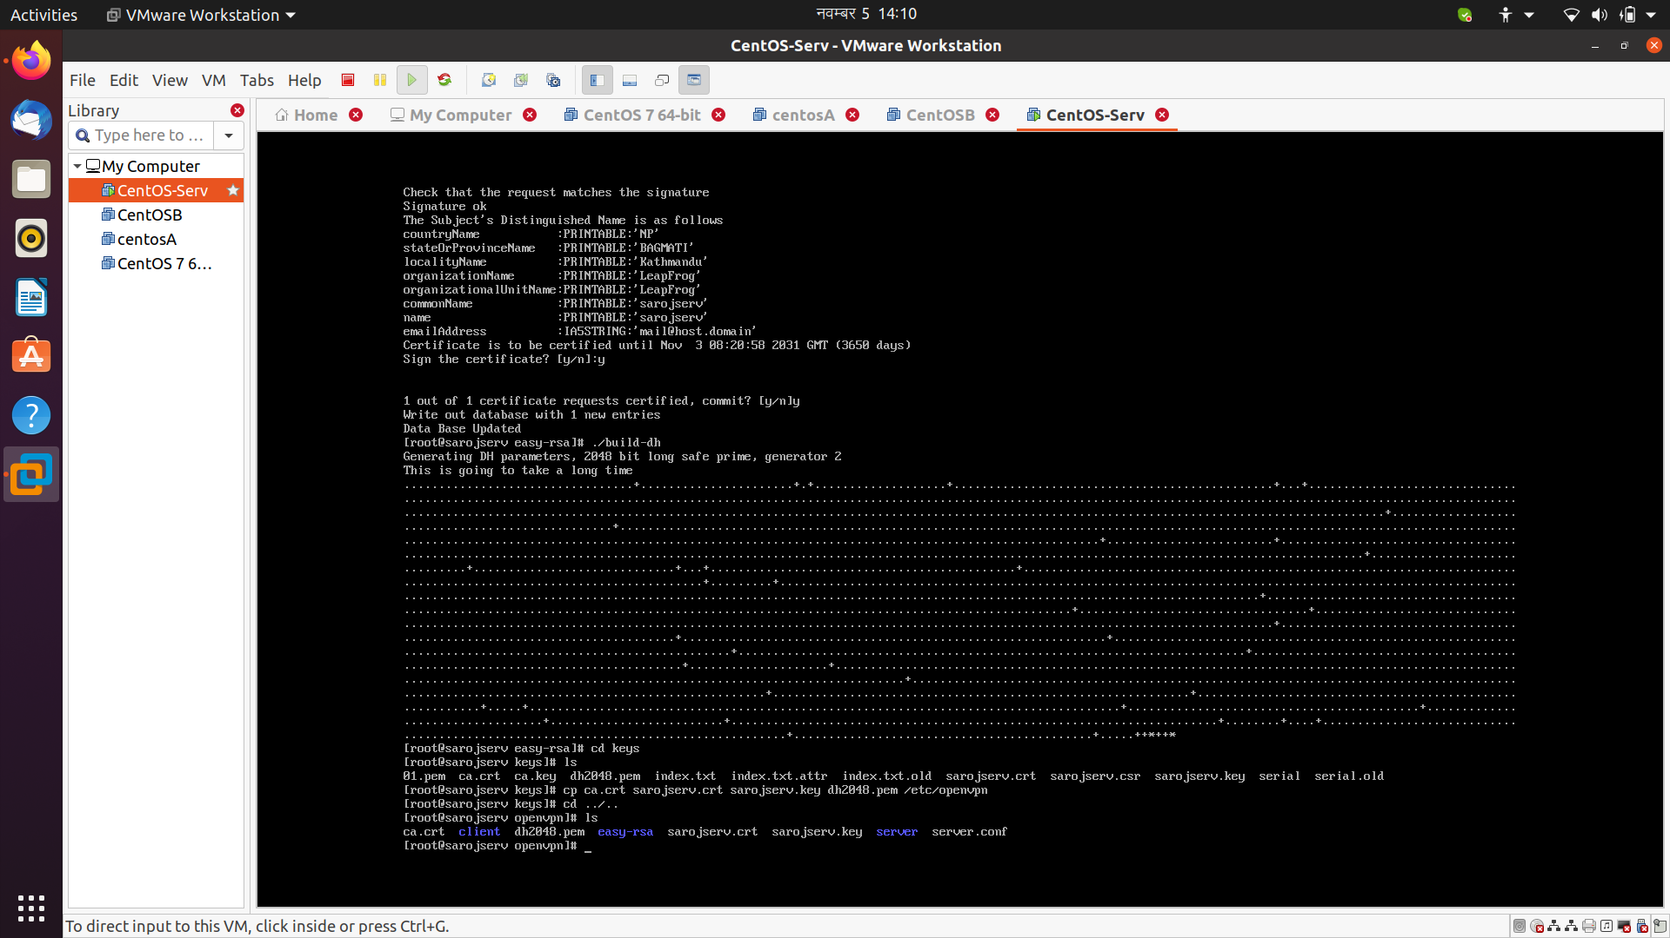

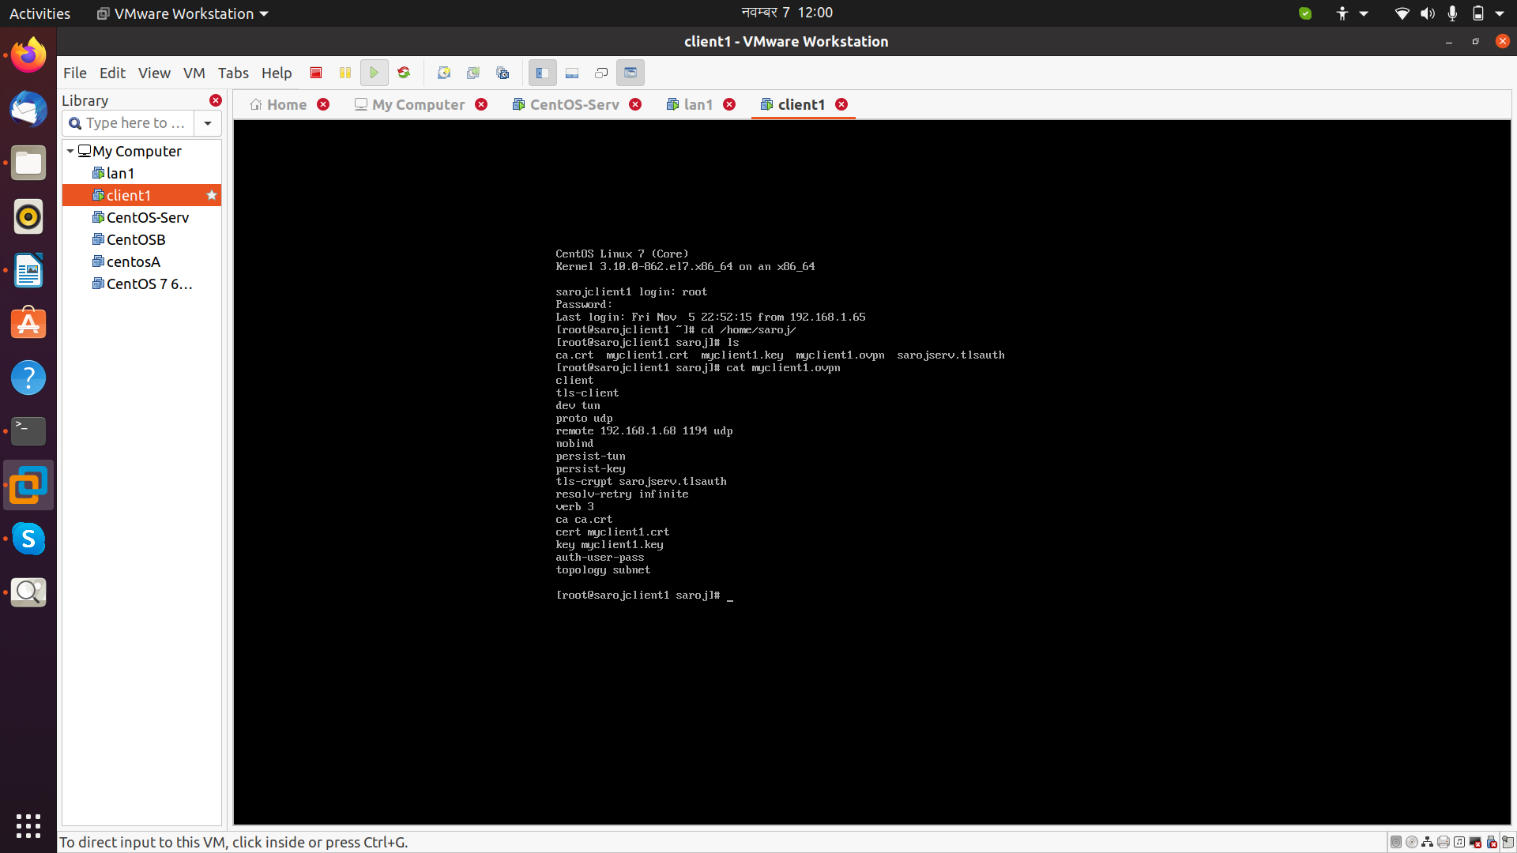

Q2
###############Installed openvpn in Q1b refer in that##############################

systemctl stop openvpn@server.service
systemctl start openvpn@server.service
systemctl status openvpn@server.service
ip a

firewall-cmd --get-active-zones
systemctl start firewalld
firewall-cmd --get-active-zones
firewall-cmd --zone=public --add-service openvpn
firewall-cmd --zone=public --add-service openvpn --permanent
firewall-cmd --list-services --zone=public
firewall-cmd --add-masquerade
firewall-cmd --query-masquerade
SHARK=$(ip route get 8.8.8.8 | awk 'NR==1 {print $(NF-2)}')
firewall-cmd --permanent --direct --passthrough ipv4 -t nat -A POSTROUTING -s 10.8.0.0/24 -o $SHARK -j MASQUERADE
firewall-cmd --reload
systemctl restart network.service
systemctl status firewalld
systemctl restart openvpn@server.service
systemctl status openvpn@server.service
ip a

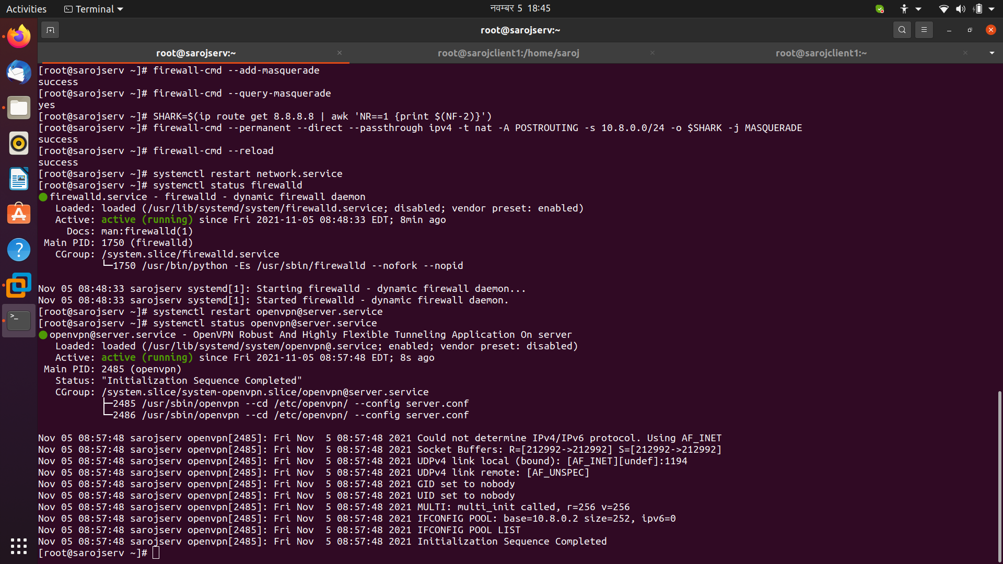

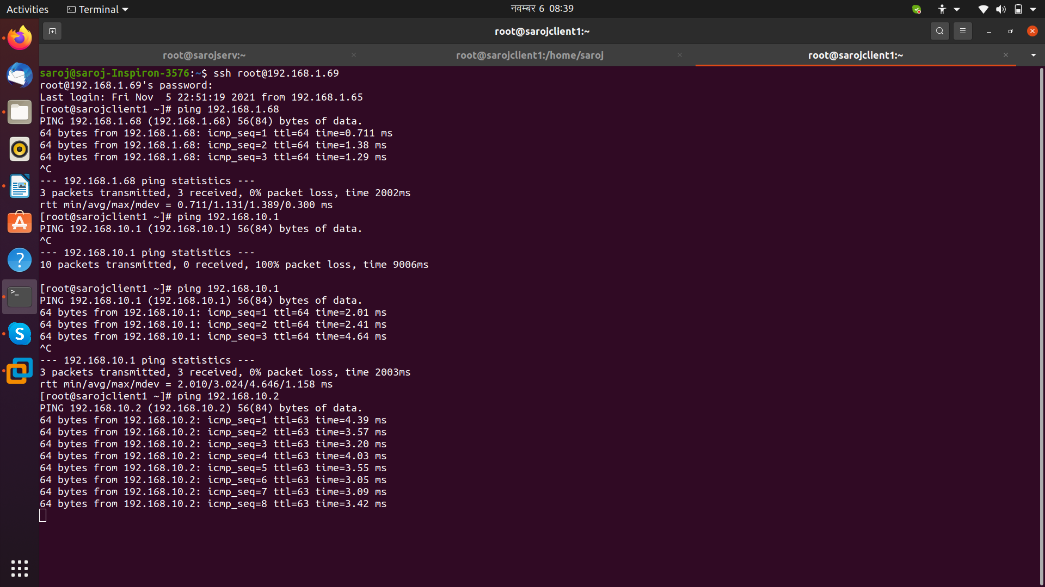

Q3

sudo su

yum -y install epel-release wget jq

curl -O https://copr.fedorainfracloud.org/coprs/jasonish/suricata-stable/repo/epel-7/jasonish-suricata-stable-epel-7.repo

yum -y install suricata

wget https://rules.emergingthreats.net/open/suricata-4.0/emerging.rules.tar.gz

tar zxvf emerging.rules.tar.gz

rm /etc/suricata/rules/* -f

mv rules/*.rules /etc/suricata/rules/

rm -f /etc/suricata/suricata.yaml

wget -O /etc/suricata/suricata.yaml http://www.branchnetconsulting.com/wazuh/suricata.yaml

systemctl daemon-reload

systemctl enable suricata

systemctl start suricata

systemctl status suricata

curl http://testmyids.com

tail -n1 /var/log/suricata/fast.log

