First of all, before installing Glassfish, we check the whether java is properly installed or not by checking the version:

Java --version
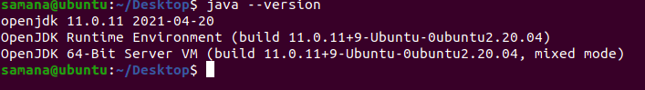

Now, we download the zip file in location /opt which will be extracted to install glassfish6
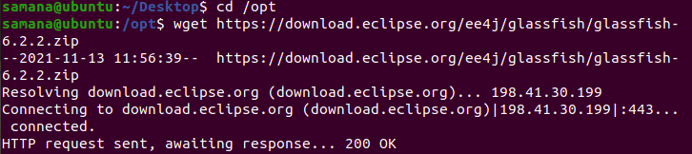

Now the zip file is being extracted:
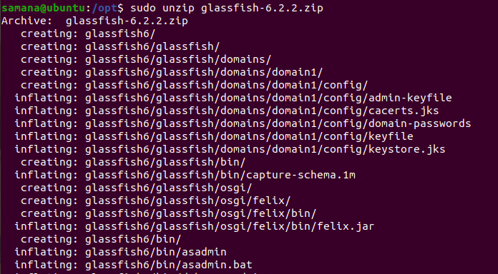

After this, the glassfish server can be started by:
sudo glassfish6/bin/asadmin start-domain
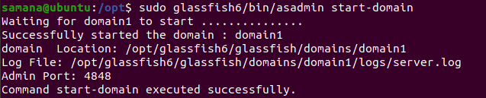

It is found to be running on port 8080 as:
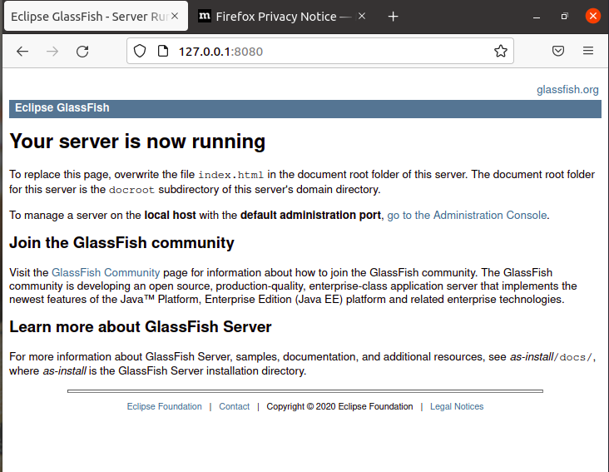

Now to change the port from 8080 to 8088, we edit the config file domain.xml
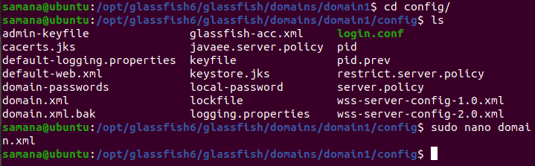

Initially the port was 8080:
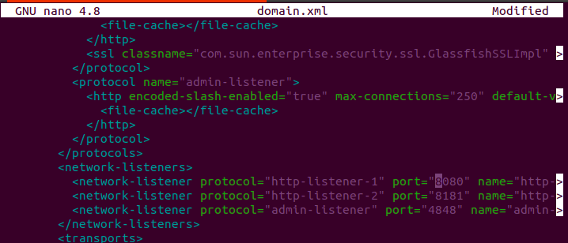

We changed the port to 8088:
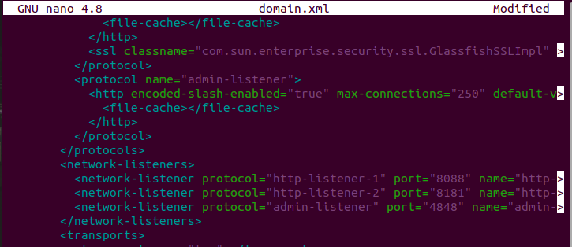

Now, we stop and start the domain as follows
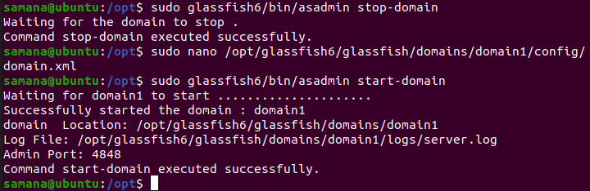

We can see that the glassfish server is now running on port 8088:
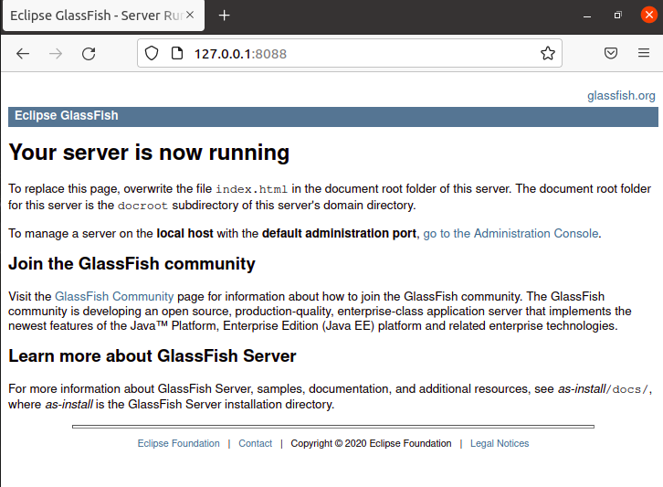

Now in order to make an application, we have created a directory named java_application inside which we create the following directories

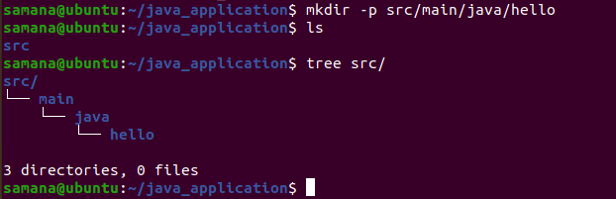

Inside the hello directory we created two files HelloWorld.java and Greeter.java which are shown as follows:
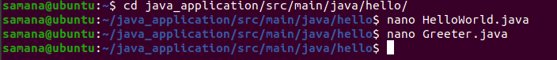

The contents of these files are:
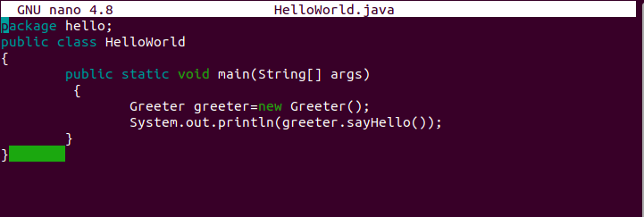
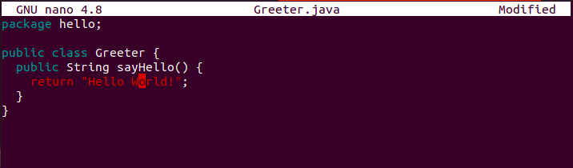

Now we install maven which is a software project management and comprehension tool.
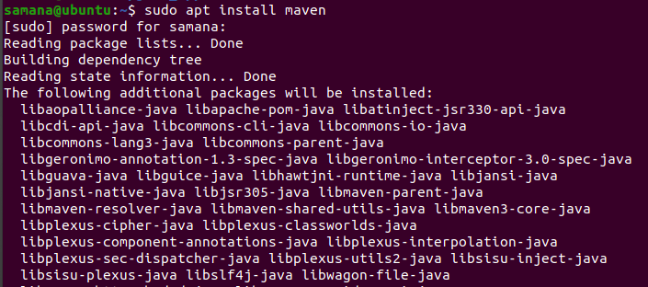
We can check the maven version by:
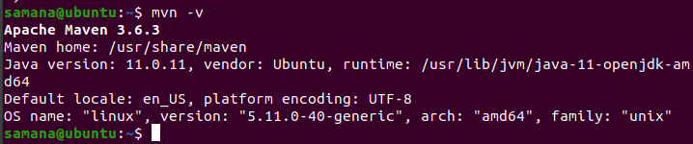

Now the pom.xml file was updated which is shown below:
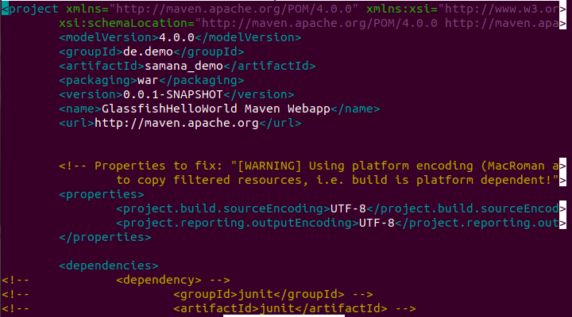
This pom file is located in the location as shown below:
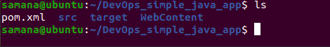
Note: Here I have changed the folder name from java_application to DevOps_simple_java_app

Now we use the command mvn clean which cleans the project and removes all files generated by the previous build
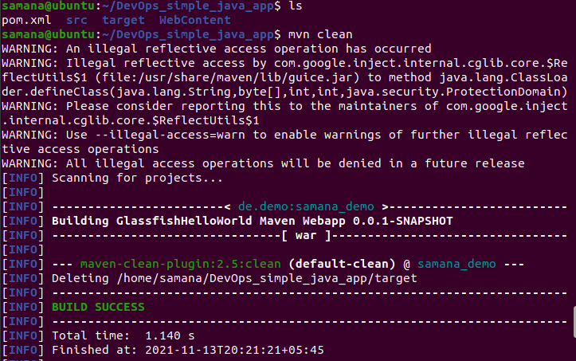

Now, we compile the contents in our folder using mvn compile
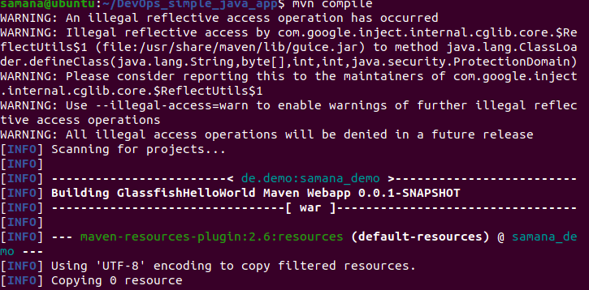

After successful compilation, we package the application as a war file(which is specified in the pom.xml file) using mvn package
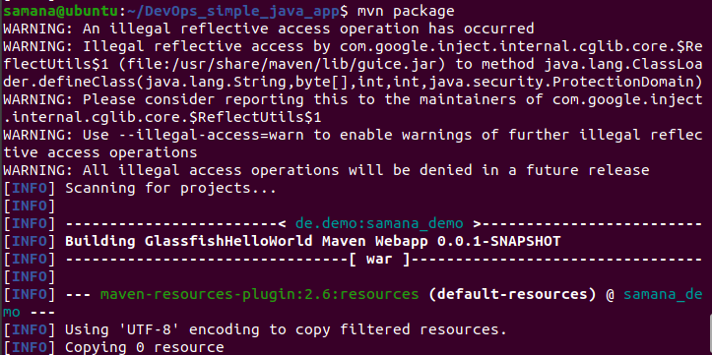

After being packaged successfully we can see the war file that has been created
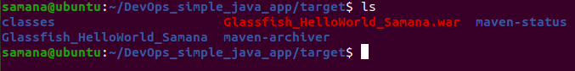

Now, we can deploy this war package as follows:
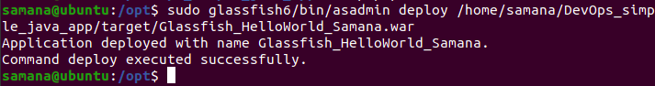

After being deployed successfully, we can view it in the deployed applications from the glassfish admin panel.
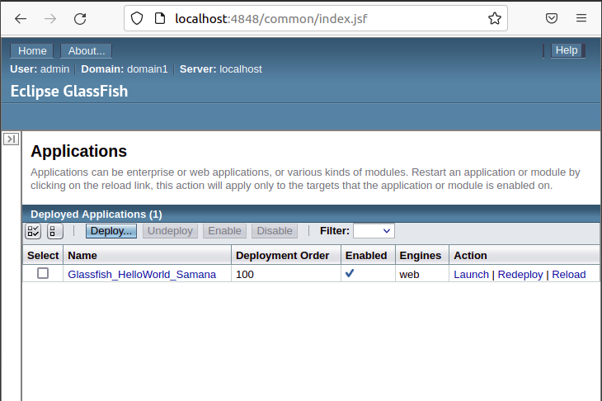
After launching the application we can see the result as given below

