First of all, we created a folder named project, where we will install a virtual environment:

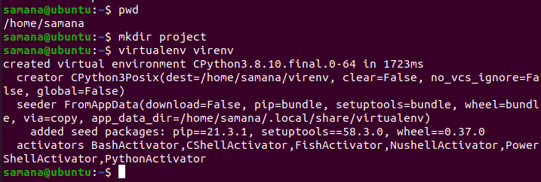

Inside the virtual environment named virenv where we install django and gunicorn.
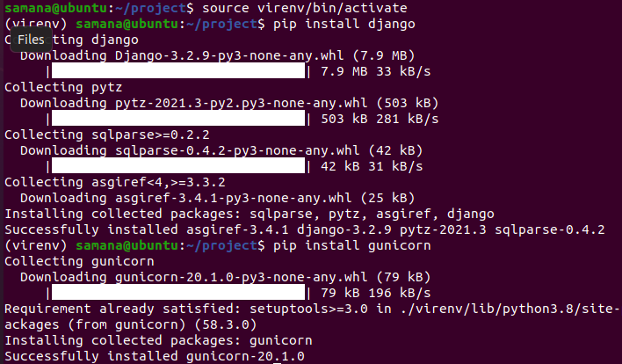

Now we create a demo project name demo_project using :
Django-admin startproject demo_project

After the project has been created, we can verify it from the screenshot below:

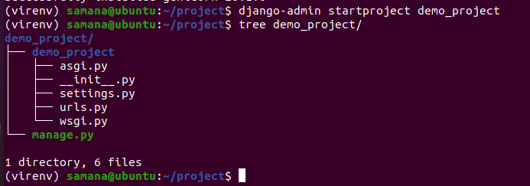

Now, we edit the settings.py file as given below where the ip of our system is 192.168.0.14.

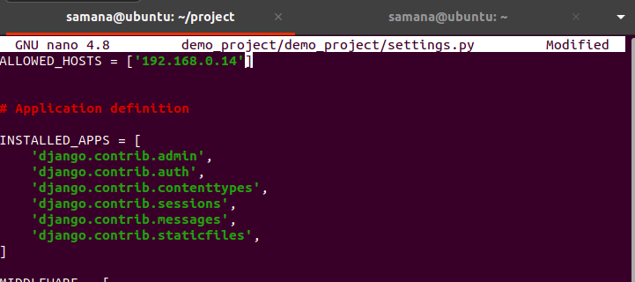

Now inside the project folder, we create a folder named conf and inside it, we create the configuration file of gunicorn as gunicorn_config.py
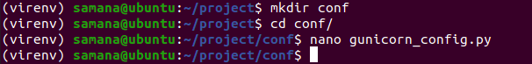

We edit the configuration file to set the port to 8089 and number of workers as 3 where workers are the processes responsible for handling requests and returning a response to the client.
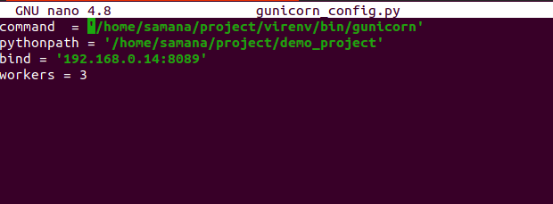

Now we deploy the demo application using gunicorn as follows:
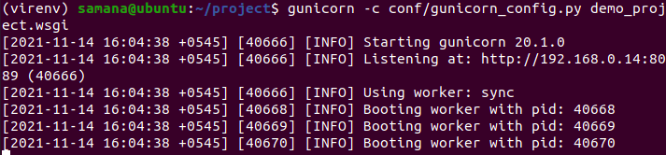

Finally we are able to see the deployed sample application at our local ip on port 8089
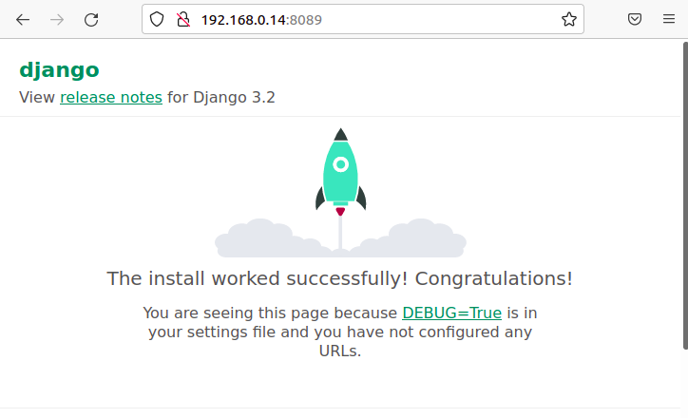

Now, we dump error log in a file and access log in a file in non-default pattern as follows:
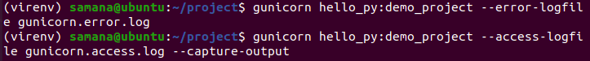

The gunicorn.error.log file is shown below which is saved
Here the error occurs because there is no module named hello.py
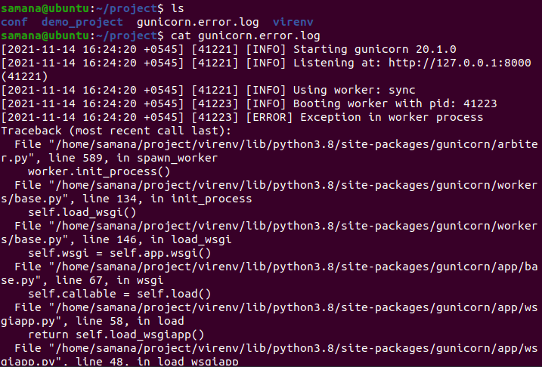

The access log file can be viewed directly (in a non default pattern) on the terminal using capture-output as:
