sudo apt-get update && sudo apt-get upgrade

apt-get install openjdk-11-jdk

java –version

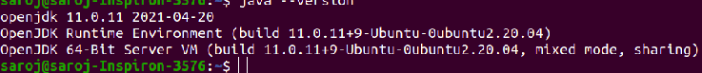
javac –version

nano ~/.bashrc
export JAVA_HOME=$(dirname $(dirname $(readlink -f $(which java))))
export PATH=$PATH:$JAVA_HOME/bin

source ~/.bashrc

mv /home/saroj/Downloads/glassfish-6.2.2.zip /opt/
cd /opt/
ls
unzip glassfish-6.2.2.zip
ls
cd glassfish6
ls
cd /bin
pwd
cd /opt/glassfish6/
ls

./asadmin start-domain
./asadmin stop-domain
./asadmin start-domain
./asadmin restart-domain

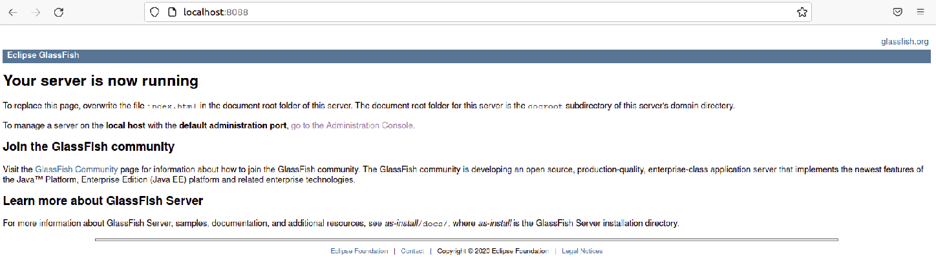

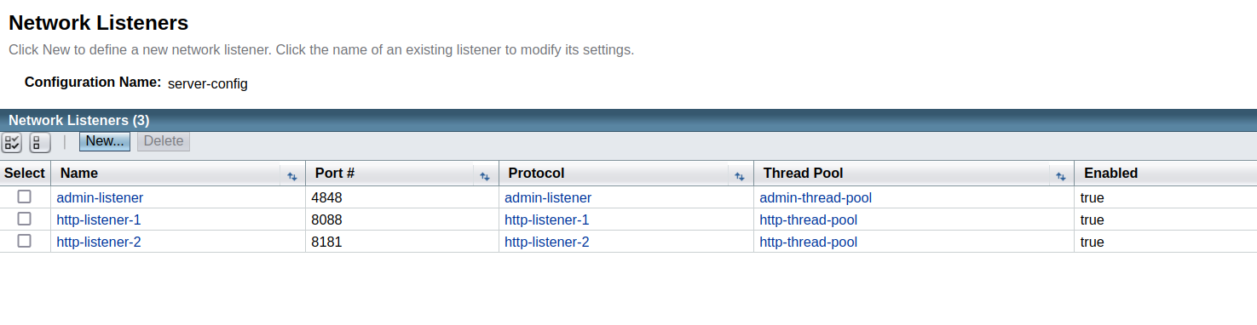
change the port by network Listener from 8080 to 8088

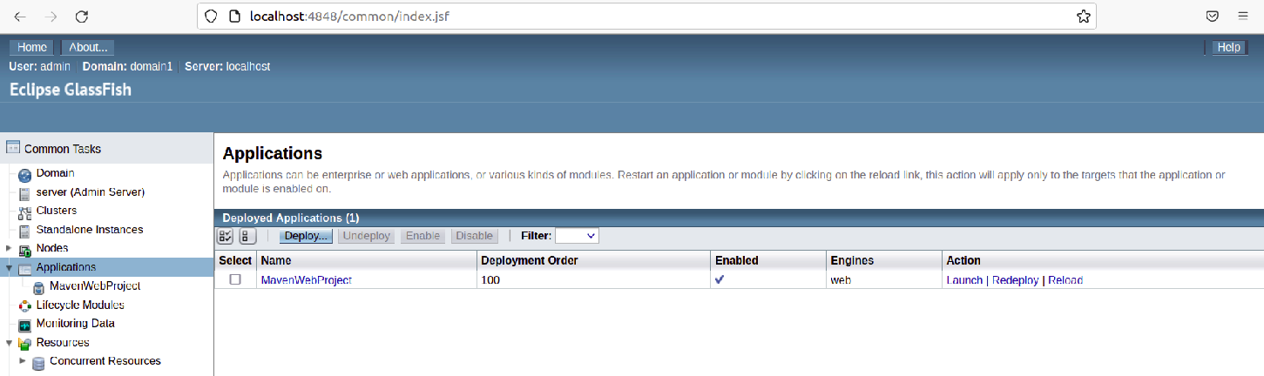
generate war file by export option and deloy it via given attached means:

