Q2.

sudo apt update
sudo apt install python3-pip python3-dev nginx
sudo pip3 install virtualenv
mkdir ~/project-saroj
cd ~/project-saroj
virtualenv env
source env/bin/activate
pip install django gunicorn
django-admin startproject trail ~/project-saroj
ls
mkdir conf
cd conf/
ls
sudo nano gunicorn_config.py
command ='/home/saroj/project-saroj/bin/gunicorn'
pythonpath = '/home/saroj/project-saroj'
bind = 'localhost:8089'
workers = 3
cd ..
gunicorn -c conf/gunicorn_config.py trail.wsgi

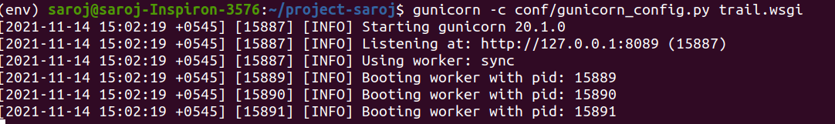
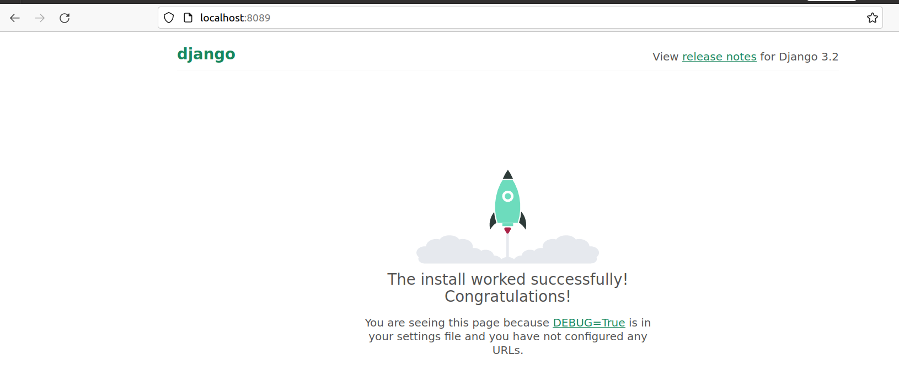

gunicorn app_py:trail --error-logfile gunicorn.error.log --access-logfile gunicorn.log –capture output
ls

cat gunicorn.log
gunicorn -c conf/gunicorn_config.py trail.wsgi

