Nodejs
First of all, we install Node js 16.x(which is latest and stable version) on our local VM using the following commands:

Curl -fsSl https://deb.nodesource.com /setup_16.x | sudo -E bash
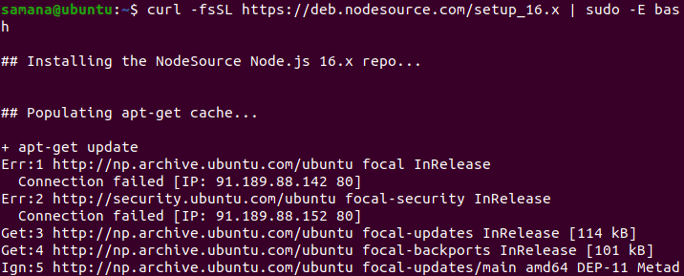

sudo apt-get install -y nodejs
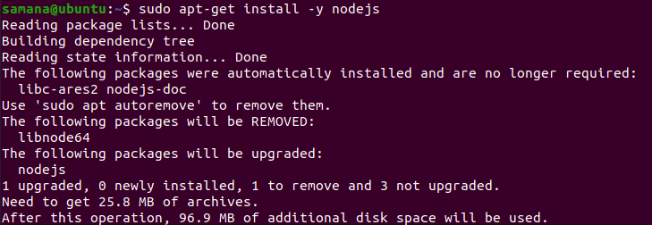

sudo apt-get install -y build-essential
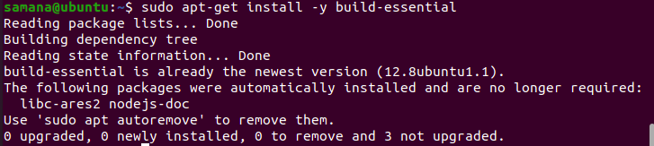

After installing node, we can verify it with the following commands:

node --version
npm --version
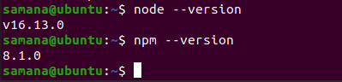

Now, inside the /var/www directory, we create a folder named nodeapp1 inside which we create a nodejs application.

Now we initialize the directory for a nodejs application.
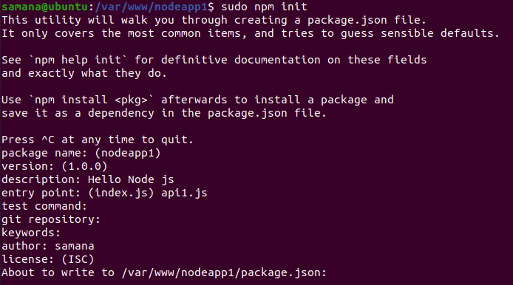

Now we edit the api1.js file to put the content “Hello Node JS” and make the application running on 6080.
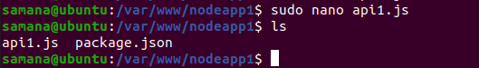

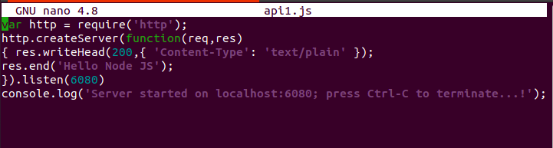

Now to start the node API we perform,
node api1.js
Therefore, the node application was found to be running on localhost 6080 as follows:

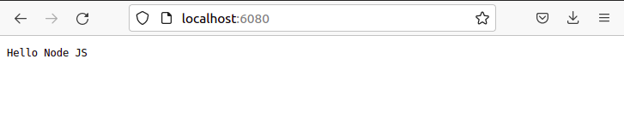

similarly we create a folder named nodeapp2 for the second node app and initialize the node application as follows:
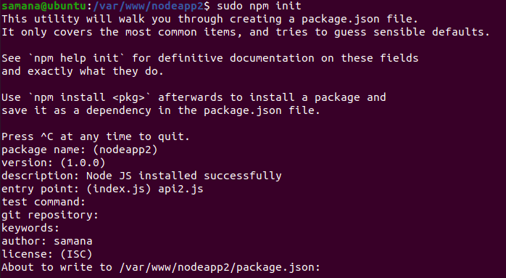

The api2.js file was edited to make the app run on port 7080 and display the message “Node JS installed successfully”
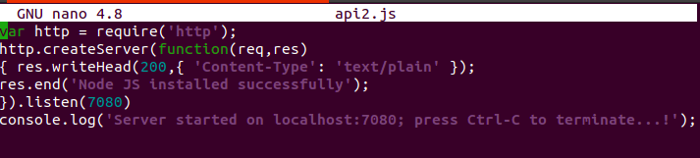

Now the server was started using the following command.

It was found to be running on port 7080 as we had set it.
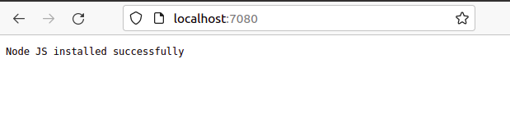

Pm2 is a production-level process manager for Node. js with a built-in load balancer
which was installed from the command given below:
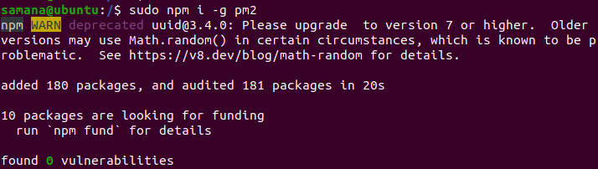

We can verify the installation by checking the version using the following command.
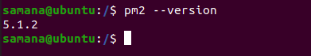

Now we start 4 cluster or 4 instance of the first api(using command sudo pm2 start api1.js -i 4) which can we verified from the table below.
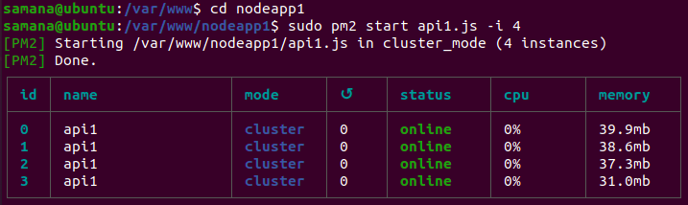

Similarly we create 4 instances of the second api.

Here every instance of an api is associated with a id
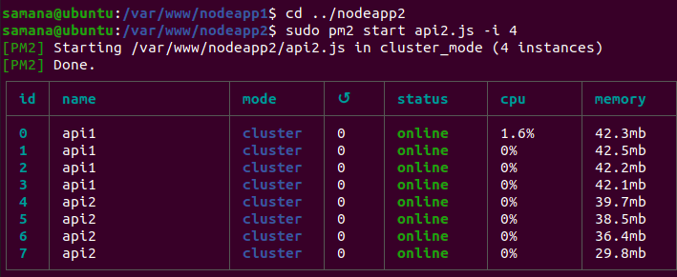

Here we have successfully deployed both APIs from pm2 in a efficient manner
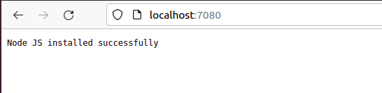

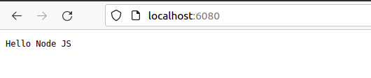
Now in order to delete the four clusters one by one from both APIs
We use the command sudo pm2 delete #pid

Here we deleted the first instances of both APIs which had process ids 0 and 4 respectively
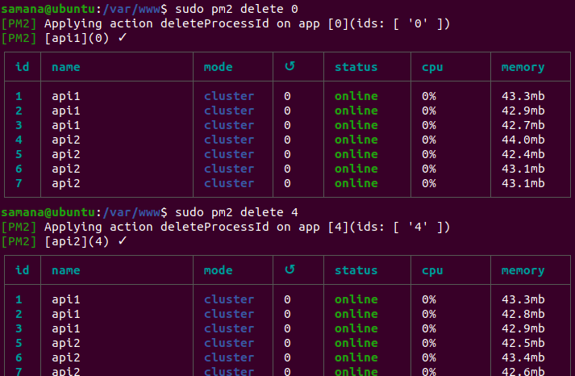

Similarly we deleted the second instance of both APIs
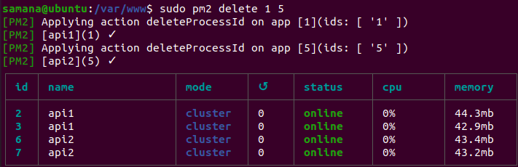

The third and fourth instance of both APIs were deleted one by one as follows:

And after running pm2 list command there were no instance of any API running because we deleted every instance one by one.
