reactjs
For creating a react application as we have npm already installed, we install the create-react-app utility as follows:
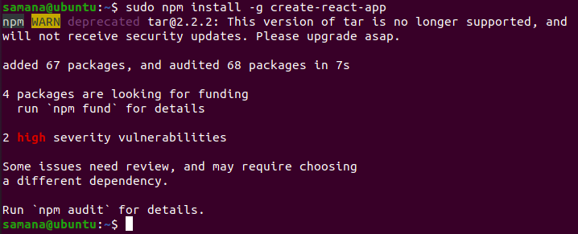

Now we create a react app named demoreactapp inside /home/samana
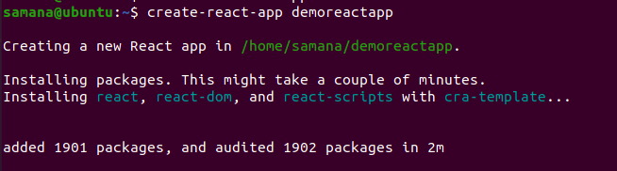

Now after running npm start we can see the following
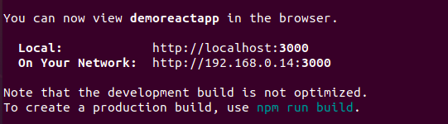
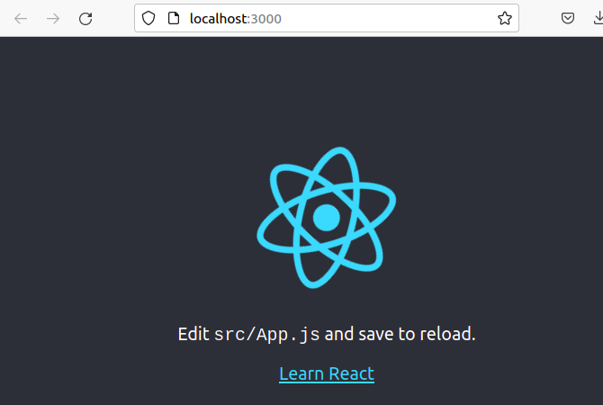

Now to build a react app according to our requirement(to display the “Hello react.js” message), we edit the App.js as follows.
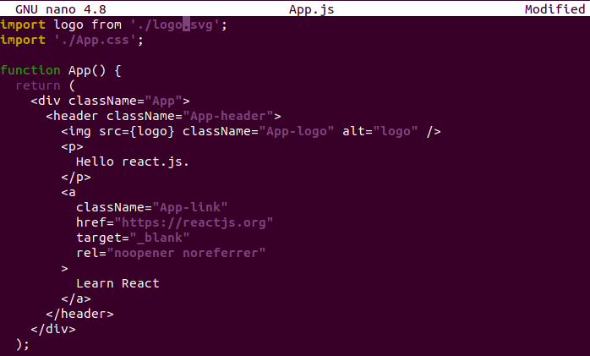

Now, to change the port no to 3001 we edit the package.json file

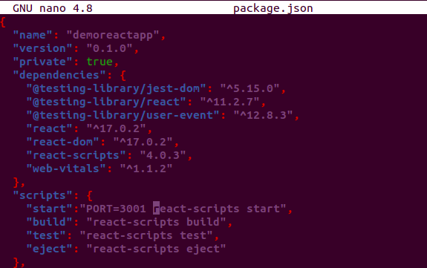

After editing the above two files we start the application
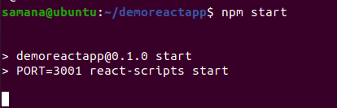

Finally we are able to see the application running on port 3001 and the message Hello react.js

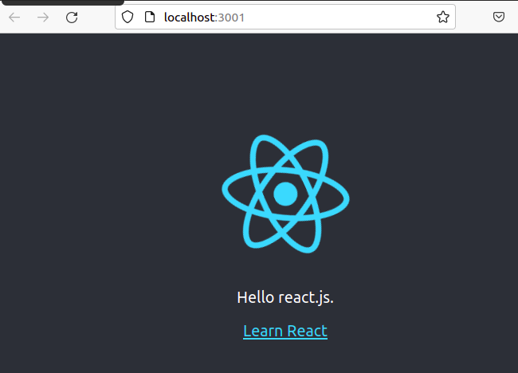

Problems occurred and Findings:

During installation i tried to install node 14.x but was unable to do so (probably because the server was down for few hours) so i went to the official node site and found that the LTS version was 16.x. Luckily i was able to download it.

when i had run npm start and node api.jsto run the application directly, I accidentally closed the terminal or hit ctrl C, and the running application was stopped.

however when I used pm2 the application continued running until I manually killed the process associated with it. That means the pm2 was running as a background process which increased the reliability.

Also, i came to know that the earlier direct deployment from the node api.js command is not suitable for several users while on the other hand, from pm2 different clusters or instances can be created which increases the performance and reliability of our applications

