Q1.
sudo apt-get install curl
curl -sL https://deb.nodesource.com/setup_14.x | sudo -E bash -
sudo apt-get install -y nodejs

sudo apt-get install -y build-essential

node -v
npm -v
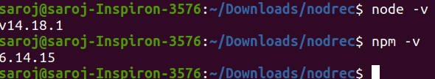

sudo mkdir -p /var/www/myapp
cd /var/www/myapp/
npm init
ls
cat package.json
ls
nano api1.js
ls
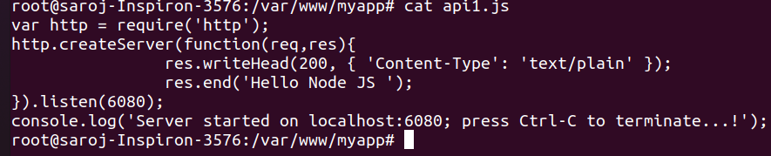
nano api2.js
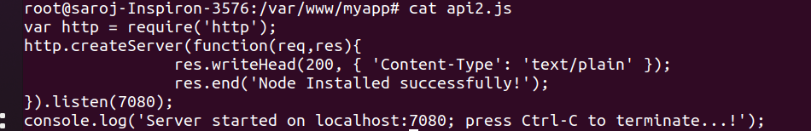

node api1.js
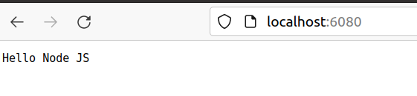

node api2.js
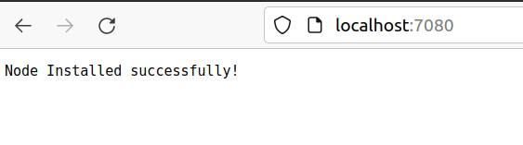

sudo npm i -g pm2
sudo pm2 start api1.js -i 4
sudo pm2 start api2.js -i 4
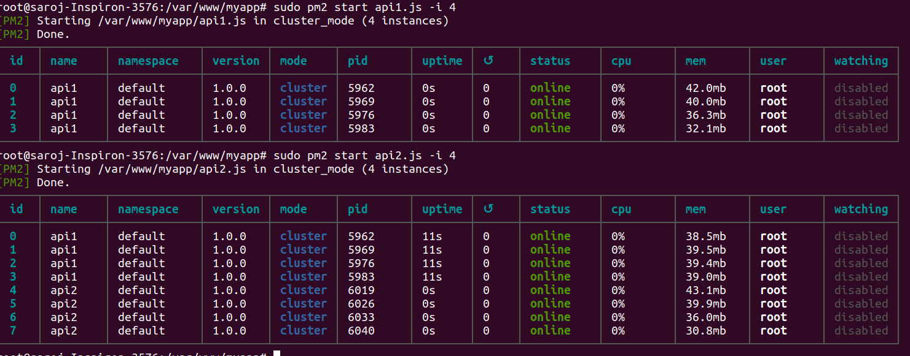

sudo pm2 delete 0

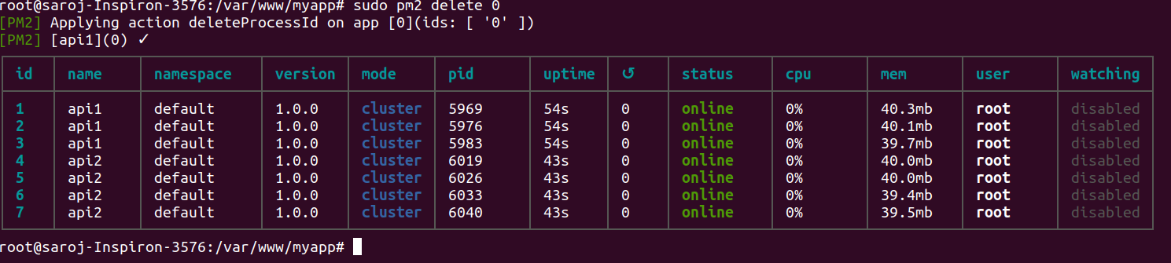

sudo pm2 delete 1

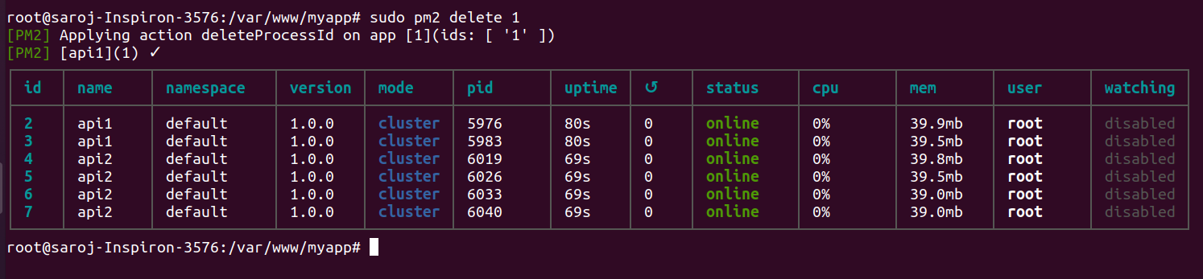

sudo pm2 delete all
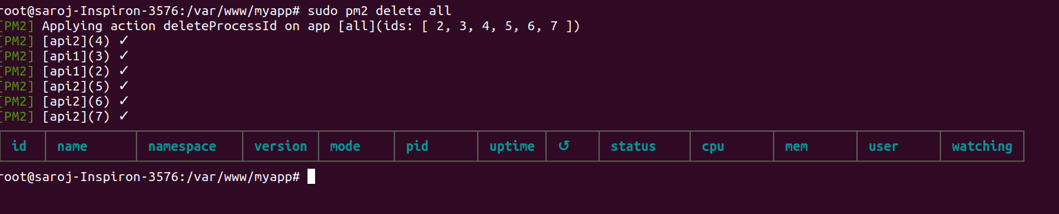

sudo pm2 stop api1.js
sudo pm2 stop all

