Q2)
cd
cd /home/saroj/Downloads/nodrec/
ls
sudo npm -g install create-react-app
create-react-app practicereact
ls
cd practicereact/
npm start
ls
cat package.json
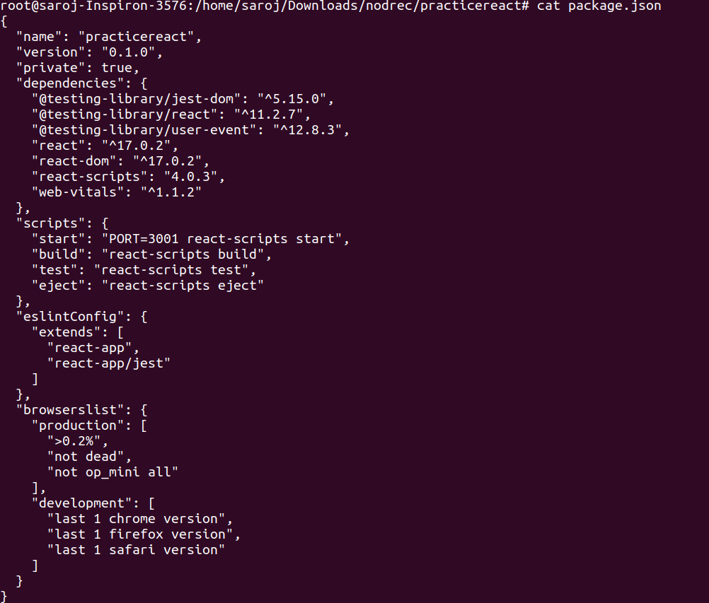
nano package.json

cd src/
ls
nano App.js
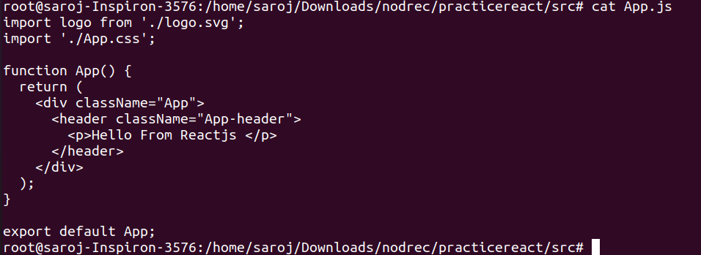

cd ..
npm start
