- Install Latest Zabbix Agent on VM or host machine or server itself to fetch logs, steps include:
- Run as active check agent
- Add a logging item to the same template for fetching /var/log/syslog(Ubuntu) or /var/log/messages (CentOS)
- Fetch those logs from the host (Make sure required permissions are set for zabbix-agent to pull logs)
- Provide agent configuration file & screenshots for target machine graph & logs

Installing zabbix agent
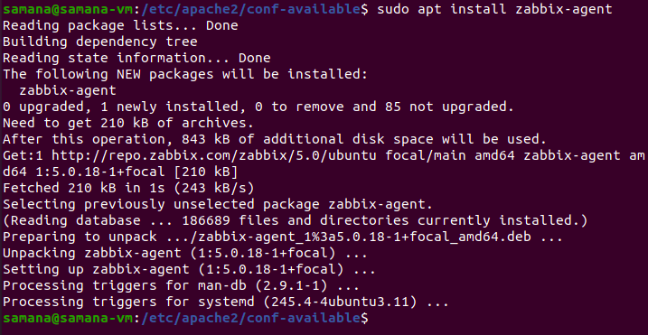
Editing the configuration file for zabbix agent.
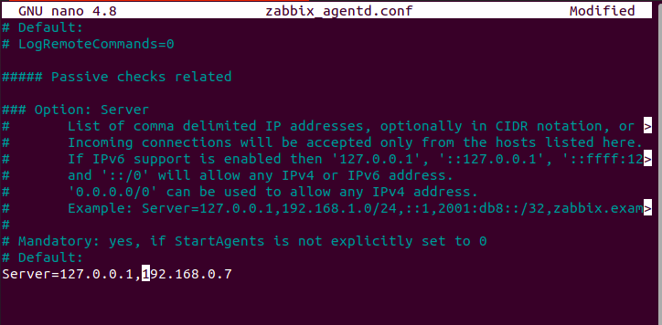
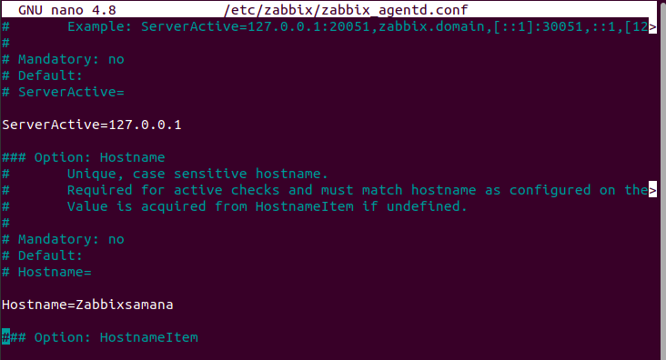

We can see that the zabbix-agent service is running successfully.
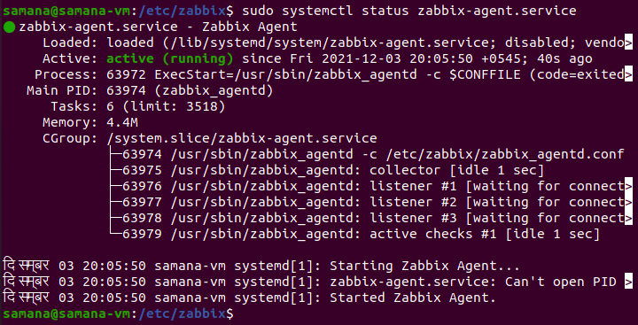
We add the zabbix user to adm group so that the user can read logs from /var/log/syslog

We create a host named Zabbixsamana
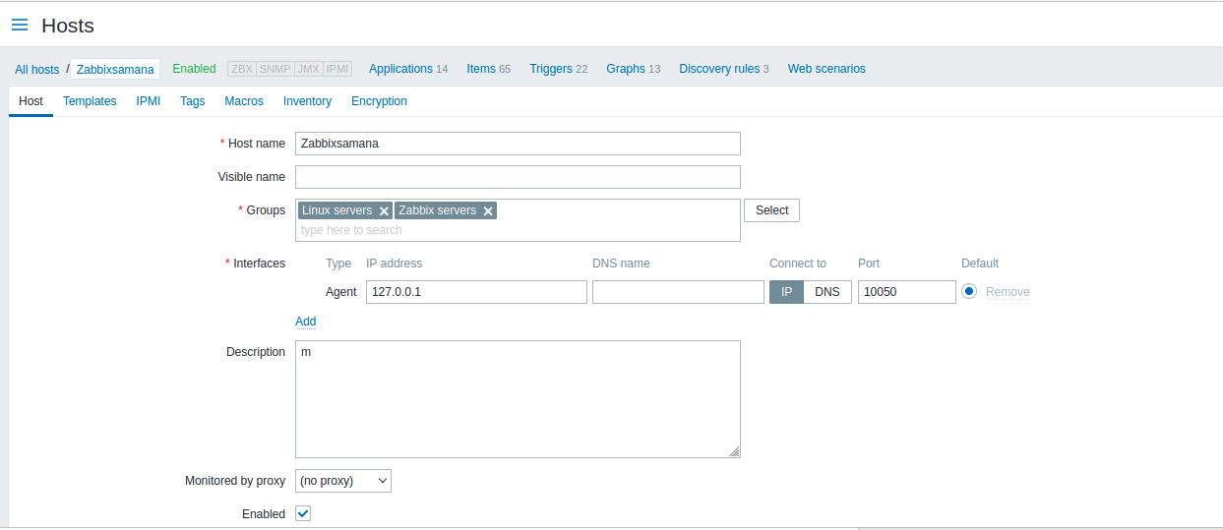

We set the template for that host as active zabbix agent
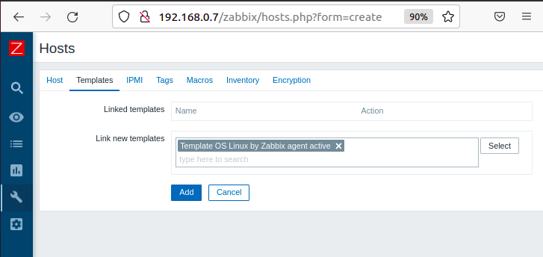

We create a item in the host that we created with the following details.
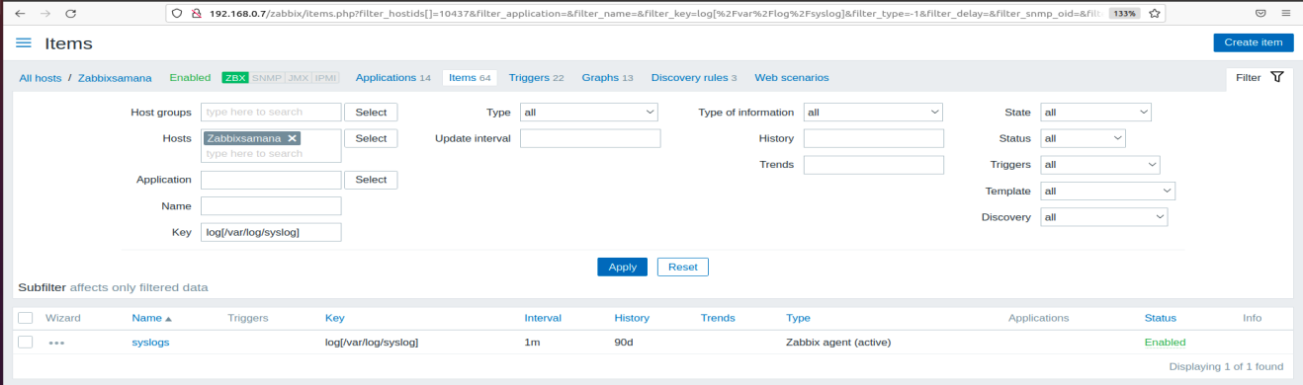

We can view the system logs as follows
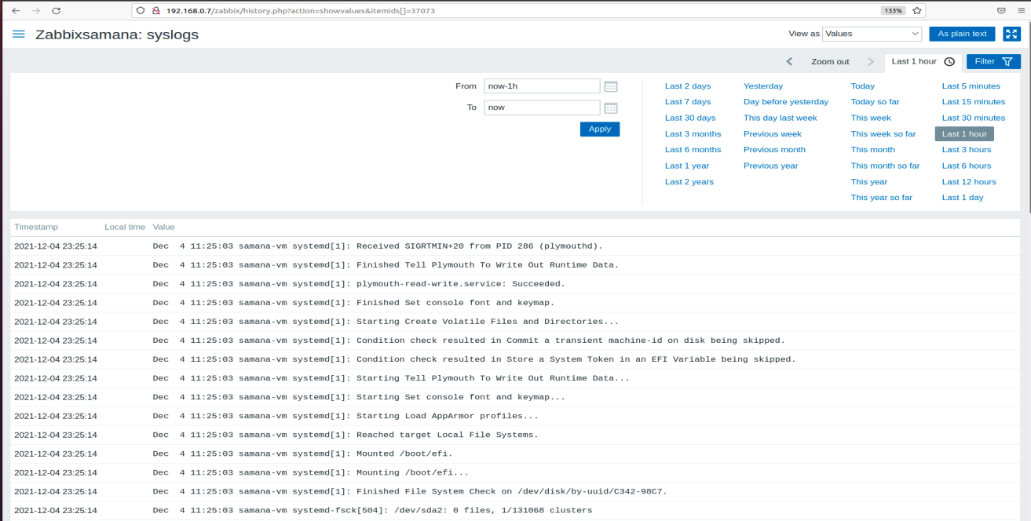
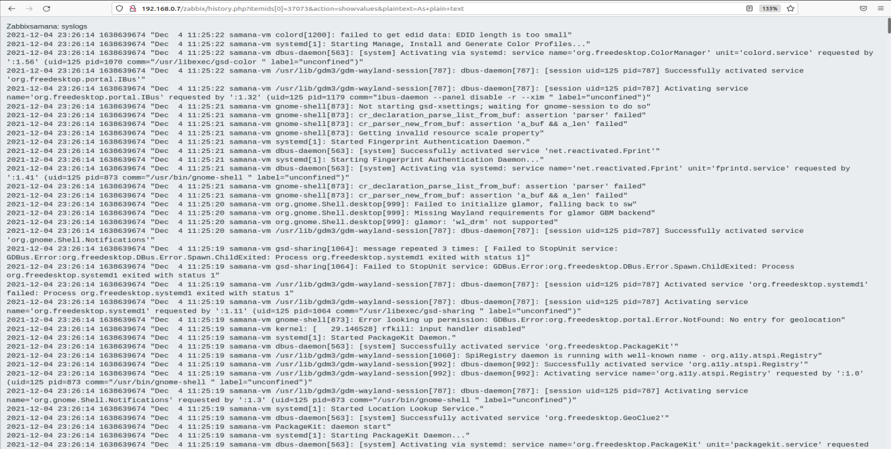

The following are the graph of logs from the system

