1 install Zabbix Server 5 on VM that includes:
- Zabbix Server
- Database
- Apache
- PHP
- Zabbix Server-Modules for Apache & Database
- Zabbix Frontend
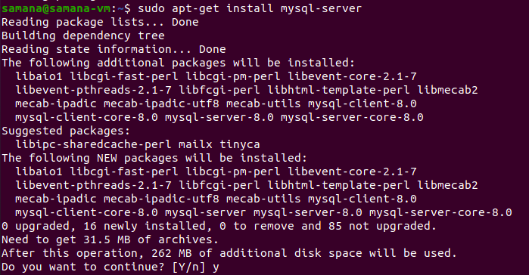
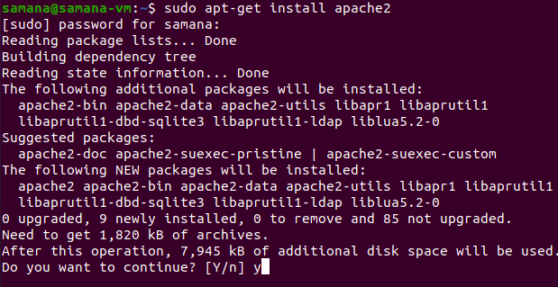
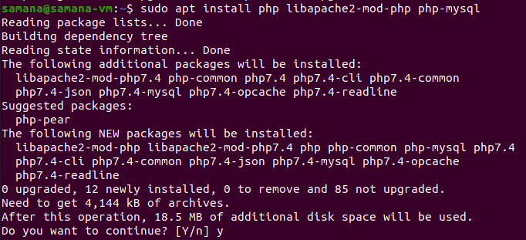
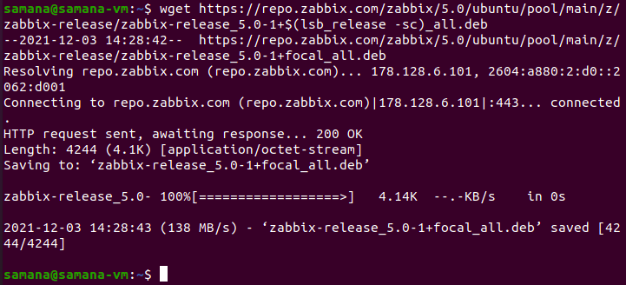
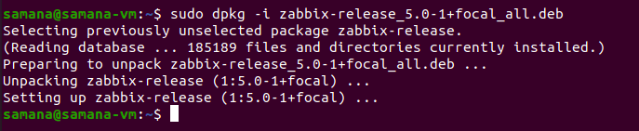
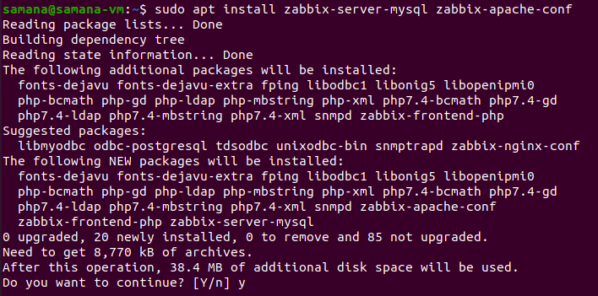
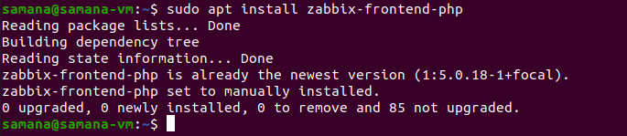

Now, we configure the mysql database for zabbix
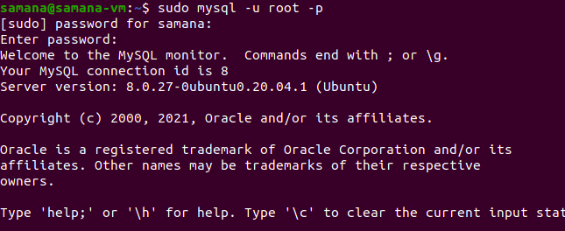

Creating a database named zabbix.
Creating a user named zabbix and password for that database user
Granting all privilege on all tables of zabbix database to zabbix user.
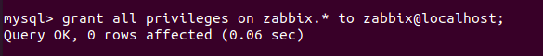
In the end we flush privileges for security reasons
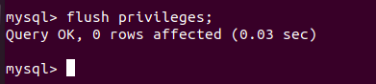
We run the following command to set up the schema and import the data into the zabbix database

We set up the timezone in the following files: /etc/apache2/conf-available/zabbix.conf and /etc/zabbix/apache.conf
