Sistemas de Comunicaciones Digitales

Tarea 02

Ejercicio 1.
In the quantification level of the sample, the relation between this q and the quantity of bits used has a really important matter. Since with a few bits the sample can be recovered. However this bring a level on noise to the signal. But on the other hand it is of no use if we simply use a lot of bits per sample to recovered it. The signal will not get better. So the objective it is to get the best audio with the less amount of bits.
Ejercicio 2.
Rb = 10^6 b/s.
Fs = 44,100 kHz
T = 10 s
14 | (14 bits) * (Fs) * (T) | (6,174,000) / Rb | 6.174 s
10 | (10 bits) * (Fs) * (T) | (4,410,000) / Rb | 4.41 s
8 | (8 bits) * (Fs) * (T) | (3,528,000) / Rb | 3.52 s
4 | (4 bits) * (Fs) * (T) | (1,764,000) / Rb | 1.76 s

Ejercicio 3.
Analysis bia the function in matlab.
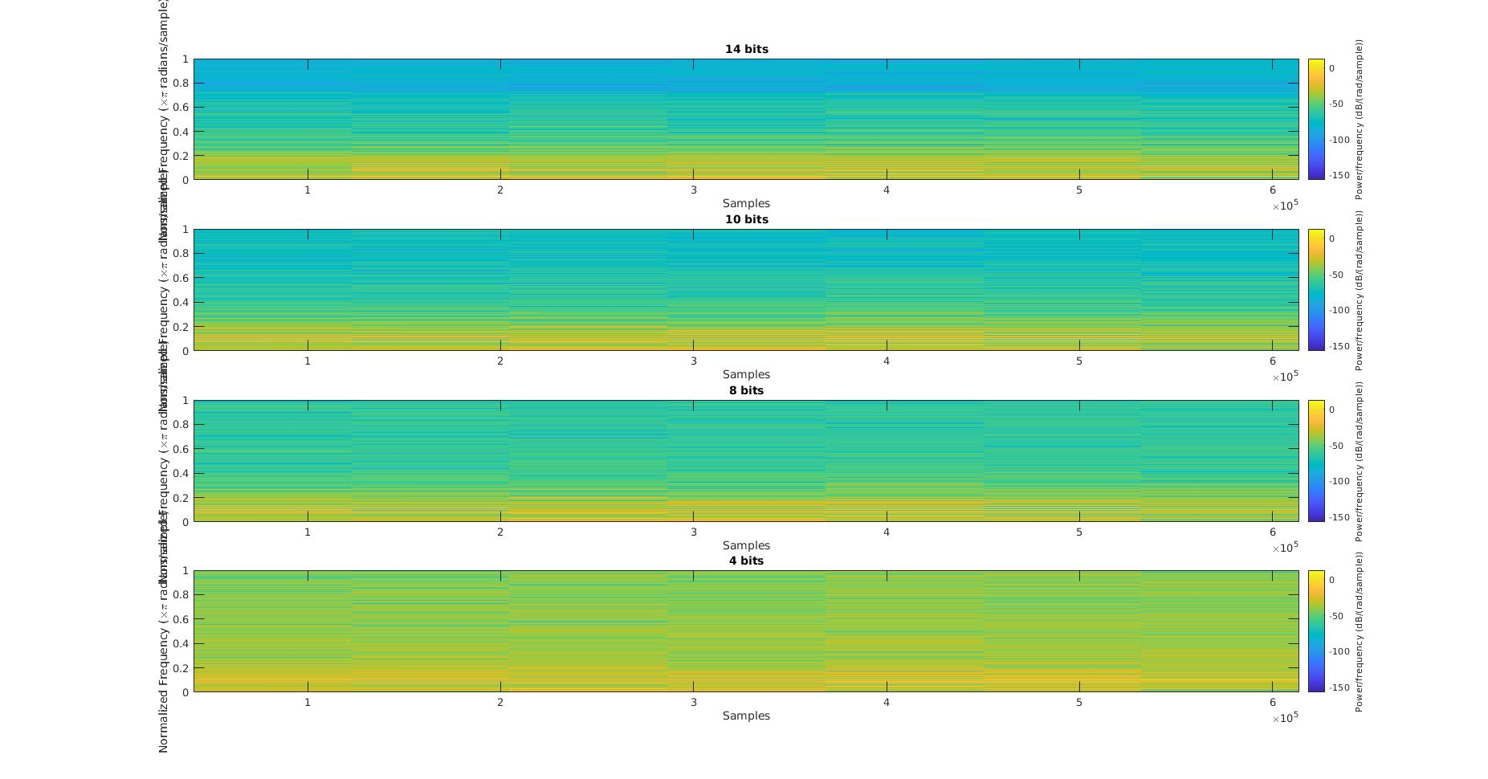

Analysis bia the app of Matlab
- data_14bits
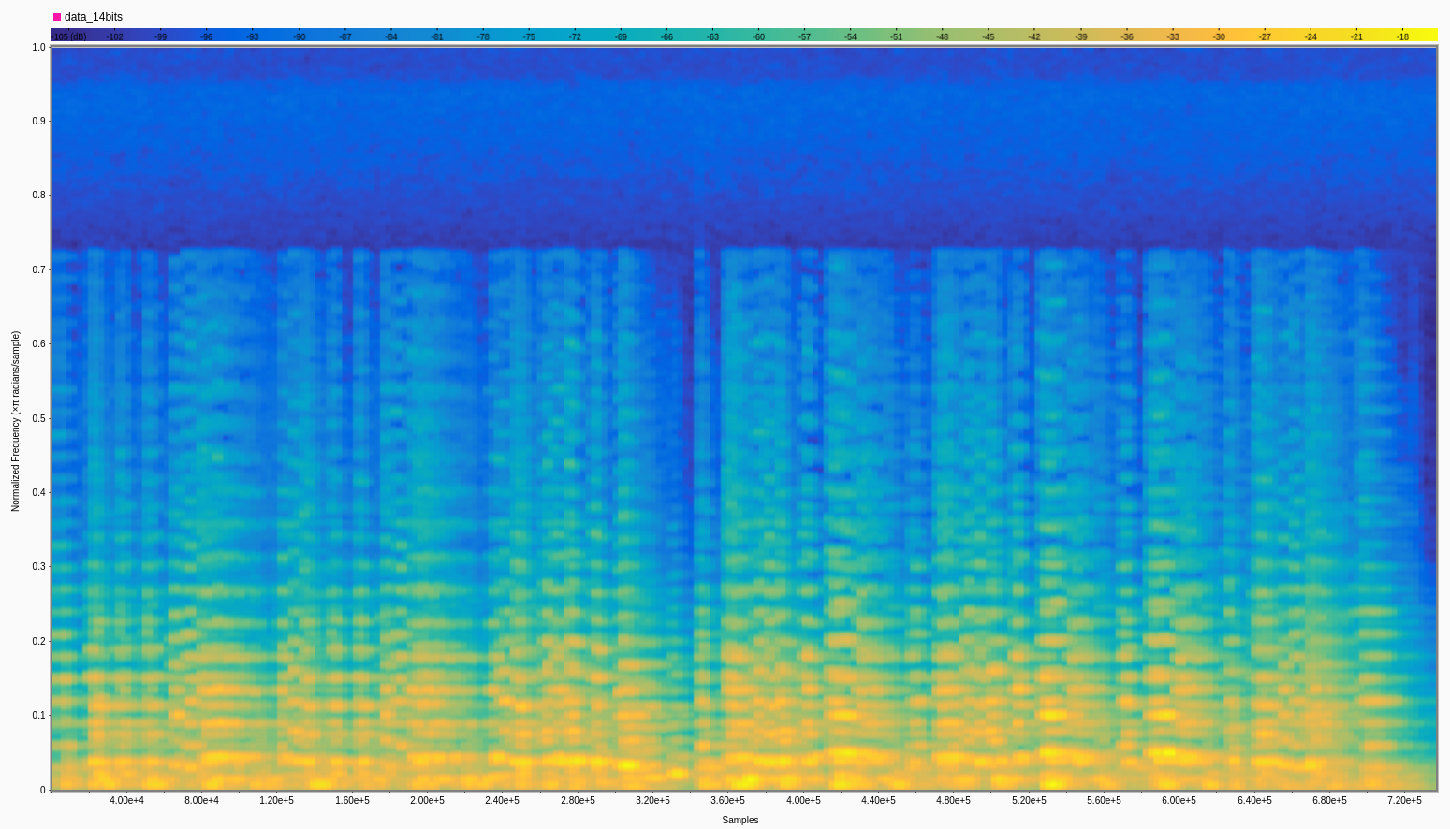

- data_10bits
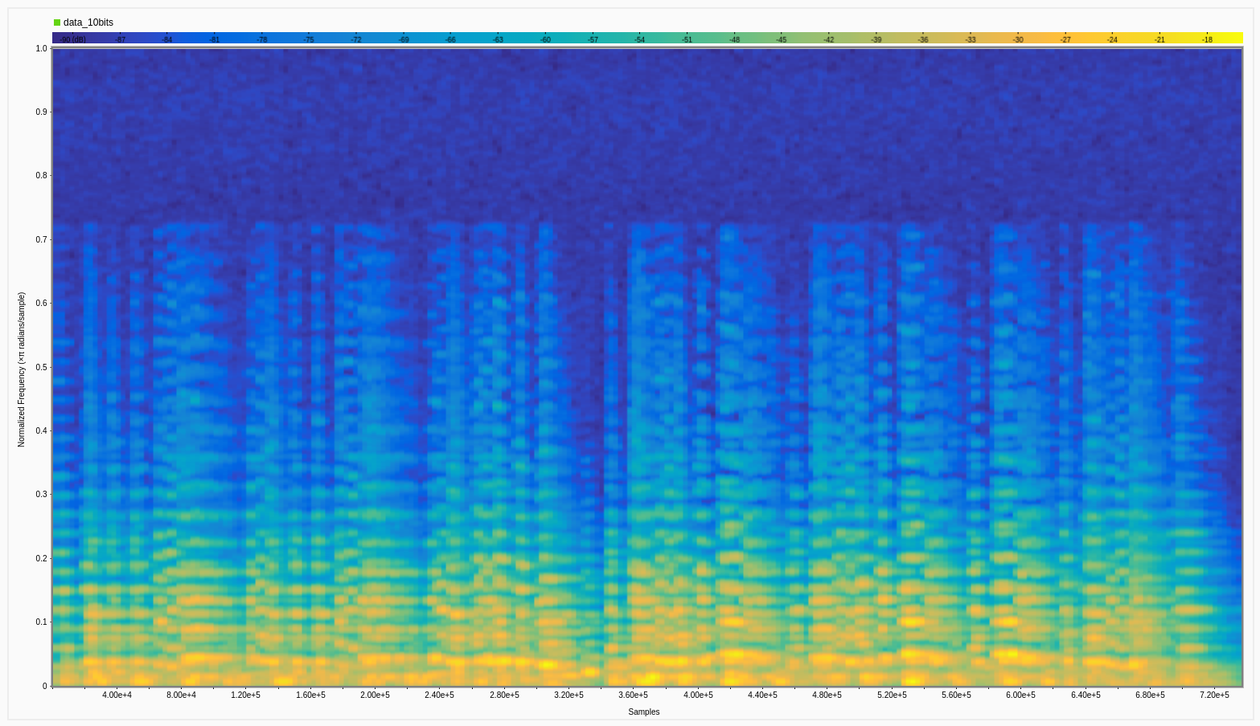

- data_8bits
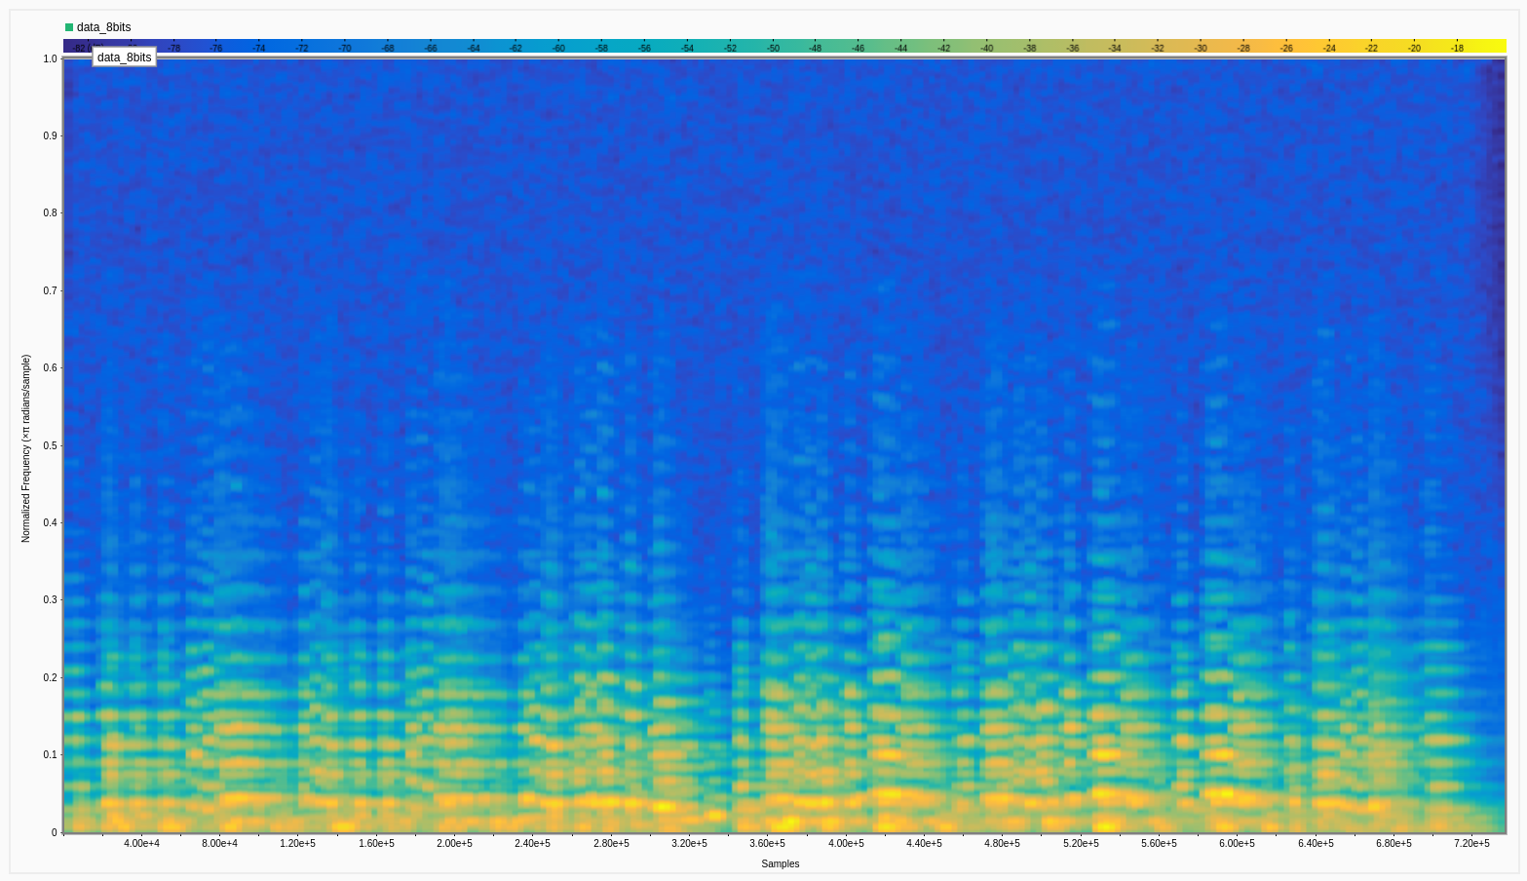
- data_4bits

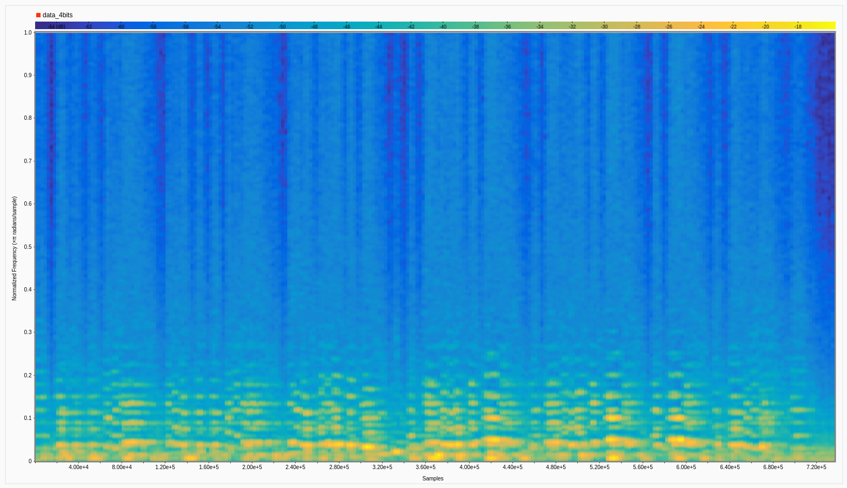

Ejercicio 4.
As the fc of the filter goes lower the quality of the signal as it goes goes lower as well. This goes because the lower the fc of the filter, it suppress a most considerable amount of signals and frequency's.
Ejercicio 5.
Rb = Fs * bits * T / Rb
8k Hz | (16 bits) * (17600 Hz) * (10 s) / (10^6 bits/s) | 2.8 s
4k Hz | (16 bits) * (8800 Hz) * (10 s) / (10^6 bits/s) | 1.4 s
1k Hz | (16 bits) * (2200 Hz) * (10 s) / (10^6 bits/s) | 0.3 s

The relation between the Fs and the transmition time it is so that to have a more amount of Fs, to be said in another way. It is more information to be sended in a shorter period of time. This can be reduce having a better baudrate.

Ejercicio 6.
One way of analyzing the data from a spectrogram. Is just by viewing the amount of ‘energy’ of each filter. As we can see from the filter of 8k Hz. This one in particular have an amount of energy way bigger than the filer of 1k Hz. This indicating that as we loose signal thanks to the filter, we loose energy as well.

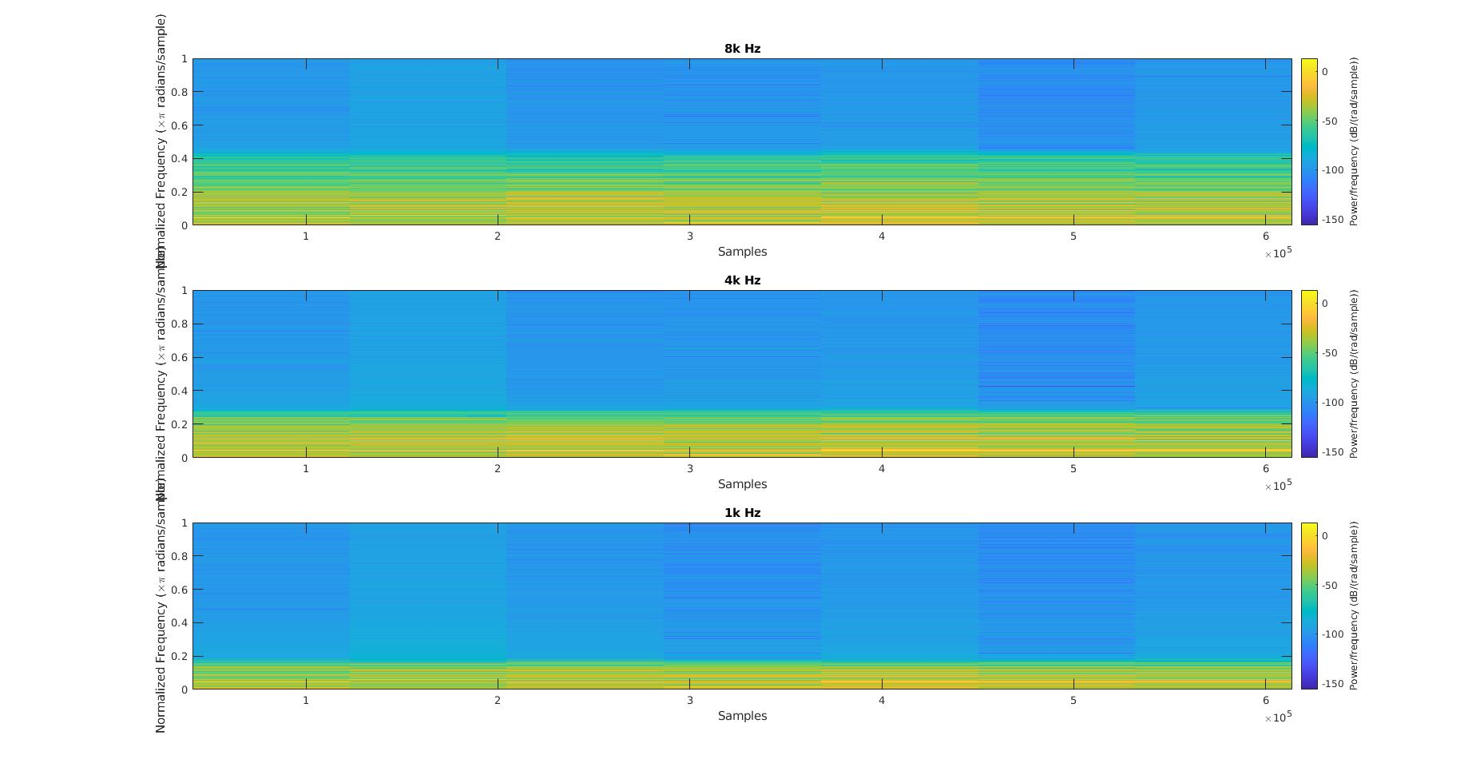
Analysis bia the app of Matlab
- lp_1k
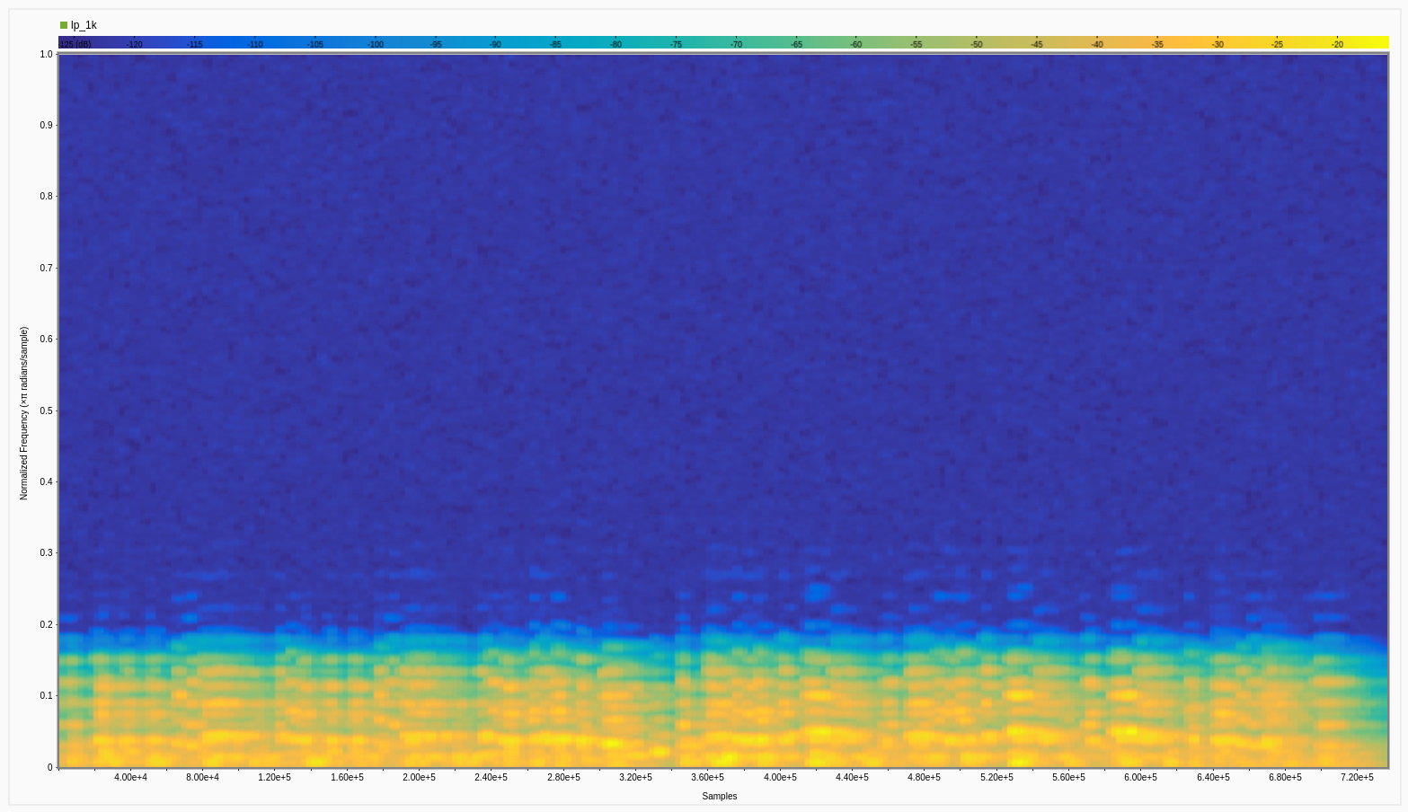

- lp_4k
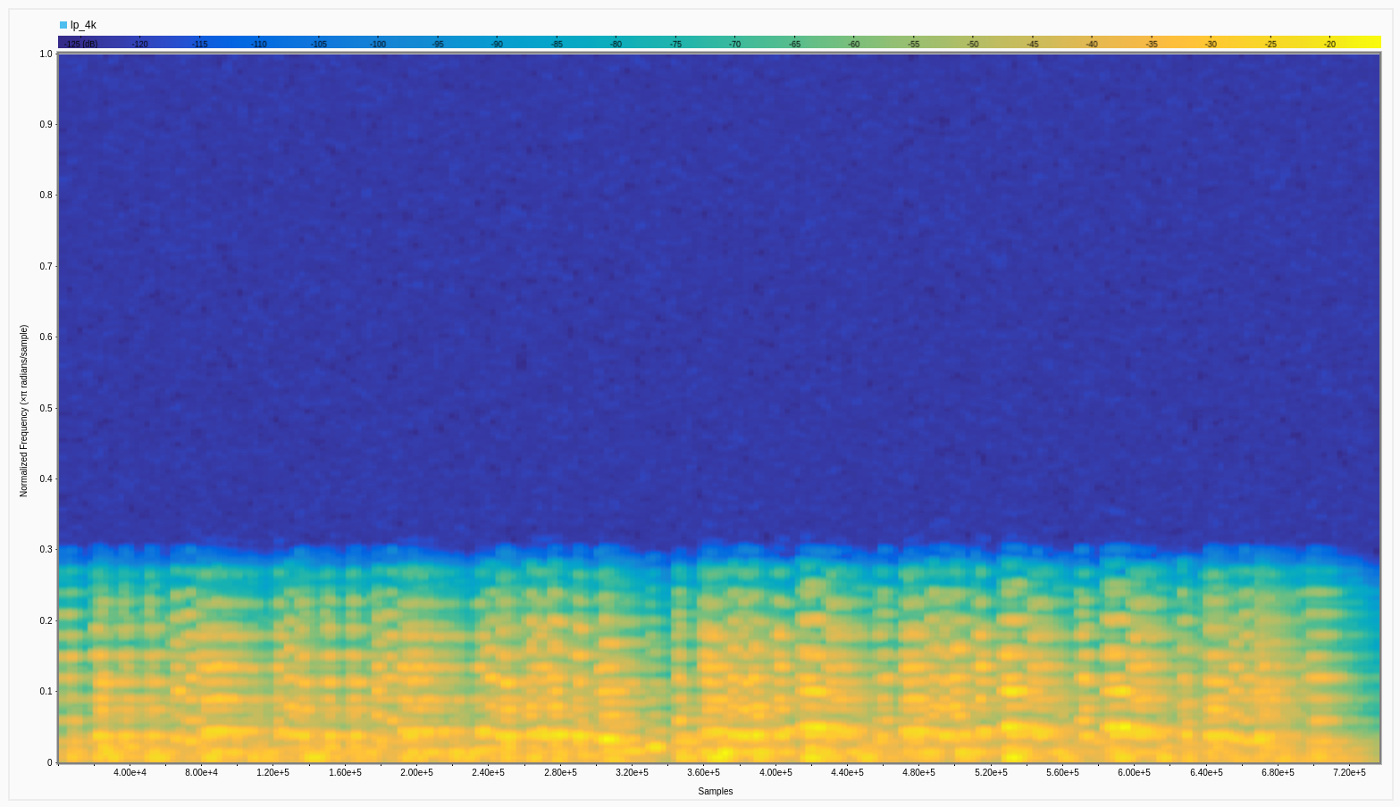
- lp_8k



