Tarea 03

Exercise 1

%% Exercise 1
Fs = 100;
Ts = 1/Fs;

start = 0;
step = Ts;
%Signal duration of 1s
stop = 1.0;

% Create a vector starting on ZERO, step of 0.1 and it will be finished at
% 1.0
t = start : step : stop;
% Create a vector filled with ZERO's. As the same length of (t).
x = zeros(1,length(t));
% Find and mark as 1 in the vector x, the values that goes according to the
% condition.
find_low = 0.4;
find_high = 0.6;

x( find((t >= find_low) & (t <= find_high) )) = 1;

plot(t,x);

wvtool(x);

Images from the code.
We can see that the pulse duration it is not exactly a pulse, since it has an slope as the real representation of a pulse it not possible to have a pulse with no slope.
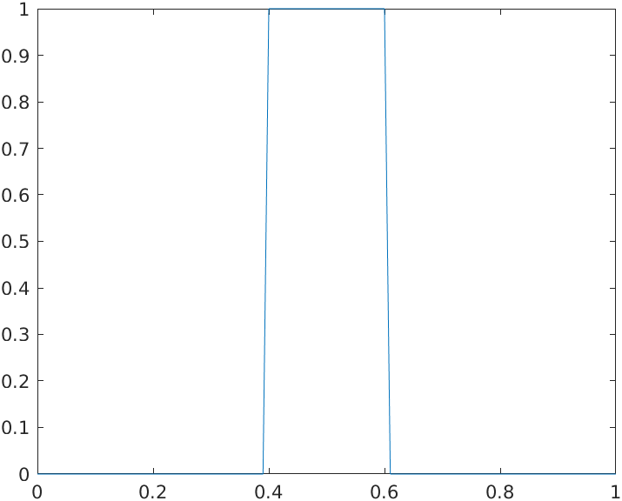Illustration 1: Image of tje duration of the pulse.

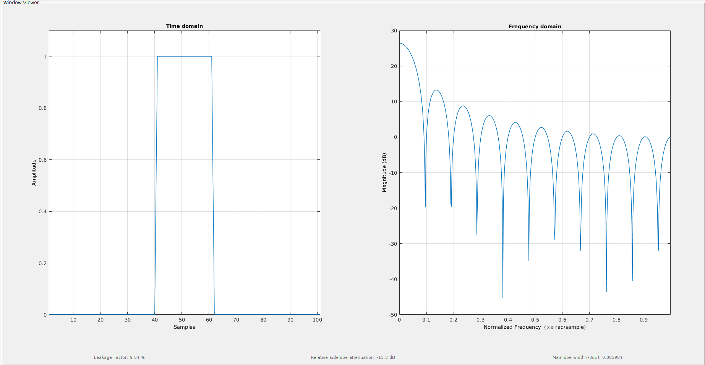

Absolute: It tend to infinite.

-3 dB: 0.975 Hz

Zero Crossing: 3.906 Hz
- It remains the same, the only change it was the time change of the pulse.

Exercise 2

MATLAB CODE:
Fs = 100;
Ts = 1/Fs;

start = 0;
step = Ts;
%Signal duration of 1s
stop = 1.0;

% Create a vector starting on ZERO, step of 0.1 and it will be finished at
% 1.0
t = start : step : stop;
% Create a vector filled with ZERO's. As the same length of (t).
x = zeros(1,length(t));
% Find and mark as 1 in the vector x, the values that goes according to the
% condition.
find_low = 0.4;
find_high = 0.6;

find_low_t = 0.7;
find_high_t = 0.9;

x( find( (t >= find_low) & (t <= find_high) ) ) = 1;
x( find( (t >= find_low_t) & (t <= find_high_t) ) ) = 1;

plot(t,x);

wvtool(x);

Images from the code.
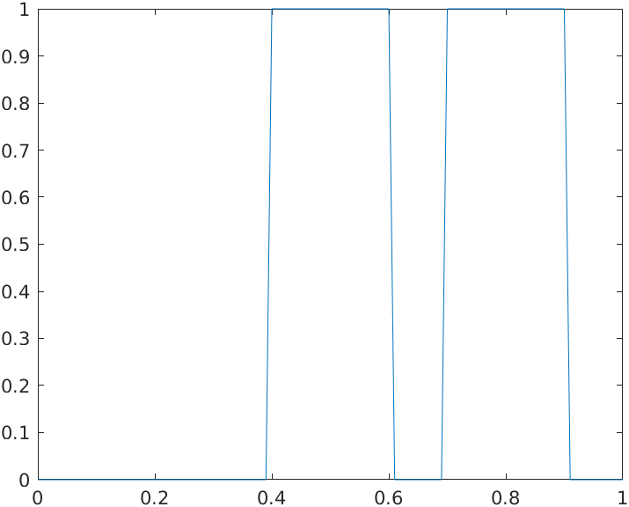
We can see that the pulse duration it is not exactly a pulse, since it has an slope as the real representation of a pulse it not possible to have a pulse with no slope.

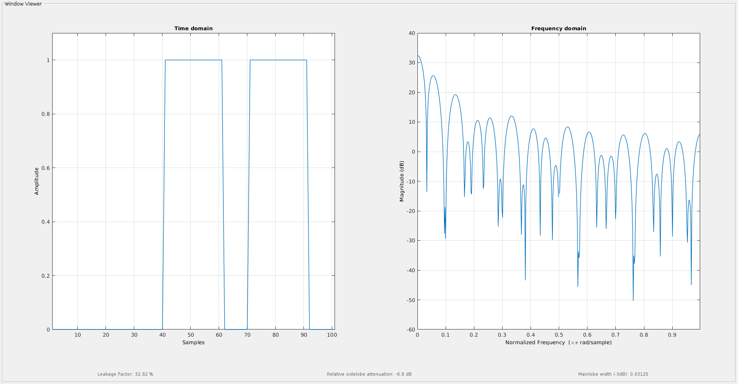

Absolute: For what I could perceive it tends to infinite also.

-3 dB: 0.78125 Hz

Zero Crossing: 4.6415 Hz

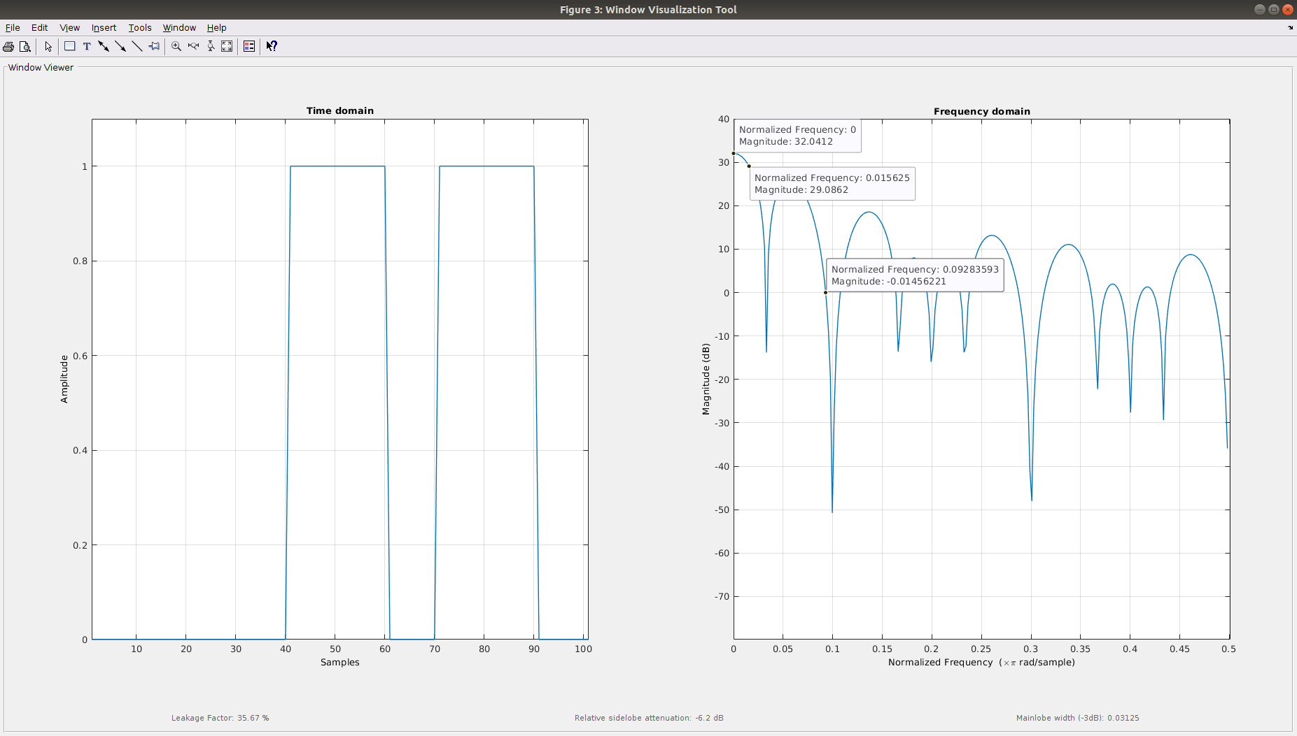

Exercise 3

MATLAB CODE:
Fs = 100;
Ts = 1/Fs;

start = 0;
step = Ts;
%Signal duration of 1s
stop = 1.0;

% Create a vector starting on ZERO, step of 0.1 and it will be finished at
% 1.0
t = start : step : stop;
% Create a vector filled with ZERO's. As the same length of (t).
x = zeros(1,length(t));
% Find and mark as 1 in the vector x, the values that goes according to the
% condition.
find_low = 0.4;
find_high = 0.6;

find_low_t = 0.7;
find_high_t = 0.9;

x( find( (t >= find_low) & (t <= find_high) ) ) = 1;
x( find( (t >= find_low_t) & (t <= find_high_t) ) ) = -1;

plot(t,x);

wvtool(x);
Images from the code.
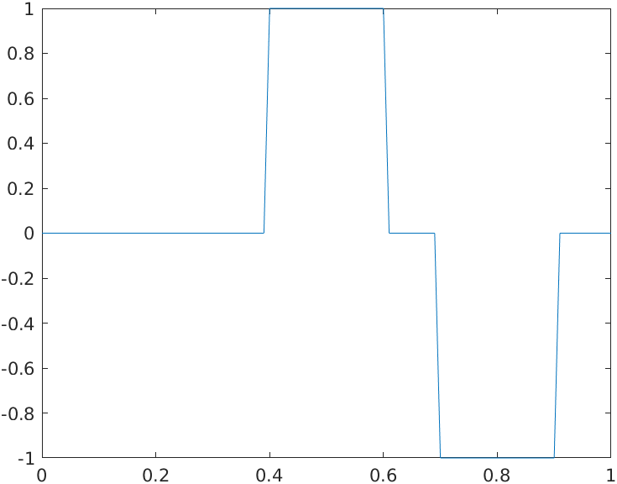
We can see that the pulse duration it is not exactly a pulse, since it has an slope as the real representation of a pulse it not possible to have a pulse with no slope.

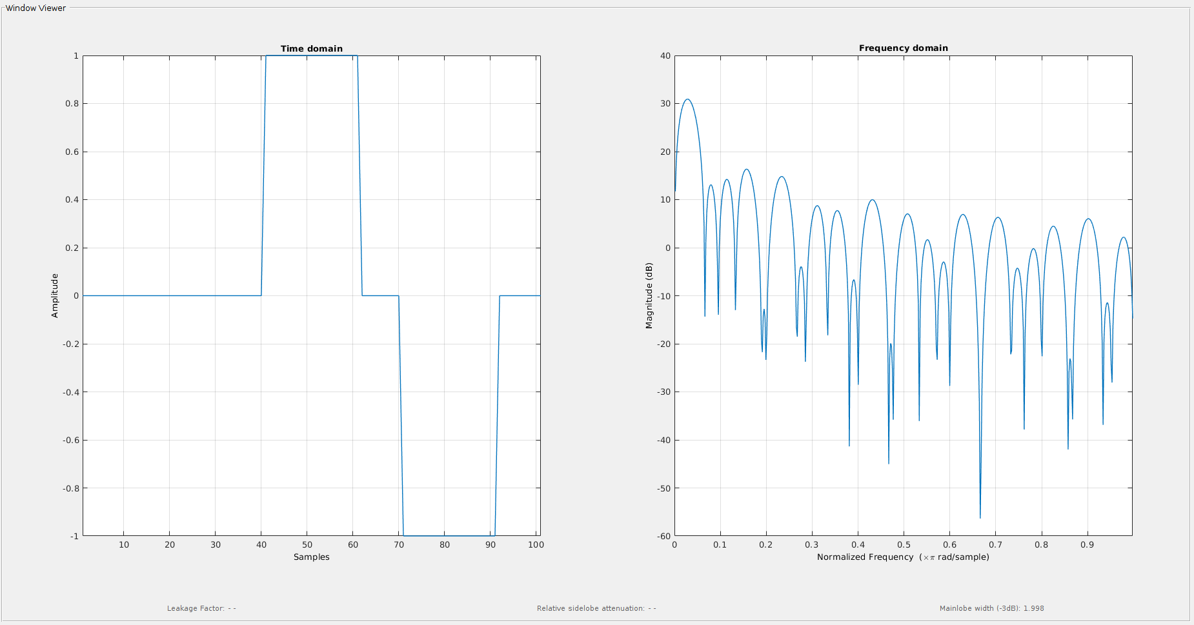

Absolute: Infinite

-3 dB: 2.245 Hz

Zero Crossing: 9.45 Hz
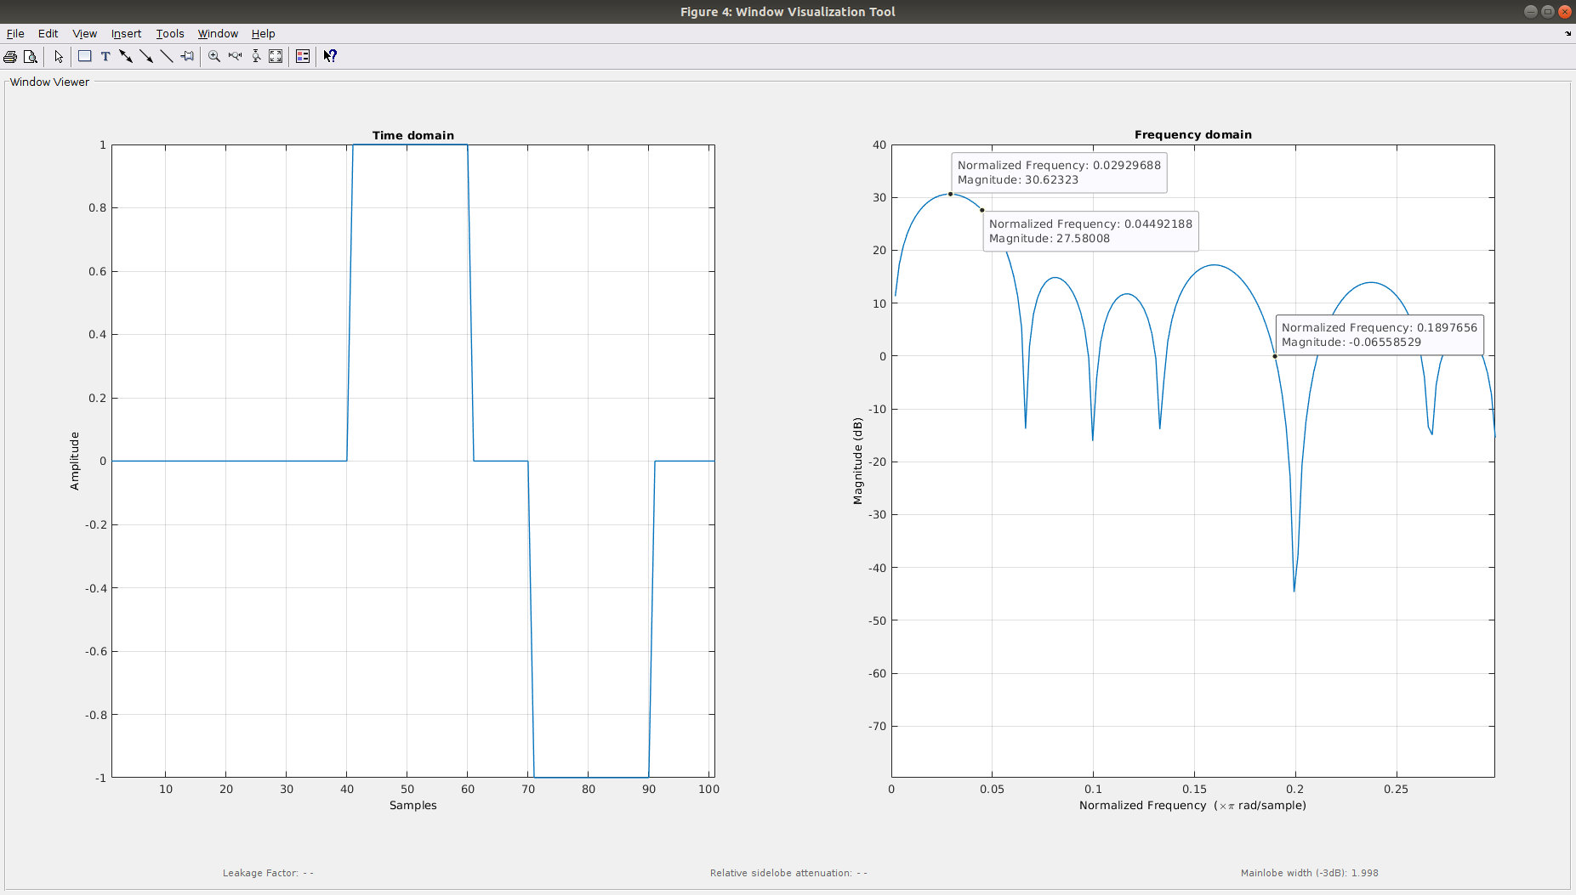

Exercise 4

- t = 0.1
MATLAB CODE:
% Create a vector filled with ZERO's. As the same length of (t).
x_4_1 = zeros(1,length(t));

x_4_1( find( (t >= 0.45) & (t <= 0.55) ) ) = 1;

plot(t,x_4_1);
wvtool(x_4_1);

Images from the code.
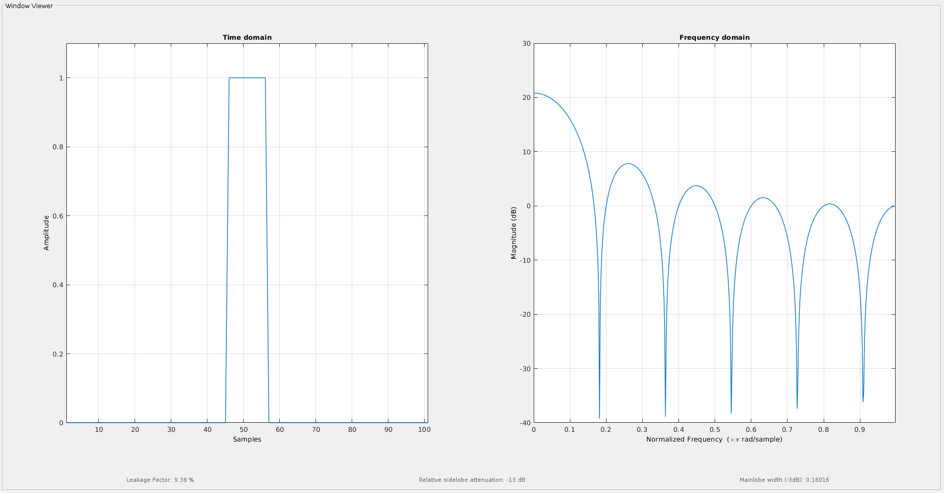
- T = 0.05
MATLAB CODE:
% Create a vector filled with ZERO's. As the same length of (t).
x_4_05 = zeros(1,length(t));

x_4_05( find( (t >= 0.475) & (t <= 0.525) ) ) = 1;

plot(t,x_4_05);
wvtool(x_4_05);

Images from the code.
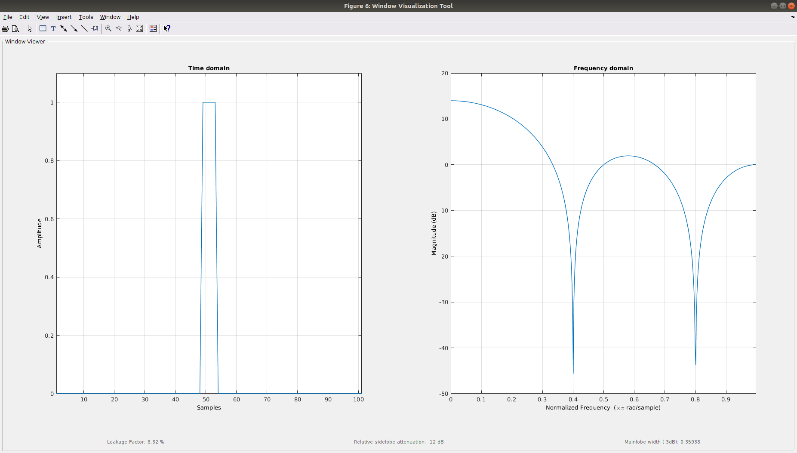

- t = 0.4
MATLAB CODE:
% Create a vector filled with ZERO's. As the same length of (t).
x_4_4 = zeros(1,length(t));

x_4_4( find( (t >= 0.3) & (t < 0.7) ) ) = 1;

plot(t,x_4_4);
wvtool(x_4_4);

Images from the code.
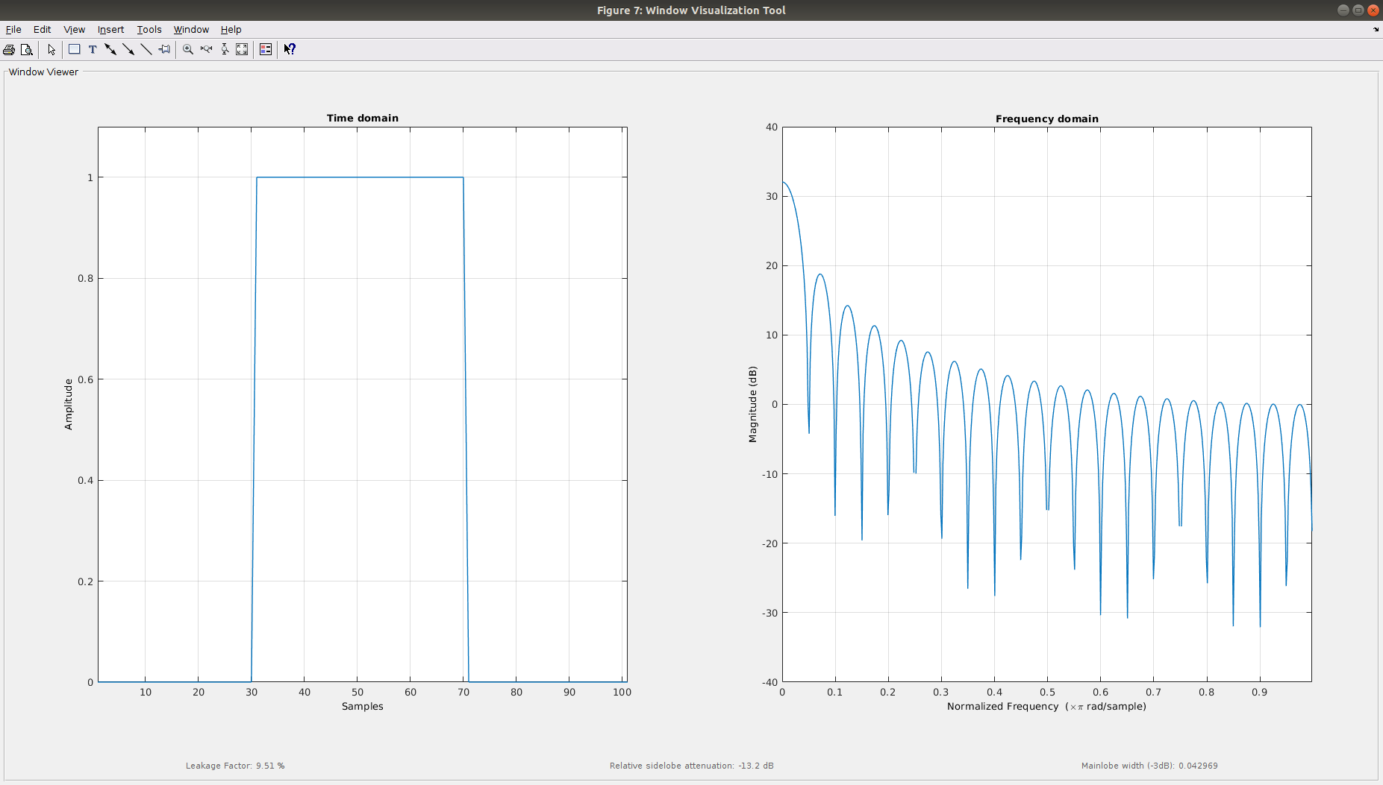
- t = 0.6
MATLAB CODE:
% Create a vector filled with ZERO's. As the same length of (t).
x_4_6 = zeros(1,length(t));

x_4_6( find( (t >= 0.2) & (t < 0.8) ) ) = 1;

plot(t,x_4_6);
wvtool(x_4_6);

Images from the code.
