

Sistemas de Comunicaciones Digitales

Tarea 0

Luis Fernando Rodriguez Gutierrez ie705694

Omar Humberto Longoria Gándara

21/01/2020

AIR 208
First of all we need to understand the importance of why an standard is so important in today’s era of technology. The reason and the importance of and standard when developing of a new way of seeing technology, it is so anyone can understand the information in the document. For example in the article
the person who developed it use the IEEE 802.11 standard. Which it is related to the WiFi technology. A big number of the achievements of this technology was thankful to this standard in particular. To achieve an increase of quality and quantity of data send through a wireless media. However, as the technology advanced, this hit some technical walls, one of this was the bandwidth. This because the bandwidth used for certain applications was already in use for another technology.
Due to multiple limitations in what the market has, this technology in some places is stagnant, although it is due to the lack of interest of the consumer to try these new components or that good works well. In this same way it is denoted that the most used standard is 208.11g since in terms of technology accessible to people it is the one that best suits their needs.

Evolution of WiFi
n this article we are mentioned how the speed was evolving, as well as the ability to increase the bandwidth to send and receive data according to time. Although these improvements came with a price, which was mostly the cost, making sure that these technologies were not used in most homes or places, but rather in a professional use where this type of technology is required.
One of the mentions that the article makes is the saturation of the 2.4 Ghz band. In which when there is a saturation of signals, this causes a noise in the same environment causing a deficiency in the same information signal. This leading to a great migration to the bandwidth of 5Ghz.

USB 3.0 Radio Frequency Interference Impact on 2.4 Ghz Wireless Devices
In this article we can look like the study that was carried out to find the failures of the wireless devices mainly when being in a vicinity of a USB 3.0 device. What is found is that USB 3.0 devices are that these tend to cause a great deal of interference with other devices if they are not properly protected. In which in this study conducted multiple tests were carried out that was whether to protect the entire device, without protection, partially protected or totally. In the results it was found that it was not necessary to protect the entire device, but only the part in which it is accessed and one more portion. Also as multiple types of protection.

Estandar WiFi
- Telefono:
Wifi 802.11ac con MIMO
- Laptop
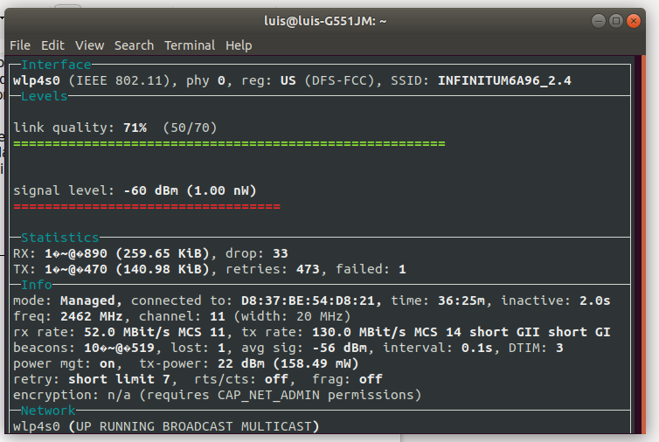

- Modem
IEEE 802.11
- Rx/Tx
  - Tx
130 Mbps
Statistics of the link:
140.96 kbps
  - Rx
52 Mbps
Statistics of the link:
259.65 kbps

