1. Fs = 8000, B = 1000, Rb = 2000, D = 10. Determine el valor de β.
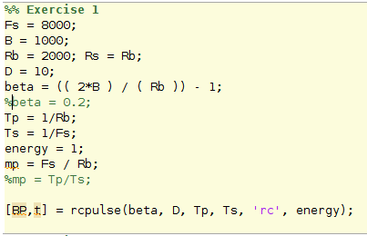
Beta = 0;
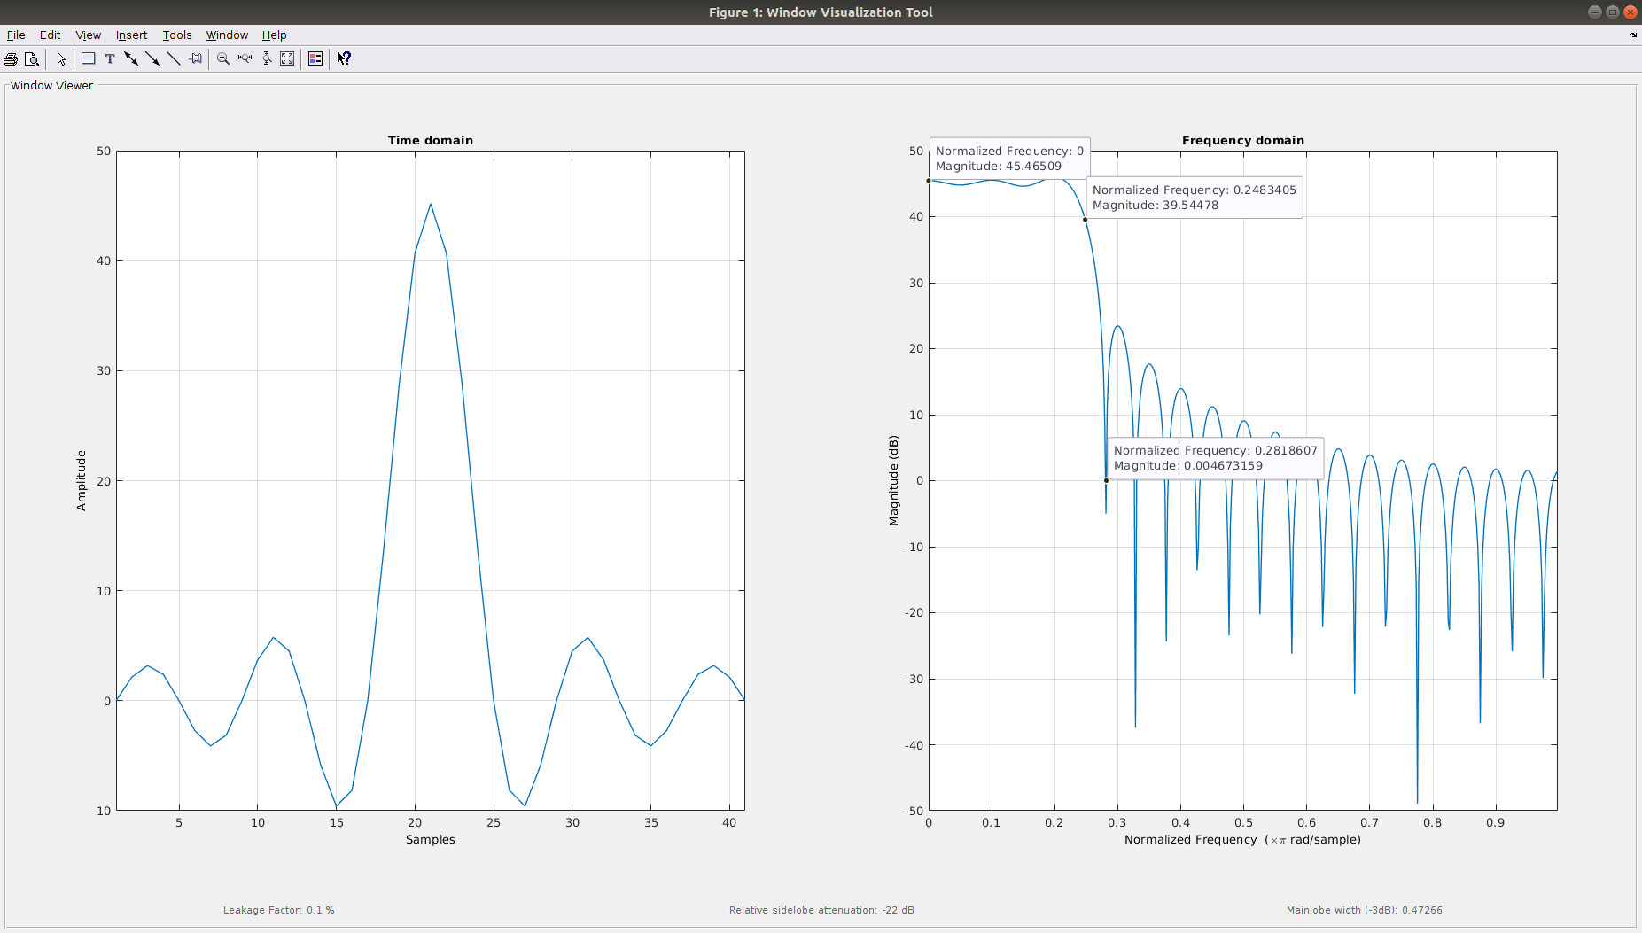Illustration 1: Specter of the signal created via the code to the left
2. Fs = 8000, B = 1000, β = 0.2, D = 10. Determine el valor de Rb.
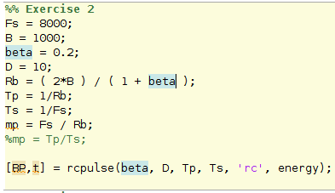
Rb = 1.6 e+03;
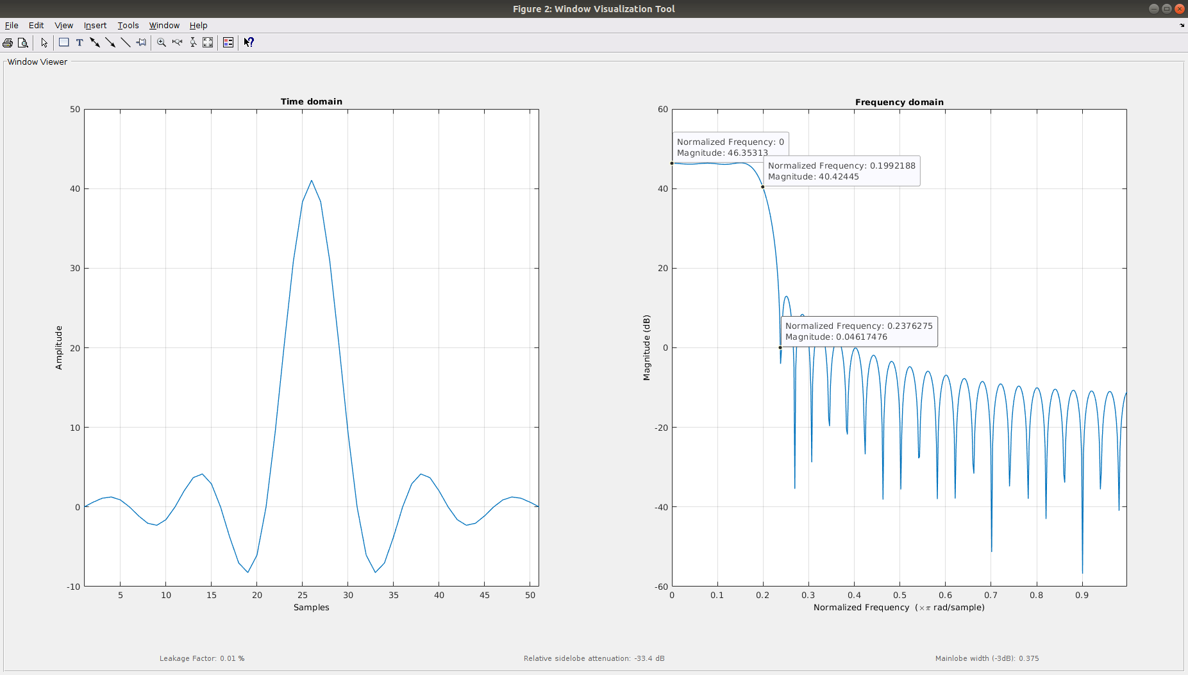Illustration 2: Specter of the signal created via the code to the left

3. Fs = 4000, β = 0.8, Rb = 2000, D = 6. Determine el valor de B.
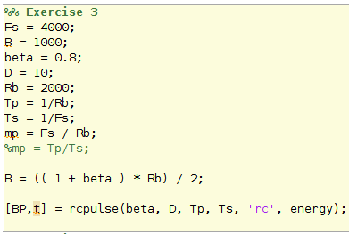
B = 1800;
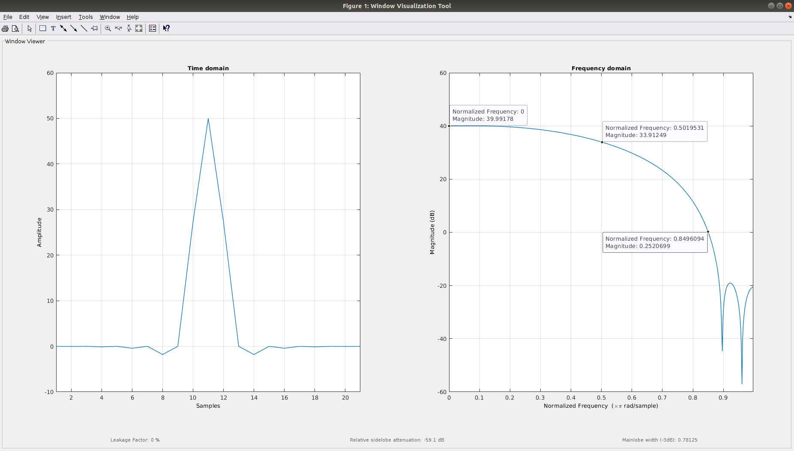Illustration 3: Specter of the signal created via the code to the left
Exercise 5.
1 & 2.
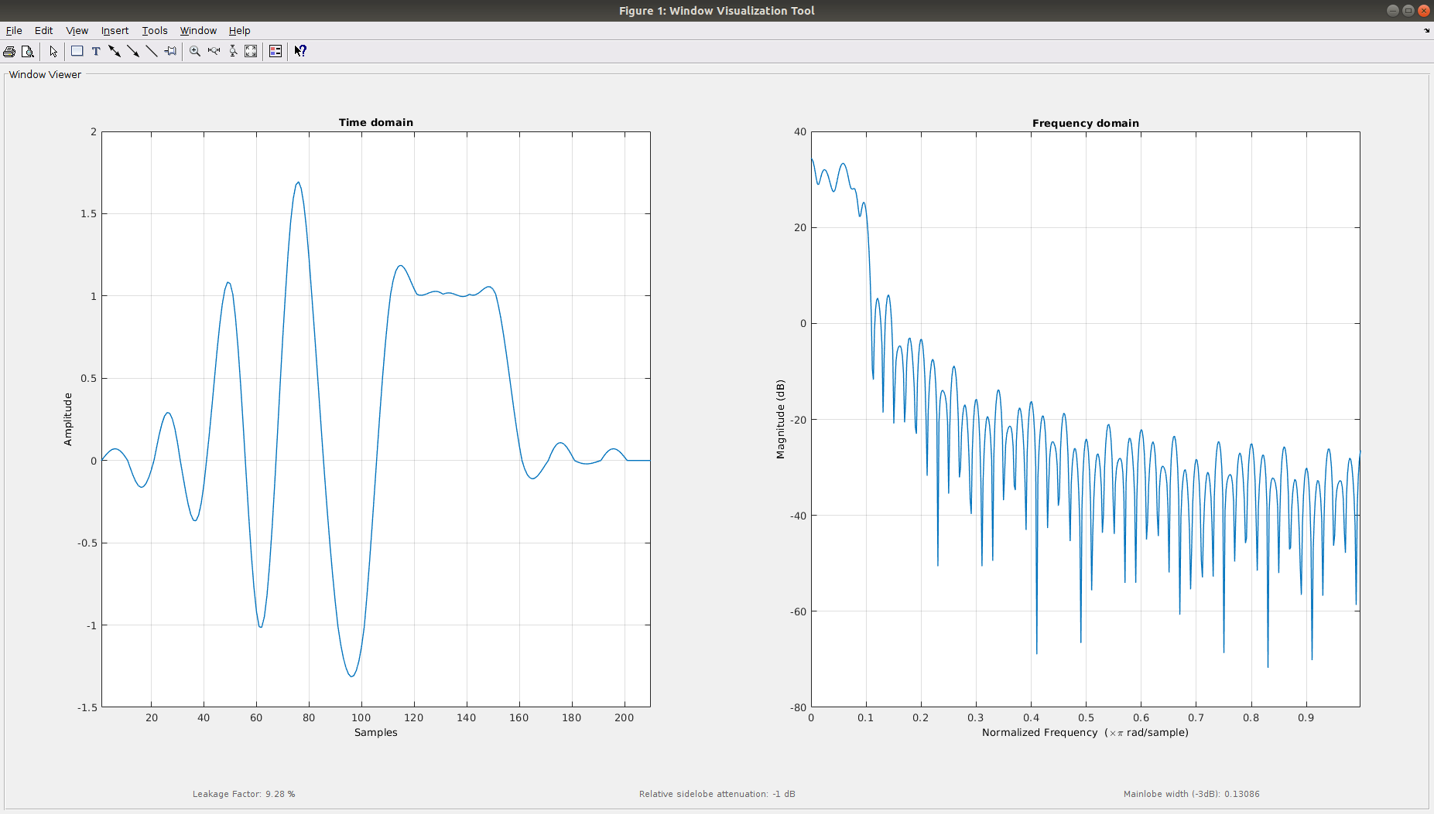Illustration 4: Signal recreated via a train pulse

3.
The shown image is the first 100 pulses of the lena image sended via the new method saw in class.
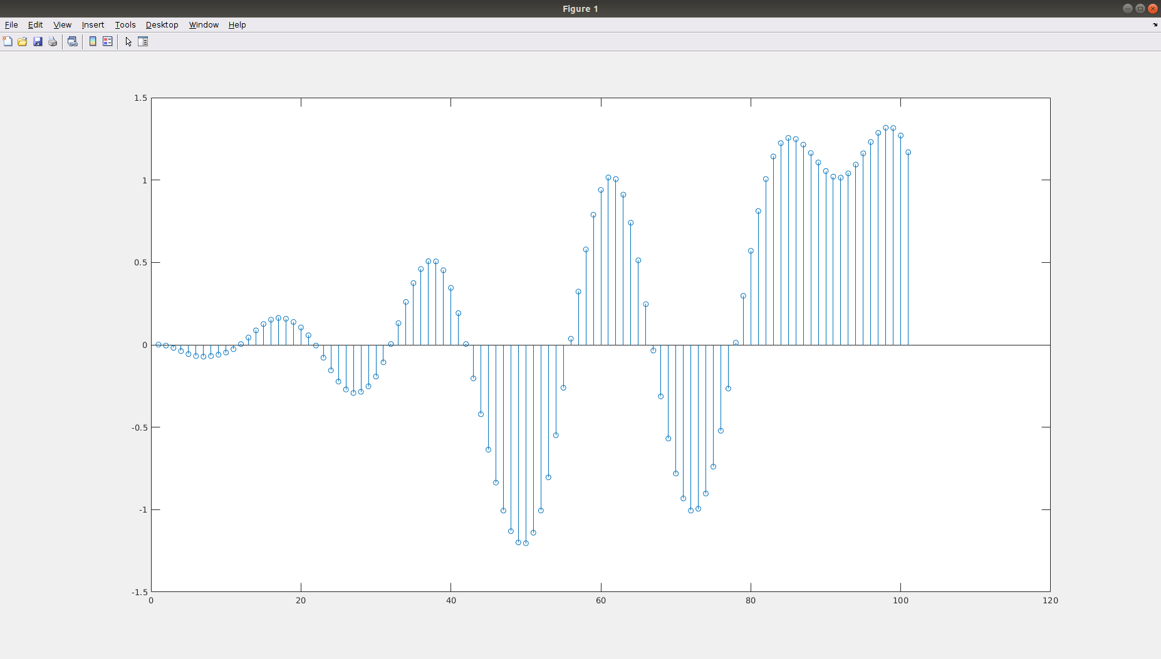Illustration 5: First 100 samples of the lena transmition.

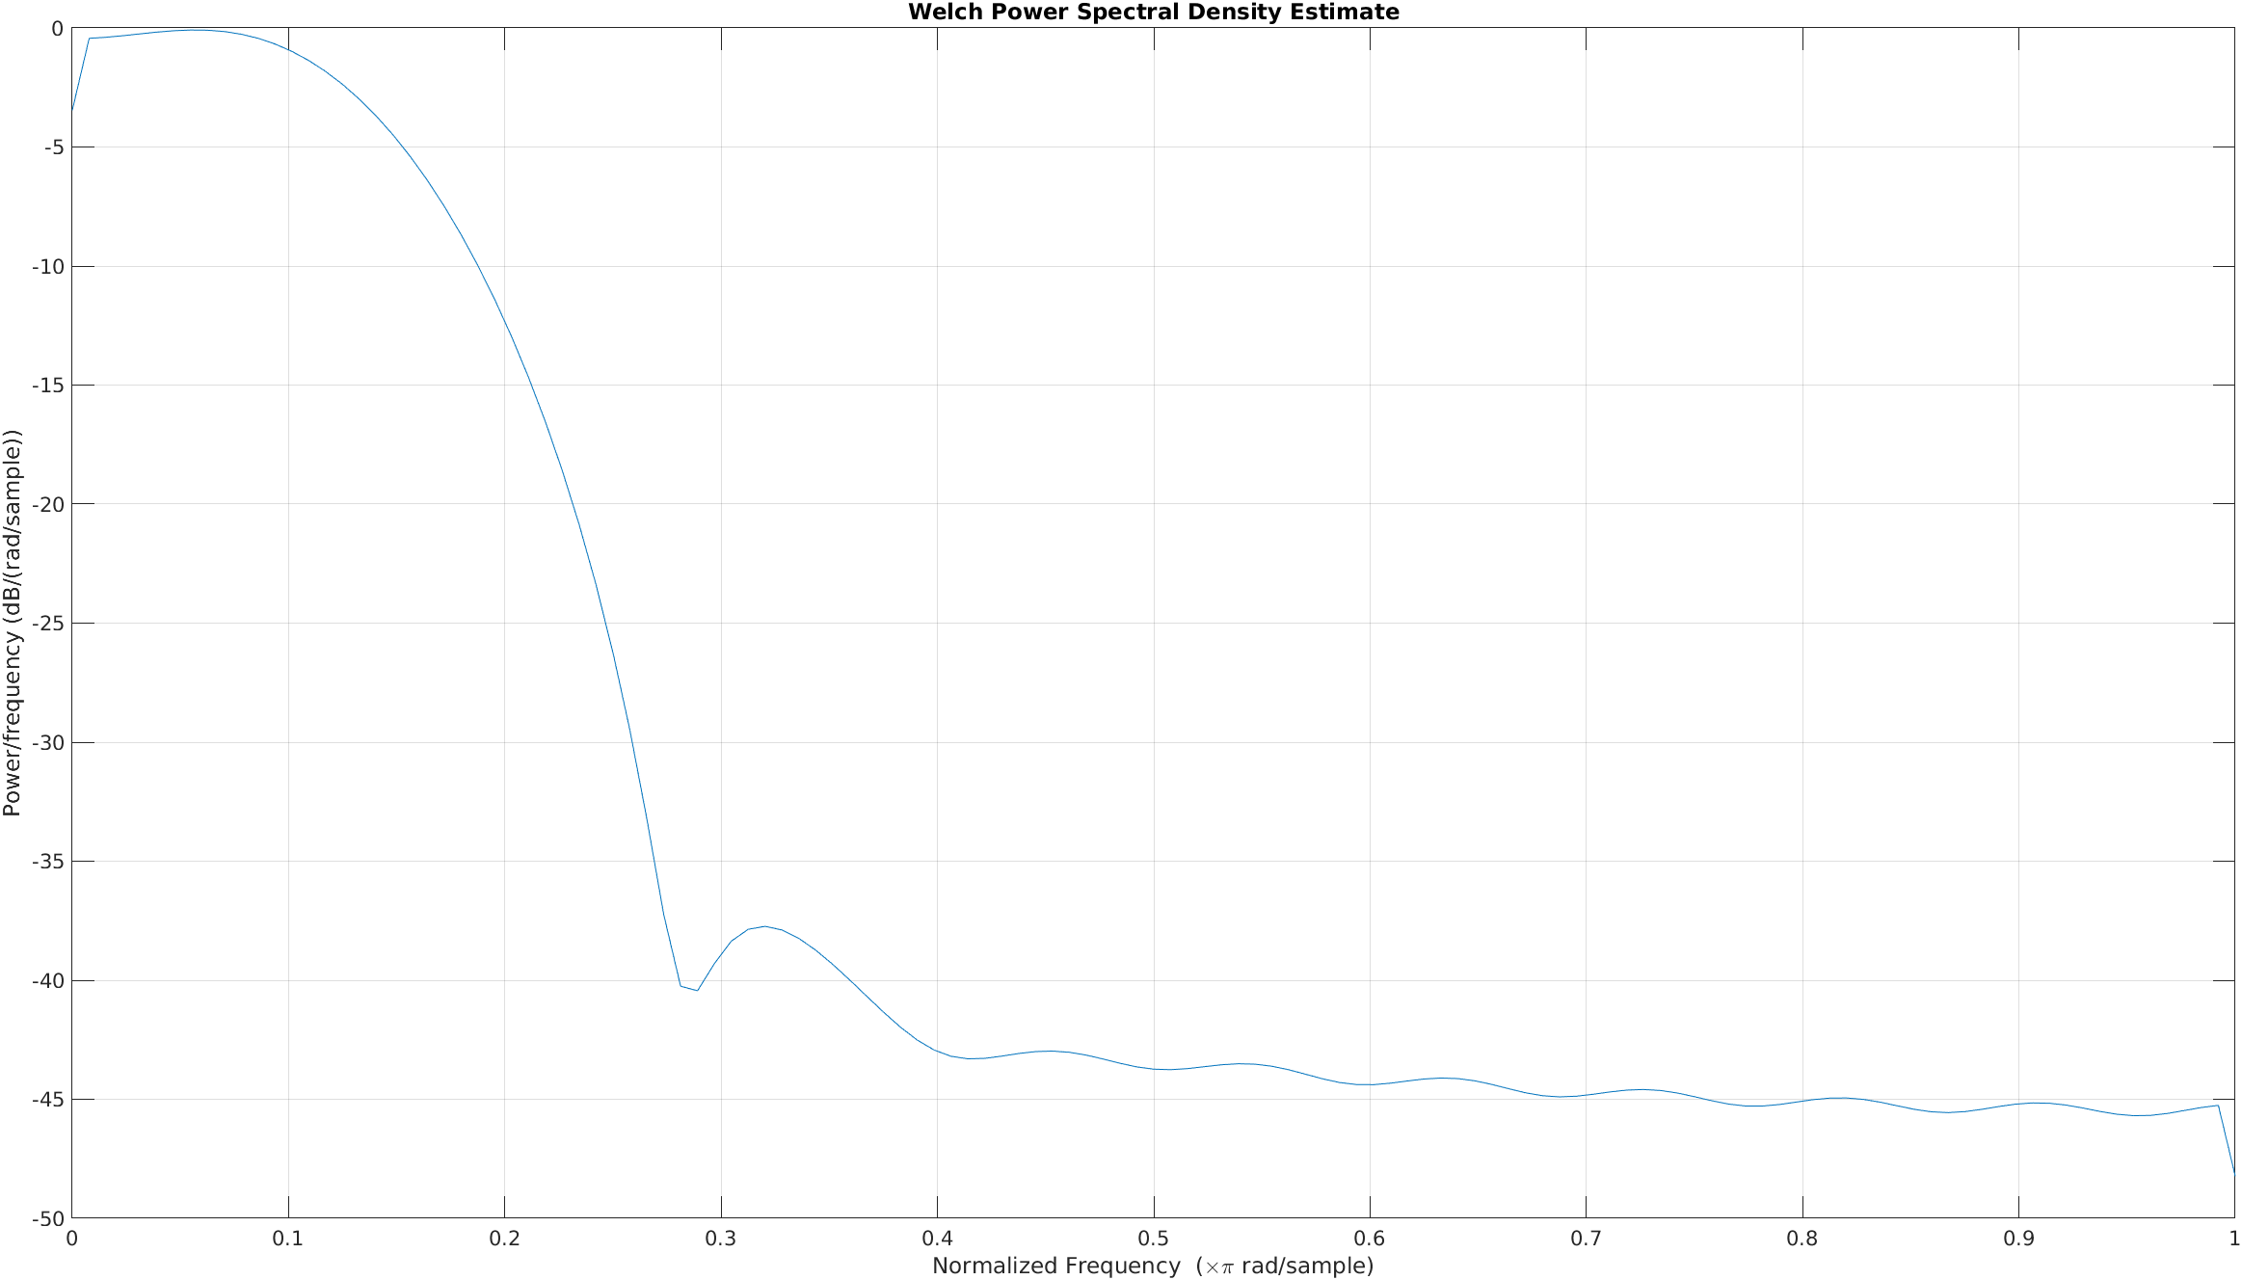Illustration 6: Spectral Power Density of the first 100 samples.
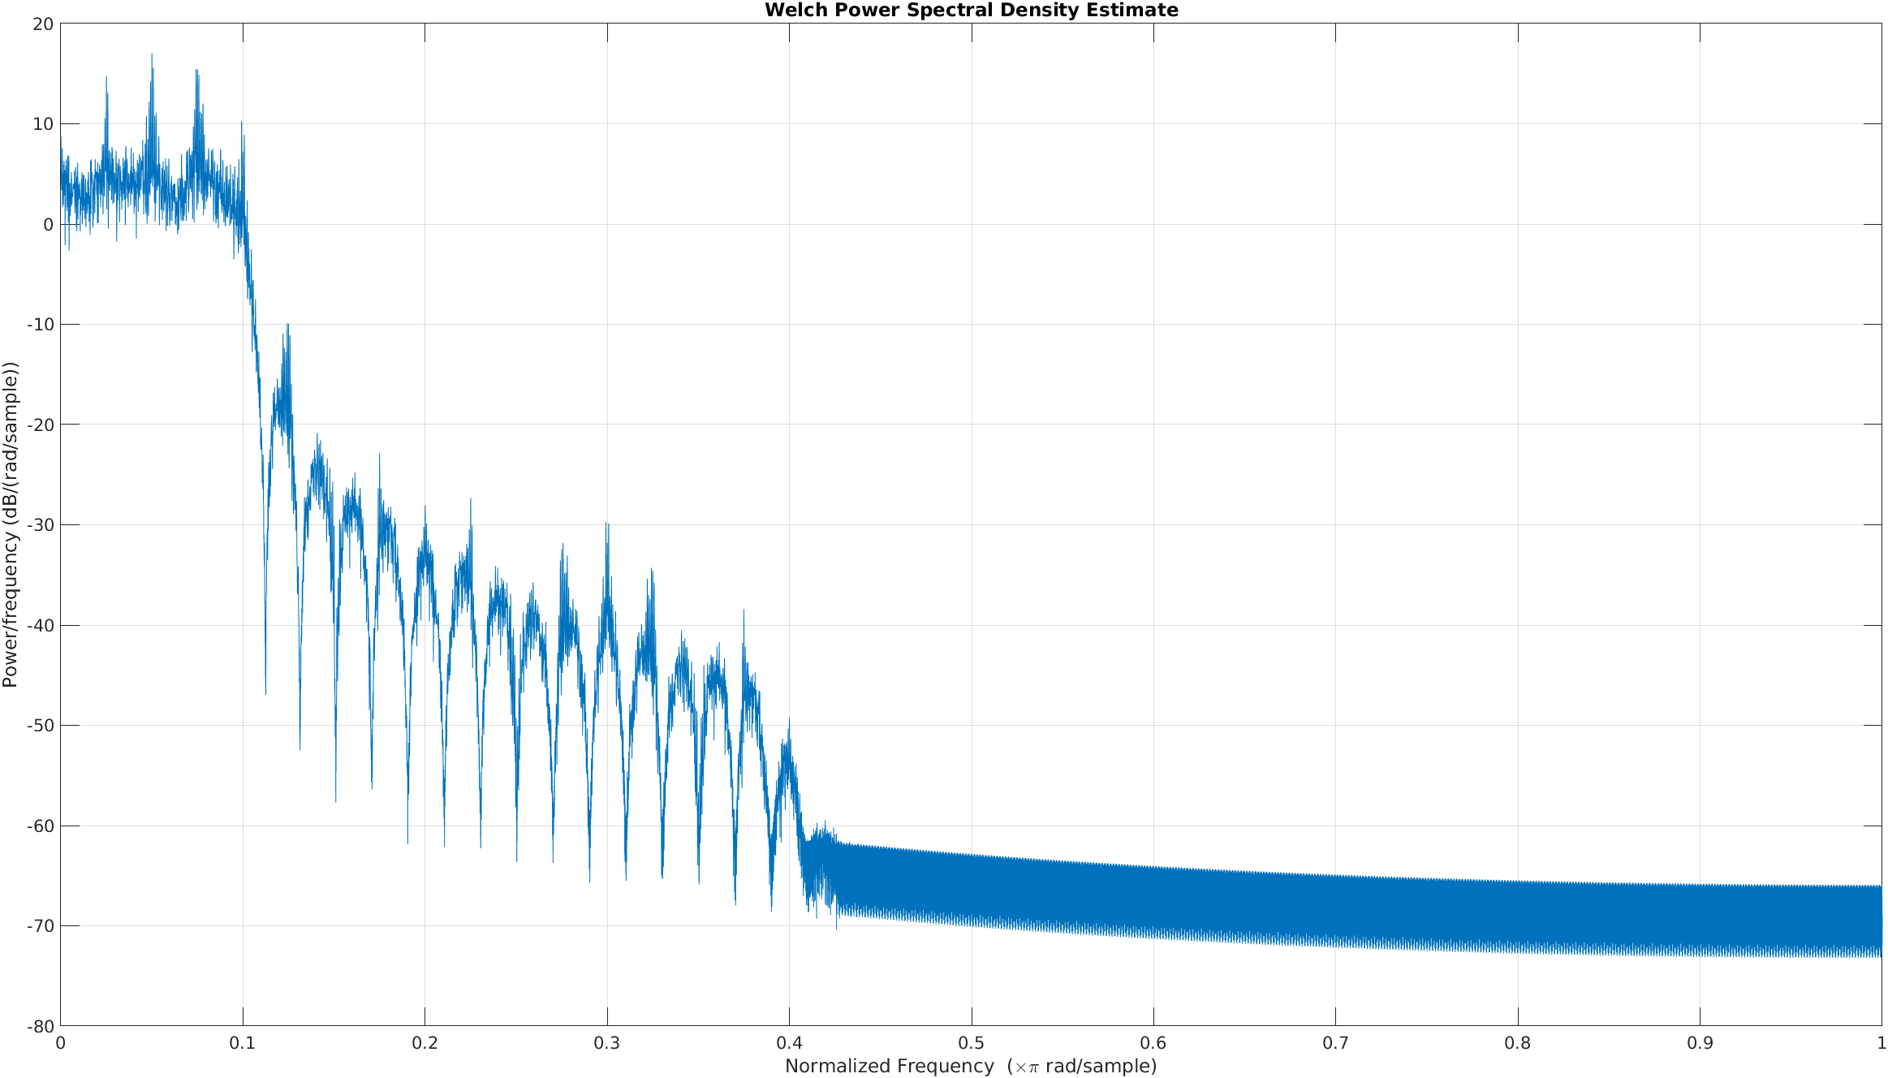Illustration 7: Spectral Power Density of the hole signal.

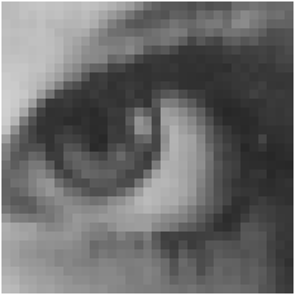Illustration 9: Recovered image.
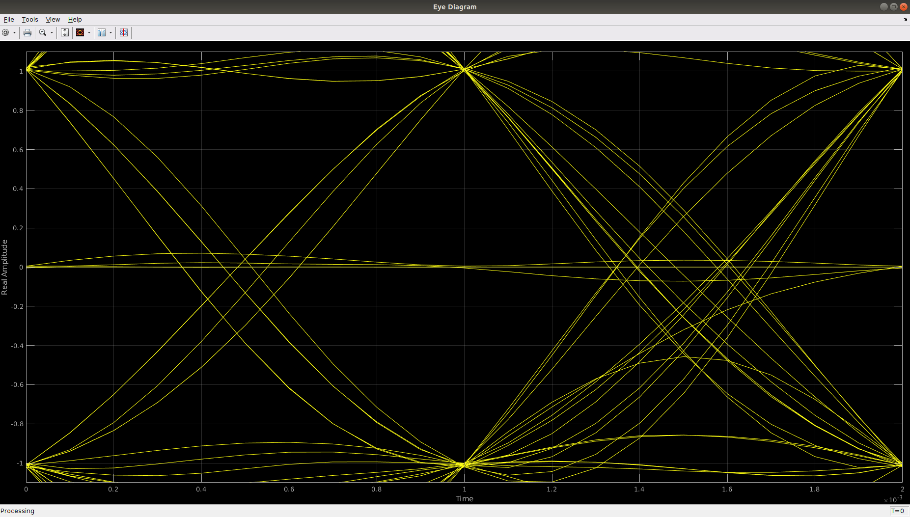Illustration 8: Eye diagram of the signal via the Polar line code.

