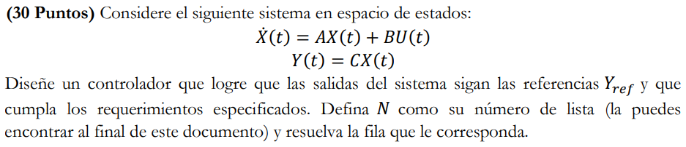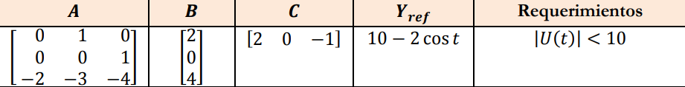

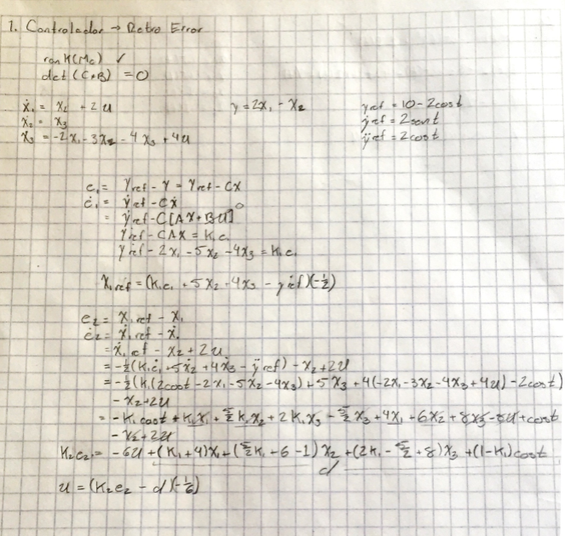

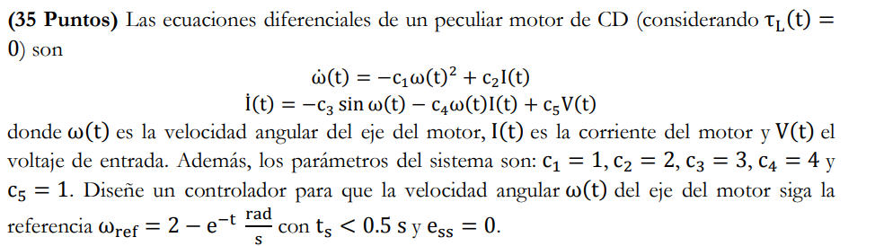Le dejo dos distintas capturas profe por que la cámara de mi celular no es la mejor del mundo que digamos.

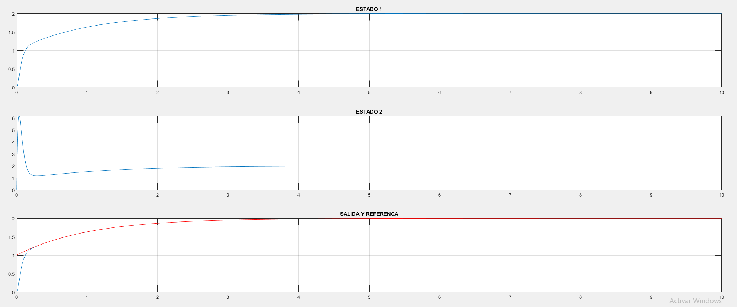

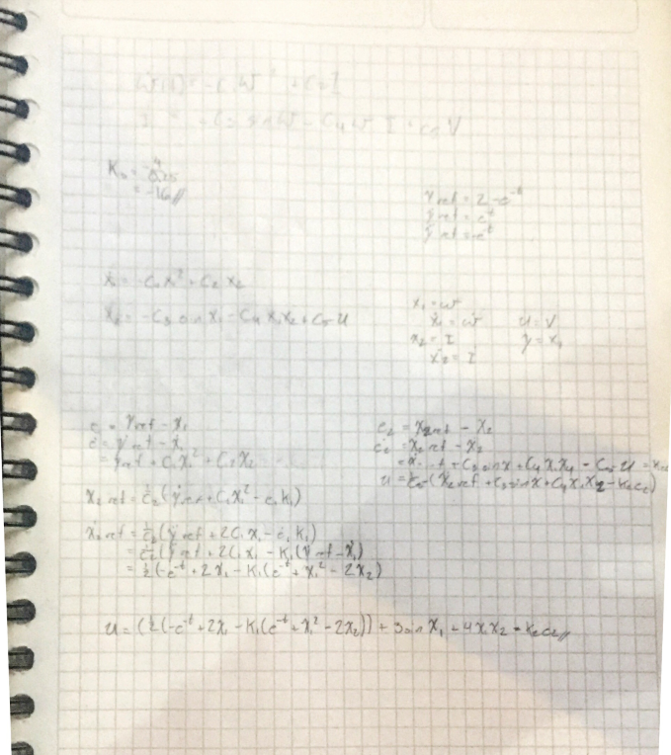

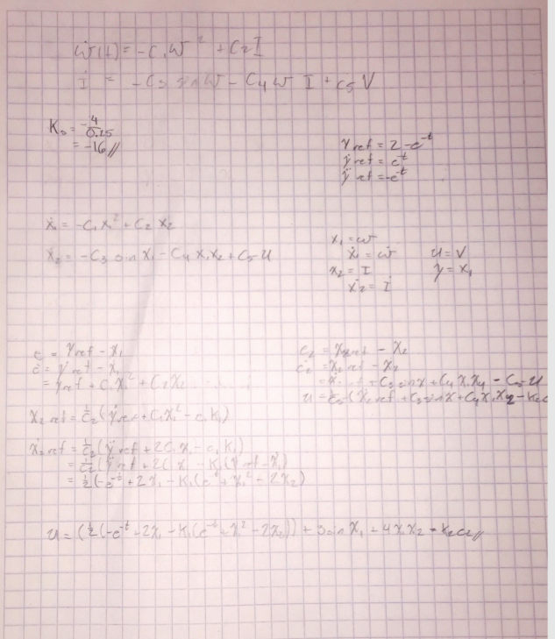



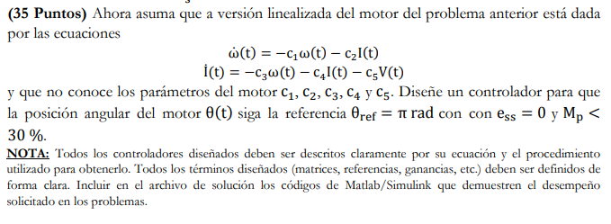

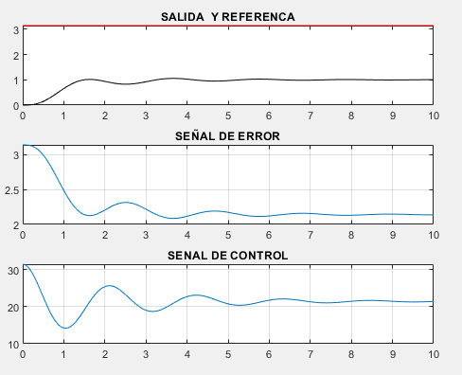C1 = 1

C2 = 1

C3 = 1

C4 = 1

C5 = 1

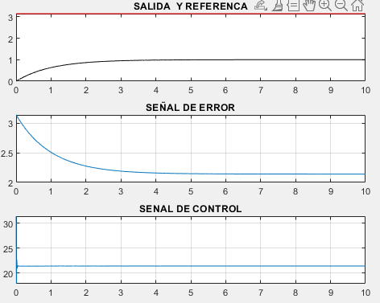C1 = 100

C2 = 100

C3 = 100

C4 = 100

C5 = 100

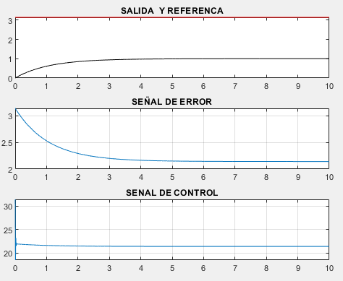C1 = 100

C2 = 200

C3 = 20

C4 = 100

C5 = 50

C1 = 100

C2 = 500

C3 = 20

C4 = 100

C5 = 50

Arreglando código, que me percate que había unos errores.

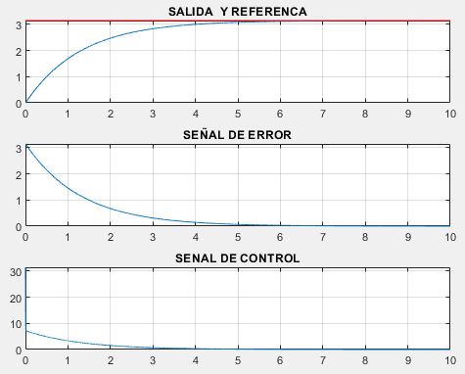C1 = 100

C2 = 500

C3 = 20

C4 = 100

C5 = 50

RESULTADO FINAL

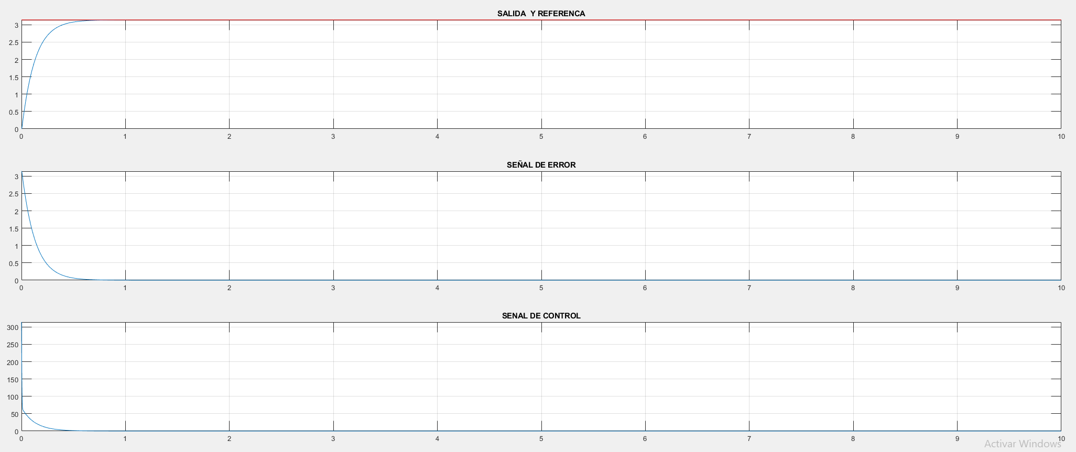

Codigo Ej1

%Examen_2 705694

tspan = [0,50];

x0 = [0;0;0];

Pd = [-2.3,-2,-2];

ej1_plot(tspan, x0, Pd);

%% Functions

function ej1_plot(tspan, x0, Pd)

global A B C K F

A = [0, 1, 0;

0, 0, 1;

-2, -3, -4];

B = [2;

0;

4];

C = [2, 0, -1];

Mc = [B A*B A^2*B]; %Matriz de controlabilidad

rank(Mc);

H = ( A - Pd(1)*eye(3) )*( A - Pd(2)*eye(3) )*( A - Pd(2)*eye(3) );

K = -[0 0 1]*inv(Mc)*H;

F = 1/(C*inv(-A-B*K)*B);

%RESUELVE LAS ECUACIONES DIFERENCIALES ORDINARIAS (ODES)

[t, X] = ode45(@ej1_sys,tspan,x0);

figure;

subplot(3,1,1); plot(t, X(:,1)); title('ESTADO 1'); grid;

subplot(3,1,2); plot(t, X(:,2)); title('ESTADO 2'); grid;

subplot(3,1,3); plot(t, X(:,3)); title('ESTADO 3'); grid;

ref = 10 - 2*cos(t);

U = X*K' + F*ref; maxU = max(abs(U))

figure; plot(t, C*X', 'r', t, ref); title('SALIDA'); grid;

figure; plot(t,U); title('SENAL DE CONTROL'); grid;

end

function dX = ej1_sys(t,X)

global A B C K F

ref = 10 - 2*cos(t);

U=K*X + F*ref; %Ley de control para seguimiento

%U=10; %Escalon

%ODEs

dX = A*X + B*U;

end

Codigo Ej2

%Examen_2 705694

tspan = [0,10];

x0 = [0;0];

Pd = [-30,-30];

ej2_plot(tspan, x0, Pd);

%% Functions

function ej2_plot(tspan, x0, Pd)

global A B C k1 k2

k1 = Pd(1);

k2 = Pd(2);

%RESUELVE LAS ECUACIONES DIFERENCIALES ORDINARIAS (ODES)

[t, X] = ode45(@ej2_sys,tspan,x0);

y_ref = 2-exp(-t);

dy_ref = exp(-t);

ddy_ref = -exp(-t);

figure;

subplot(3,1,1); plot(t, X(:,1)); title('ESTADO 1'); grid;

subplot(3,1,2); plot(t, X(:,2)); title('ESTADO 2'); grid;

subplot(3,1,3); plot(t, X(:,1),t, y_ref, 'red'); title('SALIDA Y REFERENCA');grid;

end

function dX = ej2_sys(t,X)

global A B C k1 k2

B = [0;1];

dx1 = -(X(1)^2) + 2*X(2);

dx2 = -3*sin(X(1))-4*X(1)*X(2);

y_ref = 2-exp(-t);

dy_ref = exp(-t);

ddy_ref = -exp(-t);

e1 = y_ref - X(1);

d_e1 = dy_ref - dx1;

x2_ref = (1/2)*(dy_ref + X(1)^2 - e1*k1);

dx2_ref = (1/2)*(ddy_ref + 2*dx1 - d_e1*k1);

e2 = x2_ref - X(2);

U = dx2_ref + 3*sin(X(1)) + 4*X(1)*X(2) - e2*k2;

%ODEs

dX = [dx1;

dx2] + B*U;

end

Codigo Ej1

%% Tarea_24

clc; clear; close all;

tspan = [0,10];

x0 = [0,0,0];

kp = 10;

ki = 0;

kd = 10;

k = [kp, ki, kd];

controlador_PID_plot(tspan, x0, k)

%% Functions

function controlador_PID_plot(tspan, x0, k)

global A B C Kp Ki Kd

Kp = k(1);

Ki = k(2);

Kd= k(3);

A = [0, 1, 0;

0, -10, -10;

0, -10, -10];

B = [0;

0;

-10];

C = [1, 0, 0];

[t,X] = ode45(@controlador_PID_sys, tspan, [0, x0]);

ref = pi;

dref = 0;

figure;

subplot(3,1,1); plot( t, X(:,2:4)*C', t, ref*ones(size(t)), 'red'); title('SALIDA Y REFERENCA'); grid;

e = ref - X(:,2:4)*C';

subplot(3,1,2); plot(t,e); title('SEÑAL DE ERROR'); grid;

de = dref - X(:,2:4)*A'*C';

ie = X(:,1);

U = Kp*e + Ki*ie + Kd*de;

subplot(3,1,3); plot(t,U); title('SENAL DE CONTROL'); grid;

end

function dX = controlador_PID_sys(t,X)

global A B C Kp Ki Kd

ref = 1;

dref = 0;

e = ref - C*X(2:4);

de = dref - C*A*X(2:4);

ie = X(1);

U = Kp*e + Ki*ie + Kd*de;

dX = [e;

A*X(2:4) + B*U];

end