MINI_STAR_4K board user manual

2021-03-12

Item  1, about this manual  1

1.1 Manual Content  1

1.2 For product  1

1.3 Related document  1

1.4 Technical support  2

1.5 Term, Acronym  2

2, the development board introduction  3

2.1 Overview  3

2.2 Board Kit  4

2.3 PCB component  5

2.4 System Framework  6

2.5 Feature  6

2.6 Indicator  7

2.7 Mechanical dimensions Figure  8

3, the development board details  9

3.1, FPGA  Module  9

3.1.1 Overview  9

3.1.2 I/O BANK 说天 10

3.2 Download  12

3.2.1 Overview  12

3.2.2 USB Download Circuit  13

3.2.3 Pin allocation  13

3.3 Power  13

3.3.1 Overview  13

3.3.2 Power system allocation  14

3.4 Clock  14

3.4.1 Overview  14

3.4.2 Clock Circuit Figure  1 4

3.4.3 Pin allocation  15

3.5 LED 15

3.5.1 Overview  15

3.5.2 LED circuit  15

3.5.3 Pin allocation  16

3.6 Key  16

3.6.1 Overview  16

3.6.2 Key Circuit  17

3.6.3 Pin allocation  17

3.7 Extending  IO 17

3.7.1 Overview  18

3.7.2 Extended  IO  Schematic  1 8

3.7.3 Pin allocation  18

3.8 Companion Extension Lab Board  19

3.8.1 Overview  20

3.8.2 Extended Lab Board Schematic  20

3.8.2 Extended Lab Board Size Figure  21

4, the development board uses  21

4.1 Engineering Import  21

4.2 Program compilation and download  22

4.3 Routine Operation and Phenomenon Description  24

4.4 Precautions for the use of the board  24

1, about this manual

## 1.1 Manual content

Mini_star_4K Board Suite User Manual Is divided Into Four PartS:

1. Briefly describe the functional characteristics and hardware resources of the development board
2. This paper introduces the function, circuit and pin distribution of each part of the hardware circuit on the development board
3. Precautions for board use.

## 1.2 Applicable products

The information described in this manual can be applied to the following GW1NR series FPGAs:

■ GW1NSR-LV4CQN48p

## 1.3 Related documentation

You can download and view it by logging into the High Cloud Semiconductor website www.gowinsemi.com.cn

The following related documents:

1. GW1NSR Series FPGA Product Data Sheet
2. GW1NSR Series FPGA Product Package and Pin Manual
3. GW1NSR-4 device Pinout manual
4. GW1NSR Series FPGA Product Programming Configuration Manual
5. Gowin Cloud Source Software User Manual

## 1.4 Technical support

1. For the latest FPGA technical information, please follow the public number MYMNIEYE;
2. Teaching video link update address:https://space.bilibili.com/507416742
3. Taobao Store: Small Eye Semiconductor
4. Official website:www.myminieye.com
5. Technical guidance QQ group:808770961

## 1.5 Terms, acronyms

The terms, acronyms, and related interpretations that appear in this manual are listed in Table 1-1.

Table 1-1 terms, acronyms

|  |  |  |
| --- | --- | --- |
| Terms, acronyms | Full name | meaning |
| FPGA | Field Programmable Gate Array | Field programmable door array |
| LED | Light Emitting Diode | Light-emitting diodes |
| LDO | Low Dropout Regulator | Low pressure differential linear regulator |
| GPIO | General Purpose Input Output | Universal input /output |
| LUT4 | 4-input Look-up Table | 4 Enter the find table |
| S-SRAM | Shadow SRAM | Distributed static random memory |
| B-SRAM | Block SRAM | Block static random memory |
| PLL | Phase-locked Loop | Locking the phase ring |
| DLL | Delay-locked Loop | Delayed phase lock ring |
| DSP | Digital Signal Processing | Digital signal processing |
| QN48p | QN48p | QN48p package |

# 2, the development board introduction

## 2.1 Overview

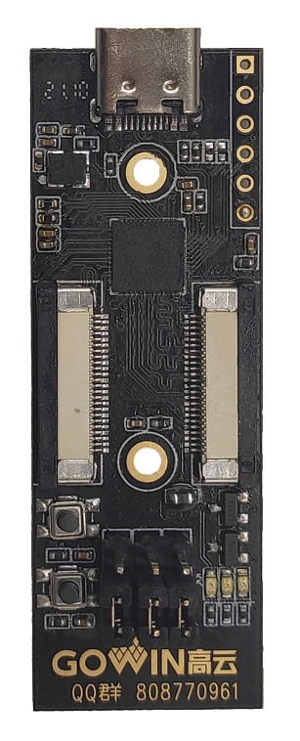

Figure 2-1 MINI_STAR_4K board

the MINI_STAR_4K board is based on the high cloud semiconductor GW1NSR series FPGA products as the core. The High Cloud Semiconductor GW1NSR Series FPGA product is the first generation ® of theLittleBee® family ofhigh cloud semiconductor fPGA products, a system-level package chip with integrated GW1NS series FPGA products and PSRAM memory chips, including GW1NSR-2C Devices,GW1NSR-4C devices and GW1NSR-2 devices,GW1NSR-4 devices.

Arm Cortex-M3 hardcore processors are embedded in GW1NSR-2C and GW1NSR-4C devices. In addition, the GW1NSR Series FPGA products are embedded in USB2 0 PHY, user flash, and ADC converter. The GW1NSR-2C / GW1NSR-4C device, with arm Cortex-M3 hardcore processors at its core, has the minimum memory needed to implement system functionality; GW1NSR-2C devices enable a seamless connection between programmable logic devices and embedded processors, are compatible with a wide range of peripheral device standards, significantly reduce user costs, and can be widely used in industrial control, communications, Internet of Things, servo drive, consumption and other fields.

## 2.2 Board Kit

The board suite includes:

The development board

Quick application manual



Figure 2 -2 MINI_STAR_4K board

## 2.3 PCB components



Figure 2-3 MINI_STAR_4K board

## 2.4 System framework

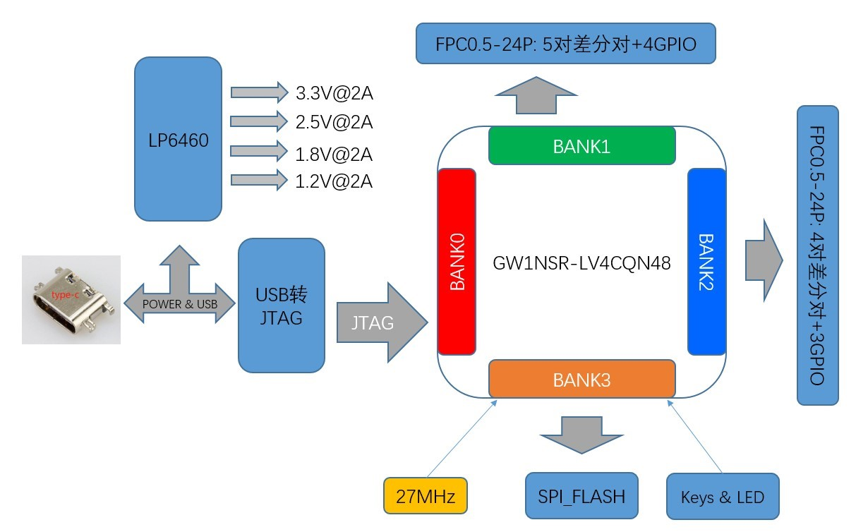

Figure 2-4 MINI_STAR_4K board

## 2.5 Features

The structure and characteristics of the board are as follows:

1. FPGA

In QN48P package

The ARM Cortex-M3 hardcore processor is embedded

1. FPGA Configuration Mode . . . JTAG
2. Clock resources

27MHz clock crystal

1. keystroke

2 key switches

1. LED

1 power LED (green).

2 user lights (green).

1. storage

■ 256Kbit flash

1. FPC extends the IO port

2 sets of FPC extended IO port

1. power supply

With voltage reverse protection;

## 2.6 indicator

Table 2 -1 A list of Combat board parameter metrics

|  |  |  |  |
| --- | --- | --- | --- |
| serial number | project | parameter | Description of the function |
| 1 | 5V power and download | 5V DC-DC;  Typc-USB | 5V power supply. USB to JTAG interface |
| 3 | Tap the button | 2 tap the button | Can be used as a test control input. (pressed low). |
| 4 | Light | 2 LED | When the FPGA corresponding pin output signal is logic high, theLED is lit; |
| 5 | clock | 1 way 27MHZ clock | Provides a 27MHz clock for FPGAs |
| 6 | Extend the interface | FPC seat extension | For control outputs such as cameras,HDMI,GPIO, etc |
| 7 | Operating temperature | Commercial grade from 0 to 70 degrees C | --- |
| 8 | Ambient humidity | 20% to 90%, non-condensation | --- |
| 9 | Mechanical size | 20mm×57mm | --- |
| 10 | PCB specifications | 4 layers, with white on black background | --- |
| 11 | Power supply | 5V/1A,typec-USB interface powered | --- |
| 12 | System power consumption | --- | --- |

## 2.7 Mechanical dimensions

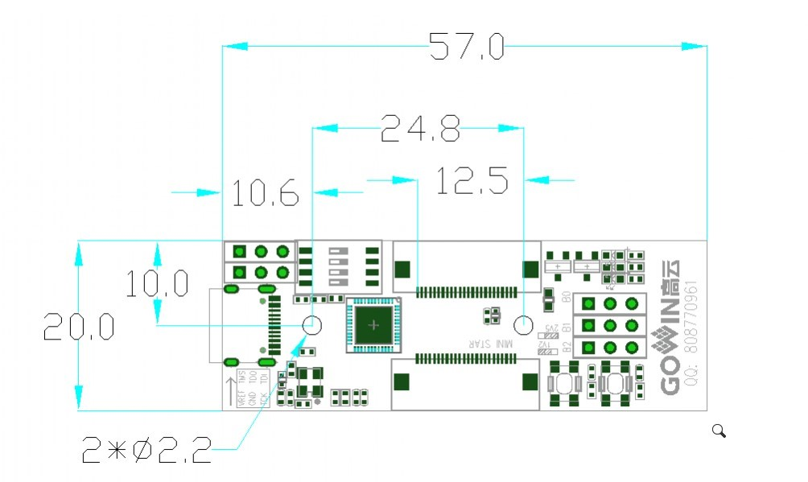

Figure 2-5 MINI_STAR_4K board

# 3, the development board details

## 3.1,FPGA module

#### 3.1.1 Overview

GW1NSR-LV4CQN48P FPGA Product Resource Information is shown in Table 3-1.

Table 3-1 GW1NSR Series FPGA Product Information List

|  |  |  |
| --- | --- | --- |
| Devices |  | GW1NSR-4 |
| Logical unit(LUT4). | 4608 |  |
| Register (FF). | 3456 |  |
| Block static random memory  B-SRAM(bits) | 180K |  |
| The number of block static random memory  B-SRAM(个) | 10 |  |
| User flash (bits). | 256K |  |
| HyperRAM(bit) | 64M | |
| Multiplier  (18x18Multiplier) | 16 | |
| Phase Lock ring (PLLs). | 2 | |
| Hard-core processor | Cortex-M3 | |
| I/O Bank 总 | 4 | |
| The maximum number of users I/O | 39 | |
| Nuclear voltage | 1.2V | |

##### 3.1.2 I/O BANK 说

The GW1NSR Series FPGA products are divided into four I/O BANKS zones, and Figure 3-1 is a holistic diagram of I/OBANKS for the GW1NSR Series FPGAs. Figure 3-2 is a diagram of the distribution of the QN48P package pins.

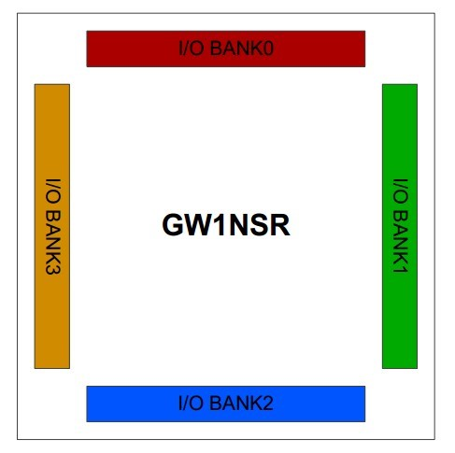

Figure 3-1 GW1NSR-LV4CQN48P Product I/O BANK Overall Diagram

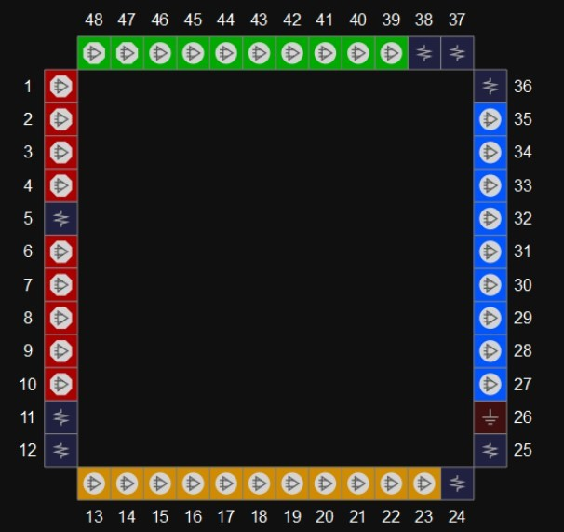

Figure 3-2 GW1NSR-LV4CQN48P package pin distribution diagram (top view).

Table 3-2 FPGA I/O BANK Voltage and Function Distribution

|  |  |  |  |
| --- | --- | --- | --- |
| BANK | voltage | function | I/O occupancy |
| 0 | 1.2V/2.5V | Jtag | 4 GPIO |
|  |  | IO extension | 1 pair of differential pairs,2 GPIO |
| 1 | 1.2V/2.5V | IO extension | 5 pairs of differential pairs |
| 2 | 1.2V/2.5V | IO extension | 4 pairs of differential pairs,1 GPIO |
| 3 | 1.8V | 27M clock | 1 GPIO |
| LED | 2 GPIO |
| keystroke | 2 GPIO |
| spi-flash | 5 GPIO |

## 3.2 Download

##### 3.2.1 Overview

The board provides a USB download interface, which is implemented by the A channel of the FT2232 USB conversion chip. Internal ARM Cortex-M3 hardcore processor downloads are also downloaded through the same set of IOs. The USB power supply needs to be maintained when debugging the download arm core, while the dial switch is dialed to disconnect the USB to JTAG module.

The downloaded connection diagram looks like the following image.

##### 3.2.2 USB download circuit

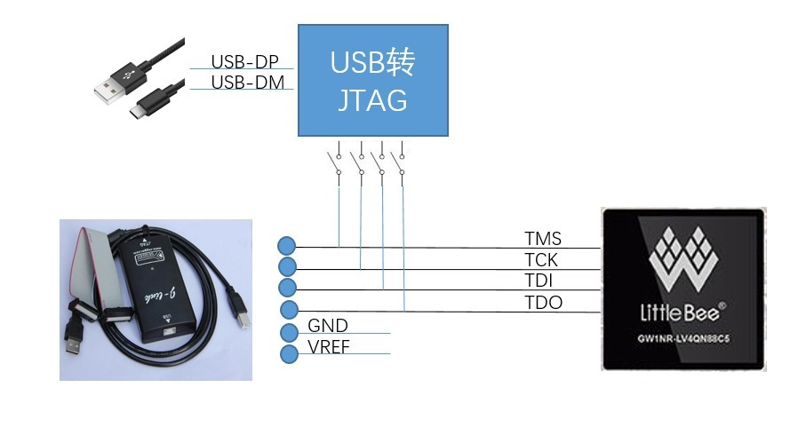

Figure 3-5 FPGA download circuit schematic

### 3.2.3 Pin distribution

Table 3-2 Download circuit pin assignments

|  |  |  |  |  |
| --- | --- | --- | --- | --- |
| Signal name | FPGA Pin No | BANK | description | I/O电平 |
| FPGA_ TMS | 6 | 0 | Tms | 3.3V |
| FPGA_ TCK | 7 | 0 | TCK | 3.3V |
| FPGA_ TDI | 3 | 0 | Tdi | 3.3V |
| FPGA_ TDO | 4 | 0 | TDO | 3.3V |

# 3.3 Power supply

### 3.3.1 Overview

The board provides DC5V input via the typec-USB interface, with 1.5A overcurrent protection against anti-reversal

protection;

The input DC5V power supply passes through the power supply IC conversion output on the board 3.3V, 2.5, 1.8V, 1.2V

### 3.3.2 Power system allocation

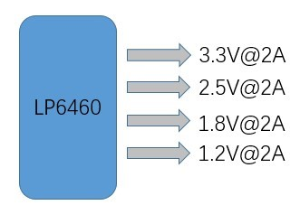

Figure 3-6 Power Circuit

# 3.4 Clock

### 3.4.1 Overview

The board provides the FPGA with a 27MHz active crystal connected to the global clock pin.

### 3.4.2 Clock circuit diagram

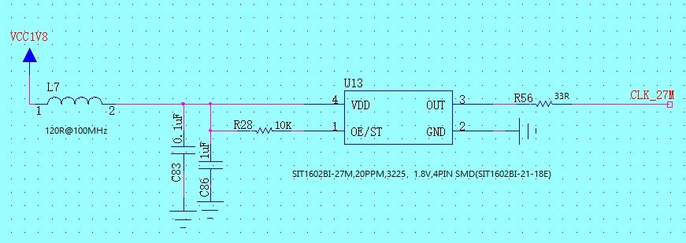

Figure 3-7 Clock-connected schematic

### 3.4.3 Pin distribution

Table 3-5 FPGA Clock with Reset Pin Allocation

|  |  |  |  |  |
| --- | --- | --- | --- | --- |
| Signal name | FPGA Pin No | BANK | description | I/O电平 |
| CLK_27MHZ_IN | 22 | 3 | 27MHz active crystal input | 1.8V |

# 3.5 LED

### 3.5.1 Overview

There are 2 user LEDs in the board that can display the desired status via LED lights. THE LED LIGHT CAN BE TESTED IN THE FOLLOWING WAYS:

When the FPGA corresponding pin output signal is logic high, theLED is lit;

When the output signal is low, theLED goes out

### 3.5.2 LED circuit

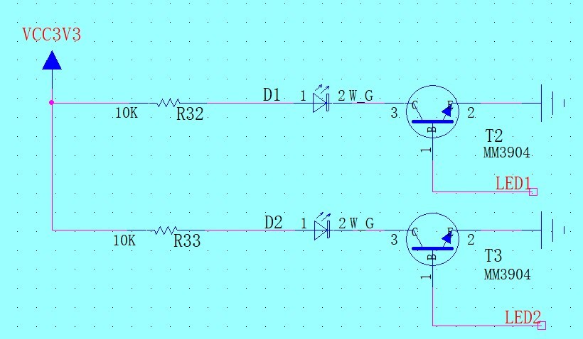Figure 3-8 LED circuit schematic

### 3.5.3 Pin distribution

Table 3-6 LED pin allocation

|  |  |  |  |  |
| --- | --- | --- | --- | --- |
| Signal name | FPGA Pin No | BANK | description | I/O电平 |
| LED1 | 13 | 3 | LED 1 | 1.8V |
| LED2 | 14 | 3 | LED 2 | 1.8V |

# 3.6 Keystrokes

### 3.6.1 Overview

The board has 2 key switches that allow the user to enter a low level into the corresponding FPGA pin via manual control, which can be used as a test control input. (pressed low).

### 3.6.2 Key circuit

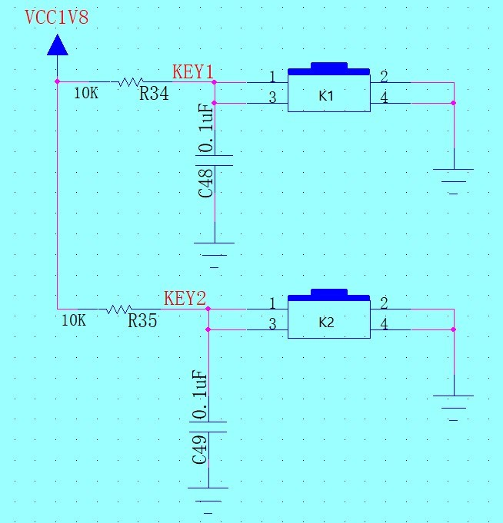

Figure 3-10 Key Circuit Schematic

### 3.6.3 Pin distribution

Table 3-8 Key Pin Allocation

|  |  |  |  |  |
| --- | --- | --- | --- | --- |
| Signal name | FPGA Pin No | BANK | description | I/O电平 |
| KEY1 | 23 | 3 | Key 1 | 1.8V |
| KEY2 | 20 | 3 | Key 2 | 1.8V |

# 3.7 Extending the IO

### 3.7.1 Overview

The board contains two sets of extended IOs,each led by two 0.5mm-24P FPC seats. The first group consists of: 1,DC5V, DC3.3V power output;2,BANK1's 5-pair difference pair to 3,BANK0's pair of difference pairs, and BANK2's one GPIO. The second group consists of:1,DC5V, DC3.3V power output;2, BANK2's 4 pairs of differential pairs; 1 GPIO(IOR9B_33IO shared with the first group); 3,BANK0's 2 GPIO. Users can support the official recommended transfer board for camera input -HDMI output experiments, etc.

### 3.7.2 Extended IO schematics

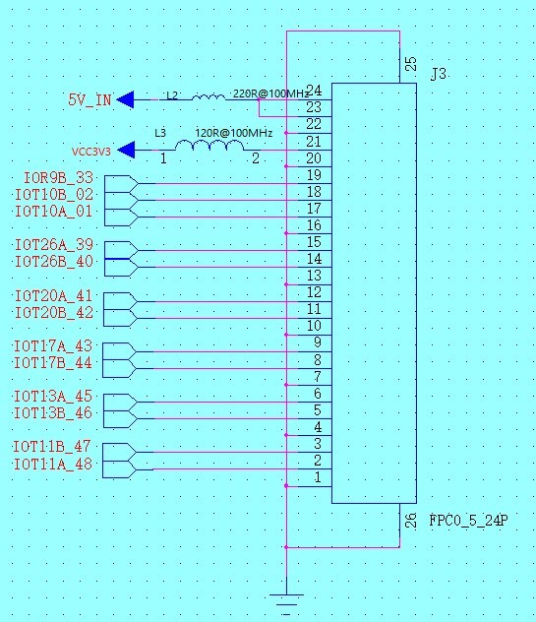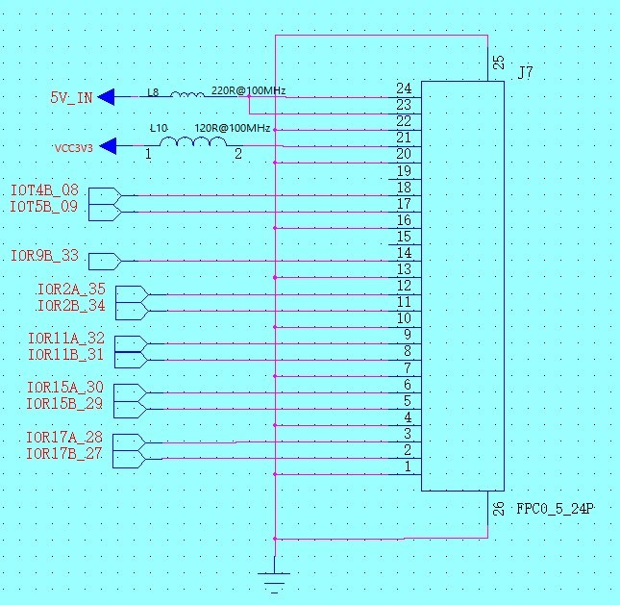

Figure 3-19 Extends the schematic

### 3.7.3 Pin distribution

|  |  |  |  |  |
| --- | --- | --- | --- | --- |
| Signal name | FPGA Pin No | BANK | description | I/O电平 |
| IOT10A_01 | 1 | 0 | The difference is right | 1.2V/2.5V |
| IOT10B_02 | 2 | 0 | 1.2V/2.5V |
| IOT4B_08 | 8 | 0 | GPIO | 1.2V/2.5V |
| IOT5B_09 | 9 | 0 | GPIO | 1.2V/2.5V |
| IOR17B_27 | 27 | 2 | The difference is right | 1.2V/2.5V |
| IOR17A_28 | 28 | 2 |  | 1.2V/2.5V |
| IOR15B_29 | 29 | 2 | The difference is right | 1.2V/2.5V |
| IOR15A_30 | 30 | 2 | 1.2V/2.5V |
| IOR11B_31 | 31 | 2 | The difference is right | 1.2V/2.5V |
| IOR11A_32 | 32 | 2 | 1.2V/2.5V |
| IOR9B_33 | 33 | 2 | GPIO | 1.2V/2.5V |
| IOR2B_34 | 34 | 2 | The difference is right | 1.2V/2.5V |
| IOR2A_35 | 35 | 2 | 1.2V/2.5V |
| IOT26A_39 | 39 | 1 | The difference is right | 1.2V/2.5V |
| IOT26B_40 | 40 | 1 | 1.2V/2.5V |
| IOT20A_41 | 41 | 1 | The difference is right | 1.2V/2.5V |
| IOT20B_42 | 42 | 1 | 1.2V/2.5V |
| IOT17A_43 | 43 | 1 | The difference is right | 1.2V/2.5V |
| IOT17B_44 | 44 | 1 | 1.2V/2.5V |
| IOT13A_45 | 45 | 1 | The difference is right | 1.2V/2.5V |
| IOT13B_46 | 46 | 1 | 1.2V/2.5V |
| IOT11B_47 | 47 | 1 | The difference is right | 1.2V/2.5V |
| IOT11A_48 | 48 | 1 | 1.2V/2.5V |

# 3.8 Supporting the expansion of the experimental board

### 3.8.1 Overview

For the convenience of simple experiments, the development board is equipped withan FPC transfer needle test board. Other lab boards should be purchased or made by yourself.

##### 3.8.2 Extended Lab Board Schematic

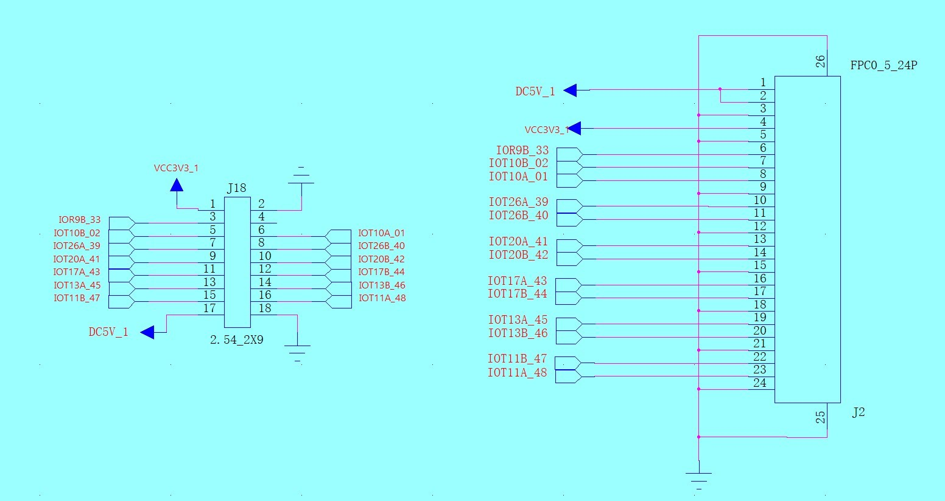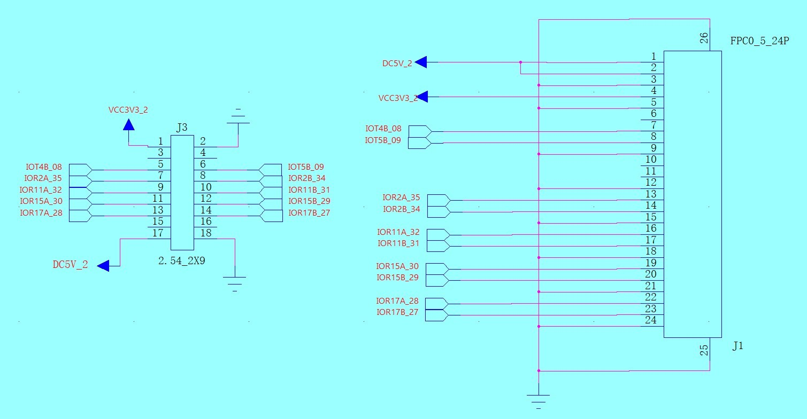

##### 3.8.2 Extended test board size chart

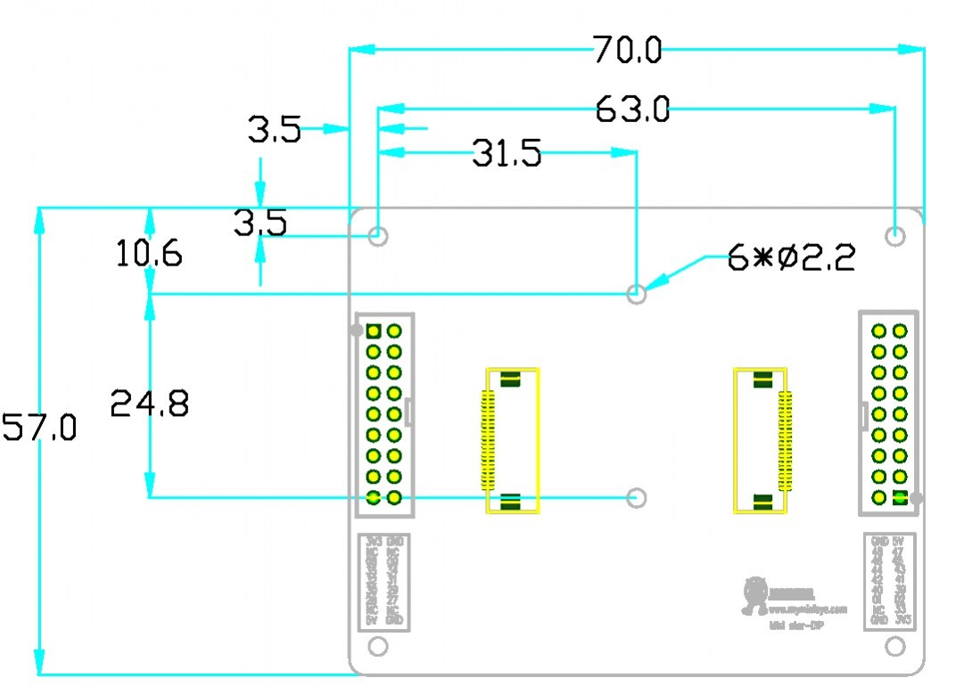

# 4, the use of the board

#### 4.1 Project Import

See the SUG100-1.7_Gowin Cloud Source Software User Guide for specific software operating instructions

1． Click directly on the .gprj file

2． After entering the development software, click on the file "→" to open "Select .gprj file import

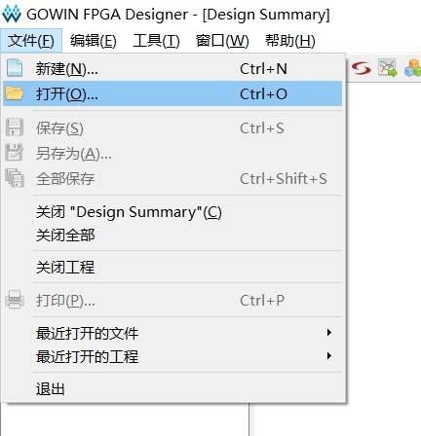

#### 4.2 The program compiles and downloads

1. After writing the program, save the click Process click Place-Route compilation, after compilation through the front will appear a green tick

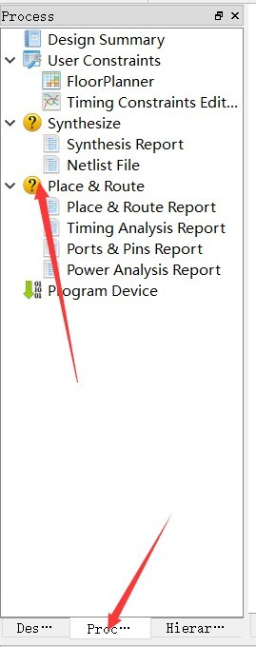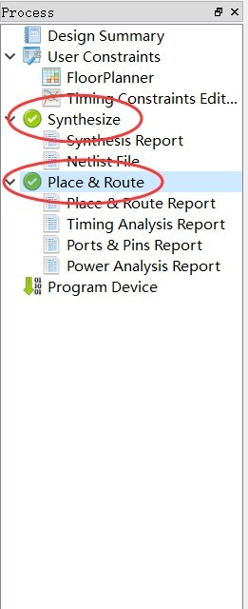

2. After compilation, double-click on Program Device to pop up the download window and click to start downloading

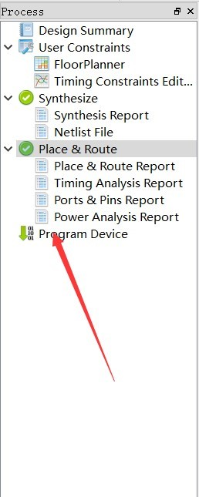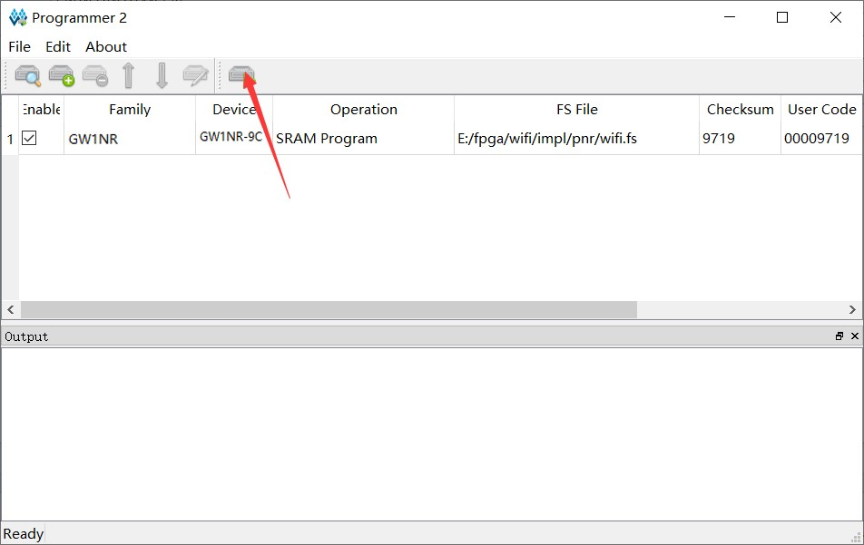

#### 4.3 Routine operation and phenomenon description

The development board set companion video will be available in Bilibili(website :

https://space.bilibili.com/507416742)and other websites and related public numbers are welcome to post welcome attention.

#### 4.4 Precautions for the use of the board

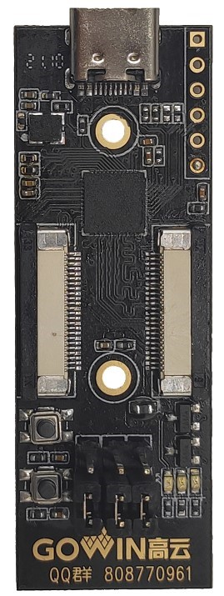

1. When using the development board, pay attention to light and light, and do a good job of static protection.
2. When downloading bitstream files for internal flash or external Flash, you need to set

The MODE foot state is on the correct configuration value.

1. When connecting the module, the power must first be turned off.