# **Introduction**

Quadcopter drones are becoming more important in many industries because they are versatile, easy to use, and cost-effective. One of the most exciting uses for quadcopters is in farming. They can help farmers in many ways, such as checking the health of crops and spraying fertilizers and pesticides precisely. These drones are changing the way farming is done, making it more efficient and productive.

A quadcopter, also known as a quadrotor, is a type of drone with four rotors. Unlike traditional helicopters, which have one main rotor and one tail rotor, quadcopters use four rotors to lift, move, and stay stable. This design allows them to take off and land vertically, making them very agile and able to work in different environments.

# **Fundamentals of Quadcopter Flight Dynamics**

### Lift, Thrust, and Maneuverability

Quadcopters achieve lift and thrust through the spinning of their four rotors. Each rotor is powered by an electric motor and spins at a high speed, creating lift by pushing air downwards. The combined lift from all four rotors allows the quadcopter to hover in place, take off, and land vertically.

* **Lift**: Lift is generated when the rotors spin and push air downwards, causing the quadcopter to rise. By adjusting the speed of the rotors, the quadcopter can increase or decrease lift, allowing it to ascend or descend.
* **Thrust**: Thrust is created by the force of the rotors pushing air downwards. The amount of thrust determines how high and how fast the quadcopter can go. By controlling the speed of each rotor individually, the quadcopter can move in different directions.
* **Maneuverability**: Maneuverability is achieved by changing the speed of individual rotors to control pitch, roll, and yaw. This allows the quadcopter to tilt, rotate, and move in any direction.

## Axes and Degrees of Freedom

To understand how a quadcopter moves, it’s important to know about its basic movements along different axes, known as degrees of freedom.

* **Pitch**: Pitch is the tilting motion of the quadcopter forward or backward. When the front rotors spin faster than the rear rotors, the front dips down, and the quadcopter moves forward. When the rear rotors spin faster, the back dips down, and the quadcopter moves backward.
* **Roll**: Roll is the tilting motion to the left or right. When the rotors on one side spin faster than those on the other, the quadcopter tilts and moves in that direction. For example, faster spinning on the left side causes the quadcopter to roll right.
* **Yaw**: Yaw is the rotation of the quadcopter around its vertical axis. By spinning the rotors diagonally opposite to each other at different speeds, the quadcopter can rotate left or right. This changes the direction the quadcopter is facing without moving its position in the air.
* **Throttle**: Throttle controls the overall speed of all four rotors. Increasing throttle makes the quadcopter rise, while decreasing throttle makes it descend.

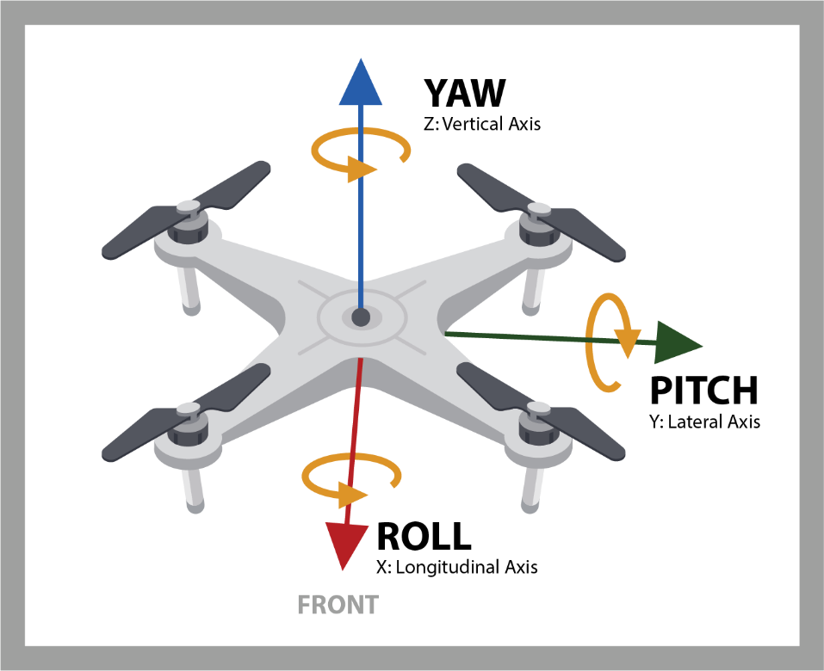

Figure 1. <https://www.immervision.com/drone-navigation-system/>

## Stability and Balance

Maintaining stability and balance is crucial for the safe and effective operation of a quadcopter, especially in farming applications where precise movements are required.

* **Stability**: Stability refers to the quadcopter's ability to maintain a steady position in the air. Gyroscopes and accelerometers are used to measure and adjust the quadcopter’s orientation, ensuring it stays level and does not tip over.
* **Balance**: Balance is achieved by evenly distributing weight and ensuring that all rotors work together harmoniously. If one rotor fails or spins slower than the others, the quadcopter can become unbalanced and crash. Modern quadcopters use sophisticated control systems to continuously monitor and adjust the speed of each rotor to maintain balance.

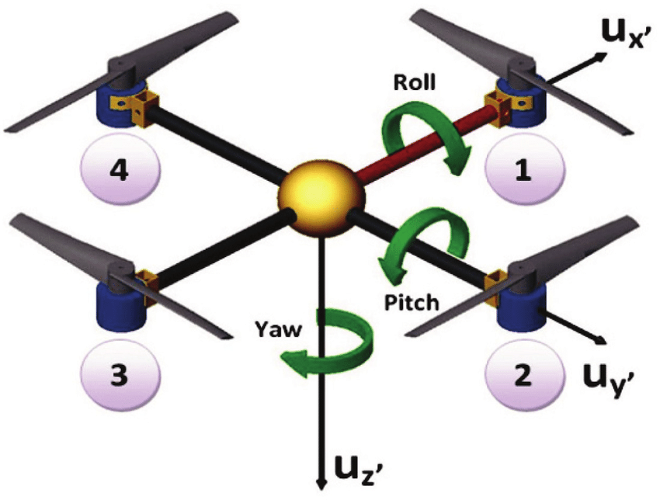

# Modeling the Quadcopter

After having a clear understanding of what type of knowledge will be needed to develop a quadcopter controller, we start with the modeling section.

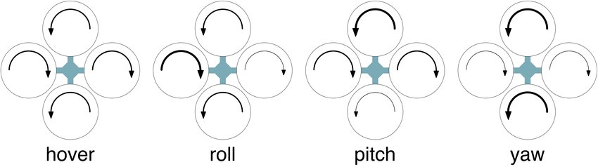

Some considerations need to be considered, like the body of the drone will be divided into two parts. One of them being the center of mass of the body and the movement around this center of mass, otherwise called barycenter. Six DOF (Degree of Freedom) are required to describe any movement of the drone in a space.

In the final controller the way we will adjust the direction and motion of the drone is by adjusting the rotational speeds of different motors. (Figure…).

By using this implication, we know that we have 4 inputs into the system with 6 possible outputs. This created an underactuated nonlinear system. Underactuated because we have more outputs than inputs into the system. To forgo this problem we make assumptions such as: the body is rigid and symmetric, also the ground effect is ignored. (check what is ground effect)

## Euler angles

Euler angles are used to describe orientation of a rigid body, this by providing three possible angles. Which will be of three components, this being:

