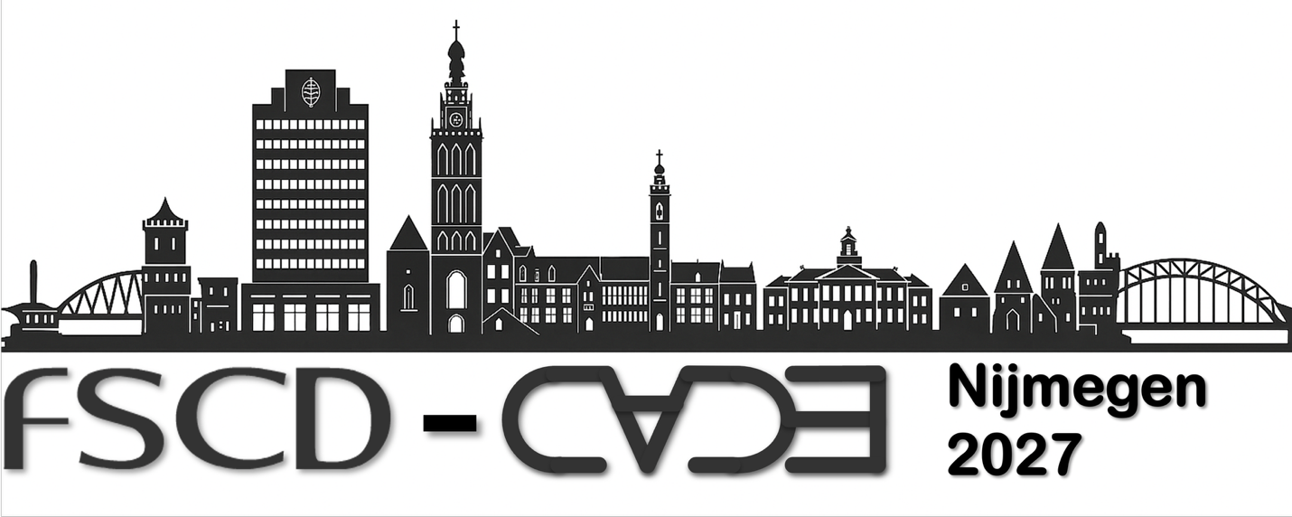

Workshop Proposal:
Workshop on Logical Frameworks and Meta-Languages: Theory and Practice
LFMTP2027
ORGANISATIONAL PART
- Contact information for the workshop organizers: Elaine Pimentel, e.pimentel@ucl.ac.uk
- Proposed affiliated conference: FSCD and CADE 2027
- Proposed affiliated date: Saturday August 21, 2027
- Estimate of the number of workshop participants: 20-40
- Proposed format and agenda: short/full paper presentations
- Potential invited speakers: Assia Mahboubi
- Procedures for selecting papers and participants: review via Easychair
- Plans for dissemination: proceedings at EPTCS
- Duration: one day
- Webpage: https://lfmtp.github.io/lfmtp-page/

SCIENTIFIC CONTENT
Description:
Logical frameworks and meta-languages form a common substrate for representing, implementing, and reasoning about a wide variety of deductive systems of interest in logic and computer science. Their design and implementation on the one hand and their use in reasoning tasks ranging from the correctness of software to the properties of formal computational systems on the other hand have been the focus of considerable research over the last three decades. This workshop will bring together designers, implementors, and practitioners to discuss various aspects impinging on the structure and utility of logical frameworks, including the treatment of variable binding, inductive and co-inductive reasoning techniques, and the expressivity and lucidity of the reasoning process.
LFMTP 2027 will provide researchers a forum to present state-of-the-art techniques and discuss progress in areas such as the following:
- Encoding and reasoning about the meta-theory of programming languages and related formally specified systems.
- Theoretical and practical issues concerning the treatment of variable binding, especially the representation of, and reasoning about, datatypes defined from binding signatures.
- Logical treatments of inductive and co-inductive definitions and associated reasoning techniques.
- New theory contributions such as canonical and substructural frameworks, contextual frameworks, proof-theoretic foundations supporting binders, functional programming over logical frameworks, or homotopy type theory.
- Systematic translation, combination, and integration of logics or theorem prover libraries.
- Applications of logical frameworks, e.g. in certification and guarantee of security properties.
- Techniques for programming with binders in functional programming languages such as Haskell, OCaml, or Agda and logic programming languages such as lambda Prolog or Alpha-Prolog.
- Automation and interactive support for reasoning in logical frameworks, including proof search, tactic languages, and integration with automated reasoning tools.
- Interactions between logical frameworks and large language models, including AI-assisted formalisation and proof development, and the use of formal methods to check or provide guarantees about AI-generated specifications and proofs.
History:
The proposed workshop continues the series of workshops on logical frameworks and meta-languages that started in 1999. It began with LFM and MERLIN, which were interleaved until 2005. These two workshops were merged in 2006 to form LFMTP, which has grown into one of the main venues for presenting results on type theories and logical frameworks.
LFM: International Workshop on Logical Frameworks and Meta-languages (1999 - 2004)
LFM'99, Paris, France, affiliated with PPDP and PLI, organized by Amy Felty (now University of Ottawa)
LFM'00, Santa Barbara, USA, affiliated with LICS, organized by Joelle Despeyroux (INRIA)
LFM'02, Copenhagen, Denmark, affiliated with LICS at FLOC, organized by Frank Pfenning (Carnegie Mellon University).
LFM'04, Cork, Ireland, affiliated with IJCAR, organized by Carsten Schürmann (Yale University)
MERLIN: International Workshop on MEchanized Reasoning about Languages with variable BInding (2001 - 2005)
MERLIN 2001, Siena, Italy, affiliated with IJCAR, organized by Roy L. Crole, Simon J. Ambler, and Alberto Momigliano (then at University of Leicester, UK)
MERLIN 2003, Uppsala, Sweden, affiliated with PLI, organized by Alberto Momigliano (then at University of Leicester, UK) and Marino Miculan (University of Udine, Italy)
MERLIN 2005, Tallinn, Estonia, affiliated with ICFP, organized by Alberto Momigliano (then at University of Edinburgh), Ivan Scagnetto (Universiy of Udine), and Alwen Tiu (INRIA Lorraine)
LFMTP: International Workshop on Logical Frameworks and Meta-Languages: Theory and Practice (2006 - present)
LFMTP'06, Seattle, USA, affiliated with LICS and IJCAR at FLoC, organized by Brigitte Pientka (McGill University) and Alberto Momigliano (University of Edinburgh)
LFMTP'07, Bremen, Germany, affiliated with CADE, organized by Carsten Schürmann (IT University of Copenhagen) and Brigitte Pientka (McGill University)
LFMTP'08, Pittsburgh, USA, affiliated with LICS, organized by Andreas Abel (LMU) and Christian Urban (TUM)
LFMTP'09, Montreal, Canada, affiliated with CADE, organized by Amy Felty (University of Ottawa) and James Cheney (University of Edinburgh)
LFMTP'10, Edinburgh, Scotland, affiliated with LICS at FLoC, organized by Karl Crary (Carnegie Mellon University) and Marino Miculan (University of Udine).
LFMTP'11, Nijmegen, The Netherlands, affiliated with ITP, organized by Herman Geuvers (Radboud University Nijmegen) and Gopalan Nadathur (University of Minnesota).
LFMTP'12, Copenhagen, Denmark, affiliated with ICFP, organized by Adam Chlipala (MIT) and Carsten Schuermann (ITU)
LFMTP'13, Boston, USA, affiliated with ICFP, organized by Alberto Momigliano (University of Milan), Brigitte Pientka (McGil University), and Randy Pollack (Harvard University)
LFMTP'14, Vienna, Austria, affiliated with CSL-LICS and IJCAR as part of FLoC and VSL'14, organized by Amy Felty (University of Ottawa) and Brigitte Pientka (McGill University)
LFMTP'15, Berlin, Germany, affiliated with CADE-25, organized by Iliano Cervesato (Carnegie Mellon University) and Kaustuv Chaudhuri (INRIA)
LFMTP'16, Porto, Portugal, affiliated with FSCD, organized by Gilles Dowek (INRIA) and Dan Licata (Carnegie Mellon University)
LFMTP'17, Oxford, UK, affiliated with FSCD, organized by Florian Rabe (Jacobs University Bremen) and Marino Miculan (University of Udine)
LFMTP'18, Oxford, UK, affiliated with FLoC, organized by Frédéric Blanqui (INRIA, France) and Giselle Reis (Carnegie Mellon University, Qatar)
LFMTP'19, Oxford, UK, affiliated with LICS'19, organized by Dale Miller (INRIA and LIX, France) and Ivan Scagnetto (University of Udine)
LFMTP'20, Paris, France, affiliated with IJCAR'20, organized by Claudio Sacerdoti Coen (University of Bologna) and Alwen Tiu (Australian National University)
LFMTP'21, Pittsburgh, Pennsylvania, USA, affiliated with CADE 28, organized by Elaine Pimentel (Universidade Federal do Rio Grande do Norte: Natal, RN, BR) and Enrico Tassi (Inria, Sophia-Antipolis, FR)
LFMTP'22, Haifa, Israel, affiliated with FLoC 2022, organized by David Baelde (ENS Cachan, France) and Vivek Nigam (Federal University of Para’ba, Brazil)
LFMTP'23, Rome, Italy, affiliated with FSCDÕ23, organized by Alberto Ciaffaglione (Università degli Studi di Udine) and Carlos Olarte (LIPN, Université Sorbonne Paris Nord)
LFMTP'24, July 8, Tallinn, Estonia, associated with FSCD at FSCD/LiCS/ICALP 2024, organized by Florian Rabe (University of Erlangen-Nuremberg, Germany) and Claudio Sacerdoti Coen (University of Bologna, Italy)
LFMTP'25, July 19, Birmingham, UK, associated with FSCD 2025, organized by Kaustuv Chaudhuri, Co-Chair (Inria) and Daniele Nantes-Sobrinho, Co-Chair (Imperial College London)
LFMTP'26, July 24, Lisbon, PT, associated with FSCD 2026, organized by Olivier Hermant, Co-Chair (Mines Paris PSL) and Sophie Tourret, Co-Chair (INRIA and MPI for Informatics)
ORGANIZATION
Workshop Co-chairs:
TBD
Steering Committee:
- David Baelde (ENS Rennes)
- Claudio Sacerdoti Coen (University of Bologna)
- Amy Felty (University of Ottawa)
- Florian Rabe (University Erlangen-Nuremberg)
- Elaine Pimentel (University College London) -- chair
- Enrico Tassi (Inria Sophia-Antipolis)
- Daniele Nantes-Sobrinho (University of Brasilia)
Potential Program Committee Members:
TBD
Estimate of Audience Size:
20-40
Proposed Format:
The workshop program will be composed of regular papers (formally reviewed and published), invited talks, and informal work-in-progress talks.

Budget:
The workshop expenses consist of expenses for about 2 invited speakers. We expect to profit from the attendance to the main conference for providing the invited speakers.
Potential Invited Speakers:
LFMTP and its predecessor workshops have had many invited speakers over the years. We will ask the program committee for suggestions. Some initial suggestions include Assia Mahboubi
Tentative Schedule:
Abstract submission deadline: May 20
Submission deadline: May 27
Notification to authors: June 20
Final version due: July 20
Workshop: August 21
Procedures for Selecting Papers and Participants:
Submissions will include regular papers of approximately 8 pages and work-in-progress papers of approximately 4 pages (formatted using EPTCS style). As in the past, we will have a program committee of 8-10 people who will formally review the papers and help select the invited speakers.
The topics are typically of interest to attendees of FSCD and CADE. As in the previous years, the workshop will be publicised through mailing lists by repeated calls for papers and participation.
Duration:
1 day

