A pragmatic approach for managing Fraser River Eulachon (*Thaleichthys pacificus*) fisheries: rapid prototyping operating model development and management procedure evaluation

Insert abstract text here.

Table of Contents

1 BACKGROUND 1

1.1 Subsection 1

2 CONSERVATION OBJECTIVES 2

3 OPERATING MODEL 2

3.1 Subsection 2

3.1.1 Smaller subsection 2

4 MANAGEMENT PROCEDURE EVALUATION 2

5 DISCUSSION 2

REFERENCES 2

6 TABLES 3

7 FIGURES 3

8 Cool Appendix 6

8.1 Subsection 6

9 Appendix B 6

9.1 Subsection 7

9.1.1 Smaller subsection 7

9.2 Figures 7

# 1 BACKGROUND

Insert text here.

## 1.1 Subsection

Insert text here.

# 2 CONSERVATION OBJECTIVES

The primary management objective for BC Eulachon aims to promote stock rebuilding to a level consistent with a COSEWIC categorization of ‘special concern’ (Schweigert et al. 2012; DFO 2023). This objective is interpreted as achieving positive growth in Eulachon spawning biomass in the short-term, and achieving historical levels of biomass over the long-term.

Formal conservation objectives for FR Eulachon that are consistent with the SFF and FSP policies (DFO 2009, 2022) have not been defined, but at a minimum they require a choice of i) a limit reference point, ii) the removal reference (RR) rate (i.e., the maximum acceptable harvest rate), with desired probabilities for biomass being above the LRP and harvest rates below the RR over a specific timeframe.

# 3 OPERATING MODEL

Insert text here.

## 3.1 Subsection

### 3.1.1 Smaller subsection

Reference tables like this: Model notation is given in Table and population dynamics and statistical model equations in Tables and , respectively.

Reference figures like this: Figure and Figure .

# 4 MANAGEMENT PROCEDURE EVALUATION

Insert text here

# 5 DISCUSSION

Insert text here.

# REFERENCES

DFO. 2009. “A Fishery Decision-Making Framework Incorporating the Precautionary Approach.” [www.dfo-mpo.gc.ca/reports-rapports/regs/sff-cpd/precaution-eng.htm](https://www.dfo-mpo.gc.ca/reports-rapports/regs/sff-cpd/precaution-eng.htm).

———. 2022. “Guidelines for Writing Rebuilding Plans Per the Fish Stocks Provisions and a Fishery Decision-Making Framework Incorporating the Precautionary Approach.” [www.dfo-mpo.gc.ca/reports-rapports/regs/sff-cpd/precautionary-precaution-eng.htm](https://www.dfo-mpo.gc.ca/reports-rapports/regs/sff-cpd/precautionary-precaution-eng.htm).

———. 2023. *Integrated Fisheries Management Plan January 1 - December, 2021*. DFO Pacific Region.

Schweigert, Jake, Chris Wood, Doug Hay, Murdoch McAllister, Jennifer Boldt, Bruce McCarter, Thomas W Therriault, and Heather Brekke. 2012. “Recovery Potential Assessment of Eulachon (*Thaleichthys Pacificus*) in Canada.” *DFO Can Sci Advis Secr Res Doc* 98.

# 6 TABLES

# 7 FIGURES

You can add figure from code block or from image files:

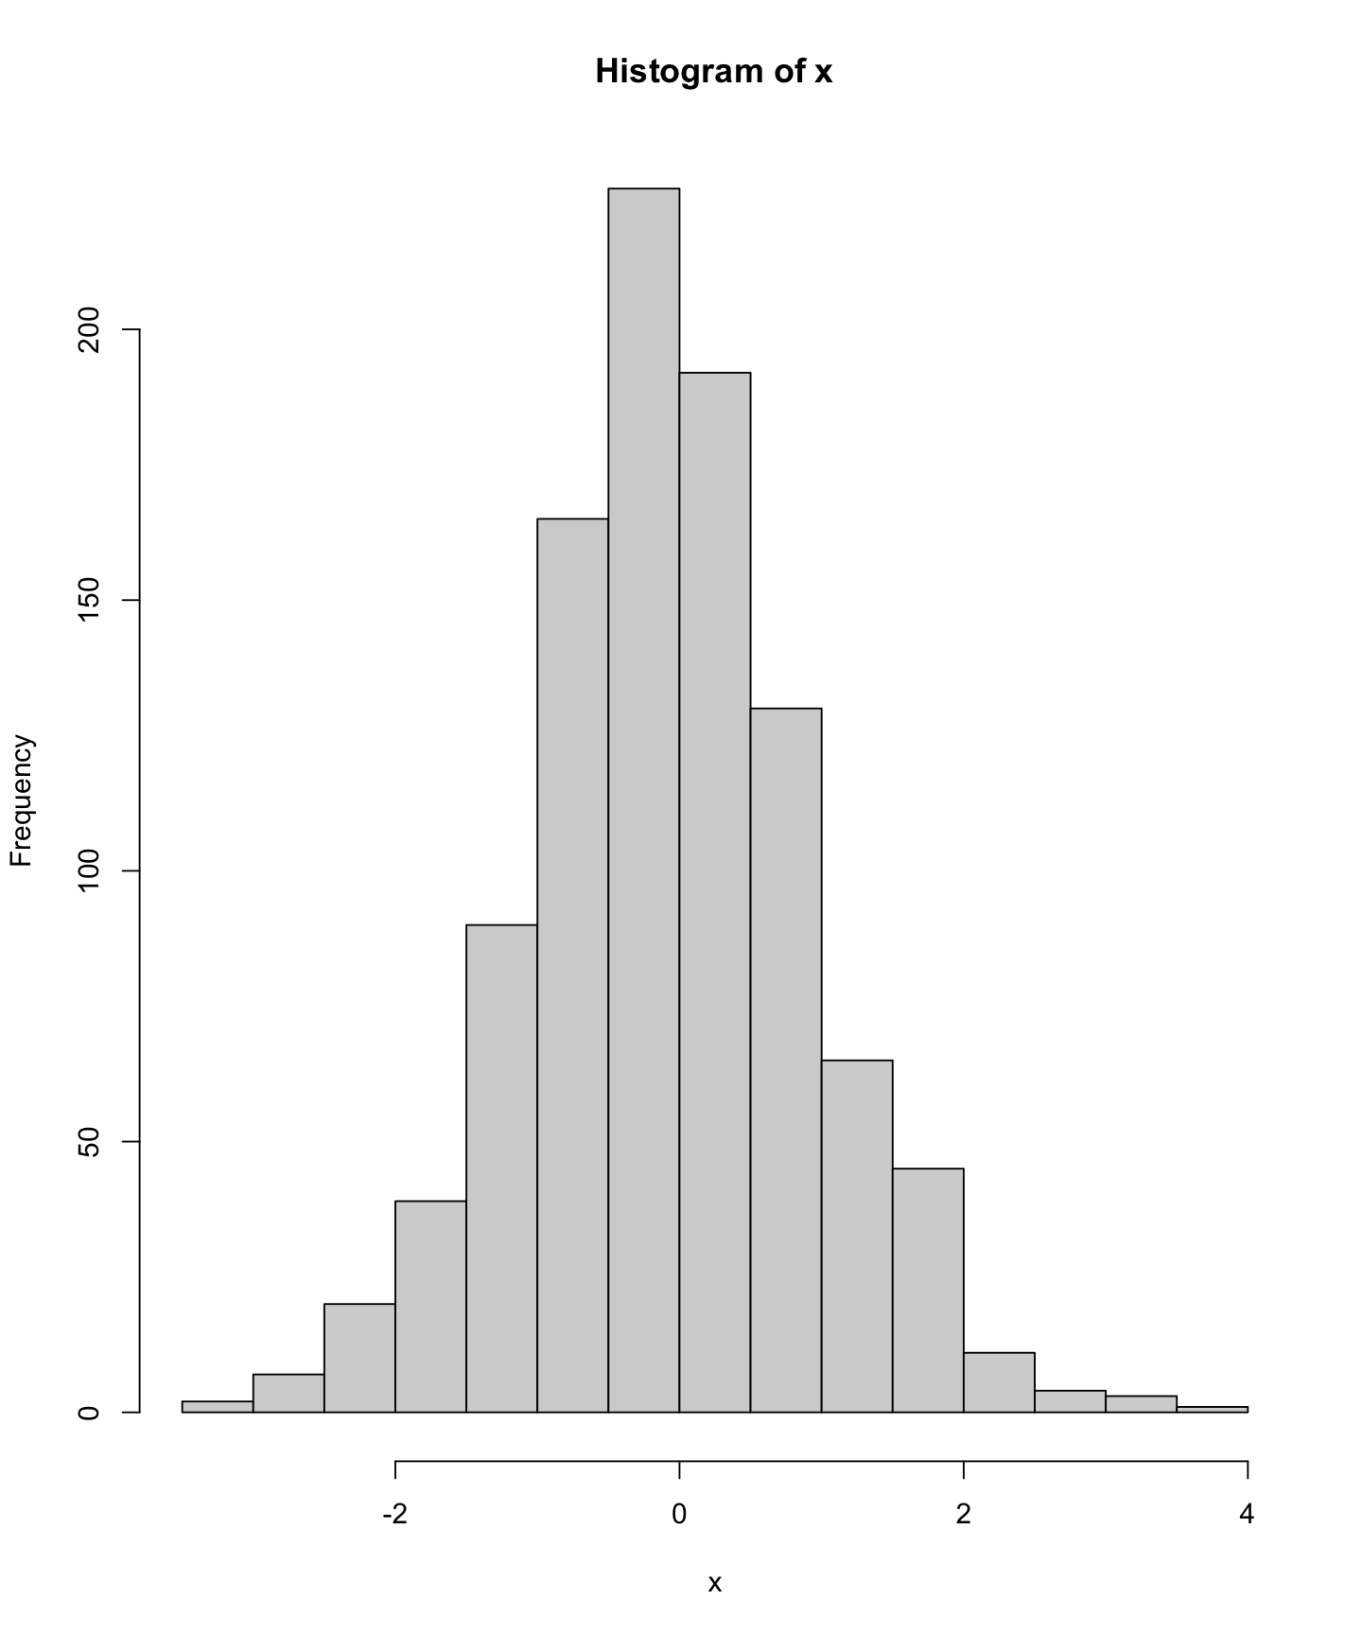 (#fig:likProfM)Negative log likelihood (NLL) profile for operating model fits with natural mortaltiy fixed at values ranging from 0.1 to 1.0. The top panel shows the total NLL, while the middle and bottom panels show NLL components for indices and length compositions, respectively.

# 8 Cool Appendix

## 8.1 Subsection

Insert text here.

Figure 8.1: Number of SMMS tows in WCVI PFMAs from 1975-2021

Figure 8.1: Number of SMMS tows in WCVI PFMAs from 1975-2021

# 9 Appendix B

Insert text here

## 9.1 Subsection

### 9.1.1 Smaller subsection

Insert text

You can also include figures in the appendix (Figure ).

## 9.2 Figures

Figure 9.1: Number of SMMS tows in WCVI PFMAs from 1975-2021

Figure 9.1: Number of SMMS tows in WCVI PFMAs from 1975-2021