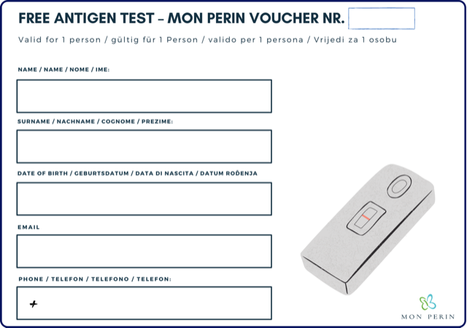

1

28

leo@g.com

fabris

leo



2

25

leo@g.com

crnkovic

ivan