CS2163 Java Homework 1 requirement

Homework 1 has two parts. Please read this document carefully and finish both Part A and Part B:

**Part A**: **create and run an Eclipse Java Project**. Follow the instructions of the steps below :

* Create a new Java Project in Eclipse, and name the project **JohnDoeHw1**, and replace **JohnDoe** with your name. Please read the instructions in file “CompileAndRunTheFirstJavaProgram.docx”, and learn how to create Java projects from scratch.
* In this project hw1, create a new java class file named JohnDoeWelcome.java , and replace JohnDoe with your name.
* In the main method of this class JohnDoeWelcome, edit the source code to add one line of print statement to output your name to the screen. For example, your java source code should look similar to this:

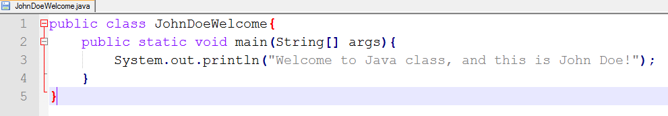

Notice that, the numbers on left side of the above picture are the line number generated by java source code editor, and the line numbers are not part of the java source code.

* Compile and run the java project, and make sure the output result is correct.
* Zip the Eclipse project folder “JohnDoeHw1”, and the zip file name is “***JohnDoeHw1.zip***” .
* Submit the zip file ***JohnDoeHw1.zip*** to Moodle “homework 1 drop box”.

**Part B: modify an existing Greenfoot project**. Follow the steps below:

* Finish textbook exercises 1.15, using the existing Greenfoot scenario “asteriods1” in textbook chapter 1. Hint: you can review textbook section 1.10 and learn how to view the source code of any class in a Greenfoot project.
* Finish the code and test the scenario, and make sure the modified source code works when you play the scenario.
* Zip the scenario folder “asteroids1”, and the zip file should have the name “***asteroids1.zip***”.
* Submit the zip file ***asteroids1.zip*** to Moodle “homework 1 drop box”. So you will have two zip files in the drop box, including the zip file from part A.

**After finishing Part A and Part B, how to verify the correctness of your submitted zip files:**

1. Download the zip files you have uploaded to Moodle homework 1 drop box.
2. Unzip each zip file to a different local folder in your computer, other than the original local folders where the zip files are generated.
3. Run the Eclipse Java project, and run the Greenfoot project and make sure each project compiles and runs correctly.
4. If your submitted zip file in the Moodle drop box

**cannot be downloaded,** or

**cannot be unzipped,** or

**cannot compile,** or

**cannot run,**

then you need to figure out the reason and fix the error, and then submit the corrected zip file to the Moodle drop box. Then start this verification process again until you can download, unzip, compile and run successfully. To upload a corrected zip file to the Moodle drop box, you need to delete the previous zip file from the Moodle drop box first.

In the first page of file “chap1-schedule.docx”, you can find the instructions on how to zip and unzip files.

The purpose of Part A is to make sure you know how to use Eclipse to create and run Java project, and the purpose of Part B is to make sure you know how to use Greenfoot IDE to run Greenfoot application.

**Grading components:**

* Part A: 10 points.
* Part B: 10 points.

This homework has 20 points in total.

**For any submitted zip file that still has syntax error and it cannot compile or run in Eclipse or Greenfoot, it will receive ZERO point**. No re-submission is allowed after the homework due day.

For Eclipse java file, if there is still any red circle check mark in java source code, you will receive zero point, because red circle check mark in Eclipse IDE means the java source code still has compilation error. You have to fix this compilation error first, before you proceed to the next phase of running java program. Even in some rare scenarios, you can run the program in Eclipse with compilation error, but a compilation error in java source code will result in zero point for the homework.

Please Click the Moodle homework drop box to see the due day of homework 1.

When coding in Eclipse and Greenfoot, please read document “RulesForIndentAndAlignCode.docx” in Moodle folder “chap 1”, and follow the 5 rules in code alignment and indentation.