CS2163 Java Homework 10 requirement

Homework 10 needs to be finished on the Greenfoot platform. Homework 10 does not involve Eclipse.

**Follow the steps below to finish homework 10:**

* work on these four exercises in textbook: **10.45, 10.46, 10.48** and **10.49** (exercise 10.47 is NOT included). It requires you to **create a new scenario**, and name this scenario **“johndoe-mp3”**. Replace johndoe with your name.
* provide the solutions for all these 4 exercises in one scenario ,
* For the mp3 file that is to be played, you can get an existing mp3 file, or generate your own mp3 file using software Audacity, or using the sound recorder in Greenfoot.
* **Refer to section 10.6 that explains class GreenfootSound** and **how to use this class and control audio playing.**
* For exercise 10.49, you need to display the volume either in a vertical bar or a horizontal bar. The lowest value is 0, and the highest value is 100. According to class GreenfootSound , its method getVolume() indicates that the volume is between 0 and 100. Alone with the bar, you also need to display the current volume level. An example volume bar looks like this horizontal bar:



, or this vertical bar:



* The step for ***increasing*** and ***decreasing*** volume should be **set to 2 or 5**.
* The solution of these four exercises can co-exist in one scenario, and you don’t need to comment out any finished exercise when you are debugging the next exercise.
* Zip the entire scenario folder “johndoe-mp3”, and rename the zip file as “***JohnDoeHw10.zip***”, where JohnDoe needs to be replaced by your first and last name
* Submit the zip file ***JohnDoeHw10.zip*** to Moodle “homework 10 drop box”.

Notice: in class GreenfootSound, you should only use its method [**setVolume**](https://www.greenfoot.org/files/javadoc/greenfoot/GreenfootSound.html#setVolume(int))(int level). When you call this method, you should plug in the desire volume level between 0 and 100.

**In this homework, why we should not call the** [**getVolume**](https://www.greenfoot.org/files/javadoc/greenfoot/GreenfootSound.html#getVolume())()**method in class GreenfootSound**?

**Answer**: because when any audio clip is played, the actual volume level changes at different pieces of the sound track, as indicated by the vertical bar display of the volume in the picture below. The horizontal line is the time, and the vertical line is the actual volume of the sound tract piece.

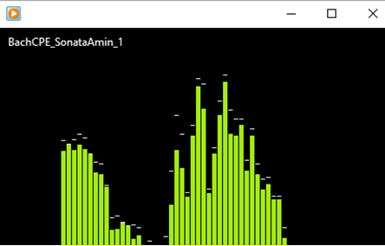

Therefore, we should not try to use the getVolume() method to retrieve the current volume level, and instead, we just need to use method [**setVolume**](https://www.greenfoot.org/files/javadoc/greenfoot/GreenfootSound.html#setVolume(int))(int level)to set the base volume level.

**After finishing this homework, how to verify the correctness of your submitted zip files:**

1. Download the zip files you have uploaded to Moodle homework drop box.
2. Unzip the zip file to a different local folder in your computer, other than the original local folder where the zip files are generated.
3. Run the Greenfoot project from the unzip folder, and make sure it compiles and runs correctly.
4. If your submitted zip file in the Moodle drop box

**cannot be downloaded,** or

**cannot be unzipped,** or

**cannot compile,** or

**cannot run,**

then you need to figure out the reason and fix the error, and then submit the corrected zip file to the Moodle drop box. Then start this verification process again until you can download, unzip, compile and run successfully. To upload a corrected zip file to the Moodle drop box, you need to delete the previous submitted zip file from the Moodle drop box first.

In the first page of file “chap1-schedule.docx”, you can find the instructions on how to zip and unzip files.

**Grading components:**

* Each one of the four exercises has 5 points, thus results in a total of 20 points for this homework

**For any submitted zip file that still has syntax error and it cannot compile or run in Greenfoot, it will receive ZERO point**. No re-submission is allowed after the homework due day.

Please click the Moodle homework drop box to see the due day of this homework.

When coding in Eclipse and/or Greenfoot, please read document “RulesForIndentAndAlignCode.docx” in Moodle folder “chap 1”, and follow the 5 rules in code alignment and indentation.