GAME DESIGN DOCUMENT

FOR

KikiKaikai J2ME GAME
(NOKIA 7650 VERSION)

Document ID:
Author(s): Li Hai Tao
Last Update: 5th Nov 2003

TABLE OF CONTENTS

1. Introduction 3
1.1 Purpose 3
1.2 Game outline 3
2. User Interface 4
2.1 Screen Transition 4
2.2 Splash Screens 5
2.3 Game Screens 5
2.4 Continue Screen 6
2.5 Scene select Screen 6
2.6 Settings Screen 6
2.7 Instruction Screen 7
2.8 About Screen 7
2.9 Game Over Screen 7
2.10 Scene clear Screen 8
2.11 All Scene clear Screen 8
3 Scoring 9
4 Game Rules 9
5 Sound and vibration Effect 9

1. Introduction

Purpose

After reading this paper, you will understand better how the game KikiKaikai is designed and can be played.

Game outline

KikiKaikai is an action shooting game released for arcade in 1986. The adorable main character ‘Sayo’ uses talisman and magic wand to defeat evil sprits. Many comical characters appear in the game to keep players entertained. This game has 7 scenes total and various boss characters on each scene. The game story is fun and is based on Japanese folk tales and legends.

Players are Sayo, a shrine maiden whose destiny is to fend off evil spirits and to prevent them from doing evil. The 7 deities have been captured by the heads of the evil spirits and it is up to you to save them. There are 7 scenes in this game. In each scene, Sayo have to defeat the evil head to rescue the deity. Sayo have 2 weapons: talisman and magical wand. Players can cast out the evil spirits by using the talismans and the magical wand. Players will be immobilised if players are touched by the evil spirits. If players are unfortunately immobilised 3 times, the game will beover.

2. User Interface

Screen Transition
The screenshots in Figure 1 shows the game screens’ transition for the game

(Start screen)

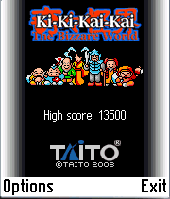

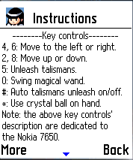
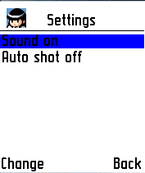
(Instructions)

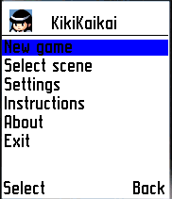
(Settings)

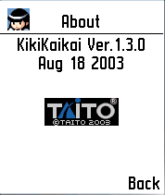
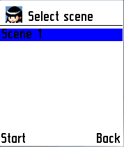
(Select scene)

(New game)
(About)
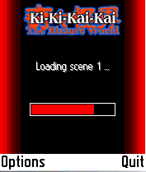

(Start)

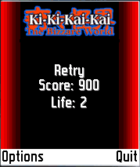
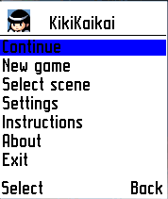
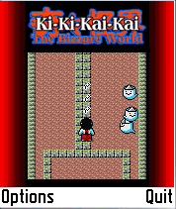
(Soft key)

(Continue)
(<= 3 times)
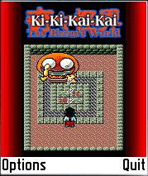
(Retry)

(Continue)
(>3 times)
(Game over)
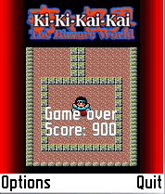
(Soft key)

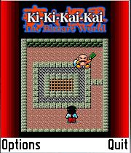

Figure 1: KikiKaikai Screens Transition
(Next mission)

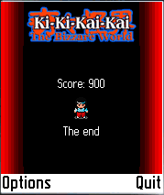
(There are 7 scenes in this game. If user cleared all 7 scenes, “The end” message will be displayed)

Splash Screens

i) When user starts the game, a signature screen (with Taito company name) will be displayed.

Signature screen
 | Screen | Key Press | Action
 |  |  | No key operation can be performed.
Title screen
 | Screen | Key Press | Action
 |  | SOFTKEY1 (Options) | To go to the main menu
 |  | SOFTKEY2 (Exit) | To exit the game.
Main menu screen
 | Screen | Key Press | Action
 |  | Select “New game”. | To start a new game.
 |  | Select “Select scene”. | To select a scene to start.
 |  | Select “Settings”. | To change settings (Sound and Auto shot).
 |  | Select “Instructions”. | To view instructions.
 |  | Select “About”. | To view game details.
 |  | Select “Exit”. | To exit the game.
 |  | “Back”. | To go to the Title screen.

Game Screens

When the “New game” menu item is selected from the main menu screen, the following game screens will appear.

Loading information screen
 | Screen | Key Press | Action
 |  |  | No key operation can be performed.
Game screen (Scene 1)
 | Screen | Key Press | Action
 |  | SOFTKEY1 | To pause the game.
 |  | SOFTKEY2 | To quit the game.
 |  | KEY 2 | To move up.
 |  | KEY 4 | To move down.
 |  | KEY 6 | To move to right.
 |  | KEY 8 | To move to left.
 |  | KEY 5 | To unleash talismans.
 |  | KEY 0 | To swing magical wand.
 |  | KEY * | To use crystal ball on hand.
 |  | KEY # | Auto talismans unleash on/off.

Continue Screen

Player can pause a game by pressing any of the soft keys when the game is in progress. The game is also paused automatically when there is an incoming call/SMS or when the battery is being charged. The main menu will appear with an additional “Continue” menu item. To continue playing, player just has to select the Continue.

Main menu screen (with Continue option)
 | Screen | Key Press | Action
 |  | Select “New game”. | To start a new game.
 |  | Select “Select scene”. | To select a scene to start.
 |  | Select “Settings”. | To change settings (Sound and Vibration).
 |  | Select “Instructions”. | To view instructions.
 |  | Select “About”. | To view game details.
 |  | Select “Exit”. | To exit the game.
 |  | “Back”. | To go to the Title screen.

Scene select Screen

In this screen, player can select a scene to start.

Scene select Screen
 | Screen | Key Press | Action
 |  | SOFTKEY2 (Back) | To return to the Main menu.
 |  | SOFTKEY1 (Start) | To start the game with the select scene.

Settings Screen

In this screen, player can turn on or off the sound. The sound setting (either On or Off) will be saved even after quitting the game. In other words, the next time when the game is started, it will still take the audio setting that was last set.

Settings Screen
 | Screen | Key Press | Action
 |  | SOFTKEY2 (Back) | To return to the Main menu.
 |  | SOFTKEY1 (Change) | To change Sound/Auto shot settings.

Instruction Screen

This screen contains the instruction on how to play the game

Instruction Screen
 | Screen | Key Press | Action
 |  | SOFTKEY2 (Back) | To return to the Main menu.
 |  | SOFTKEY1 (More) | To view next page

About Screen

This screen gives more details such as game name, version and copyright notice.

About Screen
 | Screen | Key Press | Action
 |  | SOFTKEY2 (Back) | To return to the main menu.

Game Over Screen

When Sayo is being immobilized for more than 3 times, the following game over screen will be displayed.

Game over Screen
 | Screen | Key Press | Action
 |  |  | No key operation can be performed.

Scene clear Screen

When Sayo has completed her mission, the following screen will be displayed before the next scene is started.

Scene clear Screen
 | Screen | Key Press | Action
 |  | SOFTKEY1 | To return to main menu.
 |  | SOFTKEY2 | To return to main menu.

All Scene clear Screen

There are 7 scenes in this game. If user cleared all 7 scenes, a “The end” message will be displayed

All Scene clear Screen
 | Screen | Key Press | Action
 | 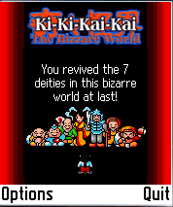 | SOFTKEY2 | To return to title screen

 | Screen | Key Press | Action
 | 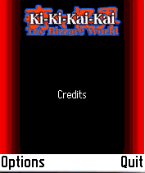 | SOFTKEY2 | To return to title screen
 | Screen | Key Press | Action
 | 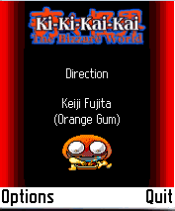 | SOFTKEY2 | To return to title screen

 | Screen | Key Press | Action
 | 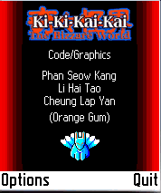 | SOFTKEY2 | To return to title screen

 | Screen | Key Press | Action
 | 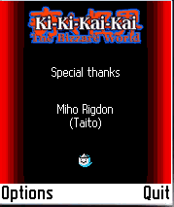 | SOFTKEY2 | To return to title screen

 | Screen | Key Press | Action
 | 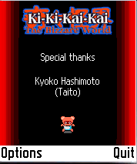 | SOFTKEY2 | To return to title screen

 | Screen | Key Press | Action
 | 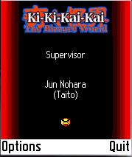 | SOFTKEY2 | To return to title screen

 | Screen | Key Press | Action
 | 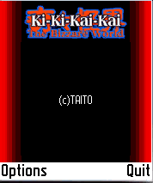 | SOFTKEY2 | To return to title screen

 | Screen | Key Press | Action
 |  | SOFTKEY2 | To return to title screen

3 Scoring

The scoring rules are as follows:

Diminish normal evil: 750 marks

Collect various talisman: 1000 marks
Collect rice dumpling: 2000 marks
Diminish boss evil : 5000 marks

Game Rules

•Control the main character Sayo to defeat evil sprites by throwing talisman while protecting her with magic wane.
•There are 2 weapons: talisman and magical wand. The talisman is for long range, and the other is for short range.
•Sayo will be immobilised if she is touched by the evil spirits. If Sayo is unfortunately immobilised 3 times, the game will be over.
•Various hidden power-up items will appear when the stone lantern is brushed by the magical wand.
•Collecting yellow talisman will enlarge your talismans.
•Collecting light-blue talisman will improve the range of your talismans.
•Collecting red talisman will allow your talismans to penetrate the evil spirits.
•Collecting dark-blue talisman will increase the speed of your talismans.
•Collecting and using light-blue crystal ball will immobilize the evil spirits for a while.
•Collecting and using yellow crystal ball will make all the evil spirits within sight to disappear.
•Collecting rice dumpling will increase your score by 2000 points.
•Collecting magical wand will increase your life by 1.
•Find the boss of a scene and defeat it to clear the scene.
•Battle through 7 scenes and rescue seven scenes to complete the game.

5 Sound and vibration Effect

There will be sound effects for the followings:

- Unleash the talisman.
- Pick up items.
- Scene is clear.
- Sayo is unfortunately immobilised.
- All scenes are cleared.
- Game over.

