**Week 4 Homework Submission File: Linux Systems Administration**

**### Step 1: Ensure/Double Check Permissions on Sensitive Files**

1. **Permissions on `/etc/shadow` should allow only `root` read and write access**.
   * Command to inspect permissions:
     + ls -l /etc/shadow
   * Command to set permissions (if needed):
     + sudo chmod 640 shadow
2. **Permissions on `/etc/gshadow` should allow only `root` read and write access.**
   * Command to inspect permissions:
     + ls -l /etc/gshadow
   * Command to set permissions (if needed):
     + sudo chmod 640 gshadow
3. **Permissions on `/etc/group` should allow `root` read and write access, and allow everyone else read access only.**
   * Command to inspect permissions:
     + ls -l /etc/group
   * Command to set permissions (if needed):
     + sudo chmod 644 group
4. **Permissions on `/etc/passwd` should allow `root` read and write access, and allow everyone else read access only.**
   * Command to inspect permissions:
     + ls -l /etc/passwd
   * Command to set permissions (if needed):
     + sudo chmod 644 passwd

**### Step 2: Create User Accounts**

1. **Add user accounts for `sam`, `joe`, `amy`, `sara`, and `admin`.**
   * Command to add each user account (include all five users):
     + sudo adduser sam
     + sudo adduser joe
     + sudo adduser amy
     + sudo adduser sara
     + sudo adduser admin
2. **Ensure that only the `admin` has general sudo access.**
   * Command to add `admin` to the `sudo` group:
     + sudo usermod -aG sudo admin

**### Step 3: Create User Group and Collaborative Folder**

1. **Add an `engineers` group to the system.**
   * Command to add group:
     + sudo addgroup engineers
2. **Add users `sam`, `joe`, `amy`, and `sara` to the managed group**.
   * Command to add users to `engineers` group (include all four users):
     + sudo usermod -aG developers sam
     + sudo usermod -aG developers joe
     + sudo usermod -aG developers amy
     + sudo usermod -aG developers sara
3. **Create a shared folder for this group at `/home/engineers`.**
   * Command to create the shared folder:
     + useradd -d /home/engineers/ -g documents sam
     + useradd -d /home/engineers/ -g documents joe
     + useradd -d /home/engineers/ -g documents amy
     + useradd -d /home/engineers/ -g documents sara
     + useradd -d /home/engineers/ -g documents -m admin
4. **Change ownership on the new engineers' shared folder to the `engineers` group.**
   * Command to change ownership of engineer's shared folder to engineer group:
     + sudo chown admin:engineers documents

**### Step 4: Lynis Auditing**

1. **Command to install Lynis:**

* sudo apt install lynis

1. **Command to see documentation and instructions:**
   * sudo lynis --help
2. **Command to run an audit:**
   * lynis audit system
3. **Provide a report from the Lynis output on what can be done to harden the system.**
   * Screenshot of report output:

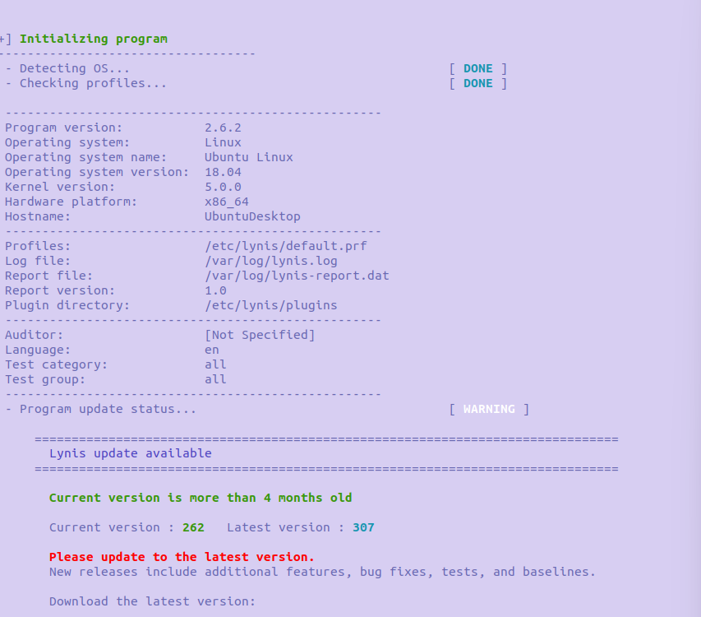

**### Bonus**

1. **Command to install chkrootkit:**
   * sudo apt install chkrootkit -y
2. **Command to see documentation and instructions:**
   * sudo man chkrootkit
3. **Command to run expert mode:**
   * sudo chkrootkit -x
4. **Provide a report from the chrootkit output on what can be done to harden the system.**
   * Screenshot of end of sample output:
   * 