LamePatch-n-Update Kit
by G1ta0

Developer/Tester/Admin Help

17/01/2008

Futures:
LamePatcher:
- compare two dirs and create patchlist;
- apply patches from patchlist;
- append patches to patchlist;
- highlight conflicting patches.
LameUpdater:
- self-updating;
- file restoration from scratch;
- incremental binary patches with compression (XDelta lib);
- resume download;
- site news viewer;
- custom full check period;
- custom force check;
- hosts file changer (not a dumb replace);
- can be used like launcher w/o patching futures;
- ability to be unique for each game client/software (just rename executable !);
- easy install with config file, or with some setup software.

Thanks to:
FireBlade for tests and criticism,
Michiru and Xardas for tests (also evil33t for "it works" =) ),
C-Ibo, Vlad for cool buttons for updater,
Nbd fixing english in some places.

I will appreciate any support; you can help the project to develop via WebMoney, and I promise that feedback will be as big as you support will ;) Thank you!

Z368612820234
E529845233746
I accept custom futures, custom interface requests and support in patch deployment only on payable statement (XMZ/WME).

e-mail: l2jdev@gmail.com
How to create patches

1.1. To create patches select File -> New
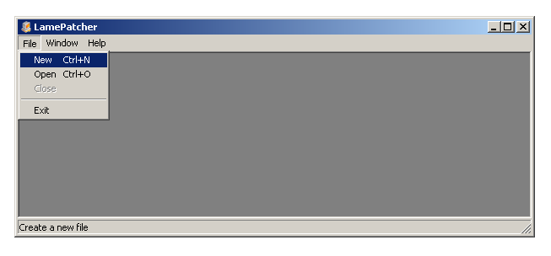1.2. Choose a source folder with the original non-modified files. On the example picture such folder is the freshly installed “Lineage II Interlude”.
Note: if you want to create patches from scratch, select Create from scratch.
Note2: if you want to use updater from the root of game dir, keep directory structure same as a root dir. If u want to process only system folder for example, copy it in some other place. Like
C:\Temp_Dir\system, and target C:\Temp_dir, NOT C:\Temp_Dir\system

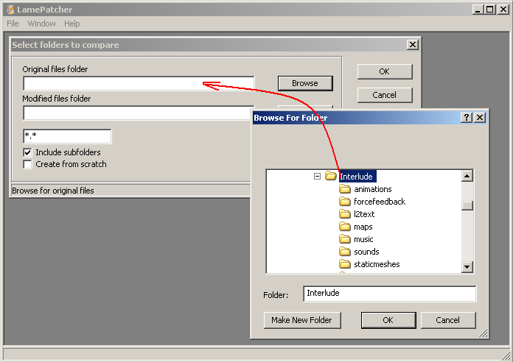

1.3. Choose a folder with the modified files, in this example it’s “Lineage II Interlude.Updated” (21-08-2007)
Note: if you want to create patches from scratch, select Create from scratch.
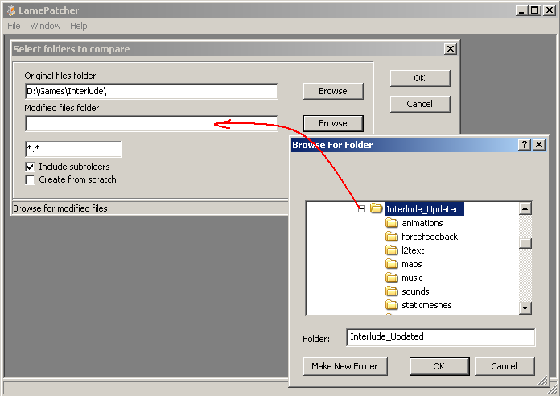

1.4. Click OK and wait until folder comparison is finished

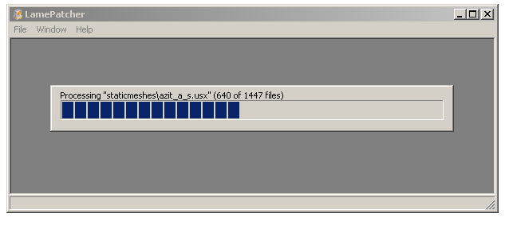

1.5. Now you can see the changes:

 New file, original folder have no such file
 Deleted file, updated folder have no such file
 Files with same names but different content
 Files are same

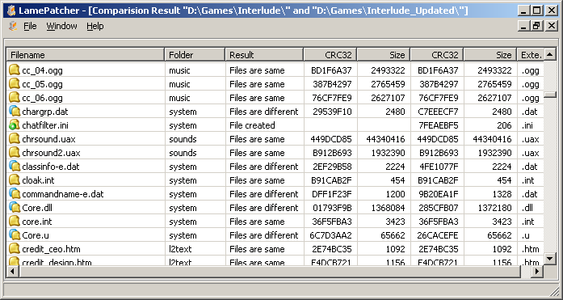

1.6. Now you can select all files and make binary patches from the freshly installed Lineage II folder to the updated one. You can select different files : Click Select Diff, and then Create patch(s) in context menu.
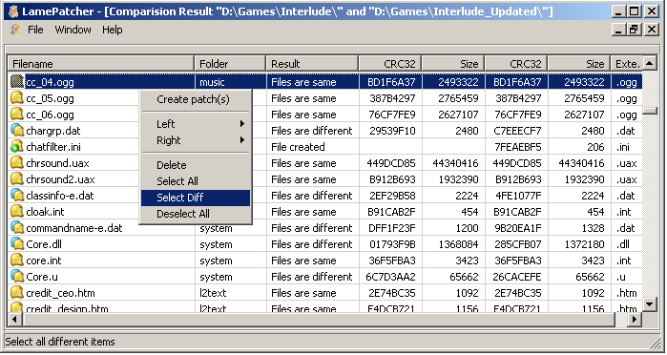

1.7. Choose a folder in the dialog menu, a filename and where the patch info will be stored.
Options:
Append to existing file – all patch items will be added to an existing patchlist file if you had one
Ignore deleted files – patchlist will be created without deleted files (for example: if file filename1.dat doesn’t exist in the second folder, then it will be added to patchlist marked as deleted)
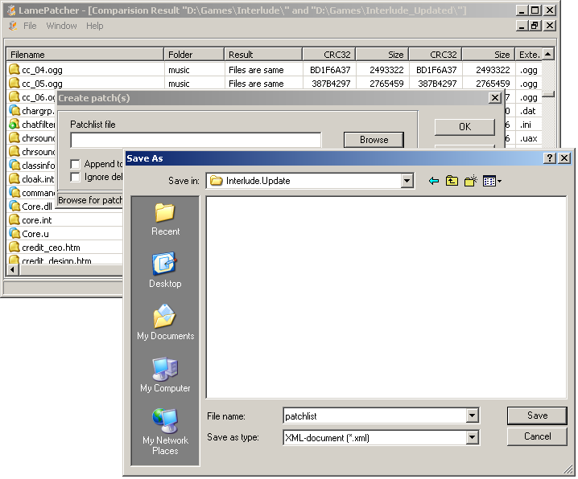

1.8. Click OK and wait untill patches will be created and stored in the chosen folder

1.9. If you open the folder with patches you can see .xdelta file for each files couple and the generated patchlist. Patchlist will be used for LameUpdater, that can download patches through HTTP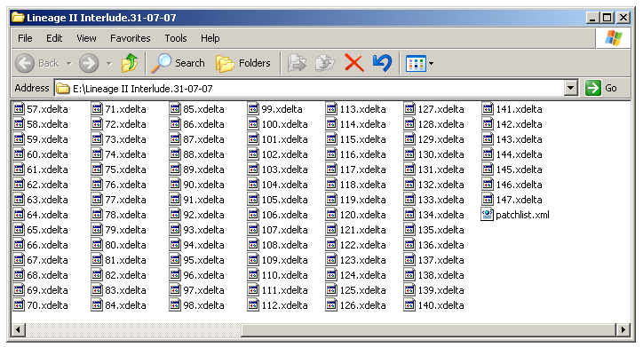

How to apply patches

2.0. To apply a patch, load created patchlist from File -> Open. Select items you want to proceed, then click Apply patch(s) in the context menu.
Please note:
 This is sign of conflicts, this conflicts must be resolved before using this patchlist with LameUpdater. Conflicts happens then one patch override another, like Create/Delete same file.
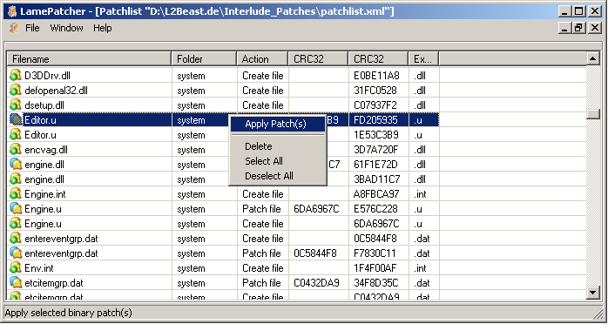
2.1. Browse to the folder with the original files
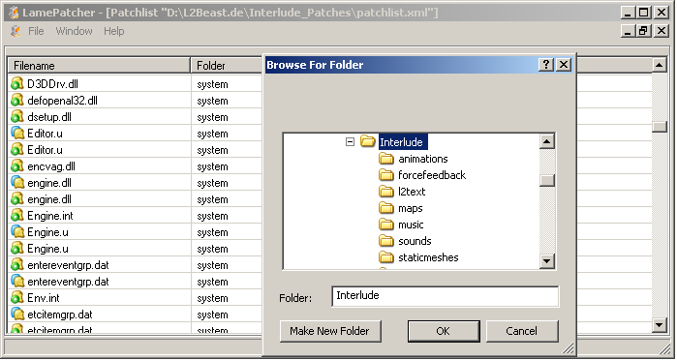

2.2. After process will be finished folder will be updated.

How to configure updater

- Make patches and patchlist.xml with the LamePatcher tool.
- Place patchlist.xml and patch files on some folder, that can be accessed via http
- Prepare options.xml for server (its config file, where all setting for updater is placed)
<options url="http://somehost.org/update/options.xml">

url – its url where server options for updater placed

<patchlist url="http://somehost.org/update/patchlist.xml"/>

url – its url where patchlist file and all .xdelta files are placed.
Note: link for .xdelta files will be http://somehost.org/update/, unless you are specify another link in patchlist file.

<news url="http://somehost.org/news/"/>

url – page with news, will be shown in updater window.

<updater url="http://g1ta0.warpt.ne/updater/common/LameUpdater.exe/>

url – url to new release of updater ( will be downloaded automaticly if updated)

<exec program="system\l2.exe" updater_close="1"/>

program – it’s a path to program, that will be started with start button.
updater_close – must updater close itself after program starts.

<full_check days="7" force="0"/>

days – interval between full checks.
force – if enabled then local patchlist will be replaced every time full check needed or “check files” button pressed.

Below its list of items, that will be checked on every updater start, here good reason to place .exe, .dll files.

<force_check>
<dir name="*" mask="*.exe;*.dll"/>
<dir name="system" mask="*.dat"/>
<dir name="systextures" mask="L2Font.utx;L2Font-e.utx"/>
</force_check>

Below its list of items, that can be custom on client side and will be restored from patchlist only if absent.

<lazy_check>
<dir name=" system\GameGuard" mask="*.*"/>
<dir name=" system" mask="Option.ini;WindowsInfo.ini"/>
</lazy_check >

Lines to add into hosts file (if such domains already present with other IPs, then such line will be commented)

<hosts>
<line ip="127.0.0.1" domain="l2authd.lineage2.com"/>
<line ip="127.0.0.1" domain="l2testauthd.lineage2.com"/>
<line ip="127.0.0.1" domain="nprotect.lineage2.com"/>
</hosts>

</options>
- Prepare client side options.xml, smallest possible client side options.xml is:
Note: options filename can be program.xml where program – its name of updater executable.

<options url="http://somehost.org/update/options.xml">

url – is url where server-side options is placed.

</options>

You can put other options here, but they will be overridden by server side options.

Alternative way, without client side options.xml, its make a small setup (like small SFX archive for example), and after updater will be copied in game client folder, run:

LameUpdater.exe /install "http://somehost.org/update/options.xml”

Where:

http://somehost.org/update/options.xml is url where server-side options is placed

If player wish to delete your application, you can put command in uninstall process.

LameUpdater.exe /uninstall

Tips & Tricks

- LameUpdater will connect and download needed patches and update itself if needed. If player has wrong, lets call them unversioned, files, then LameUpdater will try to restore the original files.
Patches for the original files can be created with LamePatcher from an empty folder, as original and filled with files folder, as modified (or just check Make from scratch option)

- Every time you modify some file and add patches to patchlist/patchfolder, you must check “Append to existing file” option – time of patchlist file will be changed, so LameUpdater will know if patchlist changed, same thing with when you modify updater options.
- 3. If you want to have unique LameUpdater ( you provide updates for more then one client, and players can run more then one instance of LameUpdater ), before share updater for download – just rename it, like L2Updater.exe etc.
Note: two or more updaters on same machine will not cause conflicts only if they have different filenames!

