

**Virtual Internship Programme on**

**DATA ANALYTICS**

**TASK-5: Exploratory data Analysis on dataset -TERRORISM**

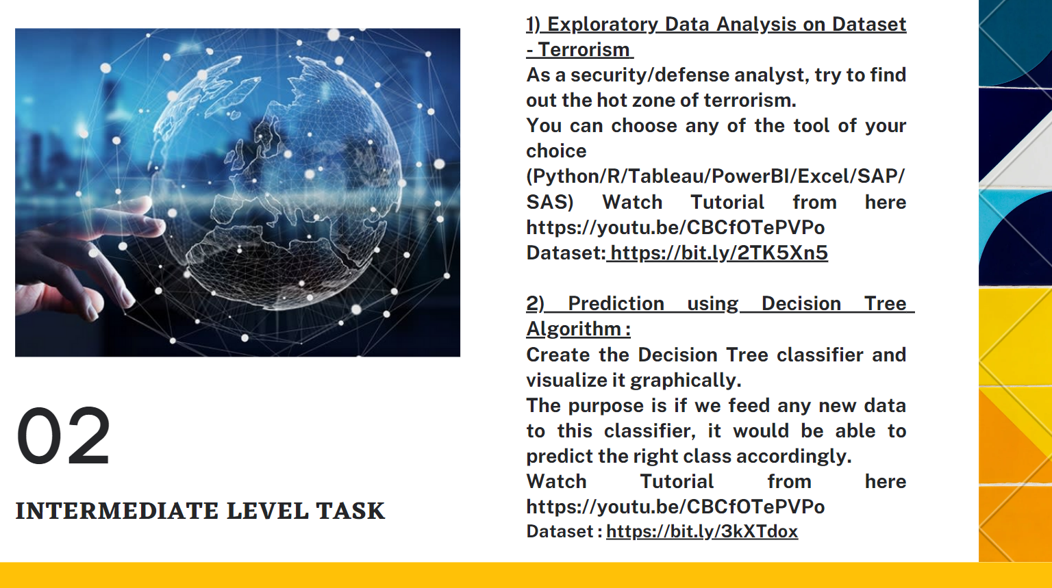

**LinkedIn profile:**

**https://www.linkedin.com/in/lahari-kasukurthi-02b894249/**

⇒ Introduction:

Terrorism, the calculated use of violence to create a general climate of fear in a population and thereby to bring about a particular political objective. Terrorism has been practiced by political organizations with both rightist and leftist objectives, by nationalistic and religious groups, by revolutionaries, and even by state institutions such as armies, intelligence services, and police.

⇒ **Terrorism-Origin of the term:**

The term ‘terrorism’ has been derived from the French ‘*terrorism*’, which is in turn, taken from the Latin word, ‘*terreo*’ meaning ‘I frighten’.

• The word was first used in the context of the French Revolution in France, especially in reference to the ‘Reign of Terror’.

• Many cite the Irish Republican Brotherhood (1858 – 1924) as the first organisation to use modern terrorist techniques.

⇒ Terrorist Activities:

Terrorists indulge in a variety of activities for primarily three things:

1. Generate fear among people.

2. Create publicity for their goals/causes.

3. Try to convince people that the government is powerless against them.

Terrorists and/or terror groups engage in random killings/assassinations, bomb blasts in public places, suicide attacks, kidnappings, extortion, destroy public property/infrastructure, hijacking, cyber-attacks, etc. They also indulge in chemical, biological, radiological and nuclear warfare. Many terror groups also engage in an armed insurgency against governments.

The aim of political terror groups varies from toppling the established government of a country to having better representation for a group of people, to seceding from a country and forming another country, to acquiring a share in the government, etc. Many other groups of terror exist solely for making illicit money and expanding their own illegal criminal empires. Many groups of organised crime are also labelled terrorist groups.

⇒ Types of Terrorism:

Although there are several types of terrorism, we can classify terrorism into the following broad types:

1. Dissent Terrorism: Groups that rebel against the government of a country. For example, the LTTE in Sri Lanka.

2. Left-wing/right-wing terrorism: Terror groups that adhere to ideological leanings on the extreme end of the left-right political spectrum. Read more on left-wing extremism in India.

3. Religious terrorism: Terror groups based on religious ideologies. For example, ISIS.

4. Criminal terrorism: Terror groups engaged in terror acts for criminal profit.

Terrorism can also be classified on the basis of the mode of operation such as cyber-terrorism, bioterrorism, etc.

⇒ Objective:

Objective of this project is to analyse the data and present meaningful insights about global terrorism.

⇒ **Data Collection and Software use:**

Data is collected from the given link: https://bit.ly/2TK5Xn5 and we have used Microsoft Excel for data analysis.

⇒ **Results of Analysis:**

• Most of the attacks were attacked through explosives and then through firearms.

• Attacks were more during 2014 and then in 2015. When compared to attacks from 1970 onwards, the last 6 years scored a maximum. But from 2014 onwards count started decreasing.

• Iraq dominates all the countries and it has the highest number of attacks and then Pakistan, Afghanistan, and India follow it.

• For most of the attacks, the target is Private Citizens& property and the next Military leads.

• Most of the attacks were through either Bombing or Explosion.

⇒ **Measures to be Taken to Reduce Terrorism:**

• By reducing access to dangerous weapons

• Government should provide more security over countries

• Security should be strengthened across borders

• Government should take measures on increased immigration

• and many more…