**Abstract**

The **BloodBridge** platform is a web-based Blood Bank Management System designed to facilitate blood donations, enhance donor engagement, and support hospitals in maintaining adequate blood supplies. Developed using PHP for backend processing and a responsive frontend, the system provides an intuitive interface for users to register, find donors, and track blood donation trends.

The homepage features an interactive dashboard displaying key statistics, including total donors, partnered hospitals, and active locations. Graphical representations of blood group distributions and donation trends enhance data visualization. The platform emphasizes ease of access through login and signup options, ensuring a secure and user-friendly experience.

By streamlining donor management and donation tracking, this system plays a crucial role in addressing blood shortages and improving medical response efficiency. The implementation of PHP and a structured database ensures reliable performance and scalability, making it a robust solution for blood donation management.

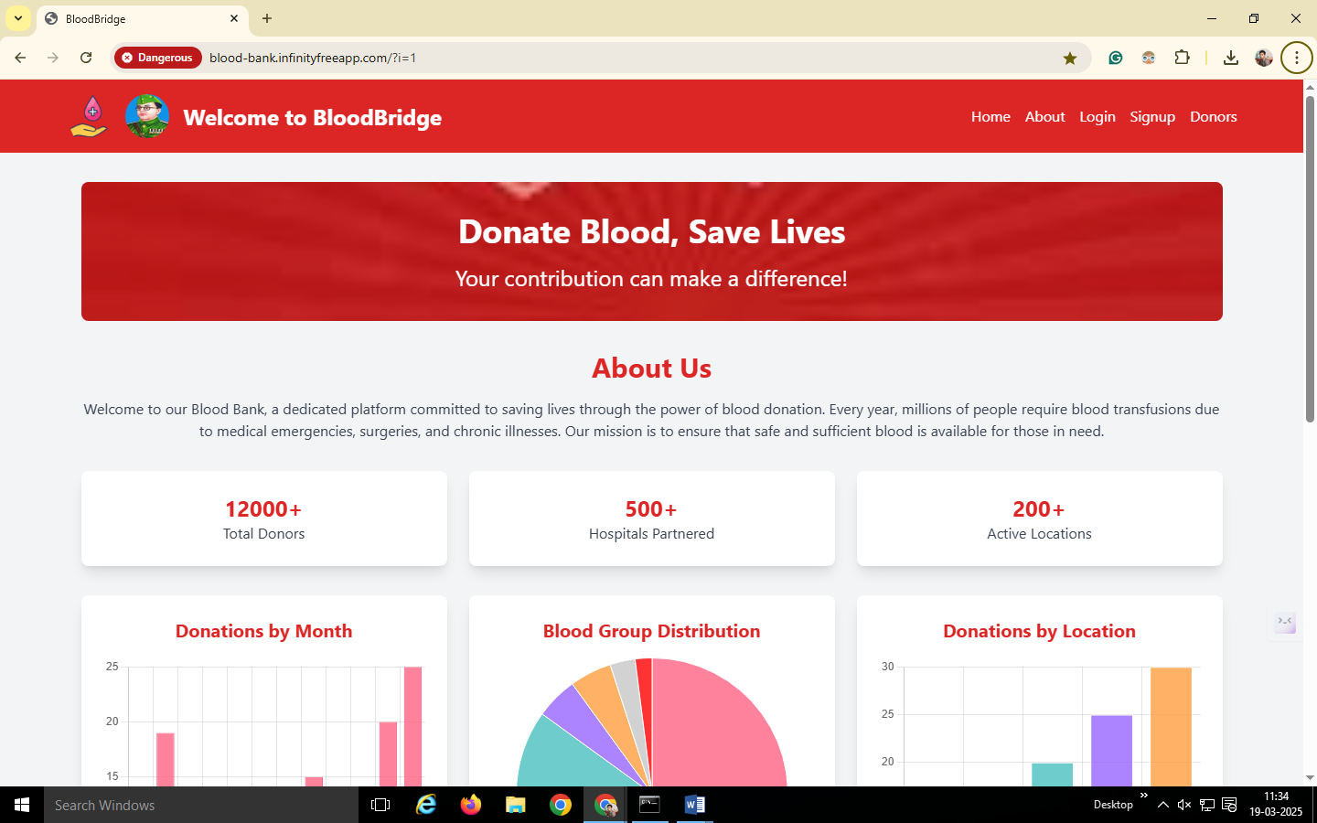

The **BloodBridge** home page is designed to create awareness about blood donation and engage donors effectively.

The **header section** displays the BloodBridge logo along with navigation links such as Home, About, Login, Signup, and Donors. A user profile icon is also available for logged-in users. The **banner section** features the slogan "Donate Blood, Save Lives," encouraging users to participate in blood donation efforts.

The **About Us section** highlights the mission of BloodBridge, which is to facilitate blood donations and ensure an adequate blood supply for medical emergencies, surgeries, and chronic illnesses. To provide important insights, key statistics are prominently displayed, including over 12,000 total donors, 500+ partnered hospitals, and 200+ active locations.

The home page includes **data visualizations** that present blood donation trends. A bar chart illustrates donations by month, a pie chart shows blood group distribution, and another graph highlights donations by location. These visual elements help users understand donation patterns and encourage participation.

The **footer section** may include contact details, social media links, FAQs, and policy-related information to assist users in navigating the platform.

The **technologies used** in developing this platform include HTML, CSS, and JavaScript for the front end. The back end is powered by PHP, which manages user authentication and interactions, while MySQL is used for storing donor details and donation statistics.

The primary **purpose** of the home page is to provide quick access to essential blood donation information, encourage user sign-ups for donation participation, and present data-driven insights to raise awareness about the importance of blood donation. The structured design ensures an intuitive and informative user experience.

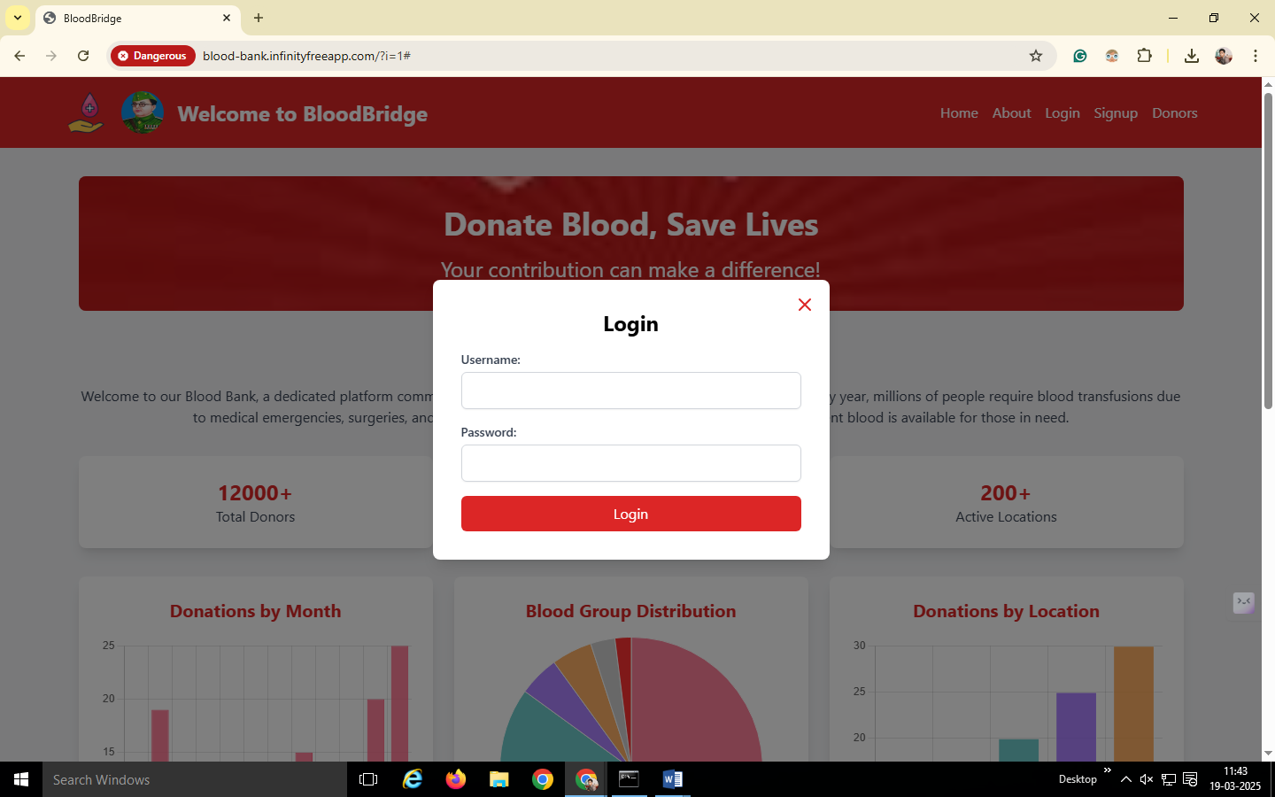

The **Login and Signup** functionalities in BloodBridge allow users to access the platform securely and register as donors or recipients. These features ensure that only authorized users can participate in blood donation activities and access relevant information. The **Login Page** provides a form with fields for email/username and password, where users must enter the correct credentials to access their accounts. It also includes a "Forgot Password?" option for password recovery and utilizes PHP for authentication along with MySQL for user data verification.

The **Signup Page** allows new users to register by filling in details such as full name, email, phone number, blood group, location, and password. Some fields require validation to ensure data accuracy, and passwords are securely hashed before storage in the database. After successful registration, users can log in and access their profiles.

Key Features:

* Secure user authentication and data validation
* Password encryption for enhanced security
* Account recovery option through "Forgot Password"
* Role-based access for donors and recipients

These features help in managing users effectively, ensuring data security, and facilitating smooth interactions within the BloodBridge platform.

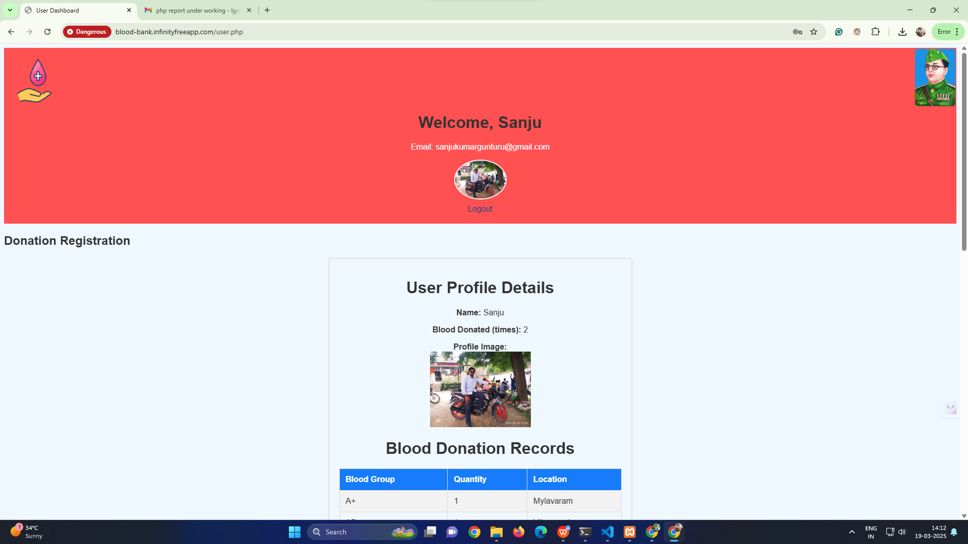

Once a user successfully logs into the BloodBridge platform, they are redirected to their **dashboard**, which provides personalized information and functionalities based on their role (donor, recipient, or admin).

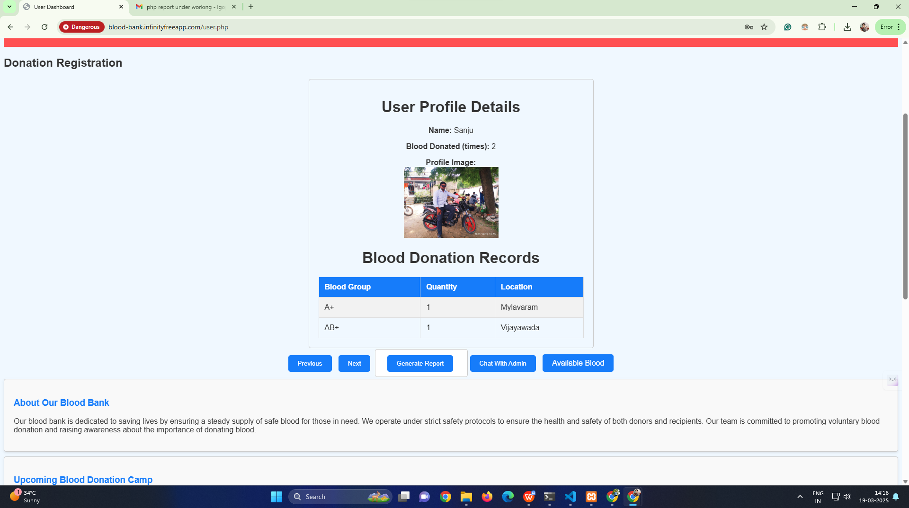

#### ****Key Features of the Dashboard****

* **User Profile**: Displays the user’s name, blood group, location, and contact details.
* **Donation History**: Lists previous blood donations with dates and locations.
* **Request Management**: Allows users to request blood or respond to donation requests.
* **Available Donors**: Displays a list of donors matching the required blood group and location.
* **Check Blood Availability**: Users can check the availability of specific blood groups in different locations and nearby hospitals.
* **Chat with Admin**: A built-in chat feature allows users to communicate with the admin for assistance, queries, or urgent requests.
* **Notifications & Alerts**: Notifies users about upcoming donation camps, urgent blood requests, and account updates.
* **Edit Profile & Settings**: Users can update personal details, change passwords, and manage account preferences.
* **Logout Option**: Ensures secure session management by allowing users to log out after use.

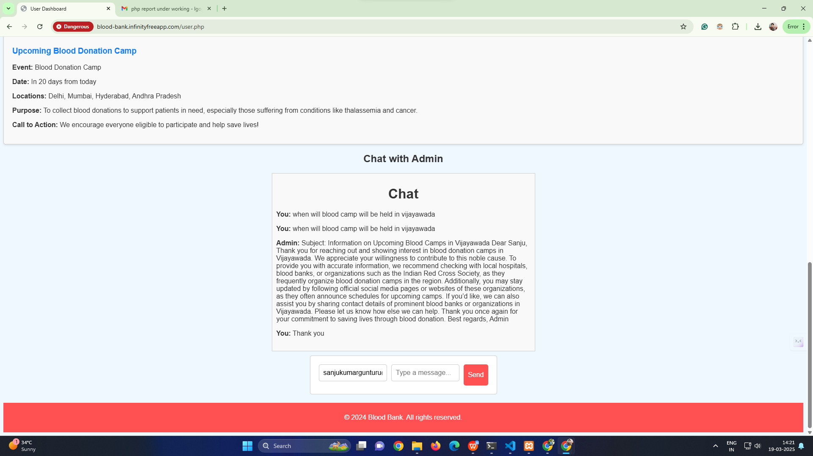

This dashboard ensures a seamless experience by providing users with relevant information, direct communication with the admin, and real-time blood availability checks. Let me know if you need any modifications.

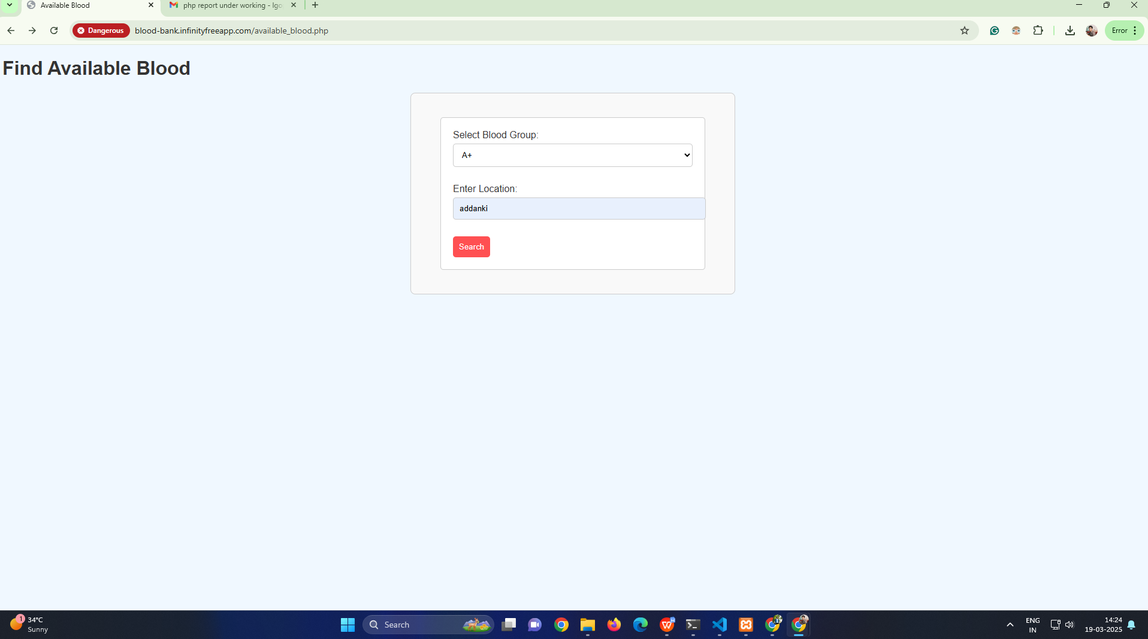

When a user searches for available blood on the BloodBridge platform, they can filter the results based on **blood group** and **location** to find suitable donors or blood banks nearby. The platform then retrieves relevant matches and displays the details of available donors.

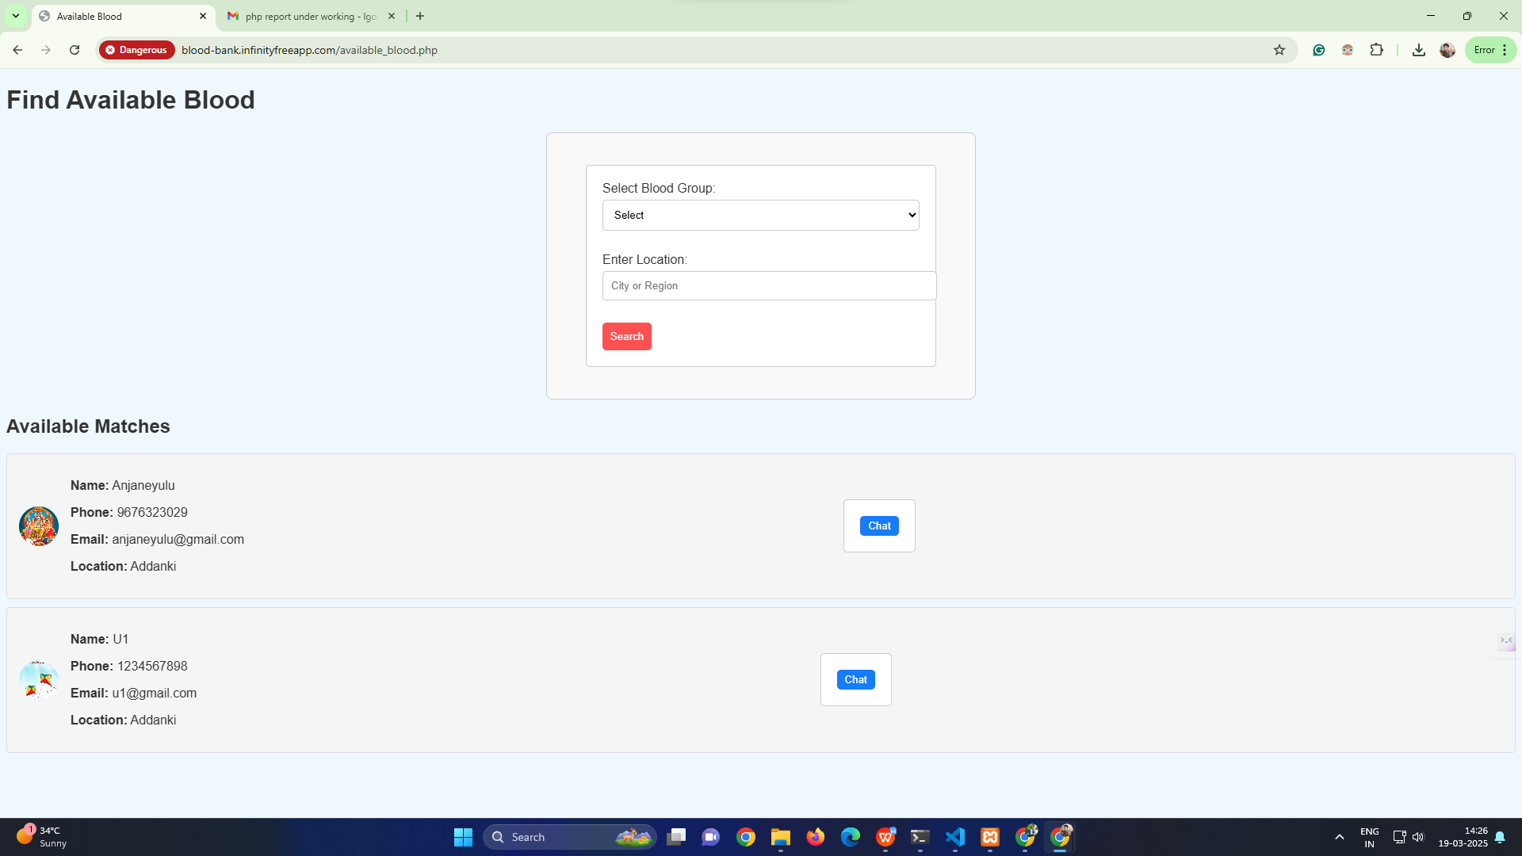

#### ****Search Process and Features****

* **Filter by Blood Group**: Users can select a specific blood group (e.g., A+, O-, B-) to refine the search results.
* **Filter by Location**: Users can enter their city or region to find donors or blood banks nearby.
* **Real-Time Availability**: The system fetches available blood units or registered donors from the database.
* **Donor Details Displayed**: Below each search result, the following details are shown:
  + **Username** of the donor
  + **Phone Number** for direct contact
  + **Email id** ofdonor
  + **Location**  of donor
* **Request Blood Option**: Users can send a request to the donor or blood bank for immediate assistance.

This feature ensures that users can quickly find blood donors based on specific requirements, making the process efficient and accessible. Let me know if you need any modifications.

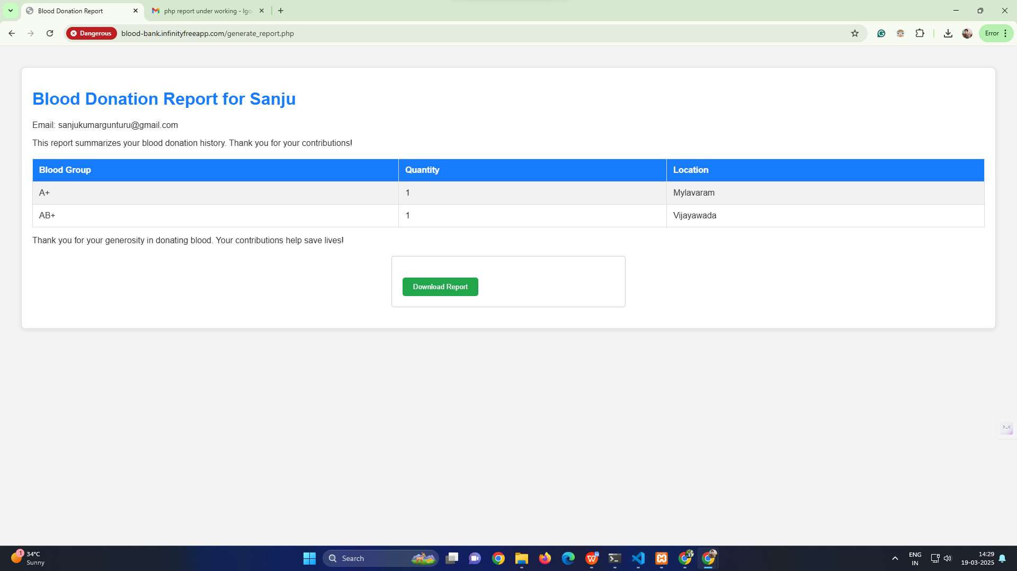

The **Download Report** feature in BloodBridge allows users to generate and download reports related to blood donation activities, donor details, and requests. This functionality helps users, hospitals, and administrators maintain records for reference and analysis.

#### ****Key Features of the Download Report Functionality****

* **User-Specific Reports**: Users can download their **donation history**, including dates, locations, and blood group details.
* **Donor Availability Report**: Generates a report of available donors based on **blood group and location** filters.
* **Blood Request Report**: Displays details of **requested and fulfilled blood donations**, including donor and recipient information.
* **Admin Reports**: Admins can generate reports for **total donations, pending requests, and overall donor statistics**.
* **Export Options**: Reports can be downloaded in **PDF, Excel, or CSV formats** for easy sharing and offline access.
* **Automated Report Generation**: The system compiles data in real time to ensure up-to-date information before downloading.

This feature provides users with an efficient way to **track, manage, and analyze blood donation records** for better decision-making. Let me know if you need any modifications.

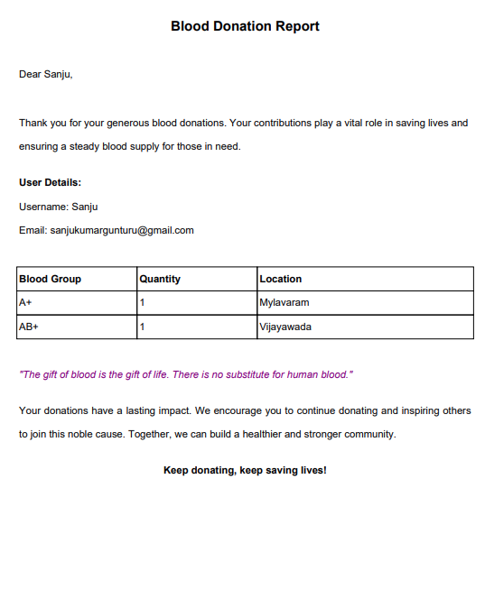

The **User Page** in BloodBridge provides a seamless and efficient experience for donors and recipients, ensuring easy access to essential blood donation services. With features like **profile management, blood search with filters, donation history, chat with admin, and report downloads**, the platform enhances user engagement and simplifies the blood donation process. The ability to **check blood availability, contact donors, and request blood in emergencies** makes BloodBridge a reliable and user-friendly system. By integrating these functionalities, the platform ensures a smooth and secure experience, encouraging more users to participate in life-saving blood donation efforts.

**Admin**

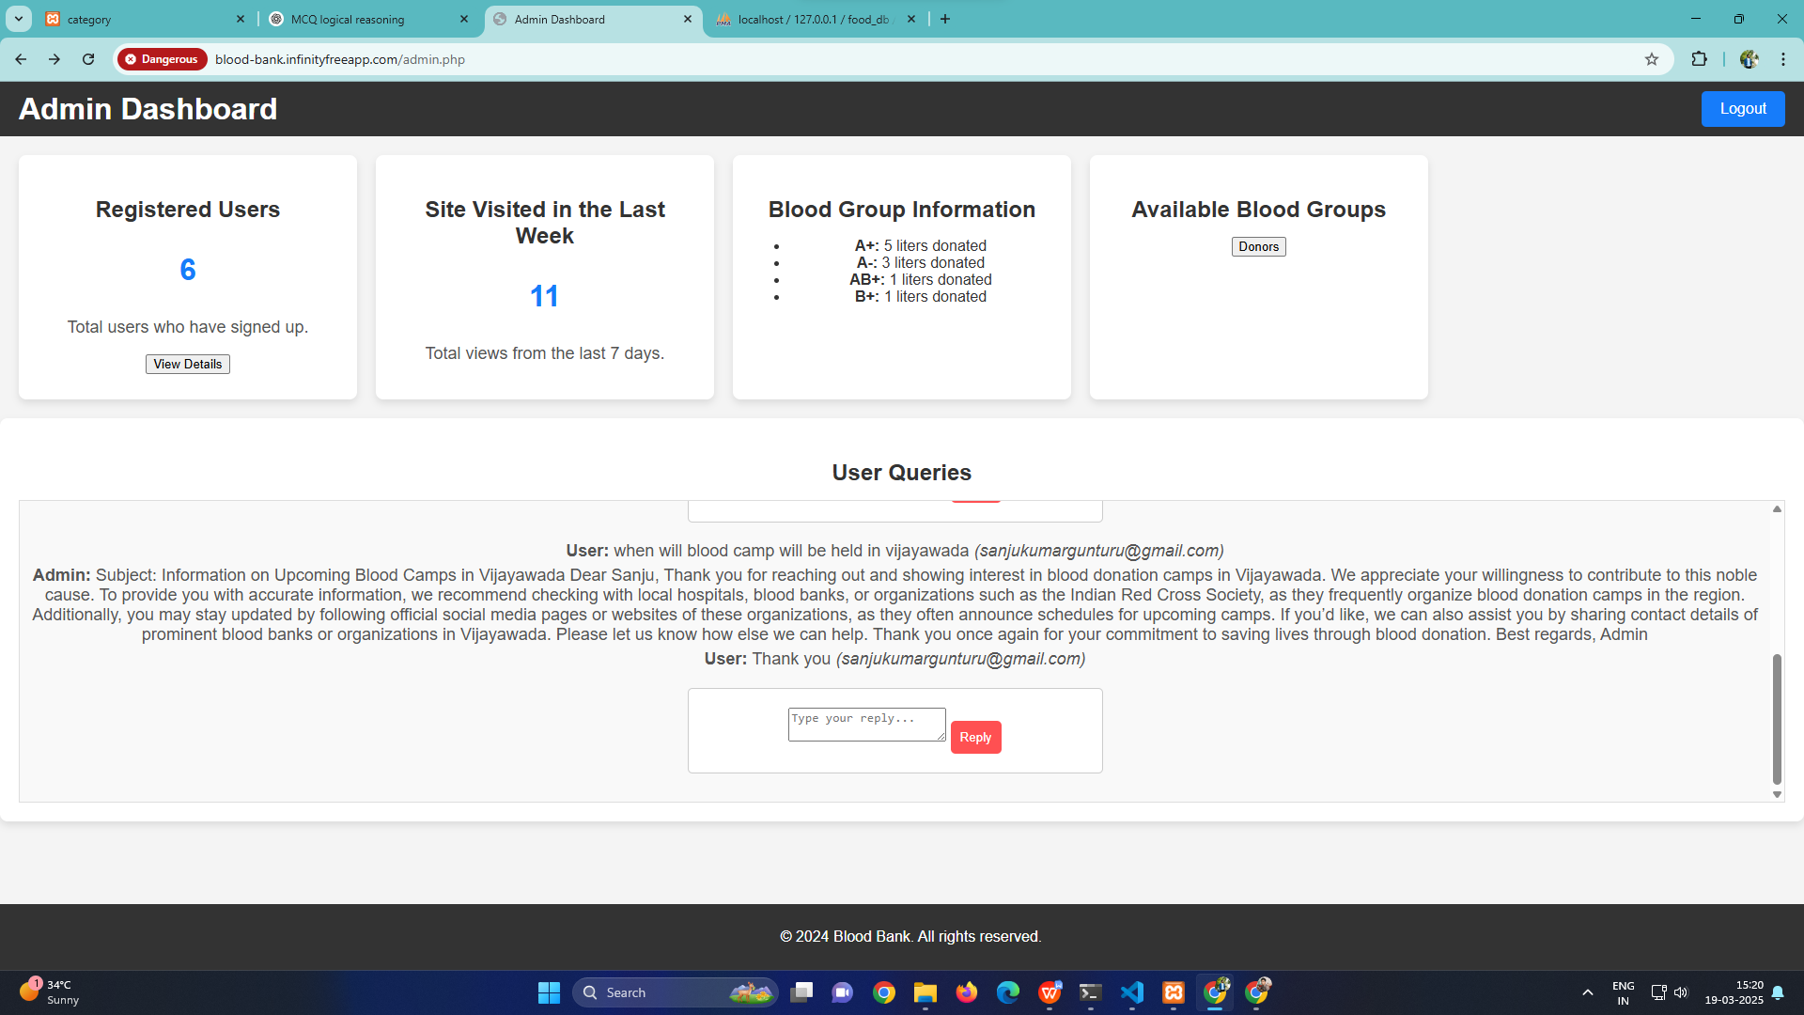

The **Admin Dashboard** in BloodBridge provides an overview of user activities, blood donation statistics, and user queries. It enables the admin to monitor and manage the platform efficiently.

#### ****Key Features of the Admin Dashboard****

* **Registered Users**: Displays the total number of users who have signed up, with an option to view detailed user information.
* **Site Visits in the Last Week**: Shows the total number of views from the last seven days, helping the admin track platform engagement.
* **Blood Group Information**: Provides data on the amount of blood donated for different blood groups, such as A+, A-, B+, and AB+.
* **Available Blood Groups**: Contains a section to view available blood groups, ensuring the admin can manage inventory effectively.
* **User Queries**: Displays messages sent by users and admin responses, allowing direct communication between users and the admin.
* **Logout** : Enables the admin to securely log out of the dashboard after monitoring and managing the platform.

The admin panel plays a crucial role in managing users, responding to queries, and tracking blood donation trends, ensuring smooth platform operations.

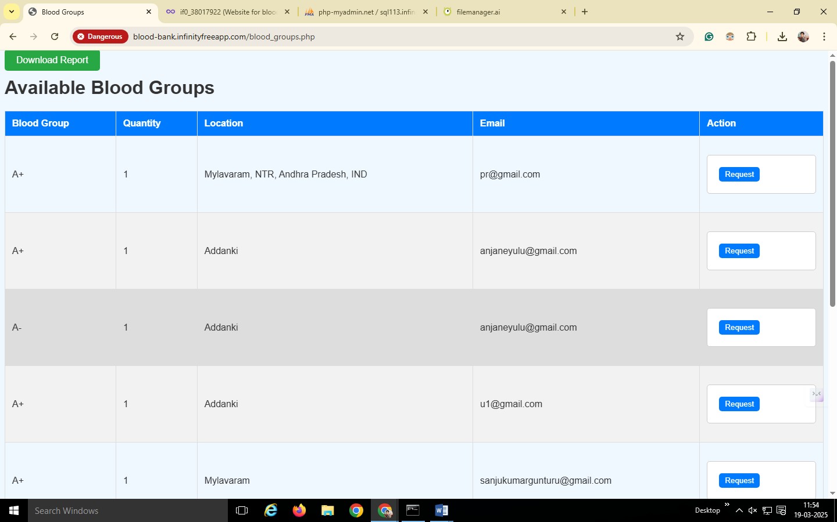

The **Available Blood Groups** section in the BloodBridge **Admin Panel** allows administrators to monitor and manage blood availability efficiently. It provides a structured overview of the available blood units, donor details, and locations.

#### ****Key Features****

* **Blood Group**: Displays different blood groups such as A+, A-, B+, etc.
* **Quantity**: Shows the number of available blood units for each blood group.
* **Location**: Indicates where the blood is available, helping users find nearby donors.
* **Email**: Lists the donor’s or hospital’s email for direct communication.
* **Action (Request Button)**: Allows users or hospitals to request specific blood groups as per their requirement.
* **Download Report**: The admin can download a report of all available blood groups and donor details for better record-keeping.

This section ensures efficient blood inventory management, allowing quick responses to requests and maintaining a steady blood supply for those in need.