Screenshot showing .dbo files

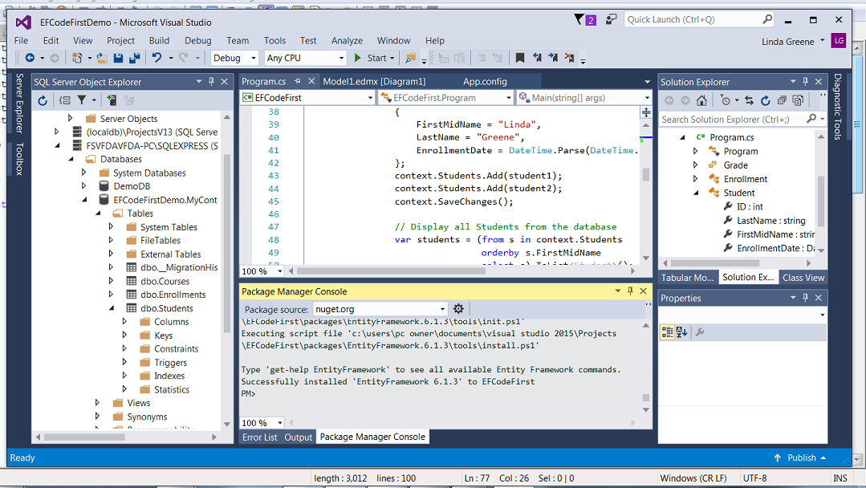

Output of Entity Framework Code First Application

