**計算機概論作業13**

(1)**中文題意**:

寫一個程式計算平均值、標準差、中位數，使數值以降序排序出來。

(2)**程式碼+註解+流程**:

program HW13

implicit none

integer, parameter :: max_size = 20 !宣告常數

real, dimension(max_size) :: value

logical :: exceed = .false.

character(len=20) :: filename !宣告字串

integer :: i, status, count=0, error

real :: temp, mean, std_dev, med !宣告實數

write(*,*)"Please enter the filename with the data to be sorted: (grace.txt)" !寫入檔案名稱grace.txt

read(*,"(a)")filename !電腦讀檔案名稱

write(*,100) filename

100 format ("The name of input-file is ", a)

open(unit=1, file=filename, status="old", action="read", iostat=status) !開啟檔案

fileopen: if(status==0)then !若檔名無誤

readdo: do

read(1, *, iostat=status)temp

if (status /=0) exit

count=count+1

size: if(count<=max_size)then !if 算出來的數小於等於max_size 數值就會等於temp

value(count)=temp

else

exceed = .true.

end if size

end do readdo

toobig: if (exceed) then !假如數值大於的話

write(*,1000)count, max_size !寫出最大值

1000 format ("Maxium array size exceeded: ", i6, " > ", i6)

else !其他的

call ave_sd(value, count, mean, std_dev, error)

call median(value, count, med)

errorcheck: if (error==2) then !若error等於2

write(*,*)"There are not enough data to calculate the mean and standard deviation." !寫出There are not enough data to calculate the mean and standard deviation.

else if (error==1) then !若error等於1

write(*,*)"There are not enough data to calculate the standard deviation." !寫出There are not enough data to calculate the standard deviation.

end if errorcheck

write(*,*)"The sorted output data values are:"

write(*,1) (value(i), i=1, count)

1 format (f6.2)

write(*,2) mean, std_dev

2 format ("The mean of the data inputted is ", f6.2, /"while the standard deviation of the data inputted is ", f6.2)

write(*,3) med !寫出med質

3 format ("The median of the data inputted is ", f6.2)

end if toobig

else fileopen

write(*,500)status !寫出500format File open failed, status =

500 format ("File open failed, status = ",i6)

end if fileopen

close (unit=2) !關閉檔案

stop

end program HW13

subroutine ave_sd(value, count, mean, std_dev, error)

implicit none

integer, intent(in) :: count

real, intent(in), dimension(count) :: value

real, intent(out) :: mean, std_dev

integer, intent(out) :: error

integer :: i

real :: sum1=0., sum2=0.

sumdo: do i=1, count

sum1 = sum1 + value(i)

sum2 = sum2 + value(i)**2

end do sumdo

enough_data: if (count>=2) then

mean = sum1 / real(count)

std_dev = SQRT( (real(count) * sum2 - sum1**2) / (real(count) * real(count-1))) !代入運算方程式

error = 0

else if (count==1) then !當count=1時

mean = sum1

std_dev = 0.

error = 1

else !剩下其他的

mean = 0.

std_dev = 0.

error = 2

end if enough_data

end subroutine ave_sd

subroutine median(value, count, med)

implicit none

integer, intent(in) :: count

real, intent(in), dimension(count) :: value

real, intent(out) :: med

call sort(value, count)

odd_even: if (mod(count, 2)==0) then

med = (value(count/2) + value(count/2+1))/2 !代入運算方程式

else !其他的話

med = value((count+1)/2)

end if odd_even

end subroutine median

subroutine sort(value, count)

implicit none

integer, intent(in) :: count !宣告

real, dimension(count), intent(inout) :: value

integer :: i, j, large !宣告整數

real :: temp !宣告實數

outerdo: do i=1, count-1

large=I !初始質

innerdo: do j = i+1, count

maxval:if( value(j) > value(large)) then

large=j

end if maxval

end do innerdo !結束do innerdo

swap: if (i /= large) then

temp = value(i)

value(i)=value(large)

value(large)=temp

end if swap

end do outerdo !結束do outerdo

end subroutine sort

**(3)執行結果:**

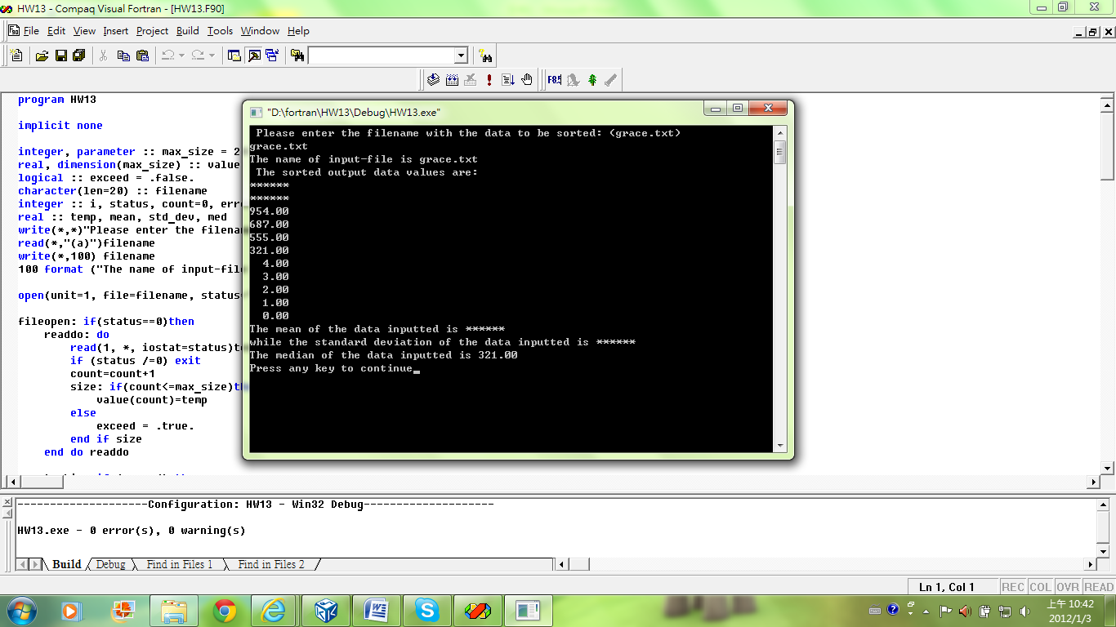**(4)心得:**這次的作業算是坐夜裡頭最難的吧，我問很多人他們都不怎麼會，我只好求助學姐，所以才勉勉強強打出來，這次算是終極的大考驗吧，我想很多人都不太會打，我打出來真的運氣還不錯。