L-Galaxies - DRAFT
User Manual
This Manual describes the use of the L-Galaxies code. This document shows the basics behind the structure and layout of the code as well as probing into the actual processes modeled by it.
Originated by Claire Le Cras, Feb 2010

Contents.

Section name | Page number
File Types | 3
File Structure and Important Files | 4
Compiling | 6
Input and Parameters | 7
Running the code | 9
Code Structure and Basic Overview | 11
Subroutine Description | 13
Data Structure | 16
Useful Resources | 17

File Types.
Within L-Galaxies various file types crop up, the most frequent of which are described below.
Source Files
These files end with .c and contain a collection of statements and declarations in a human-readable form of programming language (i.e. C programming, not binary)
Object Files
These files end with .o and contain compact code of sequences of instructions in a machine code format. This code format can be directly executed by a computer’s CPU without having to be changed. These types of files are typically produced by a compiler as a result of processing source code files.
Header files
These files end with .h and commonly contain subroutines, variables and other identifiers as well as layouts for data structures. These files are normally included at the beginning of most source files.
Text files
These files simply contain basic text as in a standard word processed document. These files are easily identified by the .txt at the end of the filename.
Program Files
These files, ending with .pro, are written in coding and are made to perform specific tasks for programs. Examples of these are files created to plot graphs in programs such as IDL.
Executable files
An example of an executable file is the L-Galaxies code itself. When the executable is run from the command prompt the code it executed and runs until either it had finished or the program is “killed”.

File Structure and Important Files.
All the files pertaining to L-Galaxies are found in the directory called ars. This contains not only the executable of the code but other programs, files and subdirectories containing source codes among many other files.
Within the ars directory the following items appear:
code L-Galaxies README
CoolFunctions Obs_data
createplot.pro output
input PhotTables
The key is as follows:
Directories
Executables
Text Files
Programs (such as for IDL)
Other items may be present depending on where your files originated from but these are the main directories and files. A few of these items are described in more detail below.
code
This is the first subdirectory within the ars directory and contains all the source code (.c) and object files (.o). Most of the files are archived in a .tar file but these can easily be extracted using the following command in the command prompt: tar –xf filename. tar.
Files to take particular note of, within this subdirectory, are allvars.h, Makefile and original_main.c.
The file allvars.h is a header file and contains all the public information of the code. It is within this file that the data structures used within the code are laid out.
The Makefile is simply a document containing a list of steps to be performed to make sure the program works. It contains all of the options that can be selected/deselected before compiling the program, hence changing how the program works and which sections of code it uses when run.
The source file original_main.c contains the main program of the L-Galaxies code. This file calls all the further subroutines needed for the program to run. The process with which the code runs as laid out in this file is looked at in further detail on page 11 onwards.

createplot.pro
This is a program written to run in IDL. It takes the information created by the semi-analytic code, which is stored in an output file, and produces a plot of both the predicted and the observed Bj luminosity functions.
input
This subdirectory contains files that are used as input for the code. The most important of these is the file input.par.
input.par contains all of the parameters that are picked up by the semi-analytic code. These parameters are dicussed in greater detail on pages 7 & 8.
L-Galaxies
This is the executable of the code and is run by entering the following command into the command promt: ./L-Galaxies input/input.par
This runs the code using the input parameters found in the file input.par which as previously mentioned is found within the ars subdirectory input.
output
This subdirectory is where the output files produced by the code are stored.
README
This is simply a text file that contains basic instructions on how to run the code and produce a basic plot of the Bj luminosity function using IDL.

Compiling.
When you compile a program your chosen compiler takes the source files (.c) that you have written and translates them into object files (.o) which contain machine-readable instructions rather than the original coding you produced.
There are three main ways to compile the L-Galaxies code, the main of which is to use the make command. This is simply done by going into the directory containing the Makefile (../ars/code) and typing make into the command prompt. This will compile the source code if needed, if not a message saying the code has already been compiled will appear.
The other two ways to compile the code are variations on make. The first of which is make clean. Again this is simply typed into the command prompt whilst in the directory containing the Makefile. This function will remove the current executable of L-Galaxies, ready for a new one to be produced when make is next called by the command prompt. Similarly the third use of make, make tidy, not only removes the executable of L-Galaxies but all of the object files (.o). Subsequently when make is next run the compiler translates all the source files into object files and then creates a new executable as well.
Both these variations must be followed by the original make command for the code to be recompiled and ready for use.

Input and Parameters.
There are many parameters used within the L-Galaxies code, most of which are found in the file input.par. How many of these parameters are used depends on which options have been preselected, such as whether you decide to include the wind model in the code or which value you select for the various differing recipes of star formation among others.
However there are a few that remain independent of these variable changes and they are described below.
FeedbackEjectionEfficiency
This parameter controls the ability of supernovae to eject gas from the galactic halo. As a guide a value of 1 would correspond to a relatively high supernova ejection efficiency.
AgnEfficiency
This controls the efficiency with which agn (active galactic nuclei) use the rest-mass energy of accreted material to heat the surrounding gas. As a guide a value of 1.e-05 would correspond to a relatively high efficiency.
ReIncorporationFactor
A fraction of gas that has been ejected into the external reservoir around a galaxy is reincorporated back into the central galaxies hot halo. This parameter sets that particular fraction of gas to be reincorporated.
SfrEfficiency
This parameter dictates the efficiency of the star formation rate of the star forming region within a galaxy.
FeedbackReheatingEpsilon
This epsilon factor dictates the amount of reheating caused by feedback from supernovae.
BlackHoleGrowthRate
This, as its name suggests, controls the rate at which black holes grow.
Yield
This parameter gives the faction of star formation mass that is produced as metals.
RecycleFraction
This parameter is similar to that of yield as it gives as fraction of the star formation mass, however this fraction is instantaneously recycled back to the cold gas.

FracZtoHot
This sets the value for the fraction of the total metals produced that go directly to the hot component.
ThreshMajorMerger
This parameter sets the mass ratio that causes a Major Merger once it is exceeded.
EnergySN, EtaSN and Reionization_z0
The above three parameters are used to give the best fit to that in Genedin (2000)
Reinonization_zr?
This is used for the analytic fit found in Kravtsov et al 2004
The remaining parameters listed below are the cosmological constants used and a few unit values. Most are pretty self explanatory.
Omega
This is known as the density parameter and refers to the ratio of the observed density of the Universe to the critical density (the density that would be necessary to stop the expansion of the Universe).
OmegaLambda
This is the ratio between the energy density due to the cosmological constant and the critical density of the universe.
BaryonFrac
The baryon fraction is the amount of hydrogen in the universe today, either in stars and galaxies, or in the hot gas between galaxies.
Hubble_h
This parameter is simply the Hubble constant.
PartMass
This is the mass of particles.
UnitLength_in_cm
UnitMass_in_g
UnitVelocity_in_cm_per_s

Running the code.
To run the code make sure you are in the directory containing the executable (usually ars) and simply type in the following command to the command prompt:
./L-Galaxies input/input.par
It should look something like the following
Once you hit enter a block of text will scroll across the screen. This has been divided up into sections below.
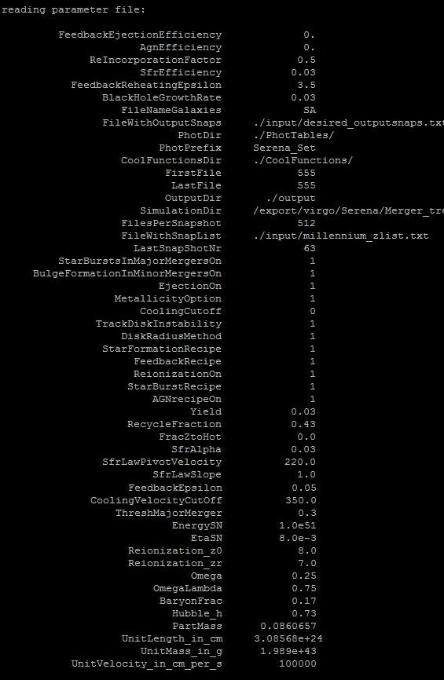
The first section to appear shows that the parameters, as found in the file input.par, have been read into the code and their individual values are displayed.

As you can see many more parameters are printed out on screen than those that were mentioned in the previous section. This is due to the fact that the code reads in all of the parameters in the input.par file regardless of whether they are actually used later on in the code. This is the case for parameters such as FeedbackEpsilon which is only used when FeedbackRecipe = 0, however looking at the above parameters it is shown that FeedbackRecipe = 1 and therefore the parameter FeedbackEpsilon is obsolete.
The next sections printed out by the code are a little more obscure:
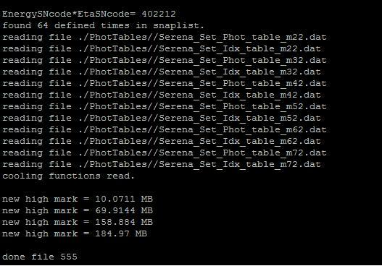

These lines shows that it reads in a group of files found in the PhotTables directory, in ars, as well as the Cooling functions. It also displays four lines showing the new high mark, these show how the code is progressing and how big the output file is at that particular point.
Finally when the code had finished it prints out the words “done file 555”. This shows that the code has finished running and the data produced has been saved in an output file within the ars subdirectory output. The name of this output file is always SA_z0.00_555

Code Structure and Basic Overview.
The L-Galaxies code ultimately works out details and properties about the current galaxy population of the universe. It does this by working backwards to find galaxies within previous dark matter haloes (progenitors) and using the merger trees of these progenitor haloes to construct and evolve the later galaxies.
This process is done by calling various subroutines and following different sequences within the main program. These are laid out in a flow diagram below along with list of the subroutines used and a brief description of what tasks they perform.
The key for the flow diagram is as follows:
Subroutines

Equations that call upon subroutines.

(These are not described in the later section purely for simplicity)

original_main
read_parameter_file
check_options
load_tree_table
load_tree
construct_galaxies
ngal = join_galaxies_of_progenitors
evolve_galaxies
infallingGas = infall_recipe
coolingGas = cooling_recipe
add_infall_to_hot
reincorporate_gas
cool_gas_onto_central
star_formation_and_feedback
deal_with_galaxy_merger
tsudy
join_galaxies_of_progenitors
Rvir = get_virial_radius
Vvir = get_virial_velocity
Mvir = get_virial_mass
DiskRadius = get_disk_radius
MergTime = estimate_merhing_time
init_galaxy
save_galaxy
free_galaxies_and_tree
finalize_galaxy_file
free_tree_table
L-Galaxies
Loops over all trees necessary.

Subroutine Desciption.
original_main
This is the controlling program, it reads in the command line arguments and calls the various subroutines, as listed and described below, within it.
read _parameter_file
This is the first subroutine called within original_main. It tells the program to read the parameter file containing the values for the various different parameters within the semi-analytic model (input.par). This loads the parameter values into the program so that they do not have to be entered individually or manually.
check_options
This checks to see which options are available within the program and which of those have been selected for use. An example of this is WindsOn.
load_tree_table
This loads the table containing the data of possible merger trees that may be used within the model.
load_tree
This loads the specific tree needed from the above table. The code loops back over sections such that it repeats load_tree until all the trees needed for the model have been analyzed.
construct_galaxies
This is the subroutine which constructs galaxies from the merger of dark matter haloes and follows the evolution of the galaxies themselves over time. This subroutine has its own daughter subroutines within in which will be listed and described in a later section.
save_galaxies
This saves the galaxy populations that have been created using the present merger tree.
free_galaxies_and_tree
This subroutine frees up the space within the program by saving and removing the new data created from the original tree, leaving it as it was when it was originally loaded, before looping around and loading the next tree for analysis.
finalize_galaxy_file
Once all the relevant merger trees have been looped over within the program finalize_galaxy_file is called. This subroutine takes all the galaxy populations and data previously found using the program and pulls it all together into one file creating the final output file.

free_tree_table
This routine works in the same way as free_galaxies_and_tree by freeing up the tree table that was originally loaded at the beginning of the program of any additional data created within the program. This leaves the original table ready to be used again by the program at a later time.

Subroutines called within construct_galaxies.
evolve_galaxies
This is the first subroutine called within construct_galaxies. It goes through the process of evolving the galaxies previously constructed by calling on its own set of separate subroutines which will be discussed in detail in a later section.
join_galaxies_of_progenitors
This routine groups the galaxies together such that all galaxies from the present haloes progenitors are together.
init_galaxy
If during the above processes and routines a progenitor is produced without a galaxy in it this routine checks to see whether the halo is a subhalo. If it is not then it places a galaxy within the progenitor.

Subroutines called within evolve_galaxies.
add_infall_to_hot
This is the first subroutine called within evolve_galaxies. It adds the ambient infalling gas to the central galaxies hot component, the central galaxy being the main galaxy within the specified dark matter halo.
reincorporate_gas
This routine reincorporates mass that has been ejected into the external reservoir back into the hot halo of the central galaxy.
cool_gas_onto_central
After being shock heated to the virial temperature gas can cool at later times and accrete into the central regions, condensing and settling onto the central disk where star formation occurs. This subroutine deals with this cooling process.

starformation_and_feedback
This subroutine, like its name suggests, deals with star formation and the feedback produced from instantaneous recycling and later supernovae.
deal_with_galaxy_merger
Within a dark matter halo there can be many galaxies, one central and other lesser satellite galaxies. Over time these galaxies merge together with eachother and the central galaxy itself. This routine works out if a merger will occur between galaxies and works through the process when necessary.
tsudy
Star forming galaxies are known to be rich in dust which has a major effect on their observed properties. This subroutine adds in the dust model to each galaxy if an output snapshot is required by the program.

Data Structure.
Throughout the process of running the code data is created and stored before being passed around for use in another section.
The structure containing all of this data is set out and defined in the file allvars.h, a header file that is included in all the source files of the main code. The basic structure is laid out in the following way:
Structure name [Array] . Variable name
And example of this is
Gal [p] .ColdGas
Using this example and the structure given above you can see that the structure name is Gal, this is the same throughout the entire code. The array name as shown in the example is p, however this changes depending on which galaxy you are currently using/ working on within the code. The end section is the variable name which in the given example is ColdGas, like the array this can change depending on the variable in use.
All the properties found using the code are stored in this way. The structure they are stored in is known as Gal, which contains all the galaxies as individual arrays. These arrays in turn hold all the variables and properties associated with each individual galaxy.
List of structures:
- halo_data: input data structure read in from tree files.

halo_data
int | Descendant | Halo ID of descendant
int | FirstProgenitor | Halo ID of first progenitor (or -1 if no progenitor)
int | NextProgenitor | Halo ID of next halo on same level (or -1 if none)
int | FirstHaloInFOFgroup | Halo ID as described, in case we need to search FOF group
int | NextHaloInFOFgroup | Halo ID as described, in case we need to search FOF group
int | Len | Number of simulation particles in halo [?]
float | M_Mean200 | Mass within spherical overdensity radius of 200 cf mean in units of 10^{10} Msun/h
float | M_Crit200 | Mass within spherical overdensity radius of 200 cf critical in units of 10^{10} Msun/h
float | M_TopHat | Mass within spherical overdensity corresponding to the virial radius for a tophat collapse in units of 10^{10} Msun/h
float | Pos[3] | Centre of mass in grid units (Mpc/h, comoving[?])
float | Vel[3] | Mean halo velocity in km/s [?]
float | VelDisp | Halo velocity dispersion in km/s [3d or 1d?]
float | Vmax | Maximum circular speed of halo in km/s
float | Spin[3] | Spin of the halo in units of Mpc/h km/s [comoving?]
long long | MostBoundID | ID of most bound particle in halo
int | SnapNum | Snap number of halo (i.e. output time)
int | FileNr | Number of file that halo is stored in
int | SubhaloIndex | Index of (sub)halo within file
float | SubHalfMass | Half-mass radius of the halo in Mpc/h [comoving?]

Partially greyed-out variables are saved by the code output but not otherwise used.
Greyed out variables are not currently used at all in the code.

Useful Resources.
Papers:
For a general overview of the semi-analytical approach:
A primer on hierarchical galaxy formation: the semi-analytical approach. C M Baugh
Websites:
For details on Dark Halo Merger Trees:
Virgo – Millennium database
http://www.g-vo.org/MyMillennium2/
Follow the link MPA:HaloTrees and click on see here .
Books:
For using Unix:
Teach Yourself Unix in 24 Hours. Dave Taylor
For using IDL:
An Introduction to Programming with IDL Iterative Data Language. Kenneth P. Bowman
For programming in C:
Practical C Programming. Steve Oualline
Notes:
For basic galaxy formation and an exercise in accessing and running the L-Galaxies code:
Astronomy Research Skills Galaxy Formation Notes. Peter Thomas

