Appendix A
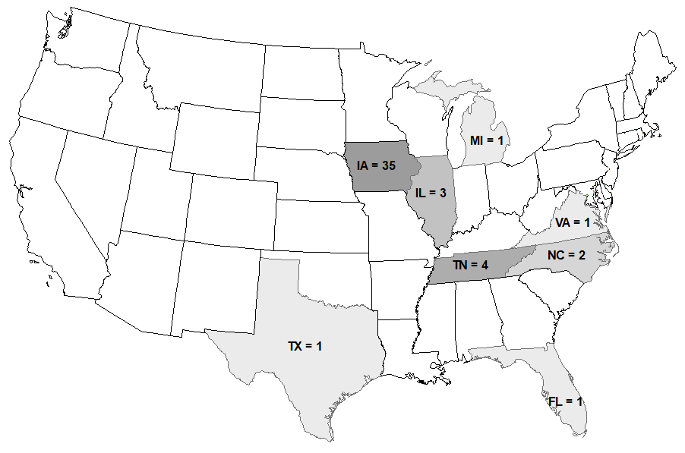
Fig. A.1. Location and number of soil samples contained in the database

Table A.1. Highlights of the database compiled for this research
References | No. of Soils | USCS of each soil type | No. of Data Points | Location | % Sand | % Silt | % Clay
Davidson et al. (1962) | 4 | SP-SM, CH -3 | 12 | Sand collected from east central Iowa, clays collected from north central Florida, Illinois, and Iowa | 0-94-30 | 2-19-12 | 6-100-71
Pietsch and Davidson (1961) | 20 | CH-4, CL-8, OL -4, OH-1, ML-2, SC-1 | 101 | Soils were collected from all over Iowa considering the parent material. | 0-41-15 | 15-81-48 | 13-69-35
Davidson and Bruns (1960) | 3 | SM,ML,CL | 15 | Collected from Iowa ( Typical widely spread material for stabilized road construction) | 0-71-34 | 22-80-44 | 7-39-22
Pietsch and Davidson (1961) | 5 | ML,CH-2, CL-2 | 19 | Collected from Iowa - South eastern, northwestern, deep loess bordering the Missouri river. | 1-37-18 | 15-81-40 | 18-63-42
Remus and Davidson (1961) | 9 | CL-4, CH-3,  ML, SM | 45 | Collected from all over US (IA, TX, MI, IL VA, NC) | 0-45-16 | 18-61-36 | 7-75-45
Whitehurst (1955) | 4 | GC, GM, SC,SM | 28 | Gravels and cherts collected from Benton county and western Tennessee | 15-65-33 | 5-15-9 | 0-15-10
Davidson et al. (1960) | 3 | CL, CH-2 | 21 | Typical subgrade found in southern Iowa | 0-32-15 | 14-61-37 | 39-71-48
Note: e.g. 2-19-12 = Minimum – Maximum – Mean

Table A.2. Highlights of Database for the US soils (Cont.)
References | LL | PI | Organic Content | %  Stabilizer | UCS – 7-day Soaked  (MPa) | UCS – 7-day Un-soaked  (MPa) | UCS – 28-day Soaked  (MPa) | UCS – 28-day Un-soaked  (MPa)
Davidson et al. (1962) | 19-87-53 | 0-53-26 | 0.00-1.50-0.50 | Cement  8-16-12 | 1.10-7.14-3.06 | 1.72-7.72-3.69 | - | -
Pietsch and Davidson (1961) | 21-76-44 | 4-54-21 | 0.00-5.00-1.00 | Lime  0-12-5 | 0 - 2.14 -0.58 | 0.23-2.36-0.90 | 0 - 4.21-0.94 | 0.26-5-1.30
Davidson and Bruns (1960) | 19-42-31 | 3-22-10 | 0.16-0.17-0.17 | Cement:  0-10-5.6 | 0-4.56-1.96 | - | 0-7.22-2.65 | -
Pietsch and Davidson (1961) | 33-76-48 | 5-50-28 | 0.10-0.50-0.25 | Cement:  0-10-5 | 0-3.28-1.37 | - | 0-4.21-1.81 | -
Remus and Davidson (1961) | 36-65-48 | 0-47-24 | 0.02-2.62-0.67 | Lime:  4-12-8 | 0.37-2.33-1.13 | - | 0.41-3.76-1.94 | -
Whitehurst (1955) | 20-32-25 | 0-13-5 | 0.00-0.00-0.00 | Lime :  1-4-2 | 0.08-0.47-0.26 | - | - | -
 |  |  |  | Cement:  1-4-2 | 0.4-2.31-1.21 | - | - | -
Davidson et al. (1960) | 42-76-56 | 22-50-34 | 0.17-0.20-0.19 | Lime  0-14-7 | 0-1.32-0.77 | - | 0-2.28-1.25 | N-
Note: e.g. 2-19-12 = Minimum – Maximum – Mean

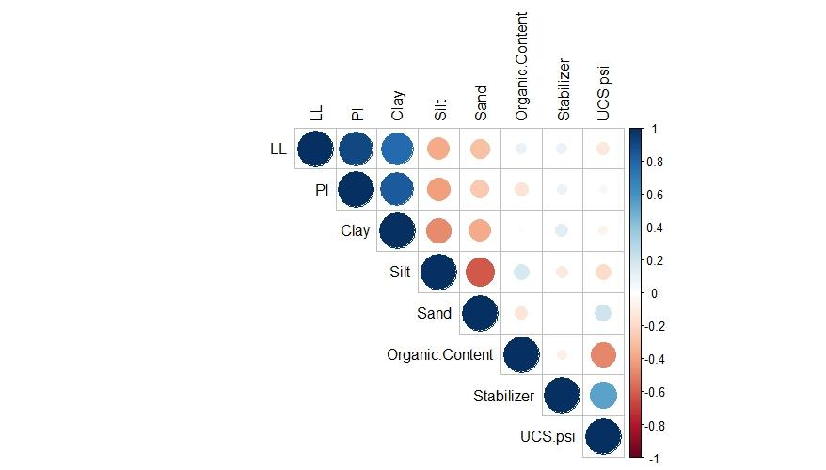
Fig. A.2. Graphical representation of correlation matrix for lime treated soils. The plot was done using “corrplot” – a package in R to display correlogram with upper triangular correlation matrix. The color/opacity/size of the elements in the figure corresponds to individual correlation between two givens soil parameters shown along the top and diagonal.
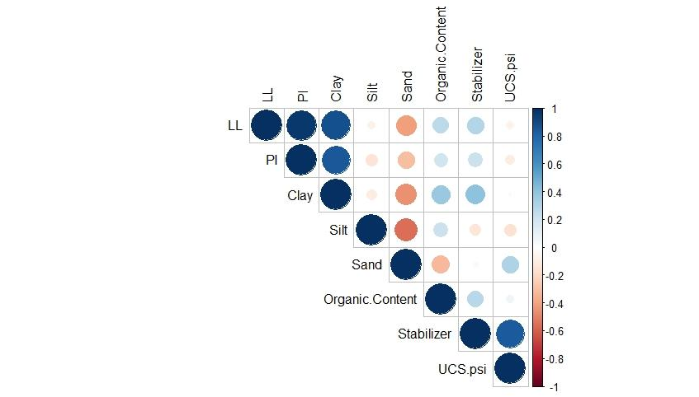
Fig. A.3. Graphical representation of correlation matrix for cement treated soils. The plot was done using “corrplot” – a package in R to display correlogram with upper triangular correlation matrix. The color/opacity/size of the elements in the figure corresponds to individual correlation between two givens soil parameters shown along the top and diagonal.

Table A.3. Summary of parameters used on model development
 |  | Predictors |  |  |  |  |  |  | Response
 |  | LL  (%) | PI  (%) | Clay  (%) | Silt  (%) | Sand  (%) | Organic Content (%) | Stabilizer (%) | UCS  (MPa)
Model for lime treatment | Min | 21 | 0 | 7 | 14 | 0 | 0.00 | 0.00 | 0.00
Model for lime treatment | Q1 | 38 | 17 | 30 | 30 | 1 | 0.00 | 2.00 | 0.27
Model for lime treatment | Median | 44 | 21 | 39 | 39 | 10 | 0.20 | 6.00 | 1.28
Model for lime treatment | Mean | 47 | 23 | 40 | 43 | 15 | 1.06 | 6.20 | 1.25
Model for lime treatment | Q3 | 52 | 30 | 46 | 61 | 30 | 1.62 | 10.00 | 1.89
Model for lime treatment | Max | 76 | 54 | 75 | 81 | 45 | 4.77 | 14.00 | 4.22
Model for cement treatment | Min | 19 | 0 | 0 | 2 | 0 | 0.00 | 0.00 | 0.00
Model for cement treatment | Q1 | 25 | 5 | 15 | 14 | 6 | 0.03 | 2.00 | 0.68
Model for cement treatment | Median | 42 | 22 | 39 | 22 | 24 | 0.16 | 6.00 | 1.63
Model for cement treatment | Mean | 40 | 18 | 34 | 29 | 27 | 0.21 | 5.87 | 1.78
Model for cement treatment | Q3 | 51 | 30 | 48 | 30 | 32 | 0.17 | 10.00 | 2.49
Model for cement treatment | Max | 88 | 53 | 82 | 81 | 94 | 1.5 | 16.00 | 7.14
Where, Q1 = First Quartile, Q3 = Third Quartile

Table A.4: Results for regression models
Model | Algorithm | R² |  | MAE(MPa) |  | RMSE(MPa)
Model | Algorithm | Train | Test | Train | Test | Train | Test
Lime | MLR | 0.54-0.55-0.57 | 0.46-0.50-0.54 | 0.53-0.54-0.55 | 0.55-0.59-0.63 | 0.67-0.69-0.71 | 0.63-0.67-0.71
Lime | GAM-SS | 0.52-0.53-0.55 | 0.43-0.48-0.53 | 0.55-0.56-0.57 | 0.57-0.60-0.64 | 0.69-0.71-0.72 | 0.65-0.71-0.72
Lime | KNN | 0.80-0.81-0.82 | 0.65-0.71-0.78 | 0.30-0.31-0.32 | 0.37-0.41-0.46 | 0.43-0.45-0.47 | 0.47-0.53-0.57
Lime | SVM - Linear | 0.52-0.54-55 | 0.45-0.49-0.52 | 0.53-0.54-0.56 | 0.56-0.59-0.63 | 0.69-0.71-0.72 | 0.64-0.68-0.72
Lime | SVM - Polynomial | 0.52-0.54-55 | 0.45-0.49-0.52 | 0.53-0.54-0.56 | 0.56-0.59-0.63 | 0.69-0.71-0.72 | 0.64-0.68-0.72
Lime | SVM - Radial | 0.83-0.83-0.84 | 0.71-0.75-0.79 | 0.37-0.37-0.38 | 0.41-0.44-0.47 | 0.41-0.42-0.43 | 0.45-0.50-0.53
Cement | MLR | 0.87-0.88-0.89 | 0.75-0.82-0.87 | 0.34-0.36-0.37 | 0.39-0.45-0.53 | 0.47-0.50-0.53 | 0.44-0.53-0.61
Cement | GAM-SS | 0.86-0.87-0.88 | 0.66-0.78-0.85 | 0.37-0.39-0.40 | 0.43-0.50-0.59 | 0.51-0.53-0.54 | 0.45-0.53-0.61
Cement | KNN | 0.76-0.78-0.80 | 0.50-0.59-0.67 | 0.45-0.47-0.49 | 0.57-0.67-0.79 | 0.62-0.68-0.71 | 0.65-0.78-0.90
Cement | SVM -Linear | 0.77-0.79-0.81 | 0.69-0.75-0.80 | 0.48-0.53-0.56 | 0.51-0.59-0.68 | 0.64-0.66-0.68 | 0.54-0.62-0.74
Cement | SVM - Polynomial | 0.71-0.74-0.77 | 0.63-0.70-0.80 | 0.56-0.59-0.63 | 0.58-0.64-0.71 | 0.68-0.73-0.78 | 0.62-0.70-0.78
Cement | SVM - Radial | 0.79-0.81-0.83 | 0.67-0.75-0.82 | 0.45-0.48-0.53 | 0.48-0.54-0.64 | 0.61-0.63-0.65 | 0.53-0.63-0.70
Note : The values in the table are Q1-Q2-Q3

Table A.5. Results for classification models for lime treatment
 | Algorithm | Correct Rate |  | Cohen’s Kappa |  | AUC |  | TPR |  | FPR
 | Algorithm | Train | Test | Train | Test | Train | Test | Train | Test | Train | Test
Lime (Cutoff)= 1.03 MPa (150psi) | LR | 0.95-0.95-0.95 | 0.85-0.90-0.95 | 0.65-0.67-0.70 | 0.55-0.62-0.70 | 0.97-0.97-0.97 | 0.95-0.96-0.97 | 0.95-0.95-0.95 | 0.85-0.90-0.95 | 0.07-0.08-0.09 | 0.05-0.11-0.15
Lime (Cutoff)= 1.03 MPa (150psi) | LDA | 0.90-0.91-0.91 | 0.85-0.88-0.93 | 0.61-0.62-0.65 | 0.52-0.58-0.68 | 0.98-0.98-0.98 | 0.94-0.96-0.97 | 0.88-0.90-0.91 | 0.82-0.86-0.93 | 0.15-0.17-0.20 | 0.15-0.20-0.26
Lime (Cutoff)= 1.03 MPa (150psi) | QDA | 0.90-0.91-0.92 | 0.80-0.85-0.88 | 0.62-0.63-0.65 | 0.45-0.55-0.60 | 0.95-0.96-0.97 | 0.90-0.92-0.95 | 0.88-0.90-0.92 | 0.80-0.87-0.92 | 0.07-0.09-0.10 | 0.08-0.15-0.22
Lime (Cutoff)= 1.03 MPa (150psi) | KNN | 0.95-0.95-0.95 | 0.85-0.90-0.93 | 0.70-0.71-0.71 | 0.54-0.62-0.70 | - | - | 0.94-0.95-0.96 | 0.86-0.91-0.95 | 0.04-0.05-0.06 | 0.08-0.10-0.17
Lime (Cutoff)= 1.03 MPa (150psi) | SVM - Lin | 0.90-0.91-0.91 | 0.86-0.89-0.91 | 0.59-0.60-0.61 | 0.49-0.55-0.61 | 0.97-0.97-0.97 | 0.95-0.96-0.97 | 0.93-0.94-0.95 | 0.86-0.90-0.95 | 0.09-0.10-0.11 | 0.06-0.13-0.17
Lime (Cutoff)= 1.03 MPa (150psi) | SVM - Poly | 0.90-0.91-0.91 | 0.86-0.89-0.91 | 0.59-0.60-0.61 | 0.49-0.55-0.61 | 0.97-0.97-0.97 | 0.95-0.96-0.97 | 0.93-0.94-0.95 | 0.86-0.90-0.95 | 0.09-0.10-0.11 | 0.06-0.13-0.17
Lime (Cutoff)= 1.03 MPa (150psi) | SVM - Rad | 0.95-0.95-0.95 | 0.88-0.92-0.95 | 0.65-0.66-0.67 | 0.54-0.61-0.67 | 0.99-0.99-0.99 | 0.98-0.99-0.99 | 0.96-0.97-0.97 | 0.90-0.94-1.00 | 0.05-0.06-0.09 | 0.05-0.10-0.15
Note : The values in the table are Q1-Q2-Q3

Table A.6: Results for classification models for cement treatment
 | Algorithm | Correct Rate |  | Cohen’s Kappa |  | AUC |  | TPR |  | FPR
 | Algorithm | Train | Test | Train | Test | Train | Test | Train | Test | Train | Test
Cement (cutoff) = 2.06 MPa (300 psi) | LR | Unstable parameters
Cement (cutoff) = 2.06 MPa (300 psi) | LDA | 0.90-0.92-0.95 | 0.75-0.80-0.85 | 0.75-0.8-0.88 | 0.45-0.52-0.60 | 0.98-0.99-1.00 | 0.85-0.90-0.95 | 0.90-0.94-1 | 0.70-0.77-0.85 | 0.00-0.05-0.10 | 0.11-0.17-0.25
Cement (cutoff) = 2.06 MPa (300 psi) | QD | Unstable parameters
Cement (cutoff) = 2.06 MPa (300 psi) | KNN | 0.85-0.87-0.90 | 0.65-0.71-0.76 | 0.55-0.62-0.71 | 0.20-0.30-0.41 | - | - | 0.70-0.80-0.86 | 0.38-0.50-0.70 | 0.05-0.06-0.12 | 0.10-0.15-0.25
Cement (cutoff) = 2.06 MPa (300 psi) | SVM – Lin | 0.90-0.93-0.95 | 0.78-0.82-0.86 | 0.70-0.78-0.86 | 0.42-0.52-0.62 | 0.00-0.50-1.00 | 0.10-0.60-0.95 | 0.83-0.90-0.95 | 0.70-0.77-0.82 | 0.00-0.04-0.05 | 0.08-0.14-0.20
Cement (cutoff) = 2.06 MPa (300 psi) | SVM - Poly | 0.90-0.93-0.95 | 0.78-0.82-0.86 | 0.70-0.78-0.86 | 0.42-0.52-0.62 | 0.00-0.50-1.00 | 0.10-0.60-0.95 | 0.83-0.90-1.00 | 0.68-0.77-0.82 | 0.00-0.04-0.05 | 0.09-0.14-0.20
Cement (cutoff) = 2.06 MPa (300 psi) | SVM - Rad | 0.94-0.95-0.96 | 0.78-0.82-0.85 | 0.74-0.80-0.88 | 0.44-0.50-0.60 | 0.00-0.99-1.00 | 0.1-0.88-0.92 | 0.85-0.90-1.00 | 0.68-0.75-0.86 | 0.00-0.00-0.05 | 0.10-0.12-0.18
Note : The values in the table are Q1-Q2-Q3

Appendix B
Multiple Linear Regression (MLR)
MLR predicts a quantitative response (Y) based on linear combinations of predictors (X) as shown in Eq.(B-1) The regression coefficients ($β$), which relates the response with predictors, are calculated by minimizing the sum-of-squared errors (SSE) which is given by Eq.(B-2)
 | $$Y_{i}=β_{0}{+β}_{1}X_{i1}+…{+β}_{p}X_{ip}+ε_{i}$$ | (B-1)
where, Y = quantitative response variable;$X_{1},X_{2},…,X_{p}$ = predictors;$β_{1}$,$β_{2}$,….,$β_{p}$ = regression coefficients; $β_{0}$ is the intercept, $ε$ = independent error term
 | $$SSE=\sum_{i=1}^{n}{{\left(y_{i}-\hat{y_{i}}\right)}^{2}}$$ | (B-2)
where, $y_{i}$ the actual value and $\hat{y_{i}}$ is the model prediction
Significant advantage of MLR is its interpretability. The coefficients $β$ represents a change in the response with respect to a unit change in that specific predictor, holding all others constant. In addition to that, the statistical significance of predictors can be computed, without complex simulations, which provides good inferential insight of the model. Limitation of this model is evident when the relationship between predictors and the response are not linear.
Logistic Regression (LR)
The output of LR model is the probability of association of a given sample to a particular categorical response. For instance, the probability of Y being 1 given a set of parameters X is given by Eq.(B-3) The coefficients $β$ are calculated by maximum likelihood i.e., choosing $β$ in such a way that the value of $p(X)$ in Eq.(B-3) is close to 1 for those samples belonging to category 1 and is close to 0 for those samples that do not belong to category 1. Such output is used to classify a given sample into binary classes.
 | $$p(X)=Pr⁡(Y=1|X)=\frac{e^{β_{0}{+β}_{1}X_{1}+…{+β}_{p}X_{p}}}{1+e^{β_{0}{+β}_{1}X_{1}+…{+β}_{p}X_{p}}}$$ | (B-3)
where, Pr ($Y=1|X$ ) = probability that Y=1 (1/0 response) given X;$X_{1},X_{2},…,X_{p}$ = predictors;$β_{1}$,$β_{2}$,….,$β_{p}$ = regression coefficients; $β_{0}$ is the intercept
LR is a powerful model due to its simple formulation and good inferential capabilities. Although the equation for $p(X)$ is non-linear, the decision boundary produced by this method is linear.
Discriminant Analysis (DA)
Discriminant analysis is a classification technique which is stable for well-separated classes in comparison to LR. Bayes theorem is used in the discriminant analysis for calculation of the posterior probability of a given observation “x” for each class “k”. This classifier is mathematically represented by Eq. (B-4). For a given observation “x”, the probability of it belonging to each of the “k” classes is calculated using Eq.(B-4). The observation is assigned to the class which has the highest probability.
 | $$\operatorname{Pr}\left(Y=k | X=x\right)=\frac{π_{k}f_{k}(x)}{\sum_{l=1}^{k}{π_{l}f_{l}(x)}}$$ | (B-4)
where, $\operatorname{Pr}\left(Y=k | X=x\right)$ = probability of x belonging to class k – posterior probability ; $f_{k}(x)$ = probability distribution function evaluated at x for class k;$π_{k}$ = class membership probabilities – prior probability
In case of linear discriminant analysis (LDA) for more than one predictor and k classes, $f_{k}(x)$ is assumed to have multivariate normal distribution with class specific mean vector ($μ_{k})$ and common covariance matrix ($∑^{-1}$). This formulation results in a linear decision boundary. In case of quadratic discriminant analysis (QDA), $f_{k}(x)$ is also assumed to have multivariate normal distribution with a class specific mean vector ($μ_{k})$ and a class specific covariance matrix (${∑^{-1}}_{k}$). The resulting decision boundary in case of QDA is quadratic. The simplified formulas for calculating the posterior class probability for LDA and QDA are given by Eq. (B-5)and Eq. (B-6) respectively.
 | $$δ_{k}\left(k\right)= X^{T}∑^{-1}μ_{k}-\frac{1}{2}{μ_{k}}^{T}∑^{-1}μ_{k}+\log{π_{k}}$$ | (B-5)
 | $$δ_{k}\left(k\right)=-\frac{1}{2}X^{T}{∑^{-1}}_{k}X+ X^{T}{∑^{-1}}_{k}μ_{k}-\frac{1}{2}{μ_{k}}^{T}{∑^{-1}}_{k}μ_{k}+\log{π_{k}}$$ | (B-6)
Generalized Additive Model (GAM)
GAM provides an excellent framework for linear models to extend their capability in the non-linear realm (Hastie 2017; Hastie and Tibshirani 1987; James et al. 2013). The model is set in such a way that each predictor is modeled by its non-linear function and maintains additivity among predictors. Formulation for GAM is given by Eq.(B-7).
 | $$Y_{i}=β_{0}{+f}_{1}(x_{i1}){+f}_{2}(x_{i2})+…{+f}_{p}{(x}_{ip})+ε_{i}$$ | (B-7)
where, $Y_{i}$ = quantitative response; $f_{1}{(x_{i1}),f}_{2}(x_{i2}),{…,f}_{p}{(x}_{ip})$ = non-linear function for individual predictor; $β_{0}$ is the intercept, $ε$ = independent error term
The non-linear functions can be modeled using polynomials, splines, local regression, etc. Moreover, the additive nature of the GAM retains its inference capability. In this study natural splines (NS) and smoothing splines (SS) were used.
K-Nearest Neighbor (KNN)
Unlike the other methods discussed – where an equation is developed from data, KNN just utilizes the sample’s location in feature space of entire training data to predict the response. This is known as instance based learning or lazy learning. Prediction is done by using only the “K” number of nearest training example to the given sample. “K” is a tuning parameter which can be estimated using various model selection techniques. The measurement scale difference between different predictors greatly affects the distance calculation. Therefore, each predictors are generally scaled and centered prior to feeding the data into the model. The quantitative response is the mean or median of the K training example as given by Eq.(B-8). For categorical response, the probability of “K” nearest training data that belong to each class is calculated as per Eq.(B-9). The sample is assigned to the class with the highest probability.
 | $$Y(for a given X)=\frac{1}{K}\sum_{iϵN_{0}}{y_{i}}$$ | (B-8)
where, K = number of nearest points to ‘X’ that is to be considered; $N_{0}$ = nearest ‘K’ number of points to observation ‘X’; $y_{i}$ = response of each training data
 | $$\operatorname{Pr}\left(Y=j | X=x\right)=\frac{1}{K}\sum_{iϵN_{0}}{I(y_{i}=j)}$$ | (B-9)
where, $\operatorname{Pr}\left(Y=j | X=x\right)$ = probability of x belonging to class j; K = number of nearest points to ‘x’ that is to be considered; $N_{0}$ = nearest ‘K’ number of points to observation ‘x’; $y_{i}$ = response (the class where x_{i}, the i-th nearest point of x belongs to); I( ) – indicator function.
KNN is non-parametric approach as doesn’t make assumptions on the distribution of predictors and decision boundary. Classification using this method is effective when the Bayes’ decision boundary is highly non-linear (James et al. 2013).
Support Vector Machines (SVM)
SVMs are popular and are considered as one of the best out-of-box machine learning algorithms (James et al. 2013; Kuhn and Johnson 2013; Tinoco et al. 2014). SVM are based on generalization of linear maximum margin classifier i.e. creating a linear maximum margin classifier in high-dimensional feature space – formed by projecting the input data using kernels (Cortes and Vapnik 1995; Kuhn and Johnson 2013). Maximum margin classifiers are based on separating hyperplanes- a flat affine surface of p-1 dimension, which perfectly separates the data into two classes. The distance between the hyperplane and nearest training data is called margin and the intent is to select such a hyperplane that maximizes the margin. Formulation for currently used SVMs are based on almost separating hyperplane, also called soft margin, which allows misclassification in the training phase. Provision of soft margin greatly increases the robustness of the classifier. The sign of the result, obtained by substituting the value of predictors in the hyperplane equation, is used to separate the class. The absolute value of such result reflects the confidence of classification. A standard representation of such hyperplane equation, as referred to as classification decision function, is given by Eq.(B-10). The coefficients $α_{i}$are obtained by maximizing the width of the margin under inequality constrains. These constrains control the tradeoff between decision function’s complexity and amount of misclassification. The shape of the hyperplane is defined by a small subset of training data known as support vectors. Support vector are those training examples which either a) lie of the margin, b) lie on the wrong side of the margin, or c) lie on the wrong side of the hyperplane. The classifier is not sensitive to extreme training data since the decision boundary is established by only support vectors.
 | $$f\left(x\right)= β_{0}+ \sum_{i ∈S}{α_{i}y_{i}K(x,x_{i})}$$ |  | (B-10)
 | For polynomial kernel  $$K\left(x_{i},x_{i}^{'}\right)={\left(1+\sum_{j=1}^{p}{x_{ij}{x^{'}}_{ij}}\right)}^{d}$$ | For radial kernel  $$K\left(x_{i},x_{i}^{'}\right)=e^{\left(-γ\sum_{j=1}^{p}{{\left(x_{ij}{-x^{'}}_{ij}\right)}^{2}}\right)}$$
where, f(x) = signed distance from hyperplane ; $K(x,x_{i})$ = kernel (complexity of hyperplane equation) ;$α_{i}$ = parameter associated with data point ‘i’; $S$ = support vectors., d = degree of polynomial; $γ$ = positive constant
Extension of SVM to regression setting has also become popular. The concept which was initiated by Smola (1996) and Drucker et al. (1997) . In a regression setting, the input vectors are mapped to high dimensional space using kernels after that a linear model fitting is done (Cherkassky and Ma 2004; Vapnik 1998, 2013). The coefficients of regression is estimated by minimizing the $ϵ$ – insensitive loss function and models complexity.

Appendix C
Database collected

