# Characteristics of places selected for every-day restoration (results descriptive part)

## Sample description

A table about the housing situation of N1, N2, N3, whole sample:

* Single house; apartment; ev. owner/tenant, apartment floor

RESTYPE 1 2 3

01_House 47.5% 31.2% 21.3%

02_GFApart 43.7% 36.6% 19.7% # ground floor

03_AGApart 24.9% 35.6% 39.6%

RESOWN 1 2 3

Owner/co-owner 47.6% 32.8% 19.6%

Rent 32.1% 30.5% 37.4%

APTFLOOR 1 2 3

1 34.4% 34.4% 31.2%

2 22.2% 36.1% 41.7%

3 17.1% 37.1% 45.7%

4 18.2% 36.4% 45.5%

5 0.0% 20.0% 80.0%

6 0.0% 0.0% 100.0%

7 0.0% 100.0% 0.0%

* Balcony/terrace; garden

RESTERR 1 2 3

No 32.2% 28.4% 39.3%

Yes 45.5% 32.5% 22.0%

RESGARD 1 2 3

No 24.5% 36.7% 38.8%

Yes 46.7% 31.3% 22.0%

* Noise level (mean + SD or median?)
* NDVI (mean + SD or median)

DISTKM HM_NDVI HM_NOISE JNYTIME NDVI250 NOISE250

----------------- --------- --------- ---------- --------- --------- ----------

Mean 3.53 0.53 48.24 19.94 0.64 41.27

Std.Dev 5.34 0.11 9.98 23.29 0.20 9.12

Min 0.00 0.11 30.00 0.00 -0.42 30.00

Q1 0.58 0.46 41.00 5.00 0.55 30.90

Median 1.38 0.53 46.40 12.00 0.69 41.34

Q3 3.90 0.60 54.45 25.00 0.80 48.63

Max 33.41 0.83 74.40 200.00 0.88 66.52

MAD 1.65 0.10 9.19 11.86 0.17 12.46

IQR 3.32 0.14 13.42 20.00 0.25 17.72

CV 1.51 0.21 0.21 1.17 0.31 0.22

Skewness 2.76 -0.42 0.49 3.08 -1.37 0.23

SE.Skewness 0.06 0.06 0.06 0.07 0.06 0.06

Kurtosis 8.64 0.50 -0.56 13.59 2.17 -1.06

N.Valid 1464.00 1464.00 1464.00 1380.00 1464.00 1464.00

Pct.Valid 100.00 100.00 100.00 94.26 100.00 100.00

* Perceived availability of restorative places in neighbourhood (ranking 1–5)

OSRELAX 1 2 3

1 60.0% 0.0% 40.0%

2 16.7% 50.0% 33.3%

3 35.1% 29.7% 35.1%

4 33.2% 37.6% 29.2%

5 47.5% 30.6% 21.9%

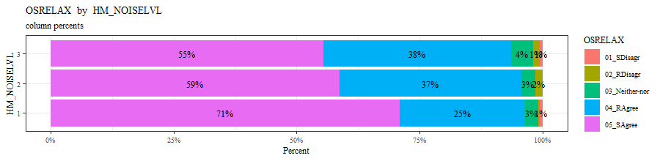

## Landscape description of RL

* Bar-charts / Histograms of NDVI and noise level for N1, N2, N3 (from manuscript)



Fig. xxx. Distribution of NDVI and noise at home and restorative locations by noise group

* Pie charts of land cover types for N1, N2, N3 (3 charts)

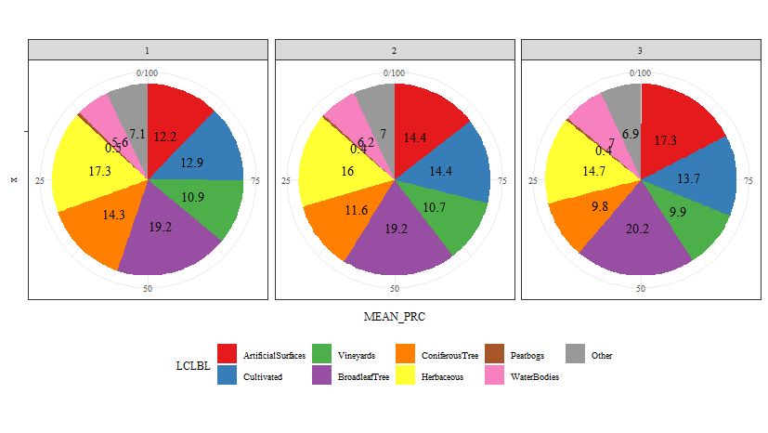

**LCLBL N1 N2 N3**

1 ArtificialSurfaces 12.2 14.4 17.3

2 Cultivated 12.9 14.4 13.7

3 Vineyards 10.9 10.7 9.9

4 BroadleafTree 19.2 19.2 20.2

5 ConiferousTree 14.3 11.6 9.8

6 Herbaceous 17.3 16 14.7

7 Peatbogs 0.5 0.4 0.4

8 WaterBodies 5.6 6.2 7

9 Other 7.1 7 6.9

## Soundscape description of RL

variable lbl

1 LDOMAUD1 Nature sounds (birds, wind, leaves and water noise)

2 LDOMAUD2 Human sounds (voices, children playing)

3 LDOMAUD3 Traffic sounds (cars, trains, airplanes)

4 LDOMAUD4 Other technical noises (construction sites, forestry work, drones, music)

5 LSOUNDS1 Pleasant

6 LSOUNDS2 Chaotic

7 LSOUNDS3 Vibrant

8 LSOUNDS4 Uneventful

9 LSOUNDS5 Tranquil

10 LSOUNDS6 Bothering

11 LSOUNDS7 Eventful

12 LSOUNDS8 Monotone

13 LSOUNDS9 Loud

14 LSANNOY1 RoadTraffic

15 LSANNOY2 PublicTransport

16 LSANNOY3 Train

17 LSANNOY4 Plane

18 LSANNOY5 Freetime

19 LSANNOY6 Music of others

20 LSANNOY7 Works

* Spider-diagrams of dominating sounds for N1, N2, N3 (0–5): LDOMAUD 1-4

[1] "Variables: LDOMAUD"

LDOMAUD1 LDOMAUD2 LDOMAUD3 LDOMAUD4

Min 1 1 1 1

Max 5 5 5 5

N1 4 2 1 1

N2 4 1 1 1

N3 4 2 1 1

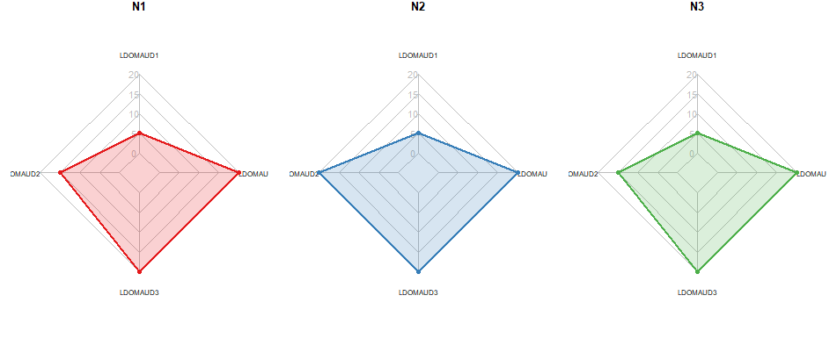

* Spider-diagrams of ISO-soundscape attributes for N1, N2, N3 (1–5): LSOUNDS 1-9

[1] "Variables: LSOUNDS"

LSOUNDS1 LSOUNDS2 LSOUNDS3 LSOUNDS4 LSOUNDS5 LSOUNDS6 LSOUNDS7 LSOUNDS8 LSOUNDS9

Min 1 1 1 1 1 1 1 1 1

Max 5 5 5 5 5 5 5 5 5

N1 5 1 4 3 4 1 2 2 1

N2 5 1 4 3 4 1 3 2 1

N3 4 1 4 3 4 1 3 2 2

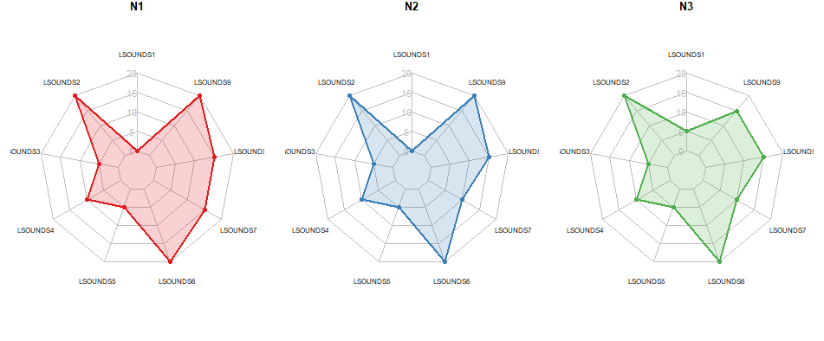

* Spider-diagrams of noise annoyance for N1, N2, N3 (0–10): LSANNOY 1-7

[1] "Variables: LSANNOY"

LSANNOY1 LSANNOY2 LSANNOY3 LSANNOY4 LSANNOY5 LSANNOY6 LSANNOY7

Min 1 1 1 1 1 1 1

Max 5 5 5 5 5 5 5

N1 2 1 1 2 1 1 1

N2 2 1 1 2 1 1 1

N3 2 1 1 2 1 2 1

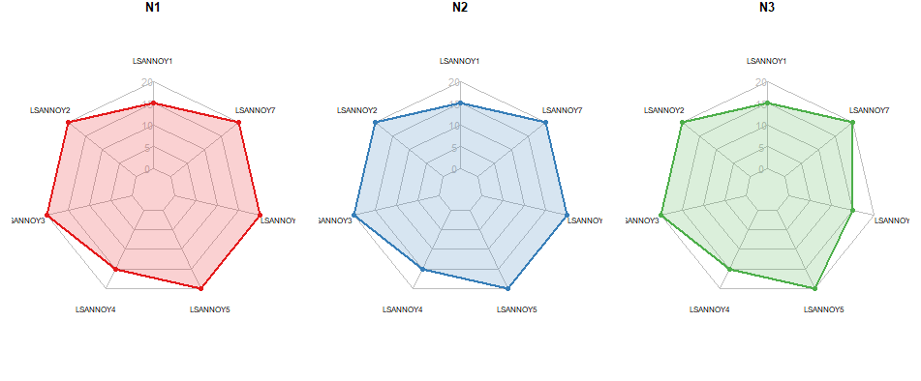

## Perceived restorativeness of RL

* Bar-charts FEELNAT for N1, N2, N3 (from manus but with 7-point scale from questionnaire)

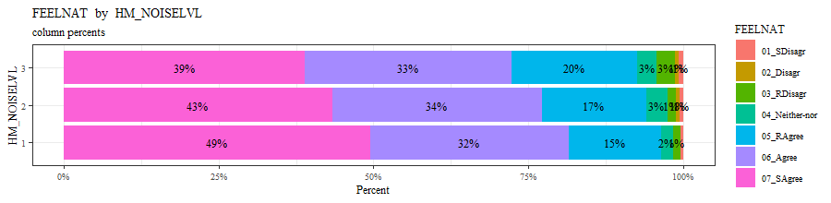

* Bar-charts SENS for N1, N2, N3

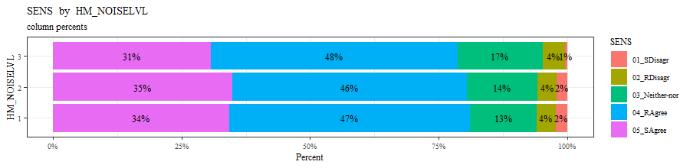

* Bar-charts LNOISE for N1, N2, N3 (from manus)

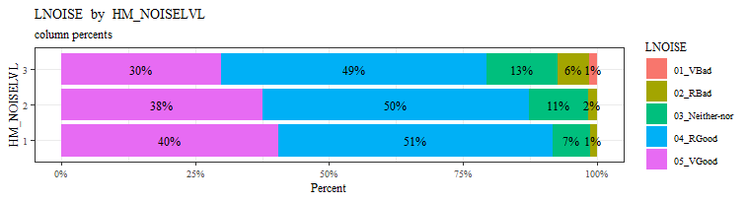

* Spider-diagrams of PRS-factors for N1, N2, N3

PRS_FA PRS_BA PRS_EC PRS_ES

Min 1 1 1 1

Max 7 7 7 7

N1 5 5 4 5

N2 5 5 4 5

N3 5 5 4 5

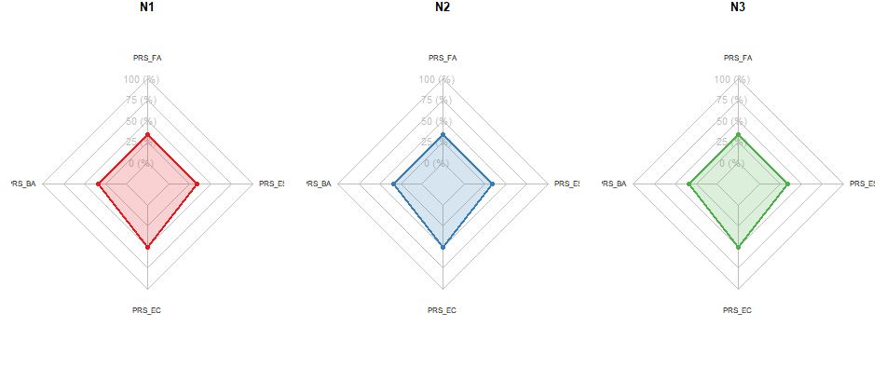

## Frequency of visits and activities (not so important for our research questions; tables and figures ev. in supplementary material)

* Table on activities, NDVI, noise level (from manus)

|  |  |  |  |  |  |  |  |  |  |  |  |  |
| --- | --- | --- | --- | --- | --- | --- | --- | --- | --- | --- | --- | --- |
| **Activity** | **Count** | **Frequency of visits (most common answer)** | **Frequency of visits (median)** | **Frequency of visits (q75)** | **Noise mean**  **(Lday in dBA)** | **Greenness mean** | **Distance mean**  **(km)** | **Travel time mean**  **(minutes)** | **Noise median**  **(Lday in dBA)** | **Greenness median** | **Distance median**  **(km)** | **Travel time median**  **(minutes)** |
| Walk | 531 | 2-3xMonth | 1xWeek | More1xWeek | 40.8 | 0.68 | 3.0 | 19.1 | 41.0 | 0.73 | 1.2 | 10.0 |
| To_Be_There | 135 | Less1xMonth | 2-3xMonth | 1xWeek | 41.8 | 0.59 | 4.6 | 24.1 | 42.3 | 0.65 | 1.6 | 15.0 |
| Meet_people | 100 | Less1xMonth | 2-3xMonth | More1xWeek | 42.7 | 0.59 | 4.9 | 19.0 | 42.4 | 0.61 | 1.9 | 15.0 |
| Do_sports_jog | 301 | Less1xMonth | 1xWeek | More1xWeek | 38.7 | 0.65 | 4.3 | 27.9 | 36.7 | 0.72 | 2.8 | 20.0 |
| Play_sports_facility | 101 | 1xWeek | More1xWeek | More1xWeek | 42.7 | 0.59 | 3.3 | 11.2 | 44.8 | 0.64 | 1.2 | 6.0 |
| Gardening | 296 | More1xWeek | More1xWeek | 7xWeek | 43.4 | 0.63 | 2.9 | 13.8 | 44.4 | 0.66 | 0.7 | 8.0 |

* Bar-charts dominant land-cover and frequency (from manus)

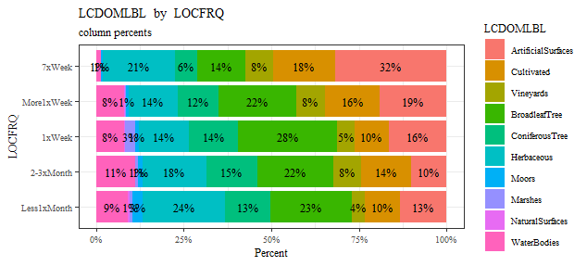

* Table on frequency, distance, noise level for N1, N2, N3)

|  |  |  |  |  |  |  |  |  |  |  |  |  |
| --- | --- | --- | --- | --- | --- | --- | --- | --- | --- | --- | --- | --- |
| **Noise group** | **Count** | **Frequency of visits (most common answer)** | **Frequency of visits (median)** | **Frequency of visits (q75)** | **Noise mean**  **(Lday in dBA)** | **Greenness mean** | **Distance mean**  **(km)** | **Travel time mean**  **(minutes)** | **Noise median**  **(Lday in dBA)** | **Greenness median** | **Distance median**  **(km)** | **Travel time median**  **(minutes)** |
| 1 | 642 | Less1xMonth | 1xWeek | More1xWeek | 40 | 0.662 | 3.4 | 20 | 39 | 0.717 | 1.3 | 15 |
| 2 | 468 | 2-3xMonth | 1xWeek | More1xWeek | 42 | 0.641 | 3.8 | 20 | 42 | 0.675 | 1.5 | 10 |
| 3 | 354 | 2-3xMonth | 1xWeek | More1xWeek | 44 | 0.619 | 3.5 | 19 | 46 | 0.649 | 1.4 | 10 |

# Predicting restorativeness of places selected for every-day restoration (results modelling part)

## PCA analysis

### N1

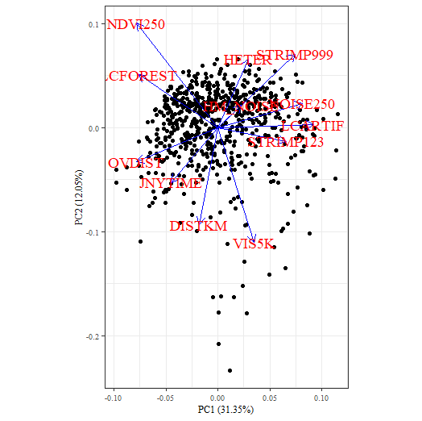

### N2

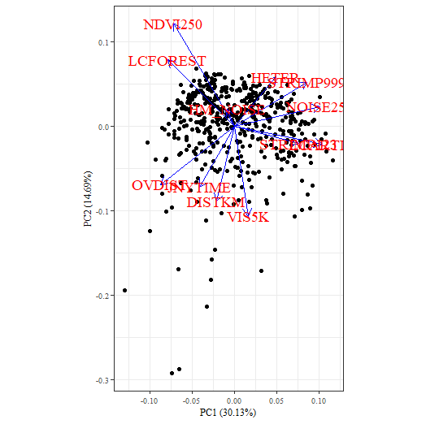

### N3

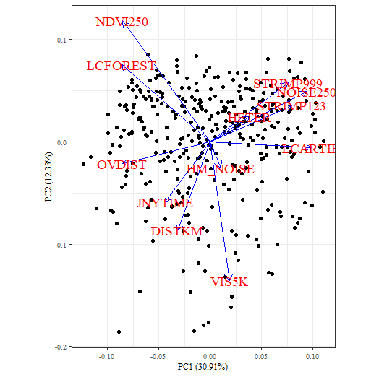

## Multiple regression for FEELNAT and LNOISE

* SENS = Y(LN) +x*NDVI + y*noiselvl + z*LCartif + p*???
* FEELNAT = Y(FN) + a*NDVI + b*noiselvl + c*LCartif + d*???
* LNOISE = Y(LN) +x*NDVI + y*noiselvl + z*LCartif + p*???

### N1

mv r2 p p_stars

1 PRS 0.021 0.413 -

2 PRS_FA 0.040 0.021 *

3 PRS_BA 0.025 0.243 -

4 PRS_EC 0.021 0.464 -

5 PRS_ES 0.042 0.028 *

6 ROS 0.045 0.011 *

7 SENS 0.046 0.006 **

8 FEELNAT 0.112 <0.001 ***

9 LNOISE 0.151 <0.001 ***

------- SENS -------

Call:

lm(formula = ff, data = data)

Residuals:

Min 1Q Median 3Q Max

-3.2446 -0.2725 -0.0310 0.7641 1.3919

Coefficients:

Estimate Std. Error t value Pr(>|t|)

(Intercept) 4.37686527 0.47227273 9.268 < 0.0000000000000002 ***

NDVI250 0.37005652 0.30208646 1.225 0.22106

NOISE250 -0.01831323 0.00608863 -3.008 0.00274 **

HM_NOISE 0.00157455 0.00939963 0.168 0.86702

DISTKM -0.00122018 0.00748065 -0.163 0.87049

JNYTIME -0.00116501 0.00185489 -0.628 0.53020

LCARTIF -0.12563756 0.36303615 -0.346 0.72941

LCFOREST -0.00258825 0.16767550 -0.015 0.98769

HETER 0.16971828 0.10694073 1.587 0.11304

VIS5K -0.00007571 0.00362948 -0.021 0.98336

OVDIST -0.00003199 0.00008512 -0.376 0.70722

STRIMP123 0.00010237 0.00020390 0.502 0.61580

STRIMP999 -0.00002371 0.00005063 -0.468 0.63969

---

Signif. codes: 0 ‘***’ 0.001 ‘**’ 0.01 ‘*’ 0.05 ‘.’ 0.1 ‘ ’ 1

Residual standard error: 0.8955 on 589 degrees of freedom

(40 observations deleted due to missingness)

Multiple R-squared: 0.04583, Adjusted R-squared: 0.02639

F-statistic: 2.357 on 12 and 589 DF, p-value: 0.005794

VIF

LCARTIF 3.571859

NDVI250 2.660818

STRIMP999 2.636170

LCFOREST 2.267916

NOISE250 2.045859

STRIMP123 1.853476

OVDIST 1.606950

VIS5K 1.426783

HETER 1.380261

JNYTIME 1.304454

DISTKM 1.168932

HM_NOISE 1.045235

------- FEELNAT -------

Call:

lm(formula = ff, data = data)

Residuals:

Min 1Q Median 3Q Max

-5.1544 -0.4561 0.3212 0.6189 1.5076

Coefficients:

Estimate Std. Error t value Pr(>|t|)

(Intercept) 6.39394816 0.47952948 13.334 < 0.0000000000000002 ***

NDVI250 0.91890775 0.30951318 2.969 0.00311 **

NOISE250 -0.00776653 0.00615277 -1.262 0.20735

HM_NOISE -0.00963159 0.00953649 -1.010 0.31293

DISTKM -0.01011429 0.00756202 -1.338 0.18158

JNYTIME -0.00113525 0.00187389 -0.606 0.54487

LCARTIF -0.01898017 0.36665364 -0.052 0.95873

LCFOREST 0.08491018 0.16978606 0.500 0.61719

HETER 0.14729784 0.10810334 1.363 0.17354

VIS5K 0.00026866 0.00369409 0.073 0.94205

OVDIST 0.00004994 0.00008604 0.580 0.56185

STRIMP123 -0.00003112 0.00020710 -0.150 0.88062

STRIMP999 -0.00011080 0.00005108 -2.169 0.03047 *

---

Signif. codes: 0 ‘***’ 0.001 ‘**’ 0.01 ‘*’ 0.05 ‘.’ 0.1 ‘ ’ 1

Residual standard error: 0.903 on 585 degrees of freedom

(44 observations deleted due to missingness)

Multiple R-squared: 0.1123, Adjusted R-squared: 0.09413

F-statistic: 6.169 on 12 and 585 DF, p-value: 0.0000000002818

VIF

LCARTIF 3.570144

NDVI250 2.719523

STRIMP999 2.627838

LCFOREST 2.281473

NOISE250 2.044010

STRIMP123 1.855031

OVDIST 1.610449

VIS5K 1.447747

HETER 1.387049

JNYTIME 1.305321

DISTKM 1.168986

HM_NOISE 1.047897

------- LNOISE -------

Call:

lm(formula = ff, data = data)

Residuals:

Min 1Q Median 3Q Max

-2.29158 -0.35878 -0.04966 0.49959 1.30541

Coefficients:

Estimate Std. Error t value Pr(>|t|)

(Intercept) 4.22916522 0.36511653 11.583 < 0.0000000000000002 ***

NDVI250 0.39673782 0.24502163 1.619 0.10607

NOISE250 -0.00896458 0.00472458 -1.897 0.05837 .

HM_NOISE -0.00002752 0.00735140 -0.004 0.99701

DISTKM 0.00667253 0.00570010 1.171 0.24235

JNYTIME -0.00017454 0.00137813 -0.127 0.89927

LCARTIF 0.37545890 0.28801566 1.304 0.19300

LCFOREST 0.33525514 0.12818458 2.615 0.00919 **

HETER 0.10655517 0.08259767 1.290 0.19766

VIS5K -0.00077599 0.00274837 -0.282 0.77780

OVDIST 0.00003172 0.00006558 0.484 0.62889

STRIMP123 -0.00042097 0.00016096 -2.615 0.00920 **

STRIMP999 -0.00005481 0.00003983 -1.376 0.16940

---

Signif. codes: 0 ‘***’ 0.001 ‘**’ 0.01 ‘*’ 0.05 ‘.’ 0.1 ‘ ’ 1

Residual standard error: 0.6206 on 477 degrees of freedom

(152 observations deleted due to missingness)

Multiple R-squared: 0.1513, Adjusted R-squared: 0.13

F-statistic: 7.087 on 12 and 477 DF, p-value: 0.000000000006208

VIF

LCARTIF 3.804453

NDVI250 2.810786

STRIMP999 2.684176

LCFOREST 2.327473

NOISE250 2.061079

STRIMP123 1.890263

OVDIST 1.591332

HETER 1.384447

VIS5K 1.376006

JNYTIME 1.270931

DISTKM 1.181467

HM_NOISE 1.057935

### N2

mv r2 p p_stars

1 PRS 0.023 0.638 -

2 PRS_FA 0.032 0.316 -

3 PRS_BA 0.024 0.604 -

4 PRS_EC 0.047 0.078 -

5 PRS_ES 0.077 0.002 **

6 ROS 0.032 0.386 -

7 SENS 0.049 0.044 *

8 FEELNAT 0.197 <0.001 ***

9 LNOISE 0.124 <0.001 ***

------- SENS -------

Call:

lm(formula = ff, data = data)

Residuals:

Min 1Q Median 3Q Max

-3.2975 -0.2695 -0.0503 0.8080 1.4806

Coefficients:

Estimate Std. Error t value Pr(>|t|)

(Intercept) 2.95302185 0.91016006 3.245 0.00127 **

NDVI250 0.61413096 0.33997612 1.806 0.07157 .

NOISE250 0.00442835 0.00748494 0.592 0.55441

HM_NOISE -0.00036846 0.01596138 -0.023 0.98159

DISTKM -0.00670367 0.00909778 -0.737 0.46163

JNYTIME 0.00085816 0.00203456 0.422 0.67339

LCARTIF -0.42663826 0.39242056 -1.087 0.27757

LCFOREST 0.06987138 0.18817984 0.371 0.71060

HETER 0.26998511 0.12378976 2.181 0.02974 *

VIS5K 0.00489295 0.00385469 1.269 0.20502

OVDIST 0.00001760 0.00010307 0.171 0.86447

STRIMP123 -0.00006159 0.00018330 -0.336 0.73705

STRIMP999 0.00006826 0.00005884 1.160 0.24671

---

Signif. codes: 0 ‘***’ 0.001 ‘**’ 0.01 ‘*’ 0.05 ‘.’ 0.1 ‘ ’ 1

Residual standard error: 0.9029 on 422 degrees of freedom

(33 observations deleted due to missingness)

Multiple R-squared: 0.0491, Adjusted R-squared: 0.02206

F-statistic: 1.816 on 12 and 422 DF, p-value: 0.04359

VIF

LCARTIF 3.455980

STRIMP999 2.566369

NDVI250 2.475101

NOISE250 2.469287

LCFOREST 2.020335

OVDIST 1.846394

STRIMP123 1.818787

HETER 1.332715

JNYTIME 1.330578

VIS5K 1.295841

DISTKM 1.215527

HM_NOISE 1.019665

------- FEELNAT -------

Call:

lm(formula = ff, data = data)

Residuals:

Min 1Q Median 3Q Max

-4.1645 -0.4899 0.2323 0.6323 2.2238

Coefficients:

Estimate Std. Error t value Pr(>|t|)

(Intercept) 7.26965467 0.97226037 7.477 0.000000000000445 ***

NDVI250 0.59041365 0.36431385 1.621 0.10585

NOISE250 -0.00014389 0.00803344 -0.018 0.98572

HM_NOISE -0.03281358 0.01705529 -1.924 0.05503 .

DISTKM 0.00883865 0.00944005 0.936 0.34966

JNYTIME 0.00027122 0.00217581 0.125 0.90086

LCARTIF -1.24707222 0.42164053 -2.958 0.00327 **

LCFOREST 0.19487549 0.20214964 0.964 0.33559

HETER 0.14194572 0.13325363 1.065 0.28738

VIS5K 0.00020278 0.00414122 0.049 0.96097

OVDIST 0.00014220 0.00011082 1.283 0.20014

STRIMP123 -0.00015729 0.00019702 -0.798 0.42510

STRIMP999 -0.00004731 0.00006308 -0.750 0.45373

---

Signif. codes: 0 ‘***’ 0.001 ‘**’ 0.01 ‘*’ 0.05 ‘.’ 0.1 ‘ ’ 1

Residual standard error: 0.9691 on 421 degrees of freedom

(34 observations deleted due to missingness)

Multiple R-squared: 0.1974, Adjusted R-squared: 0.1745

F-statistic: 8.63 on 12 and 421 DF, p-value: 0.000000000000009608

VIF

LCARTIF 3.454287

STRIMP999 2.556225

NDVI250 2.471559

NOISE250 2.461066

LCFOREST 2.020568

OVDIST 1.848855

STRIMP123 1.816853

HETER 1.336149

JNYTIME 1.319379

VIS5K 1.298774

DISTKM 1.199165

HM_NOISE 1.018581

------- LNOISE -------

Call:

lm(formula = ff, data = data)

Residuals:

Min 1Q Median 3Q Max

-2.3320 -0.3803 -0.0896 0.5563 1.2797

Coefficients:

Estimate Std. Error t value Pr(>|t|)

(Intercept) 5.85227585 0.72487139 8.074 0.0000000000000119 ***

NDVI250 -0.10217721 0.26836196 -0.381 0.7036

NOISE250 -0.01075715 0.00619633 -1.736 0.0835 .

HM_NOISE -0.02327136 0.01261152 -1.845 0.0659 .

DISTKM -0.01022972 0.00735548 -1.391 0.1652

JNYTIME 0.00251280 0.00165617 1.517 0.1301

LCARTIF -0.71784694 0.31647584 -2.268 0.0239 *

LCFOREST 0.04031522 0.15175591 0.266 0.7907

HETER 0.06783078 0.09831060 0.690 0.4907

VIS5K -0.00191533 0.00299794 -0.639 0.5233

OVDIST 0.00004781 0.00008345 0.573 0.5670

STRIMP123 -0.00004944 0.00014643 -0.338 0.7359

STRIMP999 0.00001863 0.00004613 0.404 0.6866

---

Signif. codes: 0 ‘***’ 0.001 ‘**’ 0.01 ‘*’ 0.05 ‘.’ 0.1 ‘ ’ 1

Residual standard error: 0.6562 on 341 degrees of freedom

(114 observations deleted due to missingness)

Multiple R-squared: 0.124, Adjusted R-squared: 0.09317

F-statistic: 4.022 on 12 and 341 DF, p-value: 0.000007518

VIF

LCARTIF 3.345898

NDVI250 2.550223

NOISE250 2.550088

STRIMP999 2.439555

LCFOREST 2.052620

OVDIST 1.903837

STRIMP123 1.901858

JNYTIME 1.414259

HETER 1.378722

VIS5K 1.319958

DISTKM 1.242010

HM_NOISE 1.019489

### N3

mv r2 p p_stars

1 PRS 0.054 0.121 -

2 PRS_FA 0.050 0.177 -

3 PRS_BA 0.039 0.386 -

4 PRS_EC 0.069 0.038 *

5 PRS_ES 0.094 0.004 **

6 ROS 0.076 0.022 *

7 SENS 0.086 0.003 **

8 FEELNAT 0.159 <0.001 ***

9 LNOISE 0.118 0.002 **

------- SENS -------

Call:

lm(formula = ff, data = data)

Residuals:

Min 1Q Median 3Q Max

-2.77515 -0.31305 -0.04892 0.72340 1.57730

Coefficients:

Estimate Std. Error t value Pr(>|t|)

(Intercept) 3.44730638 0.77601410 4.442 0.0000123 ***

NDVI250 0.24663590 0.35873554 0.688 0.4923

NOISE250 -0.00624185 0.00698424 -0.894 0.3721

HM_NOISE 0.00596787 0.01033863 0.577 0.5642

DISTKM -0.00082769 0.00924429 -0.090 0.9287

JNYTIME -0.00030031 0.00208269 -0.144 0.8854

LCARTIF -0.53909632 0.37789009 -1.427 0.1547

LCFOREST 0.04145507 0.20912099 0.198 0.8430

HETER 0.20776727 0.12910261 1.609 0.1085

VIS5K -0.00196433 0.00447209 -0.439 0.6608

OVDIST 0.00021973 0.00011875 1.850 0.0652 .

STRIMP123 0.00019413 0.00019658 0.987 0.3241

STRIMP999 0.00001644 0.00005736 0.287 0.7746

---

Signif. codes: 0 ‘***’ 0.001 ‘**’ 0.01 ‘*’ 0.05 ‘.’ 0.1 ‘ ’ 1

Residual standard error: 0.8138 on 322 degrees of freedom

(19 observations deleted due to missingness)

Multiple R-squared: 0.08638, Adjusted R-squared: 0.05234

F-statistic: 2.537 on 12 and 322 DF, p-value: 0.003276

VIF

LCARTIF 4.045408

STRIMP999 2.822882

NDVI250 2.807238

LCFOREST 2.456635

NOISE250 2.250990

STRIMP123 1.871165

OVDIST 1.573801

HETER 1.543628

VIS5K 1.369755

JNYTIME 1.176820

DISTKM 1.167878

HM_NOISE 1.050373

------- FEELNAT -------

Call:

lm(formula = ff, data = data)

Residuals:

Min 1Q Median 3Q Max

-5.1479 -0.4490 0.0669 0.7347 2.3530

Coefficients:

Estimate Std. Error t value Pr(>|t|)

(Intercept) 5.65497594 0.97550353 5.797 0.0000000161 ***

NDVI250 0.14710814 0.45154472 0.326 0.74480

NOISE250 0.00931949 0.00878881 1.060 0.28977

HM_NOISE -0.00096828 0.01297446 -0.075 0.94056

DISTKM -0.01013974 0.01163282 -0.872 0.38405

JNYTIME 0.00303549 0.00262026 1.158 0.24753

LCARTIF -1.28903412 0.47497783 -2.714 0.00701 **

LCFOREST -0.11440068 0.26457951 -0.432 0.66575

HETER 0.08991748 0.16264259 0.553 0.58075

VIS5K -0.00790278 0.00562882 -1.404 0.16129

OVDIST 0.00031539 0.00014936 2.112 0.03550 *

STRIMP123 -0.00041913 0.00024757 -1.693 0.09143 .

STRIMP999 0.00001769 0.00007216 0.245 0.80646

---

Signif. codes: 0 ‘***’ 0.001 ‘**’ 0.01 ‘*’ 0.05 ‘.’ 0.1 ‘ ’ 1

Residual standard error: 1.024 on 321 degrees of freedom

(20 observations deleted due to missingness)

Multiple R-squared: 0.1591, Adjusted R-squared: 0.1277

F-statistic: 5.061 on 12 and 321 DF, p-value: 0.00000009854

VIF

LCARTIF 4.038316

STRIMP999 2.821814

NDVI250 2.806004

LCFOREST 2.461583

NOISE250 2.252683

STRIMP123 1.873614

OVDIST 1.576658

HETER 1.552059

VIS5K 1.368883

JNYTIME 1.175772

DISTKM 1.166856

HM_NOISE 1.051143

------- LNOISE -------

Call:

lm(formula = ff, data = data)

Residuals:

Min 1Q Median 3Q Max

-2.77376 -0.36981 0.06998 0.61200 1.53770

Coefficients:

Estimate Std. Error t value Pr(>|t|)

(Intercept) 5.25098058 0.89209770 5.886 0.0000000128 ***

NDVI250 -0.21080075 0.46705061 -0.451 0.6521

NOISE250 -0.01925925 0.00825965 -2.332 0.0205 *

HM_NOISE -0.00474484 0.01208523 -0.393 0.6949

DISTKM -0.00900202 0.01200634 -0.750 0.4541

JNYTIME -0.00005584 0.00247613 -0.023 0.9820

LCARTIF 0.10634946 0.44879699 0.237 0.8129

LCFOREST 0.02774535 0.24601630 0.113 0.9103

HETER 0.22057151 0.15459100 1.427 0.1549

VIS5K -0.00181553 0.00527091 -0.344 0.7308

OVDIST 0.00013249 0.00013622 0.973 0.3317

STRIMP123 -0.00032184 0.00022748 -1.415 0.1584

STRIMP999 -0.00007566 0.00006835 -1.107 0.2694

---

Signif. codes: 0 ‘***’ 0.001 ‘**’ 0.01 ‘*’ 0.05 ‘.’ 0.1 ‘ ’ 1

Residual standard error: 0.8403 on 247 degrees of freedom

(94 observations deleted due to missingness)

Multiple R-squared: 0.1181, Adjusted R-squared: 0.0753

F-statistic: 2.758 on 12 and 247 DF, p-value: 0.001553

VIF

LCARTIF 4.458273

NDVI250 3.077176

STRIMP999 2.892858

LCFOREST 2.479992

NOISE250 2.210285

STRIMP123 1.844666

HETER 1.627856

OVDIST 1.554371

VIS5K 1.363682

JNYTIME 1.251325

DISTKM 1.222659

HM_NOISE 1.036861

## Multiple regression for PRS factors

* FA = Y(FA) + a*SENS + b*LNOISE
* BA = Y(BA) + a* SENS + b*LNOISE
* EC = Y(EC) + a* SENS + b*LNOISE
* ES = Y(ES) + a* SENS + b*LNOISE

**mv r2 p p_stars**

N1 PRS_FA 0.194 <0.001 ***

PRS_BA 0.066 <0.001 ***

PRS_EC 0.016 0.021 *

PRS_ES 0.112 <0.001 ***

N2 PRS_FA 0.194 <0.001 ***

PRS_BA 0.133 <0.001 ***

PRS_EC 0.008 0.223 -

PRS_ES 0.133 <0.001 ***

N3 PRS_FA 0.103 <0.001 ***

PRS_BA 0.121 <0.001 ***

PRS_EC 0.018 0.100 -

PRS_ES 0.078 <0.001 ***

### N1

**------- N1: PRS_FA -------**

Call:

lm(formula = ff, data = data)

Residuals:

Min 1Q Median 3Q Max

-3.7462 -0.5622 0.0583 0.8744 2.8050

Coefficients:

Estimate Std. Error t value Pr(>|t|)

(Intercept) 1.86125 0.34105 5.457 0.00000007588703854 ***

SENS 0.43666 0.05332 8.189 0.00000000000000218 ***

LNOISE 0.37942 0.07343 5.167 0.00000034285868226 ***

---

Signif. codes: 0 ‘***’ 0.001 ‘**’ 0.01 ‘*’ 0.05 ‘.’ 0.1 ‘ ’ 1

Residual standard error: 1.051 on 504 degrees of freedom

(135 observations deleted due to missingness)

Multiple R-squared: 0.1941, Adjusted R-squared: 0.1909

F-statistic: 60.7 on 2 and 504 DF, p-value: < 0.00000000000000022

VIF

SENS 1.062414

LNOISE 1.062414

**------- N1: PRS_BA -------**

Call:

lm(formula = ff, data = data)

Residuals:

Min 1Q Median 3Q Max

-4.5939 -0.5939 -0.0421 0.9480 2.5097

Coefficients:

Estimate Std. Error t value Pr(>|t|)

(Intercept) 2.88435 0.41094 7.019 0.00000000000725 ***

SENS 0.27590 0.06406 4.307 0.00001993439517 ***

LNOISE 0.26601 0.08826 3.014 0.00271 **

---

Signif. codes: 0 ‘***’ 0.001 ‘**’ 0.01 ‘*’ 0.05 ‘.’ 0.1 ‘ ’ 1

Residual standard error: 1.265 on 504 degrees of freedom

(135 observations deleted due to missingness)

Multiple R-squared: 0.06636, Adjusted R-squared: 0.06266

F-statistic: 17.91 on 2 and 504 DF, p-value: 0.00000003056

VIF

SENS 1.059853

LNOISE 1.059853

**------- N1: PRS_EC -------**

Call:

lm(formula = ff, data = data)

Residuals:

Min 1Q Median 3Q Max

-3.6285 -0.5759 -0.2065 1.1628 3.2154

Coefficients:

Estimate Std. Error t value Pr(>|t|)

(Intercept) 3.44189 0.46579 7.389 0.000000000000632 ***

SENS 0.18466 0.07292 2.532 0.0116 *

LNOISE 0.05267 0.10039 0.525 0.6001

---

Signif. codes: 0 ‘***’ 0.001 ‘**’ 0.01 ‘*’ 0.05 ‘.’ 0.1 ‘ ’ 1

Residual standard error: 1.427 on 495 degrees of freedom

(144 observations deleted due to missingness)

Multiple R-squared: 0.01552, Adjusted R-squared: 0.01154

F-statistic: 3.901 on 2 and 495 DF, p-value: 0.02084

VIF

SENS 1.063354

LNOISE 1.063354

**------- N1: PRS_ES -------**

Call:

lm(formula = ff, data = data)

Residuals:

Min 1Q Median 3Q Max

-4.5561 -0.7107 0.2893 1.1232 2.9802

Coefficients:

Estimate Std. Error t value Pr(>|t|)

(Intercept) 1.32883 0.46329 2.868 0.00431 **

SENS 0.22644 0.07269 3.115 0.00195 **

LNOISE 0.61902 0.10029 6.173 0.00000000142 ***

---

Signif. codes: 0 ‘***’ 0.001 ‘**’ 0.01 ‘*’ 0.05 ‘.’ 0.1 ‘ ’ 1

Residual standard error: 1.412 on 483 degrees of freedom

(156 observations deleted due to missingness)

Multiple R-squared: 0.1124, Adjusted R-squared: 0.1088

F-statistic: 30.59 on 2 and 483 DF, p-value: 0.0000000000003088

VIF

SENS 1.066227

LNOISE 1.066227

### N2

**------- N2: PRS_FA -------**

Call:

lm(formula = ff, data = data)

Residuals:

Min 1Q Median 3Q Max

-4.3087 -0.7025 0.1109 0.8779 3.4324

Coefficients:

Estimate Std. Error t value Pr(>|t|)

(Intercept) 2.05421 0.40576 5.063 0.0000006564822703 ***

SENS 0.58037 0.07304 7.946 0.0000000000000241 ***

LNOISE 0.18661 0.09084 2.054 0.0407 *

---

Signif. codes: 0 ‘***’ 0.001 ‘**’ 0.01 ‘*’ 0.05 ‘.’ 0.1 ‘ ’ 1

Residual standard error: 1.156 on 366 degrees of freedom

(99 observations deleted due to missingness)

Multiple R-squared: 0.1943, Adjusted R-squared: 0.1899

F-statistic: 44.12 on 2 and 366 DF, p-value: < 0.00000000000000022

VIF

SENS 1.126875

LNOISE 1.126875

**------- N2: PRS_BA -------**

Call:

lm(formula = ff, data = data)

Residuals:

Min 1Q Median 3Q Max

-4.4937 -0.6278 -0.0608 0.9392 3.0253

Coefficients:

Estimate Std. Error t value Pr(>|t|)

(Intercept) 2.47771 0.40788 6.075 0.00000000313 ***

SENS 0.43296 0.07321 5.914 0.00000000770 ***

LNOISE 0.21280 0.09144 2.327 0.0205 *

---

Signif. codes: 0 ‘***’ 0.001 ‘**’ 0.01 ‘*’ 0.05 ‘.’ 0.1 ‘ ’ 1

Residual standard error: 1.158 on 365 degrees of freedom

(100 observations deleted due to missingness)

Multiple R-squared: 0.133, Adjusted R-squared: 0.1282

F-statistic: 27.99 on 2 and 365 DF, p-value: 0.000000000004922

VIF

SENS 1.127508

LNOISE 1.127508

**------- N2: PRS_EC -------**

Call:

lm(formula = ff, data = data)

Residuals:

Min 1Q Median 3Q Max

-3.6449 -0.6449 -0.2925 1.3551 2.9927

Coefficients:

Estimate Std. Error t value Pr(>|t|)

(Intercept) 3.76389 0.52350 7.190 0.00000000000381 ***

SENS 0.14258 0.09378 1.520 0.129

LNOISE 0.03361 0.11729 0.287 0.775

---

Signif. codes: 0 ‘***’ 0.001 ‘**’ 0.01 ‘*’ 0.05 ‘.’ 0.1 ‘ ’ 1

Residual standard error: 1.478 on 358 degrees of freedom

(107 observations deleted due to missingness)

Multiple R-squared: 0.008357, Adjusted R-squared: 0.002817

F-statistic: 1.508 on 2 and 358 DF, p-value: 0.2226

VIF

SENS 1.124374

LNOISE 1.124374

**------- N2: PRS_ES -------**

Call:

lm(formula = ff, data = data)

Residuals:

Min 1Q Median 3Q Max

-4.6356 -0.8464 0.1536 1.0442 3.1457

Coefficients:

Estimate Std. Error t value Pr(>|t|)

(Intercept) 1.68954 0.48276 3.500 0.000526 ***

SENS 0.44532 0.08587 5.186 0.000000364 ***

LNOISE 0.34389 0.10815 3.180 0.001606 **

---

Signif. codes: 0 ‘***’ 0.001 ‘**’ 0.01 ‘*’ 0.05 ‘.’ 0.1 ‘ ’ 1

Residual standard error: 1.349 on 350 degrees of freedom

(115 observations deleted due to missingness)

Multiple R-squared: 0.1328, Adjusted R-squared: 0.1278

F-statistic: 26.8 on 2 and 350 DF, p-value: 0.00000000001487

VIF

SENS 1.12054

LNOISE 1.12054

### N3

**------- N3: PRS_FA -------**

Call:

lm(formula = ff, data = data)

Residuals:

Min 1Q Median 3Q Max

-4.7184 -0.7184 0.1938 0.8310 2.4006

Coefficients:

Estimate Std. Error t value Pr(>|t|)

(Intercept) 2.97169 0.41940 7.086 0.0000000000129 ***

SENS 0.37299 0.09044 4.124 0.0000500223055 ***

LNOISE 0.17634 0.08719 2.023 0.0441 *

---

Signif. codes: 0 ‘***’ 0.001 ‘**’ 0.01 ‘*’ 0.05 ‘.’ 0.1 ‘ ’ 1

Residual standard error: 1.182 on 261 degrees of freedom

(90 observations deleted due to missingness)

Multiple R-squared: 0.1033, Adjusted R-squared: 0.09642

F-statistic: 15.03 on 2 and 261 DF, p-value: 0.000000662

VIF

SENS 1.126454

LNOISE 1.126454

**------- N3: PRS_BA -------**

Call:

lm(formula = ff, data = data)

Residuals:

Min 1Q Median 3Q Max

-4.5359 -0.8069 0.0814 0.9697 2.7098

Coefficients:

Estimate Std. Error t value Pr(>|t|)

(Intercept) 2.44953 0.45116 5.429 0.000000129 ***

SENS 0.50557 0.09788 5.165 0.000000477 ***

LNOISE 0.11170 0.09237 1.209 0.228

---

Signif. codes: 0 ‘***’ 0.001 ‘**’ 0.01 ‘*’ 0.05 ‘.’ 0.1 ‘ ’ 1

Residual standard error: 1.282 on 262 degrees of freedom

(89 observations deleted due to missingness)

Multiple R-squared: 0.1212, Adjusted R-squared: 0.1145

F-statistic: 18.07 on 2 and 262 DF, p-value: 0.00000004431

VIF

SENS 1.121124

LNOISE 1.121124

**------- N3: PRS_EC -------**

Call:

lm(formula = ff, data = data)

Residuals:

Min 1Q Median 3Q Max

-3.6314 -0.5529 -0.1078 0.8138 2.8138

Coefficients:

Estimate Std. Error t value Pr(>|t|)

(Intercept) 3.32242 0.51084 6.504 0.000000000404 ***

SENS 0.18334 0.11015 1.664 0.0972 .

LNOISE 0.07845 0.10589 0.741 0.4595

---

Signif. codes: 0 ‘***’ 0.001 ‘**’ 0.01 ‘*’ 0.05 ‘.’ 0.1 ‘ ’ 1

Residual standard error: 1.433 on 258 degrees of freedom

(93 observations deleted due to missingness)

Multiple R-squared: 0.01773, Adjusted R-squared: 0.01011

F-statistic: 2.328 on 2 and 258 DF, p-value: 0.09956

VIF

SENS 1.124556

LNOISE 1.124556

**------- N3: PRS_ES -------**

Call:

lm(formula = ff, data = data)

Residuals:

Min 1Q Median 3Q Max

-4.2602 -0.9858 0.0971 1.2886 3.7179

Coefficients:

Estimate Std. Error t value Pr(>|t|)

(Intercept) 2.1015 0.5659 3.714 0.000251 ***

SENS 0.2744 0.1228 2.235 0.026282 *

LNOISE 0.3573 0.1167 3.062 0.002438 **

---

Signif. codes: 0 ‘***’ 0.001 ‘**’ 0.01 ‘*’ 0.05 ‘.’ 0.1 ‘ ’ 1

Residual standard error: 1.564 on 252 degrees of freedom

(99 observations deleted due to missingness)

Multiple R-squared: 0.07789, Adjusted R-squared: 0.07057

F-statistic: 10.64 on 2 and 252 DF, p-value: 0.00003655

VIF

SENS 1.124609

LNOISE 1.124609

## Mediation analysis

geodata 🡪 SENS /LNOISE 🡪 PRS factors???

>> Lukas

## Short explanation of failure of random forest models