

Project Name
Project Proposal

Team Name | Detonators
Category | University category
Theme | Industrial automation and sustainability.

Problem Definition

Introduction
Sri Lankans always preferring to have celebratious events for almost every occasion never miss the opportunity to have their hands on fireworks. But our team observed, the pyrokinetic industry in SriLanka even being handles by a few large establishments still lack technological convenience in both safety and efficiency.
For large scale firework shows most establishments still perform manual detonation which is a very risky task for their employees. Their problem was lack of capital to purchase high-end equipment. And so our team decided to innovate with tech and cost as our constraints and safety as our main motive. Hence the development of our “Remote Firework Detonation System”

Problem Analysis
The key problems of the professional pyrokinetic-technicians and domestic users were safety concern in the method of detonation and inability to detonate as per custom sequences/patterns for large scale events.
Thus failsafe mechanisms that would ensure safety of the user and a proper IoT system backed with a user-friendly mobile application would solve the custom sequence and communication problem with the detonator.
On the other hand, with our implementation design the cost can per system can be minimized meeting the capabilities of medium-scale professionals.

Proposed Solution

Proposed Product
Simply our solution is a failsafe product that would consist of a system of Controller/s and (an) igniter/s which would communicate to give the required output of the user in an efficient manner.
Our solution ensures Industry 5.0 core principles by focusing on human-well being which is prioritizing human safety and at the same time making the user take master-control for ignition. Also since the system is scalable with cascading of new detonators it can adapt as per user requirement showing resilience. Finally as our ignition is purely electrical it does not use any igniter like a match which is eco-friendly; which reduces harmful emissions from the match being struck for fire. Thereby our solution follows sustainability as well.

Uniqueness of the Solution
Current products in this scale and under this budget offer a variety of features like remote detonation but not in an individual scale. Unique features:
- Device wise scalability and extendibility.
- Peer-peer architecture replacing the master-slave architecture.
- Ability to cascade.
- An acknowledgement-based broadcasting system for communication.
- USB-C cable charging.

Technical Overview and Implementation

Technical Details
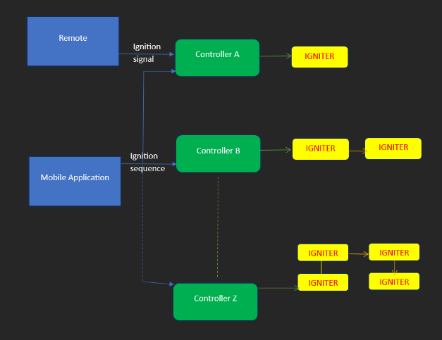

Our system integrates a set of Controllers that would be triggered by a remote signal which in turn would initiate detonation in the detonators connected to each controller. A custom sequence can be sent to the controller prior to initialization from a mobile application. Hence the system would have peer-peer control and a broadcasting-based communication.

User Scenario
A medium-scaled owner of a small firework company Amal plans on holding a firework show as an entertainment item for a newly wedded couple on their wedding-night dinner. So he sets up all the firework props with his employees in the hotel garden and set up the “wick ” in each prop.
With our system he would have access to each prop connected to the slits in the detonator which are connected to controllers. All he have to do is send the pattern which he needs to ignite to the controller/s and send the ignition initiation with the remote. Thus he can safely and conveniently perform the show.

Team Details
Please provide necessary details of your team. All fields, including photographs, are required

Team Leader
Full Name: Telge Sithum Ransika Peiris
Email: sithum.peiris01@gmail.com
Mobile Number: 0711249136

Team member
Full Name: Lakindu Uthsara Abeywickrama Gunasekara
Email:lg.sekara123@gmail.com
Mobile Number:0712503256

Team member
Full Name: Jalathage Hiruna Damsith Kariyawasam
Email:jhdkariyawasam@gmail.com
Mobile Number:0767926901

Team member
Full Name: Hiviru hansitha palihena
Email:hivirup@gmail.com
Mobile Number:0768893404

Additional Information
Market Analysis and a brief comparison
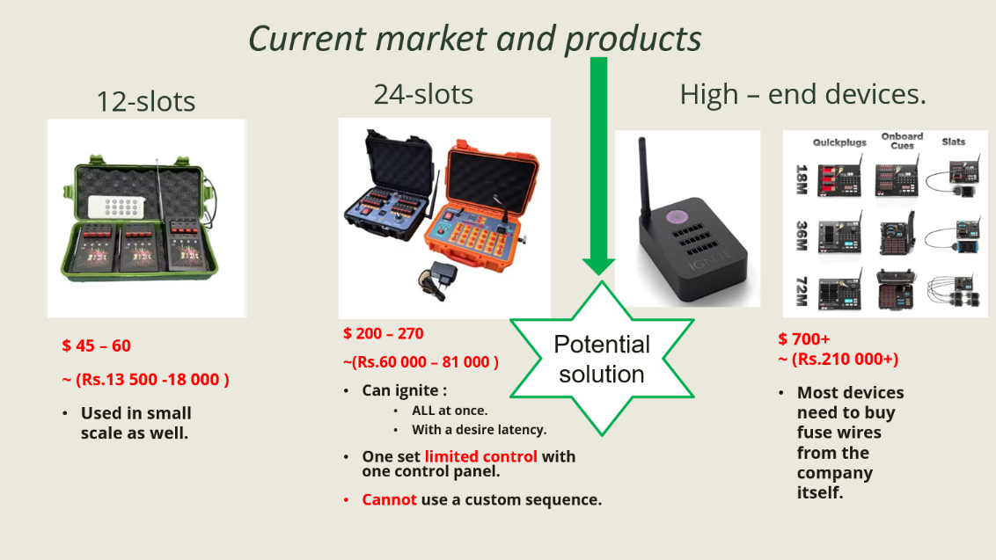

Minimum Viable Product (MVP) and system architecture
