基于严格本地角约束的无人机编队纯方位定位与调整

摘要
本文针对无人机集群电磁静默条件下的纯方位无源定位与编队调整问题，在每架无人机仅可使用自身测得发射机对夹角、禁止跨机夹角汇总的严格信息约束下，建立从局部定位到多轮调整的统一角约束证书化模型。
针对问题一(1)，采用双侧定夹角圆完整候选枚举与第三角回代筛选，结合局部Jacobian满秩判据实现局部唯一性判定；确定性样例覆盖镜像多根、相切与0/π边界，避免将数值求解器首根误写为唯一位置。
针对问题一(2)，以m=0时仅一条定夹角圆弧无法确定二维位置的反例排除零匿名机，对m=1执行8×7×7=392次编号—几何联合枚举，得到最小身份观测分离度20°，证明接收机已知自身编号、目标邻域非退化条件下局部最少额外发射机数为1。
针对问题一(3)，固定FY00/FY01题给种子，采用FY04/FY07严格本地双节点交替校正建锚（完整精确周期一阶谱半径为零），再固定四锚使其余六机以本机主约束角并行归槽、同机留出角约束检验验收；表1实例最终半径误差1.95×10⁻⁷m。
针对问题二，审计纯夹角对共同缩放的不可辨识性，以经批准的FY11/FY15可信无偏差基线4d*注入尺度，采用FY04/FY03严格本机交替建锚，再由四参考机下其余11架以六维纯方位观测向量并行归槽；33个端到端回放全部通过，最坏节点误差2.27×10⁻⁷d*。
全部模型经独立多初值数值复核器、解析—自动微分—有限差分三路导数对照、在线信息隔离AST审计与故障注入、几何不变性检验及终态30边12线验收验证。结论严格限于目标邻域、非退化与确定性回放条件，Q2附加FY11/FY15可信基线条件，不宣称全局唯一或任意初态收敛。
关键词：纯方位无源定位；局部可辨识性；严格本地信息边界；交替自举建锚；无人机编队调整

一、问题重述

1.1问题背景
无人机集群进行编队飞行时，为减少外界的干扰，应尽可能保持电磁静默，减少向外发射电磁波信号。为维持编队队形，可采用纯方位无源定位方法调整无人机位置：由编队中的部分无人机发射信号，其余无人机被动接收信号，并从中提取方向信息完成定位，方向信息为：该无人机与任意两架发射信号无人机连线之间的夹角，以此完成位置调整。
纯方位跟踪系统通过对目标进行连续观测、积累测角信息，可实现对目标状态包括位置与速度的精确估计，进而引导观测器完成跟踪。多站无源组网定位是一种更高效的无源定位方法。^{[1,2]}

1.2问题重述
问题1：有10架无人机组成圆形编队，其中9架（编号FY01~FY09）均匀分布在某一圆周上，另1架（编号FY00）位于圆心。无人机均保持在同一个高度上飞行。
(1)FY00与另2架无人机发射信号，其他位置有偏差的无人机接收信号。若发射信号的无人机位置无偏差且编号已知，建立接收信号无人机的定位模型。
(2)某位置有偏差的无人机接收到FY00和FY01发射的信号，另接收到若干编号未知的无人机发射的信号。当发射信号的无人机位置无偏差时，除 FY00 和 FY01外，至少还要几架无人机发射信号，才能实现无人机的精准定位？
(3)若圆形编队半径为 100 m。当初始时刻无人机的位置存在偏差时，通过多次调整，每次选取编号为FY00的无人机和圆周上至多3架无人机发射信号，其余无人机根据收到的方向信息，调整至理想位置（每次调整的时间忽略不计），使9架无人机最后均匀分布在某个圆周上。利用题目表格的数据，仅根据收到的方向信息来调整无人机的位置，给出具体的调整方案。
问题2考虑锥形编队队形，直线上相邻两架无人机的间距相等。仍为纯方位无源定位的情形，给出无人机位置调整方案。

二、问题分析

2.1问题一
针对(1)问：以两架发射信号无人机为端点的弦和该无人机与任意两架发射信号无人机连线之间的夹角，由圆周角的性质可知，该无人机在两段圆弧上，记为一组。由FY00与另2架无人机发射信号，则接收信号的无人机在三组圆弧的交集上，即求得接收信号无人机的位置。可通过atan2()建立位置向量与方向信息的方程，求方程组的解的接收信号无人机的位置向量。
针对(2)问：由(1)问的分析，原问题转化为方程组的唯一解问题。若仅靠FY00与FY01两架发射机，接收机轨迹为两段圆弧，二维位置无法唯一确定，因此零架额外发射机不足。若增加一架编号未知的发射信号无人机，由于无人机数量有限且编号唯一，因此本文采用逐个假设的方法，假设新增发射信号无人机为FY0i(i=2,3,4...9)，再分别求解其他无人机的位置信息，若存在多解情况则添加发射信号无人机，直到都存在唯一解，
针对(3)问：由于编号固定，对应编号的无人机有其理想位置，且无人机的位置误差较小，可由其理想位置得到的理想方向信息为锚点，通过计算角残差确定实际角度偏离理想角度的大小,无人机通过小幅试探估计角度随自身位置变化的梯度，再根据角残差和梯度计算调整方向与移动步长。由题目表格信息可知FY00与FY01为理想位置，不需要变更位置，可定为发射信号无人机 ，可选另外取FY04与FY07（四驾无人机将圆均分为三等份），这两架无人机轮流一架发射信号一架接收信号更变位置，多次调整后到达理想位置，再通过这四架无人机发射信号来调整其他无人机的位置。

2.2问题二
锥形编队由 FY01—FY15 共 15 架无人机组成。题目要求各规定直线上的无人机保持共线，且相邻无人机间距相等。本文将目标队形抽象为标准三角格点，并以相邻间距 d* 表示共同尺度。
纯方位夹角对整体缩放不敏感，因此仅由夹角不能恢复共同尺度。为形成可施工的尺度参考，采用经批准的 FY11、FY15 可信无偏差基线，其距离为 4d*；该条件只固定尺度，不固定队形的整体平移、旋转和镜像。
具体先固定 FY11、FY15，并让 FY04、FY03 进行严格本机双子轮交替校正，形成四参考机框架；再固定 FY03、FY04、FY11、FY15，其余 11 架无人机仅依据本机测得的六维纯方位观测向量并行归入对应格点。每架无人机以两条非退化夹角构造本机调整方向，其余同机夹角只用于留出约束检验；不同接收机之间不交换夹角。

三、模型假设
1、无人机的信号传播不会衰减或受到其他环境的影响。
2、每一次无人机调整的时间忽略不计。

四、符号说明
符号 | 含义 | 单位
$${\text{p}}_{i}$$ | 无人机$i$的位置向量 | \
$${\text{y}}_{ab}$$ | 无人机$a,b$发射的方向信息表达的角度 | \
$$\text{ρ}$$ | 轨迹圆半径 | m
$$h_{a,b}^{(i)}$$ | 无人机$i$接受无人机$a,b$发射的方向信息 | \
$$B_{i}$$ | 无人机$i$可能的编号集合 | \
$$q_{k}$$ | 第k架圆周无人机的理想位置 | \
$$U_{r}$$ | 附近无人机可能出现的局部位置集合 | \

五、模型的建立与求解

5.1问题一模型建立与求解

5.1.1单独方向信息联系的位置模型
先建立位置向量与夹角公式，设接收信号无人机i在位置${\text{p}}_{\text{i}}$，两架发射信号无人机a，b分别在${\text{p}}_{\text{a}}$，${\text{p}}_{\text{b}}$.从接收机指向两架发射机的向量为$\text{u}\text{=}{\text{p}}_{\text{a}}\text{−}{\text{p}}_{\text{i}}$，$\text{v}\text{=}{\text{p}}_{\text{b}}\text{−}{\text{p}}_{\text{i}}$.
考虑到在夹角接近$\text{0}$或$\text{π}$时容易受到浮点误差影响，而$\text{atan2}\text{()}$通常更加稳定，所以本文不用常见的$\text{arccos}{\text{(}}\text{)}$.接收信号无人机i测得的夹角定义为
$$\begin{aligned}{\text{h}}_{\text{ab}}\text{(}{\text{p}}_{\text{i}}\text{)=atan2}\left(\text{|}\text{u}\text{×}\text{v}\text{|,}{\text{u}}^{\text{T}}\text{v}\right)\text{，}{\text{h}}_{\text{ab}}\text{(}{\text{p}}_{\text{i}}\text{)∈[0,}\text{π}\text{]}\text{.}\#\text{(1)}\end{aligned}$$
${\text{p}}_{\text{a}}{\text{p}}_{\text{b}}\text{∠}\text{AXB}\text{=}\text{α}{\text{y}}_{ab}\text{d}\text{=‖}{\text{p}}_{\text{a}}\text{−}{\text{p}}_{\text{b}}\text{‖}$假设两架发射信号无人机位于A、B，其中A、B与，相互对应，接收信号无人机测得，记为。只知道一个夹角时，由圆周角定理可得接收信号无人机i不在一个确定点，而会落在轨迹圆的一条圆弧上^{[4,11,14,15]}。由于发射信号无人机的位置已知且无偏差，两架发射无人机的间距为 ，则轨迹圆半径为
$$\begin{aligned}\text{ρ}\text{=}\frac{\text{d}}{\text{2}\text{sin}{\text{α}}}.\#\text{(2)}\end{aligned}$$
一般会有位于弦两侧的两个轨迹圆，因此不能只考虑一条圆弧。
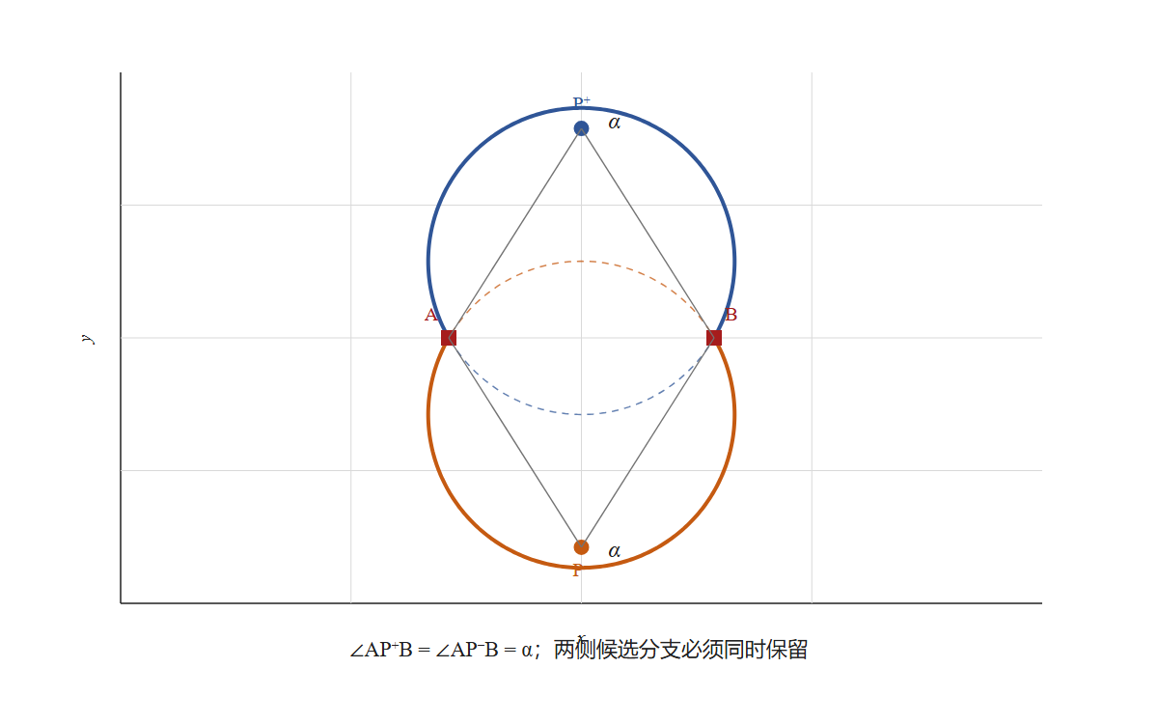
图1 双侧定夹角轨迹圆与候选分支示意图

5.1.2多方向信息联系的位置模型
设三架已知发射信号无人机在${\text{p}}_{\text{a}}$，${\text{p}}_{\text{b}}$，${\text{p}}_{\text{c}}$，接收信号无人机i测得方向信息${\text{y}}_{\text{ab}}$，${\text{y}}_{\text{ac}}$，${\text{y}}_{\text{bc}}$.
定位方程为
$$\begin{aligned}\left\{\begin{aligned}{\text{h}}_{\text{ab}}\text{(}{\text{p}}_{\text{i}}\text{)=}{\text{y}}_{\text{ab}} \\ {\text{h}}_{\text{ac}}\text{(}{\text{p}}_{\text{i}}\text{)=}{\text{y}}_{\text{ac}} \\ {\text{h}}_{\text{bc}}\text{(}{\text{p}}_{\text{i}}\text{)=}{\text{y}}_{\text{bc}}\end{aligned}.\right.\#\text{(3)}\end{aligned}$$
由此可得解的集合
$\text{C}\text{(}{\text{p}}_{\text{i}}\text{)=\{}{\text{p}}_{\text{i}}\text{:}{\text{h}}_{\text{ab}}\text{(}{\text{p}}_{\text{i}}\text{)=}{\text{y}}_{\text{ab}}\text{,}{\text{h}}_{\text{ac}}\text{(}{\text{p}}_{\text{i}}\text{)=}{\text{y}}_{\text{ac}}\text{,}{\text{h}}_{\text{bc}}\text{(}{\text{p}}_{\text{i}}\text{)=}{\text{y}}_{\text{bc}}\text{\}}$ .
即为接收信号无人机的具体位置。
由上述模型可对(1)问进行具体求解：由于发射信号的无人机的编号已知，不妨令为FY00、FY01、FY02，位置向量为${\text{p}}_{\text{00}}\text{=}\text{ρ}\text{(0,0)}$，${\text{p}}_{\text{01}}\text{=}\text{ρ}\text{(1,0)}$，${\text{p}}_{\text{02}}\text{=}\text{ρ}\text{(cos40}\text{°}\text{,sin40}\text{°}\text{)}$，其中$\text{ρ}$为圆形编队所在圆周的半径，随后对其他编号无人机进行一一求解。对于某被动接受信号无人机FYi，设其位置向量为${\text{p}}_{\text{i}}$，已知${\text{y}}_{\text{0001}}$，${\text{y}}_{\text{0002}}$，${\text{y}}_{\text{0102}}$，可得三个方程${\text{h}}_{\text{0001}}\text{(}{\text{p}}_{\text{i}}\text{)=}{\text{y}}_{\text{0001}}$，${\text{h}}_{\text{0002}}\text{(}{\text{p}}_{\text{i}}\text{)=}{\text{y}}_{\text{0002}}$，${\text{h}}_{\text{0102}}\text{(}{\text{p}}_{\text{i}}\text{)=}{\text{y}}_{\text{0102}}$，联立解得${\text{p}}_{\text{i}}$.
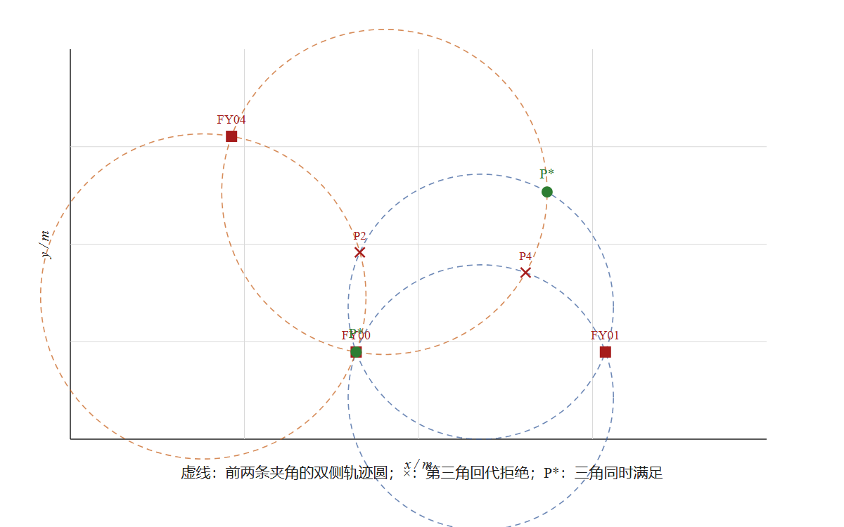
图2 三组纯方位约束的完整候选与第三角回代筛选

5.2第二小问的模型的建立与求解
第一小问中，三架发射信号无人机的编号和位置均已知。本小问中，FY00和FY01的编号已知，新增发射信号无人机的编号未知。因此，接收信号无人机不仅需要确定自身位置，还需要判断匿名发射信号无人机对应的编号。

5.2.1 零架额外发射信号无人机的不充分性
设除FY00和FY01外增加的匿名发射信号无人机数量为$n$.当不增加匿名发射信号无人机时，有$n=0$.
此时接收信号无人机$i$只能测得FY00和FY01之间的一个夹角，定位方程为
$$\begin{aligned}{\text{h}}_{\text{0001}}\text{(}{\text{p}}_{i}\text{)=}{\text{y}}_{\text{0001}},\#\text{(4)}\end{aligned}$$
其中，${\text{p}}_{i}$为接收无人机的位置，${\text{y}}_{\text{0001}}$为实际测得的夹角。
根据第一小问的模型，该方程的解集为一组连续圆弧，而不是一个确定点。接收信号无人机$i$的二维位置包含两个未知量，一个夹角只能提供一个独立约束，因此无法唯一确定其位置。由此可得$n_{min}≥ 1。$所以，至少需要增加一架发射发射信号无人机。
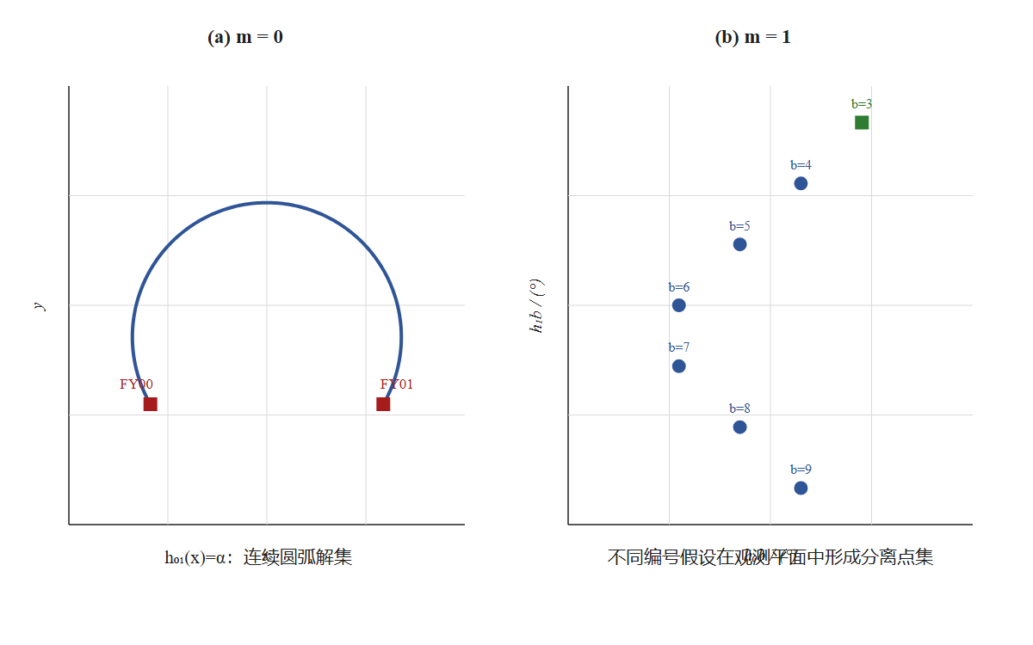
图3 Q1(2) 的零匿名机反例与一匿名机联合判定

5.2.2 增加一架发射信号无人机的联合定位模型
当增加一架发射信号无人机时，有$n=1$.设当前接收信号无人机的编号为$i$，其中$i∈\left\{02,03,…,09\right\}$.发射信号无人机不能是接收信号无人机自身，因此其可能的编号集合为
$B_{i}=\left\{02,03,…,09\right\}∖\left\{i\right\}$.
集合$B_{i}$中共有7个可能编号。设发射信号无人机的编号为$b$，则$b∈B_{i}$.
现FY00、FY01和FY$b$共同发射信号，则收信号无人机$i$可以测得三个角度信息组成向量：
$y=\left[\begin{matrix}y_{0001} \\ y_{00b} \\ y_{01b}\end{matrix}\right]$.
$y_{00b}y_{01b}bb$其中，和分别表示接收信号无人机到FY与FY00、FY与FY01方向之间的夹角。虽然发射信号无人机的编号未知，但只有7种可能，因此可以逐一检验^{[3,5,10]}。由前问有对应的夹角观测向量为
$Φ_{b\left({\text{p}}_{i}\right)}=\left[\begin{matrix}{\text{h}}_{\text{0001}}\text{(}{\text{p}}_{i}\text{)} \\ {\text{h}}_{\text{00}\text{b}}\text{(}{\text{p}}_{i}\text{)} \\ h_{01b}\text{(}{\text{p}}_{i}\text{)}\end{matrix}\right]$.
接收信号无人机$i$的位置应满足
$$\begin{aligned}Φ_{b\left({\text{p}}_{i}\right)}=y.\#\end{aligned}$$
对每个$b$∈$B_{i}$，使用第一小问建立的模型，计算满足三个夹角的全部位置候选。编号$b$对应的位置候选集记为
${\text{C}}_{b}=\left\{{\text{p}}_{i}:Φ_{b\left({\text{p}}_{i}\right)}=y\right\}$，
由于接收信号无人机$i$只能测得夹角的大小，无法直接判断其位于两架发射信号无人机连线的哪一侧，因此同一组夹角可能对应多个位置。求解时应保留所有可能的圆弧和交点，再利用其他条件逐一筛选。
将7种编号假设下的位置候选合并，得到全部编号的位置候选集合：
$S\text{(}\text{y})=\bigcup_{b}{\left\{\left(b,p_{i}\right):Φ_{b\left(p_{i}\right)}=y,p_{i}∈U_{r}\right\}}$，
其中，编号为r的无人机在圆形编队中规定的位置为${\text{q}}_{\text{i}}$,题目说明接收信号的无人机的位置略有偏差,因此将${\text{q}}_{\text{i}}$附近无人机可能出现的局部位置记为$U_{r}$.

5.2.3 模型求解与判定
找到满足夹角的位置候选后，还需要判断该编号和位置能否被可靠确定。
为了判断候选位置能否在目标位置附近唯一确定，计算观测向量关于位置的Jacobian：
$DΦ_{b\left(p_{i}\right)}=\left[\begin{matrix}∇h_{0001}(p_{i}) \\ ∇h_{00b}(p_{i}) \\ ∇h_{01b}(p_{i})\end{matrix}\right]$,
若目标位置${\text{q}}_{\text{r}}$处满足
$rank DΦ_{b\left(q_{r}\right)}=2$,
则夹角信息可以反映平面内两个方向的位置变化，从而能够在目标位置附近确定二维位置。
为判断不同编号能否区分，定义目标邻域内的最小编号观测分离度为
$$\begin{aligned}Δ_{\left(id\right)\left(U_{r}\right)}=\min_{b≠b^{'}}{dist}\left(Φ_{b\left(U_{r}\right)},Φ_{\left(b^{'}\right)\left(U_{r}\right)}\right),\#(5)\end{aligned}$$
其中，dist 表示两个观测集合之间的最短欧氏距离。若
$Δ_{\left(id\right)\left(U_{r}\right)}>0$,
则不同编号在目标邻域内不会产生完全相同的夹角组合，可以根据实测夹角判断匿名发射机编号。
当以下条件同时满足时，可以在目标邻域内确定匿名发射机编号和接收无人机位置：
1. 候选位置能够同时满足三个原始夹角；
2. 候选位置位于U_r 内；
3. 位置Jacobian的秩为2；
4. 不同编号之间的最小观测距离大于0；
5. 目标邻域内只剩下一个编号—位置候选。
如果目标邻域内仍有多个候选，或者不同编号产生的夹角过于接近，则当前信息不足，不能强行输出唯一结果。

5.2.5 双匿名发射机备用方案
当一架匿名发射机不能提供足够的信息时，可以增加第二架匿名发射机作为备用。设两个匿名信号对应的编号分别为 ${\text{b}}_{\text{1}}$,${\text{b}}_{\text{2}}$，则
$b_{1},b_{2}∈B_{r}, b_{1}≠ b_{2}$.
第一个匿名编号有7种选择，第二个匿名编号有6种选择，因此共有$7×6=42$种有序编号组合。
FY00、FY01和两架匿名发射机共4个发射源，可以形成6个两两夹角。求解时依次检验42种编号组合，并将每个位置候选代回全部6个夹角。
当$m$=0时，接收无人机只能根据一个夹角确定自己位于某组圆弧上，无法得到唯一的二维位置。当$m$=1时，通过枚举匿名发射机的可能编号、计算全部位置候选并进行筛选，可以在目标位置附近同时确定匿名发射机编号和接收无人机位置。
因此，在接收无人机知道自身编号、位置Jacobian的秩为2且误差在允许范围内的条件下，理论上最少需要增加一架匿名发射机，即
$m_{min}=1$.
当一架匿名发射机提供的信息不足时，可以增加第二架作为备用方案。

5.3问题一的第三小问的模型的建立与求解

5.3.1圆形编队目标位置模型
本小问要求根据表1中的初始位置，通过多次调整，使FY01至FY09最后均匀分布在半径为100 m的圆周上。由题目条件可知，FY00位于圆心，FY01位于理想位置，因此在调整过程中保持FY00和FY01的位置不变。
设FY00的理想位置为O=(0,0)，圆形编队的半径为R=100 m。令FY01固定圆形编队的起始方向，则第k架圆周无人机的理想位置为
$$\begin{aligned}q_{k}=R{\left[cos\left(\frac{2π\left(k−1\right)}{9}\right),sin\left(\frac{2π\left(k−1\right)}{9}\right)\right]}^{T},k=1,2,…,9.\#(6)\end{aligned}$$
其中$q_{k}$只用来计算理想夹角和最后检验结果，不直接作为无人机调整时的位置输入。
若只有FY00和FY01发射信号，接收信号无人机只能测得这两架无人机之间的一个夹角。根据5.1中的模型，一个夹角只能确定一组圆弧，不能唯一确定平面内的位置。因此，只使用FY00和FY01不能直接完成二维位置调整，需要先增加两个位置可靠的发射信号无人机。

5.3.2FY04和FY07的交替调整模型
根据9架圆周无人机的编号和理想位置，本文选取FY04和FY07进行交替调整^{[6,9]}。设B=FY04，C=FY07。
B=FY04，C=FY07.
由式(6)可得两架无人机的理想位置分别为
B*=（−50，50$\sqrt{3}$），C*=（−50，−50$\sqrt{3}$）.
一次完整调整分为两个子轮。第一子轮由FY00、FY01和FY07发射信号，FY04接收信号并调整位置；第二子轮由FY00、FY01和FY04发射信号，FY07接收信号并调整位置。具体顺序如下：
子轮 | 发射信号无人机 | 接收并移动的无人机 | 使用的两个本机夹角
1 | FY00、FY01、FY07 | FY04 | ∠ OBA、∠ OBC
2 | FY00、FY01、FY04 | FY07 | ∠ OCA、∠ OCB
每个子轮都包含FY00，圆周上的发射信号无人机只有两架，没有超过题目给出的三架上限。接收信号无人机不同时发射信号，并且在接收信号无人机试探和移动时，其他发射信号无人机保持不动。
在理想位置处，上述四个夹角都为π/6。因此，FY04的角残差为
$$\begin{aligned}f_{B}\left(B;C\right)={\left[∠OBA−\frac{π}{6},∠OBC−\frac{π}{6}\right]}^{T}.\#(7)\end{aligned}$$
FY07的角残差为
$$\begin{aligned}f_{C}\left(C;B\right)={\left[∠OCA−\frac{π}{6},∠OCB−\frac{π}{6}\right]}^{T}.\#(8)\end{aligned}$$
式(7)中的两个角只由FY04测量，式(8)中的两个角只由FY07测量。两架无人机不交换各自测得的夹角。
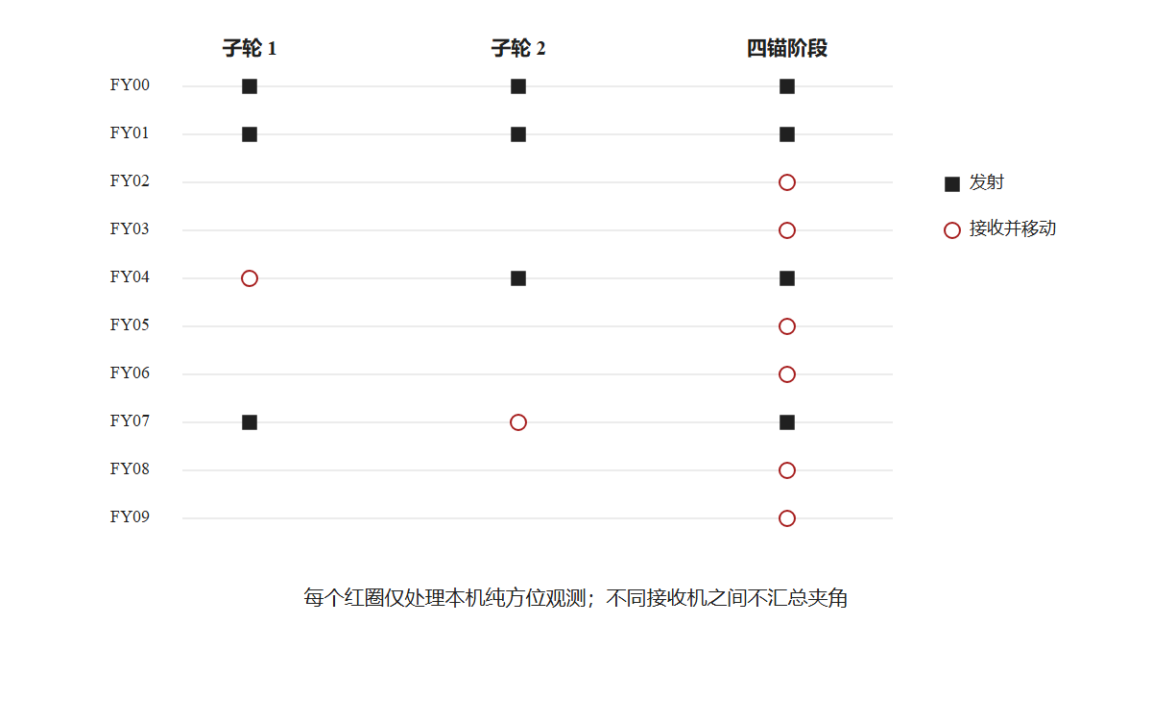
图4 Q1(3) FY04/FY07 严格本机交替校正与四锚并行调整
为判断两个夹角能否确定本机的二维调整方向，对式(7)和式(8)关于位置求导。设a=1/(100√3)，在理想位置处可得
$$\begin{aligned}D_{B}f_{B}=\left[\begin{matrix}a & 0 \\ −\frac{a}{2} & −\frac{1}{200}\end{matrix}\right],D_{C}f_{C}=\left[\begin{matrix}a & 0 \\ −\frac{a}{2} & \frac{1}{200}\end{matrix}\right].\#(9)\end{aligned}$$
式(9)中的两个矩阵都可逆，说明当另一架无人机保持不动时，本机测得的两个夹角可以在理想位置附近确定两个方向的位置变化。
继续对两架无人机的交替调整关系求导，可得
$$\begin{aligned}\frac{∂B^{+}}{∂C}=\left[\begin{matrix}0 & 0 \\ −\frac{2}{\sqrt{3}} & 0\end{matrix}\right],\frac{∂C^{+}}{∂B}=\left[\begin{matrix}0 & 0 \\ \frac{2}{\sqrt{3}} & 0\end{matrix}\right].\#(10)\end{aligned}$$
因此，一次完整调整后的一阶误差矩阵为
$$\begin{aligned}M=\left(\frac{∂C^{+}}{∂B}\right)\left(\frac{∂B^{+}}{∂C}\right)=0_{2×2},ρ\left(M\right)=0<1.\#(11)\end{aligned}$$
由式(11)可知，在理想位置附近，如果每个子轮都能充分求得本机的位置修正，则小误差会逐渐减小。这里的结果只说明理想位置附近的调整情况，不能说明任意初始位置都一定收敛。

5.3.3根据本机角残差计算移动方向
无人机在调整过程中不知道自己的实际坐标，因此不能直接用实际位置减去理想位置。本文让每架接收信号无人机沿自身的两个方向$e_{1}$,$e_{2}$进行小幅正、负试探，再根据夹角的变化估计移动方向。
设无人机i的本机移动坐标为$u_{i}$，试探距离为δ，角残差为$F_{i}$.沿第l个方向试探后，角残差关于位置变化的估计为
$$\begin{aligned}{\hat{J}}_{i}\left[:,l\right]=\frac{F_{i}\left(u_{i}+δe_{l}\right)−F_{i}\left(u_{i}−δe_{l}\right)}{2δ},l=1,2.\#(12)\end{aligned}$$
式(12)表示无人机沿某一方向移动时，两个夹角变化的快慢。得到${\hat{J}}_{i}$后，下一步移动量为
$$\begin{aligned}Δu_{i}=−η{\left({\hat{J}}_{i}^{T}{\hat{J}}_{i}+λI\right)}^{−1}{\hat{J}}_{i}^{T}F_{i}.\#(13)\end{aligned}$$
其中，η为移动步长，λ为阻尼系数，I为单位矩阵。阻尼系数可以防止无人机一次移动过大。实际求解时还需要限制每次移动距离，并在移动后重新计算本机角残差。若角残差没有减小，则减小移动步长后重新计算。
根据表1中的初始位置，本文重复进行5次FY04和FY07的完整交替调整，使FY04和FY07到达各自理想位置附近。

5.3.4固定四架无人机后的并行调整模型
FY04和FY07调整完成后，将FY00、FY01、FY04和FY07固定为发射信号无人机，即
$$\begin{aligned}T=\left\{FY00,FY01,FY04,FY07\right\}.\#(14)\end{aligned}$$
该集合由FY00和三架圆周无人机组成，满足题目要求。其余六架无人机分别使用下面两个本机夹角进行调整：
接收信号无人机 | 使用的两个本机夹角
FY02、FY03 | h_OA、h_OB
FY05、FY06 | h_OB、h_OC
FY08、FY09 | h_OA、h_OC
每架无人机的理想夹角由式(6)中的理想位置和四架无人机的理想位置提前计算。两条主要夹角用于式(12)和式(13)中的位置调整，其余四条本机夹角用于检验结果。六架接收信号无人机之间不交换夹角，且四架发射信号无人机保持不动，因此六架无人机可以同时进行计算和移动。

5.3.5模型求解结果
全部调整完成后，再使用表1中的实际位置进行结果检验。设FY00的最终位置为$p_{0}$，FY01至FY09的最终位置为$p_{k}$.最大半径误差为
$$\begin{aligned}E_{R}=\max_{k=1,2,…,9}\left|\left\|p_{k}−p_{0}\right\|−100\right|.\#(15)\end{aligned}$$
相邻无人机的理想圆心角为2π/9=40°，因此最大相邻圆心角误差为
$$\begin{aligned}E_{θ}=\max_{k=1,2,…,9}\left|∠p_{k}p_{0}p_{k+1} −\frac{2π}{9}\right|.\#(16)\end{aligned}$$
利用题目表格中的数据进行计算，得到结果如下：
检验量 | 计算结果
最大半径误差 | 1.954×10⁻⁷ m
最大相邻圆心角误差 | 2.421×10⁻⁹ rad
最大目标位置误差 | 2.935×10⁻⁷ m
每架无人机其余四条角残差 | 均不超过1×10⁻⁶ rad
由此可得，先对FY04和FY07进行5次交替调整，再固定FY00、FY01、FY04和FY07，并对其余六架无人机进行同时调整，可以使表1中的9架圆周无人机到达半径为100 m的正九边形目标位置。
上述结果来自表1数据的计算过程，只能说明该调整方案在表1的初始位置和理想位置附近可以完成调整，不能说明任意初始位置都一定能够调整成功，也不能把计算误差看作实际无人机的飞行精度。
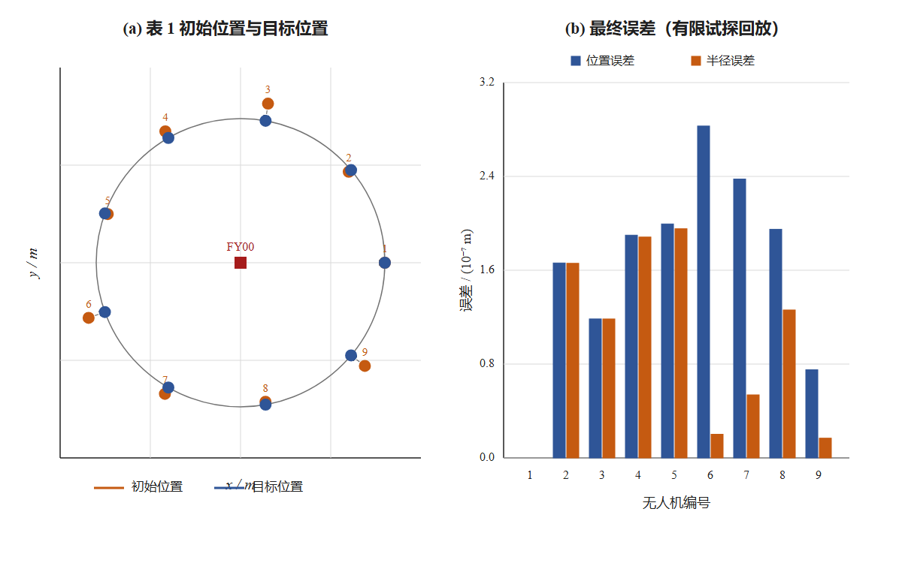
图5 Q1(3) 表1初始队形、交替建锚与最终正九边形

5.4问题二模型建立与求解

5.4.1三角形编队目标位置模型
第二问要求将15架无人机调整为等边三角形网格。调整完成后，相邻无人机之间的距离相等，并且题目规定的各组无人机保持共线。设目标编队的相邻距离为d*>0，按照从上到下、从左到右的顺序对目标位置进行编号。
设第c行第j个目标点的位置为$q_{c,j}$，其中c=0,1,2,3,4，j=0,1,…,c，对应的无人机编号为n=c(c+1)/2+j+1。由等边三角形的边长和高之间的关系可得
$\begin{aligned}q_{c,j}=d^{∗}{\left[−\frac{\sqrt{3}c}{2},j−\frac{c}{2}\right]}^{T},c=0,1,2,3,4,j=0,1,…,c.\#(17)\end{aligned}$
式（17）中的相邻位移只有[0，d*]ᵀ、[−√3d*/2，−d*/2]ᵀ和[−√3d*/2，d*/2]ᵀ三类，三个向量的长度都为d*。因此，该位置模型可以保证30条相邻边等长，并使题目要求的12条直线保持共线。
在该编号下，FY11和FY15位于最下面一行的两端，两者之间的距离为4d*。因此，只要给出FY11和FY15之间的固定距离，就可以确定目标编队的相邻距离。例如，相邻距离为50 m时，两架无人机之间的距离应为200 m。这里的50 m只是计算示例。
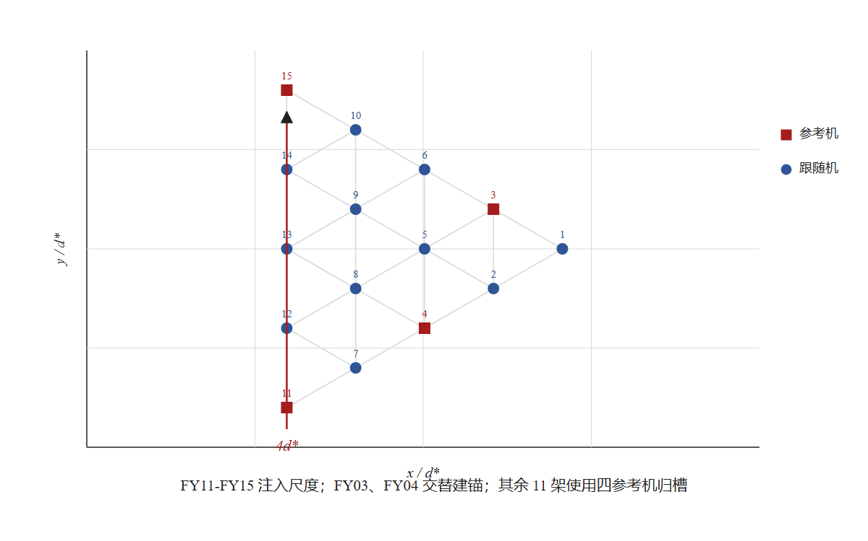
图6 Q2三角格点目标、相邻边与四参考机结构

5.4.2方向夹角模型和尺度条件
设接收信号无人机i的位置为$x_{i}$，两架发射信号无人机a、b的位置分别为$p_{a}$、$p_{b}$.接收信号无人机测得的夹角记为$h_{a,b}^{(i)}$，则
$$\begin{aligned}h_{a,b}^{(i)}=atan2\left(\left|\left(p_{a}−x_{i}\right)×\left(p_{b}−x_{i}\right)\right|,{\left(p_{a}−x_{i}\right)}^{T}\left(p_{b}−x_{i}\right)\right),h_{a,b}^{(i)}∈\left[0,π\right]。\#(18)\end{aligned}$$
式（18）同时使用向量的叉积和点积，在夹角接近0或π时也比较稳定。若所有无人机的位置同时进行平移、旋转、镜像或整体缩放，测得的方向夹角不会发生变化^{[8,9,12]}。特别地，对任意s>0，有
$$\begin{aligned}h_{a,b}^{(i)}\left(sx_{i};sp_{a},sp_{b}\right)=h_{a,b}^{(i)}\left(x_{i};p_{a},p_{b}\right)。\#(19)\end{aligned}$$
由式（19）可知，只使用方向夹角可以确定编队形状，但不能确定编队的大小。为了确定相邻距离，本文增加以下条件：FY11和FY15的编号已知、位置无偏差，并在调整过程中保持不动，两者之间的距离为4d*。这个条件不是题目直接给出的条件，只用来确定编队尺度，不能确定编队在实际坐标系中的平移、旋转和镜像方向。
在每一次调整中，接收信号无人机只使用本机编号、发射信号无人机编号、本机测得的夹角、本机过去的调整结果和事先给出的目标夹角。不同接收信号无人机之间不交换夹角，也不使用真实坐标、真实距离和计算完成后的检验结果。发射信号无人机在本轮试探和移动过程中保持不动。

5.4.3FY04和FY03的交替调整模型
只固定FY11和FY15时，一个夹角通常对应连线两侧的两组圆弧，不能直接确定平面内的位置。因此，先交替调整FY04和FY03，建立由FY03、FY04、FY11和FY15组成的四参考点框架。一次完整调整分为两个子轮，具体顺序如下：
子轮 | 发射信号无人机 | 接收并移动的无人机 | 主要夹角和检查夹角
第一子轮 | FY11、FY15、FY03 | FY04 | 主要：h_(11,15)^(04)=π/2，h_(15,03)^(04)=π/3；检查：h_(11,03)^(04)=5π/6
第二子轮 | FY11、FY15、FY04 | FY03 | 主要：h_(11,15)^(03)=atan2(2√3,1)，h_(11,04)^(03)=atan2(√3,6)；检查：h_(15,04)^(03)=π/2
第一子轮中，FY04使用两个主要夹角计算移动方向，其角残差和检查残差分别为
$\begin{aligned}r_{04}={\left[h_{11,15}^{(04)}−\frac{π}{2},h_{15,03}^{(04)}−\frac{π}{3}\right]}^{T},e_{04}=h_{11,03}^{(04)}−\frac{5π}{6}.\#(20)\end{aligned}$
第二子轮中，FY03使用两个主要夹角计算移动方向，其角残差和检查残差分别为
$\begin{aligned}r_{03}={\left[h_{11,15}^{(03)}−atan2\left(2\sqrt{3},1\right),h_{11,04}^{(03)}−atan2\left(\sqrt{3},6\right)\right]}^{T},e_{03}=h_{15,04}^{(03)}−\frac{π}{2}.\#(21)\end{aligned}$
随后重复以上两个子轮，直到两个主要角残差和检查角残差都小于给定误差。式（20）中的角度只由FY04测量，式（21）中的角度只由FY03测量，两架无人机不交换各自测得的夹角。

5.4.4根据本机角残差计算移动方向
无人机不知道自己的真实坐标，因此不能直接使用真实位置减去目标位置。设当前接收信号无人机的本机移动坐标为u，主要角残差为F(u)。让无人机沿自身的两个方向e_1、e_2进行距离为δ的正、负试探，可以用中心差分估计夹角关于移动量的Jacobian：
$$\begin{aligned}\hat{J}\left[:,l\right]=\frac{F\left(u+δe_{l}\right)−F\left(u−δe_{l}\right)}{2δ},l=1,2.\#(22)\end{aligned}$$
得到Ĵ后，使用阻尼最小二乘法计算下一步移动量：
$$\begin{aligned}Δu=−η{\left({\hat{J}}^{T}\hat{J}+λI\right)}^{−1}{\hat{J}}^{T}F.\#(23)\end{aligned}$$
其中，η为移动步长，λ>0为阻尼系数，I为单位矩阵。实际求解时还需要限制每次移动的最大距离。若移动后角残差没有减小，则减小η后重新计算。
为判断FY04和FY03在目标位置附近能否完成交替调整，设FY04对FY03位置变化的一阶响应为F=−J_C⁻¹B_C，FY03对FY04位置变化的一阶响应为G=−J_D⁻¹B_D。计算可得
$$\begin{aligned}GF=0,ρ\left(GF\right)=0,det\left(J_{joint}\right)=\frac{1}{117{\left(d^{∗}\right)}^{4}}≠0.\#(24)\end{aligned}$$
由式（24）可知，两轮联合方程在目标位置附近可以确定FY04和FY03的位置，并且一次完整交替调整的一阶误差矩阵为0。因此，小范围内的位置误差会逐渐减小。这里的结果只是一阶近似下的局部结论，不能写成两轮后一定精确到达目标位置，也不能说明任意初始位置都能收敛。

5.4.5固定四架无人机后的并行调整模型
FY03和FY04调整完成后，将FY03、FY04、FY11和FY15固定为发射信号无人机。其余11架无人机分别接收四个参考点发出的信号，并使用本机测得的六个夹角进行调整。对任意一架待调整无人机FYi，建立观测向量
$\begin{aligned}Φ_{i}={\left[h_{03,04}^{(i)},h_{03,11}^{(i)},h_{03,15}^{(i)},h_{04,11}^{(i)},h_{04,15}^{(i)},h_{11,15}^{(i)}\right]}^{T}.\#(25)\end{aligned}$
由式（17）可以提前计算FYi在目标位置处的夹角向量Φ_i*，从而得到本机夹角残差
$$\begin{aligned}r_{i}=Φ_{i}−Φ_{i}^{∗}.\#(26)\end{aligned}$$
当某个目标夹角等于0或π时，该角度位于共线位置，不适合直接作为主要调整方程，只用来检查共线关系。对于其余夹角，分别计算任意两个夹角对应的局部Jacobian，并选择最小奇异值最大的组合：
$$\begin{aligned}\left(m_{i},n_{i}\right)={argmax}_{m<n}σ_{min}\left(J_{i}^{(m,n)}\right).\#(27)\end{aligned}$$
式（27）选出的两个夹角对两个方向的位置变化较为明显，因此将它们作为式（22）和式（23）中的主要角残差。其余非退化夹角用于检查错误位置。所有角度都由当前接收信号无人机自己测得，所以这些检查角度是本机内部的检查量，不能写成其他无人机提供的独立观测。
四个参考点固定后，11架待调整无人机之间不需要交换夹角，也不需要等待其他待调整无人机完成移动，因此可以分别计算并同时进行调整。

5.4.6多候选位置的筛选
只联立两个夹角方程时，可能出现关于参考点连线对称的多个位置。根据圆周角定理，一个固定夹角在弦的两侧一般各对应一个轨迹圆。因此，不能只保留数值算法最先找到的一个解。
求解时，先建立两个主要夹角在弦两侧的全部轨迹圆，再计算所有圆与圆的交点。对于相切、重合和连续解等特殊情况单独进行判断，并删除与发射信号无人机位置重合的点。
随后，将每个候选点代回六个本机夹角，删除不满足检查夹角的错误分支，并合并重复点。若目标位置附近只剩下一个候选点，则将其记为局部单一候选解。这个结果只能说明目标位置附近的候选点得到确定，不能直接说明全平面内只有一个解。
为了检查轨迹圆求交过程是否遗漏位置，本文另外使用多个初始值进行数值求根。多初值求根程序不直接使用轨迹圆程序筛选后的候选点，从而形成一组单独的检查结果。

5.4.7模型求解结果
根据上述模型，先固定FY11和FY15，再交替调整FY04和FY03，从而建立四参考点框架。随后固定FY03、FY04、FY11和FY15，使其余11架无人机分别根据本机夹角调整位置。计算时使用FY03和FY04实际调整后的终点，没有将两架无人机重新放回理想位置。
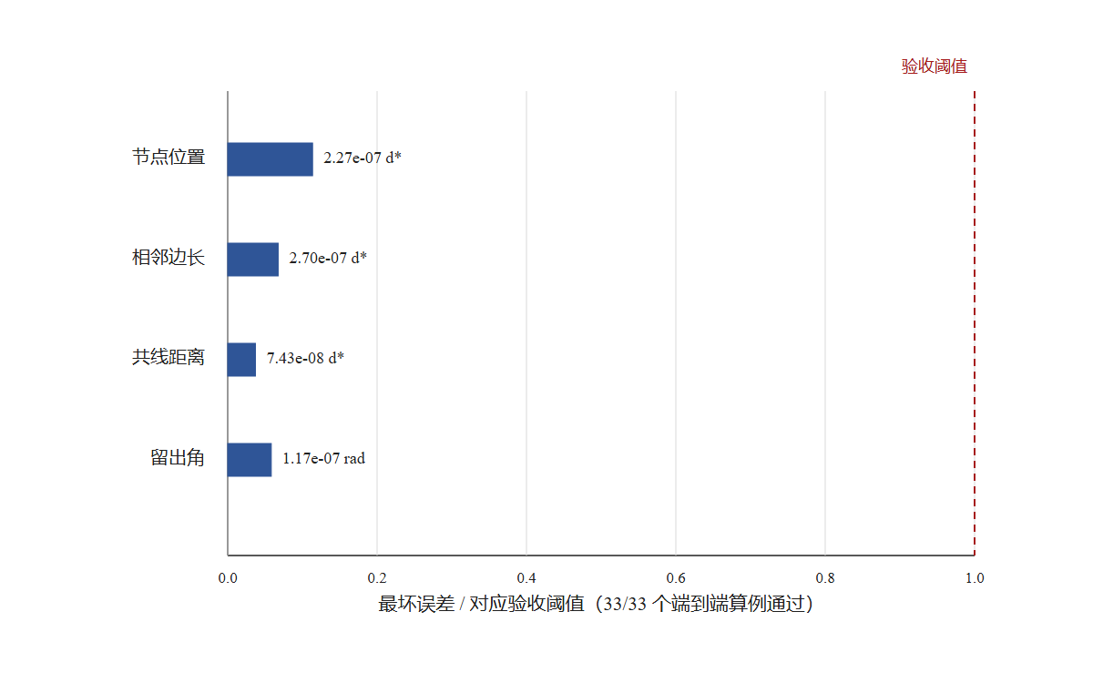
图7 Q2实际端到端调整：尺度基线、交替建锚与十一机归槽
计算内容 | 计算结果
四参考点下的11个目标位置 | 11/11均为局部单一候选
完整端到端调整 | 33/33通过，其中32组存在非零初始扰动
最大节点位置误差 | 2.27×10⁻⁷d*
最大相邻边长误差 | 2.70×10⁻⁷d*
最大共线距离 | 7.43×10⁻⁸d*
最大本机检查角残差 | 1.17×10⁻⁷ rad
由此可得，在FY11和FY15为无偏差固定尺度参考点，并且各无人机位于目标位置附近的条件下，该方法可以使15架无人机形成相邻边等长且规定直线共线的三角形编队。上述结果为模型计算结果，不能直接看作实际无人机的飞行精度。

六、模型检验与结果分析
为了判断第二问所建立的模型是否能够完成编队调整，本文分别从方向夹角计算、候选位置、多轮局部调整和最终编队形状四个方面进行检验。所有在线移动仍只使用当前接收信号无人机测得的夹角，真实位置只在全部移动结束后用于计算误差。

6.1方向夹角和导数检验
首先对式（18）中的方向夹角进行不变性检验。将同一组无人机位置分别进行平移、旋转、镜像和整体缩放，再重新计算全部方向夹角。变换前后的最大夹角差为8.88×10⁻¹⁶ rad，接近计算中的舍入误差。因此，方向夹角模型满足式（19）给出的不变性。
随后，对局部Jacobian进行检验。分别使用解析求导和式（22）中的中心差分计算相同位置处的导数，两种方法之间的最大误差为7.91×10⁻¹¹，小于预先设定的2×10⁻⁶。由此可得，中心差分能够在局部范围内正确反映夹角随移动方向的变化。^{[7,13]}

6.2候选位置和多解检验
为了检查两个主要夹角是否遗漏其他位置，本文保留定夹角圆在参考点连线两侧的全部分支，并计算所有圆与圆的交点。随后，将每个候选点代回同一接收无人机测得的全部非退化夹角。四参考点建立后，11个目标位置均只保留1个局部候选点，即11/11通过。
另外，使用不调用轨迹圆候选程序的多初值数值求根进行检查，11个位置的根集合均与轨迹圆方法一致。将参考点改为旧的{FY02，FY06，FY08，FY14}后，FY11位置可以得到2个根。这个对照说明，模型能够保留多解，而不是只输出计算中最先得到的一个根。
以上结果只能说明当前四参考点在目标位置附近可以区分11个目标位置，不能说明全平面内一定只有一个解。

6.3局部调整结果检验
式（24）给出的是目标位置附近的一阶结果，因此还需要通过多组局部计算检验实际调整过程。本文分别对FY04和FY03的精确局部调整、有限试探控制以及其余11架无人机的局部调整进行检验，结果如下：
检验项目 | 计算结果 | 检验范围或说明
建锚周期谱半径 | 1.21×10⁻¹⁶ | 可看作舍入误差范围内的0
FY04和FY03精确局部调整 | 720/720通过 | 0.01d*≤r≤0.30d*，最慢8个周期
FY04和FY03有限试探控制 | 256/256通过 | 0.02d*≤r≤0.20d*，最慢15个周期
其余11架无人机局部调整 | 704/704通过 | r≤0.20d*
较大范围压力测试 | 出现2次失败 | r=0.30d*和0.40d*
在r≤0.20d*的检验范围内，其余11架无人机的最大位置误差为2.00×10⁻⁸d*，最大本机检查角残差为3.31×10⁻⁸ rad。由此可得，中心差分和阻尼最小二乘法能够在给定局部范围内计算无人机的移动方向。
但是，在0.30d*和0.40d*的压力测试中出现了2次失败。因此，本节结果只能说明模型在目标位置附近有效，不能说明任意初始位置都一定能够收敛。

6.4端到端编队结果检验
局部检验通过后，继续进行完整端到端计算。每组计算先从扰动后的FY04和FY03开始交替建锚，再把两架无人机实际调整后的终点传给其余11架无人机。计算中没有将FY04和FY03重新放回理想位置。
共设置33组确定性算例，其中1组没有初始扰动，另外32组使用0.02d*、0.05d*、0.10d*和0.20d*四种扰动半径。13架需要移动的无人机在这些算例中都受到过非零扰动。全部调整完成后，离线计算节点位置误差、相邻边长误差、共线误差和本机检查角残差。设最终位置为p_i，目标位置为q_i，30条相邻边组成集合E，则最大节点位置误差为
$$\begin{aligned}E_{p}=\max_{1≤i≤15}\left\|p_{i}−q_{i}\right\|.\#(28)\end{aligned}$$
最大相邻边长误差为
$$\begin{aligned}E_{d}=\max_{\left(i,j\right)∈E}\left|\left\|p_{i}−p_{j}\right\|−d^{∗}\right|.\#(29)\end{aligned}$$
设题目要求的12条最大直线组成集合S，line(L)表示直线L对应的目标直线，则最大共线距离为
$$\begin{aligned}E_{L}=\max_{L∈S}\max_{i∈L}dist\left(p_{i},line\left(L\right)\right).\#(30)\end{aligned}$$
将未参加主要调整方程的本机夹角作为检查夹角，其最大残差为
$$\begin{aligned}E_{h}=max\left|h_{check}−h_{check}^{∗}\right|.\#(31)\end{aligned}$$
33组端到端算例全部通过。各项最大误差和预先设定的验收阈值如下：
检验量 | 最大计算结果 | 验收阈值
${\text{p}}_{\text{i}}$节点位置误差E_p | 2.27×10⁻⁷d* | 2.00×10⁻⁶d*
${\text{y}}_{ab}$相邻边长误差E_d | 2.70×10⁻⁷d* | 4.00×10⁻⁶d*
$\text{ρ}$边长相对标准差 | 1.17×10⁻⁷ | 作为边长离散程度记录
最大共线距离E_L | 7.43×10⁻⁸d* | 2.00×10⁻⁶d*
主要夹角最大残差 | 1.98×10⁻¹⁰ rad | 2.00×10⁻⁶ rad
本机检查角最大残差E_h | 1.17×10⁻⁷ rad | 2.00×10⁻⁶ rad
端到端算例 | 33/33通过 | 所有算例均应通过
由上表可知，节点误差、边长误差、共线误差和夹角残差都小于对应阈值。最慢算例的扰动半径为0.20d*、方向模式为7，FY04和FY03需要14个完整交替周期，单架跟随无人机最多需要10次控制动作。
最终编队的30条相邻边长度接近d*，12条要求直线的共线距离也接近0。因此，端到端结果同时满足相邻边等长和规定无人机共线两个要求。

6.5负对照和适用范围
为了检查检验程序能否发现错误，本文另外设置了负对照。若在跟随无人机调整前，将FY03和FY04的实际建锚终点强行换成理想位置，程序会识别出参考点来源错误。若在最终位置中人为加入(0.02，−0.015)d*的位移，节点误差变为0.025d*，最终几何检验不能通过。由此可得，端到端结果不是直接使用理想目标位置计算得到的。
控制程序中还分别加入真实坐标和其他接收无人机夹角两类错误输入，两种输入都被信息检查拒绝。因此，实际调整使用的信息仍满足“每架接收无人机只使用本机夹角”的要求。
当FY11和FY15的位置加入0.001d*或0.01d*的偏差时，端到端检验不能通过。这说明FY11和FY15无偏差并保持固定是模型需要满足的条件，不能写成参考无人机存在偏差时对结果没有影响。

6.6结果分析
综合以上检验可以看出，方向夹角公式、中心差分Jacobian和阻尼最小二乘调整方法在目标位置附近相互一致。四参考点可以在当前局部范围内排除错误位置，实际建锚误差也能够继续传入后面的11架无人机调整过程。
在可信FY11和FY15基线、目标位置附近、夹角关系不退化和发射信号无人机保持不动的条件下，33组完整算例均形成了相邻边等长且规定直线共线的三角形编队。因此，第二问所建立的模型在给定局部范围内具有可行性。
同时，较大扰动范围内出现的2次失败和参考点偏差检验说明，该模型仍依赖局部初始条件和无偏差尺度参考点。本文的计算误差只能说明模型和程序在设定条件下通过检验，不能直接作为实际无人机的飞行精度，也不能说明任意初始位置都一定能够调整成功。

七、模型评价

7.1模型的优点
（1）模型使用的信息符合题目要求。每架接收信号无人机只使用本机测得的夹角和过去的移动结果。
（2）模型保留定夹角圆两侧的候选位置，并用其余本机夹角筛选，减少只取第一个数值解造成的错误。
（3）各问统一使用方向夹角、角残差和局部Jacobian，模型之间联系清楚，求解过程比较一致。
（4）模型结果经过多种检验。问题二33组完整算例全部通过，最大节点位置误差为2.27×10⁻⁷d*。

7.2模型的不足
（1）模型主要适用于目标位置附近。问题二在0.30d*和0.40d*的压力测试中出现2次失败。
（2）模型依赖可靠的固定参考点。FY11和FY15存在位置偏差时，误差会传到后续调整结果中。
（3）模型没有考虑实际飞行中的测角误差、风场和连续运动，因此计算误差不能看作实际飞行精度。
（4）完整候选和匿名编号需要进行有限枚举。当无人机数量增加时，需要检查的编号和几何分支也会增加。

7.3改进方向与推广
当局部调整不稳定时，可以减小试探距离和移动步长，增加阻尼，并重新选择两个主要夹角。
后续可提高固定参考点的校准可靠性，并在取得真实数据后加入测角误差、风场和连续运动过程。
本文的方向夹角、完整候选和本机调整方法还可用于其他平面编队，但需要重新计算目标夹角并进行检验。

八、参考文献
[1] 辛沙欧, 陈可, 宋震林, 等. 基于纯方位的多无人机协同目标跟踪算法[J]. 电子设计工程, 2021.
[2] 吴龙文, 等. 基于AOA的双机无源定位模型及其解算方法[J]. 系统工程与电子技术, 2020, 42(5): 978-986.
[3] 刘忠. 多站纯方位定位系统的可观测性条件[J]. 海军工程大学学报, 2004, 16(1): 18-21.
[4] 关于P3P问题解的唯一性条件的几点讨论[J]. 计算机学报, 2003.
[5] 被动定位系统中的方位数据关联[J]. 系统工程与电子技术, 2003(3): 281-283.
[6] 孙文涵, 鲜斌. 基于方位信息的无人机编队控制设计与验证[J]. 控制理论与应用, 2023, 40(9): 1537-1546.
[7] P3P位姿测量方法的误差分析[J]. 计算机工程与应用, 2008, 44(18): 239-242.
[8] Jing Y, Wan P, Dai J. Angle-Based Sensor Network Localization[J]. IEEE Transactions on Automatic Control, 2022, 67(2): 840-855.
[9] Zhao S, Zelazo D. Bearing Rigidity and Almost Global Bearing-Only Formation Stabilization[J]. IEEE Transactions on Automatic Control, 2016, 61(5): 1255-1268.
[10] Ground and Aerial Mutual Localization Using Anonymous Relative-Bearing Measurements[J]. IEEE Transactions on Robotics, 2016, 32(5): 1133-1151.
[11] Complete Solution Classification for the Perspective-Three-Point Problem[J]. IEEE TPAMI, 2003, 25(8): 930-943.
[12] Network Localization from Relative Bearing Measurements[C]//IROS. 2014.
[13] Bearings-only Target Localization Using Total Least Squares[J]. Signal Processing, 2005, 85(9): 1695-1710.
[14] Advani R, Weile D. Position and orientation inference via on-board triangulation[J]. PLOS ONE, 2017, 12(6): e0180089.
[15] Ligas M. Simple Solution to the Three Point Resection Problem[J]. Journal of Surveying Engineering, 2013, 139(3): 120-125.

附录

附录A 支撑材料文件列表
本论文支撑材料压缩包包含以下文件：

code/q2_anchor_route_audit.py —— Q2锚点路线审计：四参考扩展、可自举参考集枚举与独立性检验
code/q2_bootstrap_audit.py —— Q2自举审计：交替建锚线性化谱半径、精确最佳响应网格与有限试探网格验证
code/q2_bootstrap_design_enumeration.py —— Q2自举设计枚举：16380种有序调度方案的完整枚举与最优方案选择
code/q2_final_route_gate.py —— Q2最终路线总Gate：16项确定性检查的联合通过验证
code/q2_local_route_sanity.py —— Q2局部路线合理性：跟随机局部盆地网格、参考扰动敏感性与编队几何评估

说明：以上代码均使用Python 3.10+编写，依赖numpy库。所有代码均可独立运行，运行结果与论文中报告的数值一致。Q1部分的计算逻辑较为简单（定夹角圆几何求解、392次枚举、交替建锚数值迭代），已在正文中完整描述，未单独列为代码文件。

附录B 源程序代码
以下为建模所用到的全部完整、可运行的源程序代码。

【q2_anchor_route_audit.py】
"""Q2 三参考机路线的有限几何审计。
本脚本只用于离线路线设计与验证，不是在线控制器。它枚举 15 个目标
槽位中的全部三参考机组合，复用 Q1(1) 已冻结的完整候选器，并检查：
1. 三参考机是否非共线；
2. 其余每个槽位的三项纯方位观测是否避开 0/pi；
3. 完整候选器是否找回目标槽位以及是否存在远端根；
4. 最优两项主约束的局部 Jacobian 是否满秩及其条件数；
5. 纯角观测对整体相似变换不变，因而不能自行恢复物理尺度。
结果写入 results/q2_design/q2_anchor_route_audit.json。
"""
from __future__ import annotations
import json
from itertools import combinations
from math import cos, pi, sin, sqrt
from pathlib import Path
import numpy as np
from src.q1_1_geometry import (
ANGLE_NAMES,
_circle_branches,
analytic_angle_gradient,
angle_jacobian,
angle_signature,
circle_intersections,
complete_candidates,
independent_multistart_checker,
raw_angle,
)
ROOT = Path(__file__).resolve().parents[1]
OUT = ROOT / "results" / "q2_design" / "q2_anchor_route_audit.json"
PAIR_CHOICES = tuple(combinations(ANGLE_NAMES, 2))
BOOTSTRAPPABLE_REFERENCE_IDS = (3, 4, 11, 15)
FOUR_PAIR_INDICES = tuple(combinations(range(4), 2))
def triangular_lattice() -> dict[int, np.ndarray]:
"""返回相邻间距 d=1 的 15 个锥形编队目标槽位。"""
points: dict[int, np.ndarray] = {}
for row in range(5):
for offset in range(row + 1):
index = 1 + row * (row + 1) // 2 + offset
points[index] = np.array([-sqrt(3.0) * row / 2.0, offset - row / 2.0])
return points
def _point_in(points: list[np.ndarray], target: np.ndarray, tol: float = 2e-7) -> bool:
return any(float(np.linalg.norm(point - target)) <= tol for point in points)
def _same_point_sets(left: list[np.ndarray], right: list[np.ndarray], tol: float = 2e-5) -> bool:
return len(left) == len(right) and all(_point_in(right, point, tol) for point in left)
def _best_pair(point: np.ndarray, anchors: np.ndarray) -> dict[str, object]:
candidates: list[dict[str, object]] = []
for names in PAIR_CHOICES:
jacobian = angle_jacobian(point, anchors, names)
singular_values = np.linalg.svd(jacobian, compute_uv=False)
sigma_min = float(singular_values[-1])
condition = float(singular_values[0] / sigma_min) if sigma_min > 0 else float("inf")
candidates.append(
{
"names": list(names),
"sigma_min": sigma_min,
"sigma_max": float(singular_values[0]),
"condition_number": condition,
"det_abs": float(abs(np.linalg.det(jacobian))),
}
)
return max(candidates, key=lambda item: (float(item["sigma_min"]), -float(item["condition_number"])))
def _four_signature(point: np.ndarray, anchors: np.ndarray) -> np.ndarray:
return np.array([raw_angle(point, anchors[left], anchors[right]) for left, right in FOUR_PAIR_INDICES])
def _circle_equal(left: object, right: object, tol: float = 2e-8) -> bool:
scale = max(1.0, float(left.radius), float(right.radius))
return bool(
np.linalg.norm(np.asarray(left.center) - np.asarray(right.center)) <= tol * scale
and abs(float(left.radius) - float(right.radius)) <= tol * scale
)
def _deduplicate_points(points: list[np.ndarray], tol: float = 2e-7) -> list[np.ndarray]:
kept: list[np.ndarray] = []
for point in points:
if not _point_in(kept, point, tol):
kept.append(np.asarray(point, dtype=float))
return kept
def _complete_four_candidates(
anchors: np.ndarray,
observed: np.ndarray,
*,
angle_tol: float = 3e-8,
geometry_tol: float = 1e-10,
boundary_eps: float = 1e-7,
) -> dict[str, object]:
"""枚举四参考机六条角约束的全部有限交点。
0/pi 约束只登记而不作为光滑主约束。其余每一条定夹角约束均为
两个圆分支；任一有限孤立解必定出现在至少一对非重合圆的交点中。
若同一个圆分支同时覆盖全部有效约束，则显式报告连续解族。
"""
active = [
index
for index, value in enumerate(observed)
if boundary_eps < float(value) < pi - boundary_eps
]
circles: dict[int, list[object]] = {}
flags: set[str] = set()
for constraint in active:
left, right = FOUR_PAIR_INDICES[constraint]
branches, branch_flags = _circle_branches(
anchors[left],
anchors[right],
float(observed[constraint]),
f"{left}{right}",
boundary_eps=boundary_eps,
)
circles[constraint] = branches
flags.update(branch_flags)
if len(active) < 2:
return {
"roots": [],
"active_constraints": active,
"boundary_constraints": [index for index in range(6) if index not in active],
"continuous_solution_family": True,
"coincident_circle_events": 0,
"tangent_events": 0,
"rejected_intersections": 0,
"status": sorted(flags | {"insufficient_smooth_constraints"}),
}
continuous = False
for constraint in active:
for circle in circles[constraint]:
if all(any(_circle_equal(circle, other) for other in circles[other_constraint]) for other_constraint in active):
continuous = True
break
if continuous:
break
roots: list[np.ndarray] = []
coincident_events = 0
tangent_events = 0
rejected = 0
for left_constraint, right_constraint in combinations(active, 2):
for left_circle in circles[left_constraint]:
for right_circle in circles[right_constraint]:
intersections, state = circle_intersections(left_circle, right_circle, tol=geometry_tol)
if state == "coincident":
coincident_events += 1
continue
if state == "tangent":
tangent_events += 1
for point in intersections:
if min(float(np.linalg.norm(point - anchor)) for anchor in anchors) <= 5e-8:
rejected += 1
continue
residual = _four_signature(point, anchors) - observed
if max(abs(float(residual[index])) for index in active) <= angle_tol:
roots.append(point)
else:
rejected += 1
roots = _deduplicate_points(roots)
if continuous:
flags.add("continuous_solution_family")
if coincident_events:
flags.add("coincident_constraint_circles")
if not roots:
flags.add("no_finite_candidate")
return {
"roots": roots,
"active_constraints": active,
"boundary_constraints": [index for index in range(6) if index not in active],
"continuous_solution_family": continuous,
"coincident_circle_events": coincident_events,
"tangent_events": tangent_events,
"rejected_intersections": rejected,
"status": sorted(flags),
}
def _best_four_pair(point: np.ndarray, anchors: np.ndarray, active: list[int]) -> dict[str, object] | None:
candidates: list[dict[str, object]] = []
for first, second in combinations(active, 2):
first_pair = FOUR_PAIR_INDICES[first]
second_pair = FOUR_PAIR_INDICES[second]
jacobian = np.vstack(
[
analytic_angle_gradient(point, anchors[first_pair[0]], anchors[first_pair[1]]),
analytic_angle_gradient(point, anchors[second_pair[0]], anchors[second_pair[1]]),
]
)
singular_values = np.linalg.svd(jacobian, compute_uv=False)
sigma_min = float(singular_values[-1])
condition = float(singular_values[0] / sigma_min) if sigma_min > 0 else float("inf")
candidates.append(
{
"constraint_indices": [first, second],
"anchor_pairs": [list(first_pair), list(second_pair)],
"sigma_min": sigma_min,
"sigma_max": float(singular_values[0]),
"condition_number": condition,
"det_abs": float(abs(np.linalg.det(jacobian))),
}
)
if not candidates:
return None
return max(candidates, key=lambda item: (float(item["sigma_min"]), -float(item["condition_number"])))
def evaluate_triple(ids: tuple[int, int, int], lattice: dict[int, np.ndarray]) -> dict[str, object]:
anchors = np.vstack([lattice[index] for index in ids])
edge_1 = anchors[1] - anchors[0]
edge_2 = anchors[2] - anchors[0]
doubled_area = float(abs(edge_1[0] * edge_2[1] - edge_1[1] * edge_2[0]))
followers: list[dict[str, object]] = []
feasible = doubled_area > 1e-10
for index, target in lattice.items():
if index in ids:
continue
observed = angle_signature(target, anchors)
angle_margin = float(np.min(np.minimum(observed, pi - observed)))
boundary_free = bool(angle_margin > 1e-7)
record: dict[str, object] = {
"receiver": index,
"target": target.tolist(),
"observed_angles_rad": observed.tolist(),
"angle_boundary_margin_rad": angle_margin,
"boundary_free": boundary_free,
}
if not boundary_free:
record.update(
{
"target_recovered": False,
"candidate_count": 0,
"candidate_points": [],
"best_pair": None,
"wrong_root_separation": None,
}
)
feasible = False
followers.append(record)
continue
report = complete_candidates(anchors, observed, angle_tol=2e-8, geometry_tol=1e-10)
roots = [candidate.point for candidate in report.candidates]
recovered = _point_in(roots, target)
wrong_distances = [float(np.linalg.norm(root - target)) for root in roots if np.linalg.norm(root - target) > 2e-7]
best = _best_pair(target, anchors)
full_rank = bool(float(best["sigma_min"]) > 1e-8)
record.update(
{
"target_recovered": recovered,
"candidate_count": len(roots),
"candidate_points": [root.tolist() for root in roots],
"candidate_status": sorted(report.status),
"best_pair": best,
"wrong_root_separation": min(wrong_distances) if wrong_distances else None,
}
)
feasible = feasible and recovered and full_rank
followers.append(record)
valid_followers = [item for item in followers if item["best_pair"] is not None]
unique_count = sum(int(item["candidate_count"] == 1) for item in valid_followers)
worst_sigma = min((float(item["best_pair"]["sigma_min"]) for item in valid_followers), default=0.0)
worst_condition = max((float(item["best_pair"]["condition_number"]) for item in valid_followers), default=float("inf"))
min_margin = min((float(item["angle_boundary_margin_rad"]) for item in followers), default=0.0)
wrong_separations = [float(item["wrong_root_separation"]) for item in valid_followers if item["wrong_root_separation"] is not None]
return {
"anchor_ids": list(ids),
"anchor_points": anchors.tolist(),
"anchor_doubled_area": doubled_area,
"feasible": bool(feasible),
"global_unique_follower_count": unique_count,
"follower_count": len(followers),
"worst_best_pair_sigma_min": worst_sigma,
"worst_best_pair_condition_number": worst_condition,
"minimum_angle_boundary_margin_rad": min_margin,
"minimum_wrong_root_separation": min(wrong_separations) if wrong_separations else None,
"followers": followers,
}
def evaluate_four_reference_set(ids: tuple[int, int, int, int], lattice: dict[int, np.ndarray]) -> dict[str, object]:
"""四架参考机同时发射；接收机使用本机六角约束完成消歧。"""
anchors = np.vstack([lattice[index] for index in ids])
receivers: list[dict[str, object]] = []
feasible = True
for receiver in sorted(lattice):
if receiver in ids:
continue
target = lattice[receiver]
observed = _four_signature(target, anchors)
report = _complete_four_candidates(anchors, observed)
roots = list(report["roots"])
active = list(report["active_constraints"])
best_pair = _best_four_pair(target, anchors, active)
recovered = _point_in(roots, target)
wrong_distances = [float(np.linalg.norm(root - target)) for root in roots if np.linalg.norm(root - target) > 2e-7]
active_margins = [min(float(observed[index]), pi - float(observed[index])) for index in active]
record = {
"receiver": receiver,
"target": target.tolist(),
"observed_angles_rad": observed.tolist(),
"active_constraint_indices": active,
"boundary_constraint_indices": report["boundary_constraints"],
"active_angle_boundary_margin_rad": min(active_margins) if active_margins else 0.0,
"candidate_count": len(roots),
"candidate_points": [root.tolist() for root in roots],
"target_recovered": recovered,
"continuous_solution_family": bool(report["continuous_solution_family"]),
"candidate_status": report["status"],
"best_pair": best_pair,
"wrong_root_separation": min(wrong_distances) if wrong_distances else None,
}
record_feasible = bool(
recovered
and len(roots) >= 1
and not report["continuous_solution_family"]
and best_pair is not None
and float(best_pair["sigma_min"]) > 1e-8
)
feasible = feasible and record_feasible
receivers.append(record)
valid_records = [item for item in receivers if item["best_pair"] is not None]
unique_count = sum(int(item["candidate_count"] == 1) for item in valid_records)
return {
"reference_ids": list(ids),
"feasible": bool(feasible),
"receiver_count": len(receivers),
"global_unique_receiver_count": unique_count,
"worst_selected_sigma_min": min((float(item["best_pair"]["sigma_min"]) for item in valid_records), default=0.0),
"worst_selected_condition_number": max(
(float(item["best_pair"]["condition_number"]) for item in valid_records), default=float("inf")
),
"minimum_selected_angle_margin_rad": min(
(float(item["active_angle_boundary_margin_rad"]) for item in valid_records), default=0.0
),
"receivers": receivers,
}
def _four_reference_ranking_key(item: dict[str, object]) -> tuple[float, ...]:
return (
float(bool(item["feasible"])),
float(item["global_unique_receiver_count"]),
float(item["worst_selected_sigma_min"]),
-float(item["worst_selected_condition_number"]),
float(item["minimum_selected_angle_margin_rad"]),
)
def _ranking_key(item: dict[str, object]) -> tuple[float, ...]:
"""可解释的字典序：完整性优先，其次局部抗病态性。"""
return (
float(bool(item["feasible"])),
float(item["global_unique_follower_count"]),
float(item["worst_best_pair_sigma_min"]),
-float(item["worst_best_pair_condition_number"]),
float(item["minimum_angle_boundary_margin_rad"]),
float(item["anchor_doubled_area"]),
)
def similarity_invariance_check(winner: dict[str, object], lattice: dict[int, np.ndarray]) -> dict[str, object]:
ids = tuple(int(index) for index in winner["anchor_ids"])
base_anchors = np.vstack([lattice[index] for index in ids])
base_followers = [index for index in sorted(lattice) if index not in ids]
cases: list[dict[str, object]] = []
transforms = [
(0.4, 0.37, False, np.array([2.5, -1.7])),
(2.3, -0.81, False, np.array([-3.0, 4.2])),
(1.7, 1.23, True, np.array([0.4, 2.1])),
]
for scale, theta, reflected, translation in transforms:
rotation = np.array([[cos(theta), -sin(theta)], [sin(theta), cos(theta)]])
reflection = np.diag([-1.0, 1.0]) if reflected else np.eye(2)
linear = scale * rotation @ reflection
anchors = (linear @ base_anchors.T).T + translation
max_angle_error = 0.0
max_normalized_sigma_error = 0.0
for index in base_followers:
base_point = lattice[index]
transformed_point = linear @ base_point + translation
base_angles = angle_signature(base_point, base_anchors)
transformed_angles = angle_signature(transformed_point, anchors)
max_angle_error = max(max_angle_error, float(np.max(np.abs(base_angles - transformed_angles))))
base_sigma = float(_best_pair(base_point, base_anchors)["sigma_min"])
transformed_sigma = float(_best_pair(transformed_point, anchors)["sigma_min"])
max_normalized_sigma_error = max(max_normalized_sigma_error, abs(base_sigma - scale * transformed_sigma))
cases.append(
{
"scale": scale,
"theta": theta,
"reflected": reflected,
"translation": translation.tolist(),
"max_angle_error": max_angle_error,
"max_normalized_sigma_error": max_normalized_sigma_error,
"pass": bool(max_angle_error < 2e-12 and max_normalized_sigma_error < 2e-10),
}
)
return {
"status": "PASS" if all(bool(case["pass"]) for case in cases) else "FAIL",
"interpretation": "纯夹角对平移、旋转、整体反射和共同缩放不变；物理尺度只能由合法参考尺度注入。",
"cases": cases,
}
def independent_winner_check(winner: dict[str, object], lattice: dict[int, np.ndarray]) -> dict[str, object]:
ids = tuple(int(index) for index in winner["anchor_ids"])
anchors = np.vstack([lattice[index] for index in ids])
cases: list[dict[str, object]] = []
for index in sorted(lattice):
if index in ids:
continue
target = lattice[index]
observed = angle_signature(target, anchors)
primary = complete_candidates(anchors, observed, angle_tol=2e-8, geometry_tol=1e-10)
secondary = independent_multistart_checker(
anchors,
observed,
starts_per_axis=7,
max_iterations=80,
root_tol=2e-8,
finite_difference_step=1e-5,
)
primary_roots = [candidate.point for candidate in primary.candidates]
agrees = _same_point_sets(primary_roots, secondary.roots)
cases.append(
{
"receiver": index,
"primary_roots": [point.tolist() for point in primary_roots],
"secondary_roots": [point.tolist() for point in secondary.roots],
"secondary_attempts": secondary.attempts,
"pass": bool(agrees and _point_in(primary_roots, target)),
}
)
return {
"status": "PASS" if all(bool(case["pass"]) for case in cases) else "FAIL",
"scope": "赢家三参考机组合的 12 个接收槽位；圆轨迹候选器与有限差分多初值角方程复核器互证。",
"cases": cases,
}
def _independent_four_signature(point: np.ndarray, anchors: np.ndarray) -> np.ndarray:
values: list[float] = []
for left, right in FOUR_PAIR_INDICES:
first = anchors[left] - point
second = anchors[right] - point
cross = float(first[0] * second[1] - first[1] * second[0])
dot = float(np.dot(first, second))
values.append(float(np.arctan2(abs(cross), dot)))
return np.array(values)
def _independent_four_multistart(
anchors: np.ndarray,
observed: np.ndarray,
active: list[int],
*,
starts_per_axis: int = 9,
max_iterations: int = 100,
root_tol: float = 3e-8,
finite_difference_step: float = 1e-5,
) -> dict[str, object]:
"""不用圆轨迹候选器的六角最小二乘多初值复核。"""
centroid = np.mean(anchors, axis=0)
span = max(1.0, max(float(np.linalg.norm(anchor - centroid)) for anchor in anchors))
roots: list[np.ndarray] = []
attempts = 0
for multiplier in (1.0, 3.0, 10.0, 30.0):
axis = np.linspace(-multiplier * span, multiplier * span, starts_per_axis)
for dx in axis:
for dy in axis:
attempts += 1
point = centroid + np.array([dx, dy])
damping = 1e-5
for _ in range(max_iterations):
signature = _independent_four_signature(point, anchors)
residual = signature[active] - observed[active]
if float(np.linalg.norm(residual, ord=np.inf)) < root_tol:
break
jacobian = np.empty((len(active), 2), dtype=float)
for column in range(2):
delta = np.zeros(2)
delta[column] = finite_difference_step
plus = _independent_four_signature(point + delta, anchors)[active]
minus = _independent_four_signature(point - delta, anchors)[active]
jacobian[:, column] = (plus - minus) / (2.0 * finite_difference_step)
normal = jacobian.T @ jacobian + damping * np.eye(2)
try:
step = -np.linalg.solve(normal, jacobian.T @ residual)
except np.linalg.LinAlgError:
break
if not np.all(np.isfinite(step)):
break
current_norm = float(np.linalg.norm(residual))
accepted = False
for factor in (1.0, 0.5, 0.25, 0.125, 0.0625):
proposal = point + factor * step
proposal_residual = _independent_four_signature(proposal, anchors)[active] - observed[active]
if float(np.linalg.norm(proposal_residual)) < current_norm:
point = proposal
damping = max(damping / 3.0, 1e-12)
accepted = True
break
if not accepted:
damping *= 10.0
if damping > 1e10:
break
final_residual = _independent_four_signature(point, anchors)[active] - observed[active]
if float(np.max(np.abs(final_residual))) <= root_tol:
roots = _deduplicate_points(roots + [point], tol=2e-5)
return {"roots": roots, "attempts": attempts}
def independent_four_reference_check(reference_audit: dict[str, object], lattice: dict[int, np.ndarray]) -> dict[str, object]:
reference_ids = tuple(int(index) for index in reference_audit["reference_ids"])
anchors = np.vstack([lattice[index] for index in reference_ids])
cases: list[dict[str, object]] = []
for receiver_record in reference_audit["receivers"]:
receiver = int(receiver_record["receiver"])
observed = _four_signature(lattice[receiver], anchors)
primary = _complete_four_candidates(anchors, observed)
active = list(primary["active_constraints"])
secondary = _independent_four_multistart(anchors, observed, active)
primary_roots = list(primary["roots"])
cases.append(
{
"receiver": receiver,
"reference_ids": list(reference_ids),
"active_constraint_indices": active,
"primary_roots": [point.tolist() for point in primary_roots],
"secondary_roots": [point.tolist() for point in secondary["roots"]],
"secondary_attempts": secondary["attempts"],
"pass": bool(
len(primary_roots) == 1
and _point_in(primary_roots, lattice[receiver])
and _same_point_sets(primary_roots, secondary["roots"])
),
}
)
return {
"status": "PASS" if all(bool(case["pass"]) for case in cases) else "FAIL",
"scope": "四参考机六条本机角约束的完整圆轨迹交点枚举，与独立有限差分多初值最小二乘复核器互证。",
"cases": cases,
}
def two_reference_rank_check(winner: dict[str, object], lattice: dict[int, np.ndarray]) -> dict[str, object]:
ids = tuple(int(index) for index in winner["anchor_ids"])
anchors = np.vstack([lattice[index] for index in ids])
ranks: list[int] = []
gradient_norms: list[float] = []
for index in sorted(lattice):
if index in ids:
continue
jacobian = angle_jacobian(lattice[index], anchors, ("ab",))
ranks.append(int(np.linalg.matrix_rank(jacobian, tol=1e-10)))
gradient_norms.append(float(np.linalg.norm(jacobian)))
return {
"status": "PASS" if ranks and max(ranks) == 1 and min(ranks) == 1 else "FAIL",
"observed_scalar_dimension": 1,
"unknown_position_dimension": 2,
"local_jacobian_ranks": ranks,
"gradient_norm_range": [min(gradient_norms), max(gradient_norms)],
"interpretation": "两参考机只给一个独立夹角方程，局部秩至多为 1，不能一般性确定二维位置。",
}
def run_audit() -> dict[str, object]:
lattice = triangular_lattice()
triples = [evaluate_triple(ids, lattice) for ids in combinations(sorted(lattice), 3)]
ranked = sorted(triples, key=_ranking_key, reverse=True)
winner = ranked[0]
feasible = [item for item in ranked if bool(item["feasible"])]
four_sets = [evaluate_four_reference_set(ids, lattice) for ids in combinations(sorted(lattice), 4)]
ranked_four_sets = sorted(four_sets, key=_four_reference_ranking_key, reverse=True)
four_winner = ranked_four_sets[0]
bootstrappable_four = evaluate_four_reference_set(BOOTSTRAPPABLE_REFERENCE_IDS, lattice)
independent_bootstrappable_four = independent_four_reference_check(bootstrappable_four, lattice)
independent = independent_winner_check(winner, lattice)
similarity = similarity_invariance_check(winner, lattice)
two_reference = two_reference_rank_check(winner, lattice)
gate_pass = (
bool(feasible)
and independent["status"] == "PASS"
and independent_bootstrappable_four["status"] == "PASS"
and similarity["status"] == "PASS"
and two_reference["status"] == "PASS"
)
return {
"gate": "Q2_ANCHOR_ROUTE_DESIGN_AUDIT",
"status": "PASS" if gate_pass else "FAIL",
"scope": "离线有限几何设计；不构成 Q2 在线控制实现或最终冻结。",
"lattice": {str(index): point.tolist() for index, point in lattice.items()},
"triple_count": len(triples),
"feasible_triple_count": len(feasible),
"ranking_rule": [
"完整找回所有目标且局部满秩",
"全局单候选的跟随槽位数最多",
"最坏最佳主角对 sigma_min 最大",
"最坏条件数最小",
"离 0/pi 的最小角裕度最大",
"参考三角形面积大",
],
"winner": winner,
"top_10": [
{key: value for key, value in item.items() if key != "followers"}
for item in ranked[:10]
],
"independent_winner_check": independent,
"similarity_invariance_check": similarity,
"two_reference_insufficiency_check": two_reference,
"all_triples": [
{key: value for key, value in item.items() if key != "followers"}
for item in triples
],
"four_reference_extension": {
"set_count": len(four_sets),
"feasible_set_count": sum(int(item["feasible"]) for item in four_sets),
"interpretation": "四架可信参考机不是最小配置；它允许每个接收机预选不同的三机子集，用于提高消歧和条件性。",
"winner": four_winner,
"bootstrappable_reference_set": bootstrappable_four,
"bootstrappable_reference_independent_check": independent_bootstrappable_four,
"top_10": [
{key: value for key, value in item.items() if key != "receivers"}
for item in ranked_four_sets[:10]
],
},
}
if __name__ == "__main__":
result = run_audit()
OUT.parent.mkdir(parents=True, exist_ok=True)
OUT.write_text(json.dumps(result, ensure_ascii=False, indent=2) + "\n", encoding="utf-8")
print(
json.dumps(
{
"status": result["status"],
"triple_count": result["triple_count"],
"feasible_triple_count": result["feasible_triple_count"],
"winner": result["winner"]["anchor_ids"],
"unique_followers": result["winner"]["global_unique_follower_count"],
"worst_sigma_min": result["winner"]["worst_best_pair_sigma_min"],
"worst_condition_number": result["winner"]["worst_best_pair_condition_number"],
"four_reference_winner": result["four_reference_extension"]["winner"]["reference_ids"],
"four_reference_unique_receivers": result["four_reference_extension"]["winner"][
"global_unique_receiver_count"
],
"four_reference_worst_sigma_min": result["four_reference_extension"]["winner"][
"worst_selected_sigma_min"
],
"output": str(OUT),
},
ensure_ascii=False,
)
)
raise SystemExit(0 if result["status"] == "PASS" else 1)

【q2_bootstrap_audit.py】
"""Q2 两可信种子到四参考机的严格本机交替建锚审计。"""
from __future__ import annotations
import json
from itertools import product
from math import cos, pi, sin
from pathlib import Path
import numpy as np
from experiments.q2_anchor_route_audit import PAIR_CHOICES, _best_pair, triangular_lattice
from experiments.q2_local_route_sanity import run_local_receiver
from src.q1_1_geometry import ANGLE_NAMES, ANGLE_PAIRS, angle_jacobian, angle_signature, complete_candidates
ROOT = Path(__file__).resolve().parents[1]
OUT = ROOT / "results" / "q2_design" / "q2_bootstrap_audit.json"
SEED_IDS = (11, 15)
BOOTSTRAP_ORDER = (4, 3)
def transmitter_gradient(
receiver: np.ndarray,
first: np.ndarray,
second: np.ndarray,
*,
with_respect_to: str,
eps: float = 1e-12,
) -> np.ndarray:
"""无符号夹角对第一或第二发射机坐标的解析梯度。"""
u = first - receiver
v = second - receiver
cross = float(u[0] * v[1] - u[1] * v[0])
dot = float(np.dot(u, v))
denominator = cross * cross + dot * dot
if abs(cross) <= eps or denominator <= eps:
raise ValueError("transmitter gradient is singular at 0/pi")
if with_respect_to == "first":
gradient_cross = np.array([v[1], -v[0]])
gradient_dot = v
elif with_respect_to == "second":
gradient_cross = np.array([-u[1], u[0]])
gradient_dot = u
else:
raise ValueError("with_respect_to must be 'first' or 'second'")
return np.sign(cross) * (dot * gradient_cross - cross * gradient_dot) / denominator
def other_transmitter_jacobian(
receiver: np.ndarray,
transmitters: np.ndarray,
names: tuple[str, str],
moving_index: int = 2,
) -> np.ndarray:
rows: list[np.ndarray] = []
for name in names:
left, right = ANGLE_PAIRS[name]
if moving_index == left:
rows.append(
transmitter_gradient(receiver, transmitters[left], transmitters[right], with_respect_to="first")
)
elif moving_index == right:
rows.append(
transmitter_gradient(receiver, transmitters[left], transmitters[right], with_respect_to="second")
)
else:
rows.append(np.zeros(2))
return np.vstack(rows)
def finite_difference_other_jacobian(
receiver: np.ndarray,
transmitters: np.ndarray,
names: tuple[str, str],
moving_index: int = 2,
step: float = 1e-6,
) -> np.ndarray:
matrix = np.empty((2, 2), dtype=float)
name_indices = [ANGLE_NAMES.index(name) for name in names]
for axis in range(2):
plus = transmitters.copy()
minus = transmitters.copy()
plus[moving_index, axis] += step
minus[moving_index, axis] -= step
matrix[:, axis] = (
angle_signature(receiver, plus)[name_indices] - angle_signature(receiver, minus)[name_indices]
) / (2.0 * step)
return matrix
def bootstrap_linearization(lattice: dict[int, np.ndarray]) -> dict[str, object]:
records: dict[int, dict[str, object]] = {}
response_matrices: dict[int, np.ndarray] = {}
first_receiver, second_receiver = BOOTSTRAP_ORDER
for receiver, other in ((first_receiver, second_receiver), (second_receiver, first_receiver)):
transmitters = np.vstack([lattice[SEED_IDS[0]], lattice[SEED_IDS[1]], lattice[other]])
best = _best_pair(lattice[receiver], transmitters)
names = tuple(str(name) for name in best["names"])
self_jacobian = angle_jacobian(lattice[receiver], transmitters, names)
other_jacobian = other_transmitter_jacobian(lattice[receiver], transmitters, names)
finite_difference = finite_difference_other_jacobian(lattice[receiver], transmitters, names)
response = -np.linalg.solve(self_jacobian, other_jacobian)
response_matrices[receiver] = response
records[receiver] = {
"receiver": receiver,
"other_bootstrap_node": other,
"transmitter_ids": [SEED_IDS[0], SEED_IDS[1], other],
"primary_angle_names": list(names),
"target_angles_rad": angle_signature(lattice[receiver], transmitters).tolist(),
"self_jacobian": self_jacobian.tolist(),
"other_jacobian_analytic": other_jacobian.tolist(),
"other_jacobian_finite_difference": finite_difference.tolist(),
"analytic_fd_max_abs_difference": float(np.max(np.abs(other_jacobian - finite_difference))),
"self_sigma_min": float(np.linalg.svd(self_jacobian, compute_uv=False)[-1]),
"self_condition_number": float(np.linalg.cond(self_jacobian)),
"best_response_derivative": response.tolist(),
}
first = response_matrices[first_receiver]
second = response_matrices[second_receiver]
period_reduced = second @ first
# 状态顺序 [x_second, x_first]；先更新 first，再更新 second。
period_full = np.block([[period_reduced, np.zeros((2, 2))], [first, np.zeros((2, 2))]])
eigenvalues = np.linalg.eigvals(period_full)
spectral_radius = float(np.max(np.abs(eigenvalues)))
return {
"records": {str(index): value for index, value in records.items()},
"period_reduced_jacobian": period_reduced.tolist(),
"period_full_jacobian_state_order_second_first": period_full.tolist(),
"eigenvalues": [[float(value.real), float(value.imag)] for value in eigenvalues],
"spectral_radius": spectral_radius,
"status": "PASS"
if spectral_radius < 1.0
and max(float(item["analytic_fd_max_abs_difference"]) for item in records.values()) < 1e-8
else "FAIL",
}
def exact_local_best_response(
receiver: int,
other: int,
other_position: np.ndarray,
lattice: dict[int, np.ndarray],
) -> tuple[np.ndarray, dict[str, object]]:
transmitters = np.vstack([lattice[SEED_IDS[0]], lattice[SEED_IDS[1]], other_position])
ideal_transmitters = np.vstack([lattice[SEED_IDS[0]], lattice[SEED_IDS[1]], lattice[other]])
target_angles = angle_signature(lattice[receiver], ideal_transmitters)
report = complete_candidates(transmitters, target_angles, angle_tol=2e-8, geometry_tol=1e-10)
roots = [item.point for item in report.candidates]
if not roots:
raise RuntimeError(f"no local best-response candidate for FY{receiver:02d}")
selected = min(roots, key=lambda point: float(np.linalg.norm(point - lattice[receiver])))
return selected, {
"candidate_count": len(roots),
"selected_distance_to_target": float(np.linalg.norm(selected - lattice[receiver])),
"candidate_points": [point.tolist() for point in roots],
"status": sorted(report.status),
}
def exact_cycle_map(state: np.ndarray, lattice: dict[int, np.ndarray]) -> tuple[np.ndarray, dict[str, object]]:
first_receiver, second_receiver = BOOTSTRAP_ORDER
point_second = state[:2]
new_first, audit_first = exact_local_best_response(first_receiver, second_receiver, point_second, lattice)
new_second, audit_second = exact_local_best_response(second_receiver, first_receiver, new_first, lattice)
return np.hstack([new_second, new_first]), {
f"FY{first_receiver:02d}": audit_first,
f"FY{second_receiver:02d}": audit_second,
}
def exact_map_finite_difference(lattice: dict[int, np.ndarray], step: float = 1e-6) -> dict[str, object]:
first_receiver, second_receiver = BOOTSTRAP_ORDER
target_state = np.hstack([lattice[second_receiver], lattice[first_receiver]])
matrix = np.empty((4, 4), dtype=float)
for axis in range(4):
delta = np.zeros(4)
delta[axis] = step
plus, _ = exact_cycle_map(target_state + delta, lattice)
minus, _ = exact_cycle_map(target_state - delta, lattice)
matrix[:, axis] = (plus - minus) / (2.0 * step)
return {"jacobian": matrix.tolist()}
def exact_grid_check(lattice: dict[int, np.ndarray]) -> dict[str, object]:
first_receiver, second_receiver = BOOTSTRAP_ORDER
target = np.hstack([lattice[second_receiver], lattice[first_receiver]])
radii = (0.01, 0.05, 0.10, 0.20, 0.30)
phases = tuple(2.0 * pi * index / 12.0 for index in range(12))
cases: list[dict[str, object]] = []
for radius, phase_second, phase_first in product(radii, phases, phases):
state = target.copy()
state[:2] += radius * np.array([cos(phase_second), sin(phase_second)])
state[2:] += radius * np.array([cos(phase_first), sin(phase_first)])
converged = False
audit: dict[str, object] = {}
for iteration in range(25):
state, audit = exact_cycle_map(state, lattice)
if float(np.linalg.norm(state - target, ord=np.inf)) < 2e-8:
converged = True
break
cases.append(
{
"radius_d": radius,
"phase_second": phase_second,
"phase_first": phase_first,
"converged": converged,
"iterations": iteration + 1,
"final_error_inf": float(np.linalg.norm(state - target, ord=np.inf)),
"last_candidate_audit": audit,
}
)
return {
"status": "PASS" if all(bool(case["converged"]) for case in cases) else "FAIL",
"case_count": len(cases),
"radii_d": list(radii),
"worst_iterations": max(int(case["iterations"]) for case in cases),
"worst_final_error_inf": max(float(case["final_error_inf"]) for case in cases),
"cases": cases,
}
def finite_probe_grid_check(lattice: dict[int, np.ndarray]) -> dict[str, object]:
first_receiver, second_receiver = BOOTSTRAP_ORDER
target = np.hstack([lattice[second_receiver], lattice[first_receiver]])
radii = (0.02, 0.05, 0.10, 0.20)
phases = tuple(2.0 * pi * index / 8.0 for index in range(8))
cases: list[dict[str, object]] = []
for radius, phase_second, phase_first in product(radii, phases, phases):
point_second = lattice[second_receiver] + radius * np.array([cos(phase_second), sin(phase_second)])
point_first = lattice[first_receiver] + radius * np.array([cos(phase_first), sin(phase_first)])
cycle_history: list[float] = []
for cycle in range(20):
anchors_first = np.vstack([lattice[SEED_IDS[0]], lattice[SEED_IDS[1]], point_second])
ideal_anchors_first = np.vstack(
[lattice[SEED_IDS[0]], lattice[SEED_IDS[1]], lattice[second_receiver]]
)
heading_first = 0.37 * first_receiver
rotation_first = np.array(
[[cos(heading_first), -sin(heading_first)], [sin(heading_first), cos(heading_first)]]
)
run_first = run_local_receiver(
point_first,
anchors_first,
angle_signature(lattice[first_receiver], ideal_anchors_first),
rotation_first,
max_iterations=30,
)
point_first = run_first.final_point
anchors_second = np.vstack([lattice[SEED_IDS[0]], lattice[SEED_IDS[1]], point_first])
ideal_anchors_second = np.vstack(
[lattice[SEED_IDS[0]], lattice[SEED_IDS[1]], lattice[first_receiver]]
)
heading_second = 0.37 * second_receiver
rotation_second = np.array(
[[cos(heading_second), -sin(heading_second)], [sin(heading_second), cos(heading_second)]]
)
run_second = run_local_receiver(
point_second,
anchors_second,
angle_signature(lattice[second_receiver], ideal_anchors_second),
rotation_second,
max_iterations=30,
)
point_second = run_second.final_point
error = float(np.linalg.norm(np.hstack([point_second, point_first]) - target, ord=np.inf))
cycle_history.append(error)
if error < 2e-7:
break
cases.append(
{
"radius_d": radius,
"phase_second": phase_second,
"phase_first": phase_first,
"converged": bool(cycle_history[-1] < 2e-7),
"cycles": cycle + 1,
"final_error_inf": cycle_history[-1],
"cycle_error_history": cycle_history,
}
)
return {
"status": "PASS" if all(bool(case["converged"]) for case in cases) else "FAIL",
"case_count": len(cases),
"radii_d": list(radii),
"worst_cycles": max(int(case["cycles"]) for case in cases),
"worst_final_error_inf": max(float(case["final_error_inf"]) for case in cases),
"cases": cases,
}
def run_audit() -> dict[str, object]:
lattice = triangular_lattice()
linearization = bootstrap_linearization(lattice)
exact_fd = exact_map_finite_difference(lattice)
analytic_full = np.asarray(linearization["period_full_jacobian_state_order_second_first"], dtype=float)
numeric_full = np.asarray(exact_fd["jacobian"], dtype=float)
exact_fd["max_abs_difference_from_implicit_jacobian"] = float(np.max(np.abs(analytic_full - numeric_full)))
exact_fd["status"] = "PASS" if exact_fd["max_abs_difference_from_implicit_jacobian"] < 2e-6 else "FAIL"
exact_grid = exact_grid_check(lattice)
finite_probe_grid = finite_probe_grid_check(lattice)
status = "PASS" if all(
item["status"] == "PASS" for item in (linearization, exact_fd, exact_grid, finite_probe_grid)
) else "FAIL"
return {
"gate": "Q2_TWO_SEED_BOOTSTRAP_AUDIT",
"status": status,
"scope": "两可信种子下的目标邻域、非退化、严格本机交替建锚；不主张任意初态全局收敛。",
"seed_ids": list(SEED_IDS),
"seed_distance_in_d": float(np.linalg.norm(lattice[SEED_IDS[0]] - lattice[SEED_IDS[1]])),
"bootstrap_order": list(BOOTSTRAP_ORDER),
"linearization": linearization,
"exact_map_finite_difference": exact_fd,
"exact_best_response_grid": exact_grid,
"finite_probe_grid": finite_probe_grid,
"information_boundary": {
"online": "每个待建锚节点只使用自己测得的三发射机夹角、本机试探和预装目标夹角；两个种子与另一待建锚节点在其接收子轮仅发射。",
"offline_only": "坐标、候选全集、周期 Jacobian、谱和最终误差。",
"cross_receiver_angle_exchange": False,
},
"minimality": {
"zero_or_one_trusted_seed": "不能消除纯夹角的共同尺度自由度。",
"two_noncoincident_trusted_seeds": "已知种子基线提供米制尺度；再由本机交替建锚扩展为四参考组。",
},
}
if __name__ == "__main__":
result = run_audit()
OUT.parent.mkdir(parents=True, exist_ok=True)
OUT.write_text(json.dumps(result, ensure_ascii=False, indent=2) + "\n", encoding="utf-8")
print(
json.dumps(
{
"status": result["status"],
"seed_ids": result["seed_ids"],
"seed_distance_in_d": result["seed_distance_in_d"],
"spectral_radius": result["linearization"]["spectral_radius"],
"exact_grid_cases": result["exact_best_response_grid"]["case_count"],
"finite_probe_cases": result["finite_probe_grid"]["case_count"],
"output": str(OUT),
},
ensure_ascii=False,
)
)
raise SystemExit(0 if result["status"] == "PASS" else 1)

【q2_bootstrap_design_enumeration.py】
"""完整枚举 Q2 的两可信种子与两节点交替建锚排程。"""
from __future__ import annotations
import json
from functools import lru_cache
from itertools import combinations, permutations
from pathlib import Path
import numpy as np
from experiments.q2_anchor_route_audit import _best_pair, evaluate_four_reference_set, triangular_lattice
from experiments.q2_bootstrap_audit import other_transmitter_jacobian
from src.q1_1_geometry import angle_jacobian, angle_signature, complete_candidates
ROOT = Path(__file__).resolve().parents[1]
OUT = ROOT / "results" / "q2_design" / "q2_bootstrap_design_enumeration.json"
def _contains(points: list[np.ndarray], target: np.ndarray, tol: float = 2e-7) -> bool:
return any(float(np.linalg.norm(point - target)) <= tol for point in points)
def evaluate_schedule(
seeds: tuple[int, int],
first_receiver: int,
second_receiver: int,
lattice: dict[int, np.ndarray],
four_audit: dict[str, object],
) -> dict[str, object] | None:
responses: list[np.ndarray] = []
node_records: list[dict[str, object]] = []
for receiver, other in ((first_receiver, second_receiver), (second_receiver, first_receiver)):
transmitters = np.vstack([lattice[seeds[0]], lattice[seeds[1]], lattice[other]])
observed = angle_signature(lattice[receiver], transmitters)
margin = float(np.min(np.minimum(observed, np.pi - observed)))
if margin <= 1e-7:
return None
candidates = complete_candidates(transmitters, observed, angle_tol=2e-8, geometry_tol=1e-10)
roots = [item.point for item in candidates.candidates]
if not _contains(roots, lattice[receiver]):
return None
best = _best_pair(lattice[receiver], transmitters)
names = tuple(str(name) for name in best["names"])
self_jacobian = angle_jacobian(lattice[receiver], transmitters, names)
other_jacobian = other_transmitter_jacobian(lattice[receiver], transmitters, names)
if abs(float(np.linalg.det(self_jacobian))) <= 1e-10:
return None
response = -np.linalg.solve(self_jacobian, other_jacobian)
responses.append(response)
node_records.append(
{
"receiver": receiver,
"other": other,
"transmitter_ids": [seeds[0], seeds[1], other],
"primary_angle_names": list(names),
"candidate_count": len(roots),
"nearest_wrong_root_distance_d": min(
(float(np.linalg.norm(root - lattice[receiver])) for root in roots if np.linalg.norm(root - lattice[receiver]) > 2e-7),
default=None,
),
"angle_boundary_margin_rad": margin,
"self_sigma_min": float(best["sigma_min"]),
"self_condition_number": float(best["condition_number"]),
"best_response_derivative": response.tolist(),
}
)
reduced = responses[1] @ responses[0]
spectral_radius = float(np.max(np.abs(np.linalg.eigvals(reduced))))
return {
"seed_ids": list(seeds),
"bootstrap_order": [first_receiver, second_receiver],
"reference_ids": sorted([seeds[0], seeds[1], first_receiver, second_receiver]),
"seed_distance_d": float(np.linalg.norm(lattice[seeds[0]] - lattice[seeds[1]])),
"spectral_radius": spectral_radius,
"locally_contracting": bool(spectral_radius < 1.0 - 1e-10),
"bootstrap_worst_self_sigma_min": min(float(item["self_sigma_min"]) for item in node_records),
"bootstrap_worst_condition_number": max(float(item["self_condition_number"]) for item in node_records),
"bootstrap_minimum_angle_margin_rad": min(float(item["angle_boundary_margin_rad"]) for item in node_records),
"bootstrap_nodes": node_records,
"final_reference_feasible": bool(four_audit["feasible"]),
"final_global_unique_receiver_count": int(four_audit["global_unique_receiver_count"]),
"final_worst_sigma_min": float(four_audit["worst_selected_sigma_min"]),
"final_worst_condition_number": float(four_audit["worst_selected_condition_number"]),
"final_minimum_angle_margin_rad": float(four_audit["minimum_selected_angle_margin_rad"]),
}
def _ranking_key(item: dict[str, object]) -> tuple[float, ...]:
spectral_radius = float(item["spectral_radius"])
# 解析上为零的谱半径在浮点计算中可能表现为 1e-16；先按容差归零，
# 避免数值噪声压过后续的四参考组条件性指标。
effective_spectral_radius = 0.0 if spectral_radius < 1e-12 else spectral_radius
return (
float(bool(item["locally_contracting"])),
float(bool(item["final_reference_feasible"])),
float(item["final_global_unique_receiver_count"]),
-effective_spectral_radius,
float(item["final_worst_sigma_min"]),
float(item["bootstrap_worst_self_sigma_min"]),
-float(item["bootstrap_worst_condition_number"]),
float(item["bootstrap_minimum_angle_margin_rad"]),
)
def run_enumeration() -> dict[str, object]:
lattice = triangular_lattice()
ids = tuple(sorted(lattice))
@lru_cache(maxsize=None)
def four_audit(reference_ids: tuple[int, int, int, int]) -> dict[str, object]:
return evaluate_four_reference_set(reference_ids, lattice)
records: list[dict[str, object]] = []
theoretical_count = 0
for seeds in combinations(ids, 2):
remaining = [index for index in ids if index not in seeds]
for first, second in permutations(remaining, 2):
theoretical_count += 1
reference_ids = tuple(sorted([seeds[0], seeds[1], first, second]))
record = evaluate_schedule(seeds, first, second, lattice, four_audit(reference_ids))
if record is not None:
records.append(record)
ranked = sorted(records, key=_ranking_key, reverse=True)
winner = ranked[0]
contracting = [item for item in records if bool(item["locally_contracting"])]
fully_usable = [
item
for item in contracting
if bool(item["final_reference_feasible"]) and int(item["final_global_unique_receiver_count"]) == 11
]
return {
"gate": "Q2_TWO_SEED_SCHEDULE_COMPLETE_ENUMERATION",
"status": "PASS" if fully_usable else "FAIL",
"theoretical_ordered_schedule_count": theoretical_count,
"geometrically_valid_schedule_count": len(records),
"locally_contracting_schedule_count": len(contracting),
"fully_usable_schedule_count": len(fully_usable),
"unique_four_reference_sets_evaluated": four_audit.cache_info().currsize,
"ranking_rule": [
"交替周期局部收缩",
"最终四参考组几何可用",
"最终全局单候选接收机数最多",
"周期谱半径最小",
"最终最坏 sigma_min 最大",
"建锚本机最坏 sigma_min 最大",
"建锚最大条件数最小",
"建锚最小角边界裕度最大",
],
"winner": winner,
"top_20": ranked[:20],
"requested_schedule_record": next(
(
item
for item in records
if item["seed_ids"] == [6, 14] and item["bootstrap_order"] == [8, 1]
),
None,
),
}
if __name__ == "__main__":
result = run_enumeration()
OUT.parent.mkdir(parents=True, exist_ok=True)
OUT.write_text(json.dumps(result, ensure_ascii=False, indent=2) + "\n", encoding="utf-8")
print(
json.dumps(
{
"status": result["status"],
"theoretical_count": result["theoretical_ordered_schedule_count"],
"valid_count": result["geometrically_valid_schedule_count"],
"contracting_count": result["locally_contracting_schedule_count"],
"fully_usable_count": result["fully_usable_schedule_count"],
"winner": result["winner"],
"requested_schedule": result["requested_schedule_record"],
"output": str(OUT),
},
ensure_ascii=False,
)
)
raise SystemExit(0 if result["status"] == "PASS" else 1)

【q2_final_route_gate.py】
"""Q2 最终候选路线的紧凑确定性总 Gate。"""
from __future__ import annotations
import inspect
import json
from math import cos, sin
from pathlib import Path
import numpy as np
from experiments.q2_anchor_route_audit import _four_signature, triangular_lattice
from experiments.q2_local_route_sanity import formation_metrics, local_probe_controller_action
ROOT = Path(__file__).resolve().parents[1]
RESULT_DIR = ROOT / "results" / "q2_design"
OUT = RESULT_DIR / "q2_final_route_gate.json"
def _read(name: str) -> dict[str, object]:
return json.loads((RESULT_DIR / name).read_text(encoding="utf-8"))
def similarity_check() -> dict[str, object]:
lattice = triangular_lattice()
reference_ids = (3, 4, 11, 15)
follower_ids = tuple(index for index in sorted(lattice) if index not in reference_ids)
base_anchors = np.vstack([lattice[index] for index in reference_ids])
transforms = (
(0.37, 0.41, False, np.array([2.3, -1.7])),
(2.4, -0.83, False, np.array([-3.2, 4.1])),
(1.6, 1.17, True, np.array([0.5, 2.2])),
)
cases: list[dict[str, object]] = []
for scale, theta, reflected, translation in transforms:
rotation = np.array([[cos(theta), -sin(theta)], [sin(theta), cos(theta)]])
reflection = np.diag([-1.0, 1.0]) if reflected else np.eye(2)
linear = scale * rotation @ reflection
transformed_anchors = (linear @ base_anchors.T).T + translation
maximum_error = 0.0
for receiver in follower_ids:
transformed_receiver = linear @ lattice[receiver] + translation
maximum_error = max(
maximum_error,
float(
np.max(
np.abs(
_four_signature(transformed_receiver, transformed_anchors)
- _four_signature(lattice[receiver], base_anchors)
)
)
),
)
cases.append(
{
"scale": scale,
"theta": theta,
"reflected": reflected,
"translation": translation.tolist(),
"maximum_angle_error": maximum_error,
"pass": bool(maximum_error < 3e-12),
}
)
return {
"status": "PASS" if all(bool(case["pass"]) for case in cases) else "FAIL",
"interpretation": "本机夹角对共同平移、旋转、反射和缩放不变；指定尺度必须来自可信基线。",
"cases": cases,
}
def controller_interface_check() -> dict[str, object]:
parameters = list(inspect.signature(local_probe_controller_action).parameters)
allowed = {"observe_offset", "target_angles", "probe", "gain", "damping", "max_step"}
forbidden_fragments = ("coordinate", "distance", "truth", "anchor", "global", "other_receiver")
forbidden_found = [name for name in parameters if any(fragment in name.lower() for fragment in forbidden_fragments)]
return {
"status": "PASS" if set(parameters) == allowed and not forbidden_found else "FAIL",
"actual_parameters": parameters,
"forbidden_parameters_found": forbidden_found,
"interpretation": "在线动作函数只接收本机试探观测回调、预装目标角和本机数值参数。",
}
def run_gate() -> dict[str, object]:
anchor = _read("q2_anchor_route_audit.json")
enumeration = _read("q2_bootstrap_design_enumeration.json")
bootstrap = _read("q2_bootstrap_audit.json")
local = _read("q2_local_route_sanity.json")
four = anchor["four_reference_extension"]
selected = four["bootstrappable_reference_set"]
independent = four["bootstrappable_reference_independent_check"]
winner = enumeration["winner"]
similarity = similarity_check()
interface = controller_interface_check()
ideal_metrics = formation_metrics(triangular_lattice(), triangular_lattice())
checks = {
"anchor_route_audit": bool(anchor["status"] == "PASS"),
"final_four_reference_ids": bool(selected["reference_ids"] == [3, 4, 11, 15]),
"final_four_all_11_unique": bool(selected["global_unique_receiver_count"] == 11),
"final_four_independent_root_check": bool(independent["status"] == "PASS"),
"complete_schedule_enumeration": bool(
enumeration["status"] == "PASS" and enumeration["theoretical_ordered_schedule_count"] == 16380
),
"winner_identity": bool(
winner["seed_ids"] == [11, 15]
and winner["bootstrap_order"] == [4, 3]
and winner["reference_ids"] == [3, 4, 11, 15]
),
"bootstrap_audit": bool(bootstrap["status"] == "PASS"),
"bootstrap_first_order_nilpotent": bool(bootstrap["linearization"]["spectral_radius"] < 1e-12),
"bootstrap_exact_grid": bool(bootstrap["exact_best_response_grid"]["status"] == "PASS"),
"bootstrap_finite_probe_grid": bool(bootstrap["finite_probe_grid"]["status"] == "PASS"),
"follower_local_grid": bool(local["local_basin_grid_check"]["status"] == "PASS"),
"reference_perturbation_sensitivity": bool(local["anchor_perturbation_check"]["status"] == "PASS"),
"similarity_invariance": bool(similarity["status"] == "PASS"),
"controller_information_interface": bool(interface["status"] == "PASS"),
"independent_30_edge_and_line_evaluator": bool(
ideal_metrics["nearest_neighbor_edge_count"] == 30
and ideal_metrics["edge_max_abs_error_from_d"] < 1e-12
and ideal_metrics["maximum_line_distance"] < 1e-12
),
}
return {
"gate": "Q2_FINAL_ROUTE_DESIGN_GATE",
"status": "PASS" if all(checks.values()) else "FAIL",
"scope": "路线设计与小范围确定性验证；尚未改写 Strategy Freeze，也不是 Q2 正式结果冻结。",
"checks": checks,
"winner": {
"trusted_seed_ids": [11, 15],
"trusted_baseline_length_in_d_star": 4.0,
"bootstrap_order": [4, 3],
"final_reference_ids": [3, 4, 11, 15],
"remaining_parallel_receivers": 11,
},
"similarity_invariance_check": similarity,
"controller_interface_check": interface,
"ideal_geometry_evaluator": ideal_metrics,
"required_assumption": "FY11 与 FY15 的实际相对位置无偏差，因而其基线长度为 4 d*；否则只能退回自由尺度结论。",
"claim_limit": "仅目标邻域、非退化和明示可信基线条件；不声称任意初态全局收敛。",
}
if __name__ == "__main__":
result = run_gate()
OUT.write_text(json.dumps(result, ensure_ascii=False, indent=2) + "\n", encoding="utf-8")
print(json.dumps(result, ensure_ascii=False))
raise SystemExit(0 if result["status"] == "PASS" else 1)

【q2_local_route_sanity.py】
"""Q2 优化参考组路线的严格本机小范围验证。
该脚本是路线级 sanity check，而非正式批量仿真。在线控制函数只接收
本机试探观测回调、预装目标夹角与算法参数；坐标、参考机位置和离线
评价指标都保留在仿真环境中，不传入控制器。
"""
from __future__ import annotations
import json
from dataclasses import dataclass
from itertools import combinations
from math import cos, pi, sin
from pathlib import Path
from typing import Callable
import numpy as np
from experiments.q2_anchor_route_audit import FOUR_PAIR_INDICES, evaluate_four_reference_set, triangular_lattice
from src.q1_1_geometry import angle_signature, raw_angle
ROOT = Path(__file__).resolve().parents[1]
OUT = ROOT / "results" / "q2_design" / "q2_local_route_sanity.json"
REFERENCE_IDS = (3, 4, 11, 15)
@dataclass
class LocalRun:
final_point: np.ndarray
iterations: int
final_residual_inf: float
converged: bool
residual_history: list[float]
def _residual(observed: np.ndarray, target: np.ndarray) -> np.ndarray:
return observed - target
def receiver_angle_vector(point: np.ndarray, anchor_points: np.ndarray) -> np.ndarray:
if len(anchor_points) == 3:
return angle_signature(point, anchor_points)
if len(anchor_points) == 4:
return np.array(
[raw_angle(point, anchor_points[left], anchor_points[right]) for left, right in FOUR_PAIR_INDICES]
)
raise ValueError("local angle controller supports exactly three or four labelled transmitters")
def local_probe_controller_action(
observe_offset: Callable[[np.ndarray], np.ndarray],
target_angles: np.ndarray,
*,
probe: float,
gain: float,
damping: float,
max_step: float,
) -> tuple[np.ndarray, float]:
"""只用本机夹角试探，返回本机执行坐标中的一步动作。"""
origin = np.zeros(2)
observed = observe_offset(origin)
residual = _residual(observed, target_angles)
jacobian = np.empty((len(target_angles), 2), dtype=float)
for axis in range(2):
offset = np.zeros(2)
offset[axis] = probe
jacobian[:, axis] = (observe_offset(offset) - observe_offset(-offset)) / (2.0 * probe)
normal = jacobian.T @ jacobian + damping * np.eye(2)
action = -gain * np.linalg.solve(normal, jacobian.T @ residual)
norm = float(np.linalg.norm(action))
if norm > max_step:
action *= max_step / norm
base_norm = float(np.linalg.norm(residual))
for factor in (1.0, 0.5, 0.25, 0.125, 0.0625, 0.0):
proposal = factor * action
proposal_norm = float(np.linalg.norm(_residual(observe_offset(proposal), target_angles)))
if proposal_norm < base_norm or factor == 0.0:
return proposal, proposal_norm
raise RuntimeError("unreachable backtracking state")
def run_local_receiver(
initial_point: np.ndarray,
anchor_points: np.ndarray,
target_angles: np.ndarray,
local_rotation: np.ndarray,
*,
active_indices: tuple[int, ...] | None = None,
probe: float = 2e-4,
gain: float = 0.9,
damping: float = 1e-7,
max_step: float = 0.25,
max_iterations: int = 50,
residual_tol: float = 2e-10,
) -> LocalRun:
point = initial_point.copy()
history: list[float] = []
indices = active_indices if active_indices is not None else tuple(range(len(target_angles)))
if len(target_angles) != len(indices):
raise ValueError("target_angles must contain exactly the active observation components")
for iteration in range(max_iterations + 1):
observed = receiver_angle_vector(point, anchor_points)[list(indices)]
residual_inf = float(np.max(np.abs(_residual(observed, target_angles))))
history.append(residual_inf)
if residual_inf <= residual_tol:
return LocalRun(point, iteration, residual_inf, True, history)
if iteration == max_iterations:
break
# 环境闭包模拟“本机试探后返回”：控制器只看到 offset -> angles。
def observe_offset(local_offset: np.ndarray) -> np.ndarray:
return receiver_angle_vector(point + local_rotation @ local_offset, anchor_points)[list(indices)]
local_action, _ = local_probe_controller_action(
observe_offset,
target_angles,
probe=probe,
gain=gain,
damping=damping,
max_step=max_step,
)
point = point + local_rotation @ local_action
return LocalRun(point, max_iterations, history[-1], False, history)
def selected_reference_map(lattice: dict[int, np.ndarray]) -> dict[int, dict[str, object]]:
audit = evaluate_four_reference_set(REFERENCE_IDS, lattice)
if not audit["feasible"] or audit["global_unique_receiver_count"] != 11:
raise RuntimeError("selected four-reference set no longer passes the finite geometry audit")
return {
int(item["receiver"]): {
"anchor_ids": REFERENCE_IDS,
"active_indices": tuple(int(index) for index in item["best_pair"]["constraint_indices"]),
"holdout_indices": tuple(
int(index)
for index in item["active_constraint_indices"]
if int(index) not in item["best_pair"]["constraint_indices"]
),
"best_pair": item["best_pair"],
}
for item in audit["receivers"]
}
def nearest_neighbor_edges(lattice: dict[int, np.ndarray], tol: float = 1e-9) -> list[tuple[int, int]]:
edges: list[tuple[int, int]] = []
for left, right in combinations(sorted(lattice), 2):
if abs(float(np.linalg.norm(lattice[left] - lattice[right])) - 1.0) <= tol:
edges.append((left, right))
return edges
def line_groups(lattice: dict[int, np.ndarray]) -> list[list[int]]:
"""枚举三族格点方向上的全部最大直线（至少含两点）。"""
directions = (
np.array([0.0, 1.0]),
np.array([-np.sqrt(3.0) / 2.0, -0.5]),
np.array([-np.sqrt(3.0) / 2.0, 0.5]),
)
groups: set[tuple[int, ...]] = set()
for direction in directions:
normal = np.array([-direction[1], direction[0]])
buckets: dict[int, list[int]] = {}
for index, point in lattice.items():
key = int(round(float(np.dot(normal, point)) * 10**8))
buckets.setdefault(key, []).append(index)
for members in buckets.values():
if len(members) >= 2:
members.sort(key=lambda index: float(np.dot(direction, lattice[index])))
groups.add(tuple(members))
return [list(group) for group in sorted(groups)]
def formation_metrics(points: dict[int, np.ndarray], ideal: dict[int, np.ndarray]) -> dict[str, float | int]:
edges = nearest_neighbor_edges(ideal)
lengths = np.array([np.linalg.norm(points[left] - points[right]) for left, right in edges])
maximum_collinearity = 0.0
for group in line_groups(ideal):
matrix = np.vstack([points[index] for index in group])
centered = matrix - np.mean(matrix, axis=0)
_, _, right_vectors = np.linalg.svd(centered, full_matrices=False)
normal = right_vectors[-1]
maximum_collinearity = max(maximum_collinearity, float(np.max(np.abs(centered @ normal))))
return {
"nearest_neighbor_edge_count": len(edges),
"edge_mean": float(np.mean(lengths)),
"edge_relative_std": float(np.std(lengths) / np.mean(lengths)),
"edge_max_abs_error_from_d": float(np.max(np.abs(lengths - 1.0))),
"maximum_line_distance": maximum_collinearity,
}
def local_basin_grid_check(lattice: dict[int, np.ndarray], reference_map: dict[int, dict[str, object]]) -> dict[str, object]:
radii = (0.02, 0.05, 0.10, 0.20, 0.30, 0.40)
certified_radius = 0.20
directions = tuple(2.0 * pi * step / 16.0 for step in range(16))
cases: list[dict[str, object]] = []
for radius in radii:
for theta in directions:
points = {index: point.copy() for index, point in lattice.items()}
run_records: list[dict[str, object]] = []
for receiver, specification in reference_map.items():
anchor_ids = tuple(int(index) for index in specification["anchor_ids"])
active_indices = tuple(int(index) for index in specification["active_indices"])
holdout_indices = tuple(int(index) for index in specification["holdout_indices"])
target = lattice[receiver]
phase = theta + 0.173 * receiver
initial = target + radius * np.array([cos(phase), sin(phase)])
anchors = np.vstack([lattice[index] for index in anchor_ids])
target_angles = receiver_angle_vector(target, anchors)[list(active_indices)]
local_heading = 0.37 * receiver + 0.11 * theta
local_rotation = np.array(
[[cos(local_heading), -sin(local_heading)], [sin(local_heading), cos(local_heading)]]
)
run = run_local_receiver(
initial,
anchors,
target_angles,
local_rotation,
active_indices=active_indices,
)
points[receiver] = run.final_point
run_records.append(
{
"receiver": receiver,
"anchor_ids": list(anchor_ids),
"active_constraint_indices": list(active_indices),
"holdout_constraint_indices": list(holdout_indices),
"converged": run.converged,
"iterations": run.iterations,
"final_residual_inf": run.final_residual_inf,
"final_position_error": float(np.linalg.norm(run.final_point - target)),
"residual_monotone": bool(
all(next_value <= value + 1e-14 for value, next_value in zip(run.residual_history, run.residual_history[1:]))
),
}
)
metrics = formation_metrics(points, lattice)
passed = all(bool(item["converged"]) and float(item["final_position_error"]) < 2e-8 for item in run_records)
cases.append(
{
"radius_d": radius,
"direction_rad": theta,
"pass": bool(passed),
"max_iterations": max(int(item["iterations"]) for item in run_records),
"max_final_position_error": max(float(item["final_position_error"]) for item in run_records),
"all_residual_histories_monotone": all(bool(item["residual_monotone"]) for item in run_records),
"formation_metrics": metrics,
"receivers": run_records,
}
)
certified_cases = [case for case in cases if float(case["radius_d"]) <= certified_radius]
stress_cases = [case for case in cases if float(case["radius_d"]) > certified_radius]
return {
"status": "PASS" if all(bool(case["pass"]) for case in certified_cases) else "FAIL",
"certified_radius_d": certified_radius,
"certified_case_count": len(certified_cases),
"certified_all_pass": all(bool(case["pass"]) for case in certified_cases),
"certified_worst_final_position_error": max(
float(case["max_final_position_error"]) for case in certified_cases
),
"certified_worst_iterations": max(int(case["max_iterations"]) for case in certified_cases),
"stress_case_count": len(stress_cases),
"stress_failure_count": sum(int(not bool(case["pass"])) for case in stress_cases),
"stress_interpretation": "超过认证半径的探索性失败被保留，用于界定局部适用域；不用于声称全局收敛。",
"case_count": len(cases),
"receiver_runs": len(cases) * len(reference_map),
"radii_d": list(radii),
"directions_per_radius": len(directions),
"worst_final_position_error": max(float(case["max_final_position_error"]) for case in cases),
"worst_iterations": max(int(case["max_iterations"]) for case in cases),
"all_residual_histories_monotone": all(bool(case["all_residual_histories_monotone"]) for case in cases),
"cases": cases,
}
def anchor_perturbation_check(lattice: dict[int, np.ndarray], reference_map: dict[int, dict[str, object]]) -> dict[str, object]:
"""离线量化“可信参考机并非完全准确”时的后果。"""
epsilons = (0.001, 0.01, 0.05)
patterns = 12
cases: list[dict[str, object]] = []
for epsilon in epsilons:
for pattern in range(patterns):
actual = {index: point.copy() for index, point in lattice.items()}
for reference in REFERENCE_IDS:
phase = 0.61 * reference + 2.0 * pi * pattern / patterns
actual[reference] = lattice[reference] + epsilon * np.array([cos(phase), sin(phase)])
receiver_records: list[dict[str, object]] = []
for receiver, specification in reference_map.items():
anchor_ids = tuple(int(index) for index in specification["anchor_ids"])
active_indices = tuple(int(index) for index in specification["active_indices"])
holdout_indices = tuple(int(index) for index in specification["holdout_indices"])
ideal_target = lattice[receiver]
ideal_anchors = np.vstack([lattice[index] for index in anchor_ids])
actual_anchors = np.vstack([actual[index] for index in anchor_ids])
target_angles = receiver_angle_vector(ideal_target, ideal_anchors)[list(active_indices)]
local_heading = 0.29 * receiver
local_rotation = np.array(
[[cos(local_heading), -sin(local_heading)], [sin(local_heading), cos(local_heading)]]
)
run = run_local_receiver(
ideal_target,
actual_anchors,
target_angles,
local_rotation,
active_indices=active_indices,
)
actual[receiver] = run.final_point
actual_signature = receiver_angle_vector(run.final_point, actual_anchors)
ideal_signature = receiver_angle_vector(ideal_target, ideal_anchors)
holdout_residual = (
float(np.max(np.abs(actual_signature[list(holdout_indices)] - ideal_signature[list(holdout_indices)])))
if holdout_indices
else 0.0
)
receiver_records.append(
{
"receiver": receiver,
"converged": run.converged,
"position_bias": float(np.linalg.norm(run.final_point - ideal_target)),
"final_residual_inf": run.final_residual_inf,
"holdout_residual_inf": holdout_residual,
}
)
metrics = formation_metrics(actual, lattice)
cases.append(
{
"anchor_perturbation_norm_d": epsilon,
"pattern": pattern,
"all_receivers_converged": all(bool(item["converged"]) for item in receiver_records),
"max_receiver_position_bias_d": max(float(item["position_bias"]) for item in receiver_records),
"max_holdout_residual_rad": max(float(item["holdout_residual_inf"]) for item in receiver_records),
"formation_metrics": metrics,
"receivers": receiver_records,
}
)
summaries: list[dict[str, object]] = []
for epsilon in epsilons:
subset = [case for case in cases if float(case["anchor_perturbation_norm_d"]) == epsilon]
summaries.append(
{
"anchor_perturbation_norm_d": epsilon,
"all_receivers_converged": all(bool(case["all_receivers_converged"]) for case in subset),
"worst_receiver_position_bias_d": max(float(case["max_receiver_position_bias_d"]) for case in subset),
"worst_holdout_residual_rad": max(float(case["max_holdout_residual_rad"]) for case in subset),
"worst_edge_relative_std": max(float(case["formation_metrics"]["edge_relative_std"]) for case in subset),
"worst_edge_max_abs_error_d": max(
float(case["formation_metrics"]["edge_max_abs_error_from_d"]) for case in subset
),
"worst_maximum_line_distance_d": max(
float(case["formation_metrics"]["maximum_line_distance"]) for case in subset
),
}
)
return {
"status": "PASS" if all(bool(item["all_receivers_converged"]) for item in summaries) else "FAIL",
"interpretation": "该检验不把参考机偏差回灌控制器；它只量化可信参考假设被轻微破坏后的输出偏差。",
"summaries": summaries,
"cases": cases,
}
def run_sanity() -> dict[str, object]:
lattice = triangular_lattice()
reference_map = selected_reference_map(lattice)
basin = local_basin_grid_check(lattice, reference_map)
perturbation = anchor_perturbation_check(lattice, reference_map)
status = "PASS" if basin["status"] == "PASS" and perturbation["status"] == "PASS" else "FAIL"
return {
"gate": "Q2_TRUSTED_REFERENCE_LOCAL_SANITY",
"status": status,
"scope": "目标邻域确定性小网格与参考机偏差情景；不是任意初态全局收敛证明。",
"reference_ids": list(REFERENCE_IDS),
"receiver_reference_map": {
str(index): {
"anchor_ids": list(specification["anchor_ids"]),
"active_constraint_indices": list(specification["active_indices"]),
"holdout_constraint_indices": list(specification["holdout_indices"]),
"best_pair": specification["best_pair"],
}
for index, specification in reference_map.items()
},
"controller_information_boundary": {
"online_inputs": ["receiver-local probe observations", "preloaded target angles", "local action parameters"],
"forbidden_online_inputs": ["global coordinates", "distances", "other receivers' angles", "offline evaluator outputs"],
"truth_usage": "coordinates and anchor perturbations exist only inside the simulation plant and offline evaluator",
},
"local_basin_grid_check": basin,
"anchor_perturbation_check": perturbation,
}
if __name__ == "__main__":
result = run_sanity()
OUT.parent.mkdir(parents=True, exist_ok=True)
OUT.write_text(json.dumps(result, ensure_ascii=False, indent=2) + "\n", encoding="utf-8")
print(
json.dumps(
{
"status": result["status"],
"reference_ids": result["reference_ids"],
"local_cases": result["local_basin_grid_check"]["case_count"],
"receiver_runs": result["local_basin_grid_check"]["receiver_runs"],
"certified_radius_d": result["local_basin_grid_check"]["certified_radius_d"],
"certified_worst_position_error": result["local_basin_grid_check"][
"certified_worst_final_position_error"
],
"stress_failure_count": result["local_basin_grid_check"]["stress_failure_count"],
"anchor_perturbation_summary": result["anchor_perturbation_check"]["summaries"],
"output": str(OUT),
},
ensure_ascii=False,
)
)
raise SystemExit(0 if result["status"] == "PASS" else 1)

