Note on the mutipole expansion of a heaving hemisphere   
on the free surface

YoungMyung Choi

LHHEA, Ecole Centrale de Nantes, Nantes, France

Heaving hemisphere problem

An heaving hemisphere problem was first solved by Havelock(1955). Havelock uses multipole expansion which is similar methodology of Ursell(1949). He expressed the velocity potential with multipoles composed of wave source and wave free terms. Later, Hulme(1982) modified the expression of Havelock in a more rigorous way.

The coordinates for heaving hemisphere is defined in below figure.

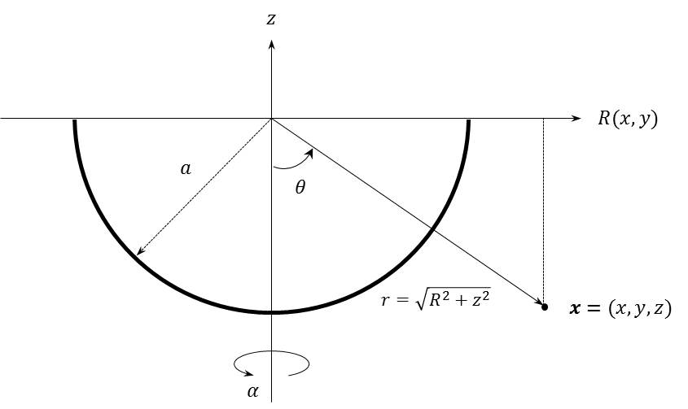

Multipole expansion of heaving hemisphere

The multipole expansion for heaving hemisphere is given by Hulme (1982). Because heave is symmetric motion, the velocity potential can be expressed as following. The multipoles, satisfying the Laplace equation, the free surface boundary condition, bottom boundary condition and radiation condition, are used.

where

Wave-pole can be expressed with alternative form. Please remind that the expression of di-gamma function in the following form is correct.

cf)

Multipole amplitudes

The body boundary condition is applied to calculate the multipole amplitudes.

Integrate above expression with respect to *μ* over (0, 1), Hulme(1982) assume *c*0 is not zero.

where

Let

Substitute

Recall the body boundary condition

Following equations are obtained after some manipulation :

Multiply ) and integrate with respect to *μ* over (0, 1).

Using the orthogonality of Legendre functions

The system equation of heaving hemisphere expressed with the multipoles are given as :

where

An alternative form is given as :

The value of *c*0 is given as :

Force acting on the heaving hemisphere

The acting forces are given as

Nondimensionalized force are given as

Wave elevation and fluids velocity

Wave elevation

Velocity

Because heave motion is symmetry,

The components to be evaluate for the velocity computation

**Derivatives with respect to r (Wave-term)**

Cf)

**Derivatives with respect to r (Wave-free-term)**

Cf)

**Derivatives with respect to theta (Wave-term)**

**Derivatives with respect to theta (Wave-free-term)**

**Jacobian (Gasirowicz 1974, pp: 167-168, Arfket 1985; p.108)**

: See Wolfram alpha ( definition is opposite ,

Results

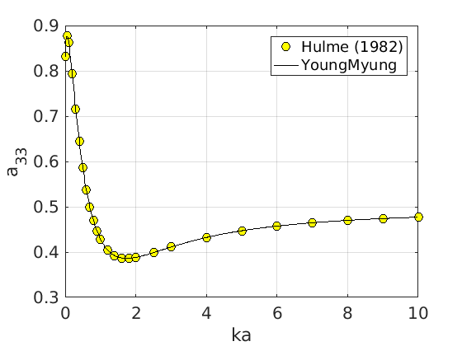

Nondimensionalized Added Mass

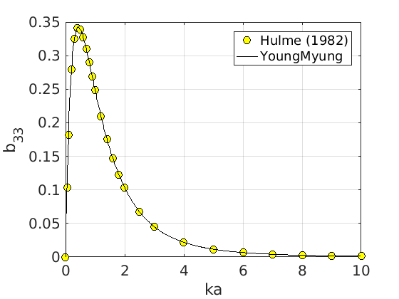

Nondimensionalized Damping

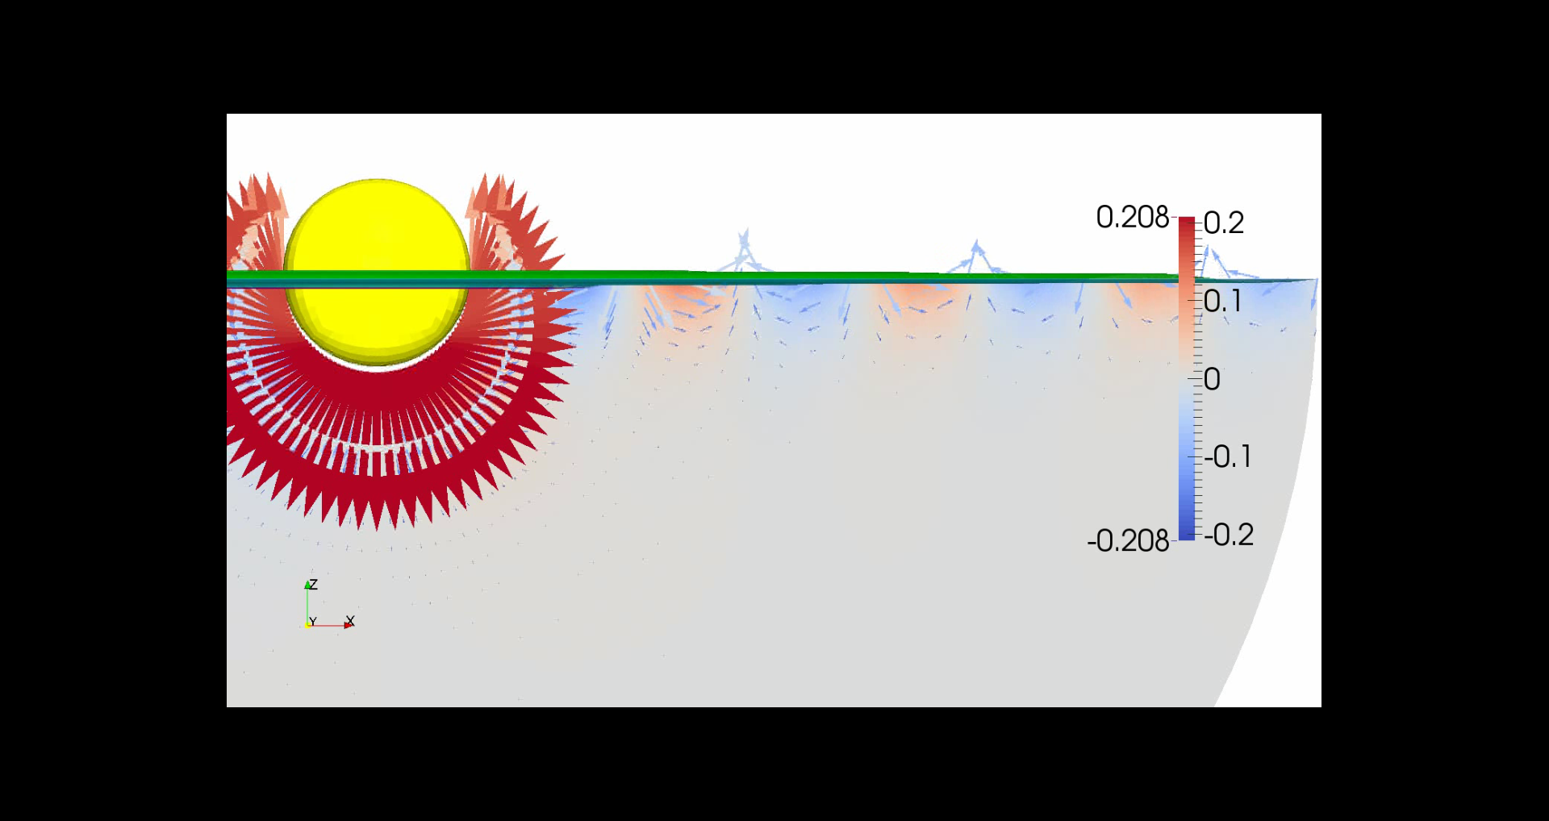

Velocity field of heaving hemisphere ()

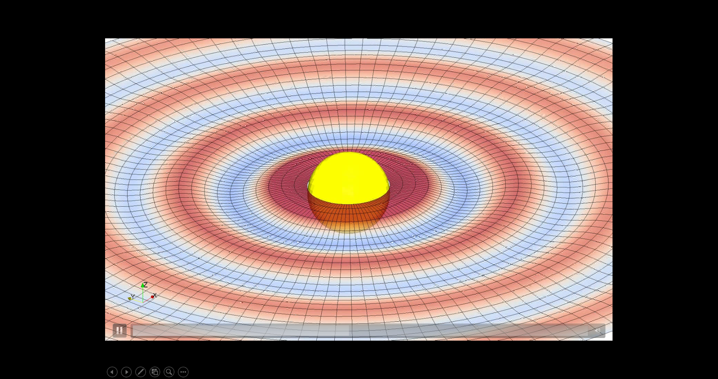

Wave field of heaving hemisphere ()

References

Hulme A.,1982. The wave forces acting on a floating hemisphere undergoing forced periodic oscillations, *Journal of Fluid Mechanics*, Vol 121, pp. 443-463.

Ursell F.,1949. On the heaving motion of a circular cylinder on the surface of a fluid, *Quart. J. Mech. Appl. Math.* Vol 2, pp. 218-231.

Szmytkowski R.,2011. On the derivative of the associated Legendre function of the first kind of integer order with respect to its degree (with applications to the construction of the associated Legendre function of the second kind of integer degree and order), *Journal of Mathematical Chemistry*, Vol 49 (7), pp. 1436-1477.

Havelock T. 1955. Waves due to a floating hemi-sphere making periodic heaving oscillations. *Proc. R. Soc. Lond*. A 231. pp.1-7.

**Appendix A.** Legendre Function and Multipoles

Evaluate

* Velocity and Potential, Wave Elevation

**Derivatives with respect to order (n)**

The derivaties with respect to order of Legendre function is given in Szmytkowski(2011).

where

**Residual Form (Safe and Efficient)**

**Schelknuoff Representation**

**Appendix B.** Auxiliary Integrals

***Jm* Term**

***Imn* term**

**The derivatives of *Imn*  with respect to order**

if *m* = *n*

where

Therefore

Integral with log is integrated with adaptive numerical quadrature

if *m* != *n*

If *m* is even

If *m* is odd

where