**Topic 5. Multimedia Product Service Platform (eg, Netflix, Spotify)**

1. **Topic Overview**

* **Context of the Problem:**

In today's context, multimedia product service platforms such as Netflix and Spotify are facing major security challenges. Finding and resolving vulnerabilities in this system is extremely important to ensure the safety of user data and prevent attacks. With large amounts of user data, payment information, and intellectual property across multimedia platforms, security becomes a critical issue. Threats such as piracy and unauthorized access need to be effectively prevented.

* **Related parties:**

+ Content Providers: play an important role in ensuring the security of multimedia data. They must ensure that the content provided is not illegally altered, and that any important information is closely guarded.

+ User: is the key element in the system and sets the expectation for privacy and safety of personal data. Protecting personal information and interaction history is important to creating a safe and trustworthy user experience.

+ Regulator: responsible for ensuring that multimedia platforms comply with regulations and security standards. They oversee the implementation of security measures and ensure data safety according to legal regulations and policies.

+ Platform Administrator: plays an important role in building and maintaining the security system. They need to implement access controls, monitor systems, and face security-related challenges.

* **Security Requirements:**

- User Data Protection:

+ Data Encryption: Ensure that all user data, including personal information and interaction history, is tightly encrypted to prevent unauthorized access from outside parties.

+ Secure Key Management: Implement robust key management methods to ensure that only authorized users can access relevant data.

- User Authentication and Authorization Security:

+ Two-Factor Authentication: Supports two-factor authentication to enhance user login security and prevent unauthorized access.

+ Secure Login and Session Management: Ensure that the login and session management process is secure, avoiding attacks such as session hijacking and credential theft.

- Ensuring Data Integrity and Authentication:

+ Data Integrity Checking: Deploy data integrity checking mechanisms to prevent unauthorized third-party modification.

+ Data Authentication: Authenticate the origin of the data to ensure that it has not been tampered with and is trustworthy.

* **Overview of Solutions:**

- Chaos-Based Stream Cipher

+ Objective: Chaos-based stream cryptography is applied to ensure unpredictability and high efficiency of the encryption process in the context of a multimedia product service platform.

+ Unpredictability: Chaos-based stream ciphers were chosen for their ability to generate unpredictable random number sequences, increasing the security of multimedia data streaming.

+ Efficiency and Speed: This method typically provides high performance, helping to ensure that multimedia data can be streamed without major performance hitches.

- AES (Advanced Encryption Standard)

+ Objective: AES, or Advanced Encryption Standard, is used in the encryption and decryption process to ensure the security and safety of multimedia data.

+ High Security: AES is a widely recognized symmetric encryption algorithm that provides a high level of security during the encryption and decryption of multimedia data.

+ Data Security: The use of AES ensures the safety and integrity of multimedia data during storage and transmission.

* Key Results:

The combination of chaos-based stream cipher and AES creates a powerful security system for multimedia product service platforms. Stream ciphers ensure unpredictability and efficiency, while AES ensures data confidentiality and security. This combination helps prevent cyber threats and ensures that users' multimedia information is tightly protected.

1. **Proposed Research Directions and Expected Results**

* Key References:

Smith, J., & Jones, A. (2022). "Security Challenges in Multimedia Streaming Platforms." Journal of Cybersecurity, 10(3), 245-260.

Brown, M., & White, L. (2021). "Enhancing User Authentication in Multimedia Services." International Conference on Multimedia Security, Proceedings, 45-58.

Garcia, R., & Patel, S. (2020). "A Comprehensive Analysis of Threats to Multimedia Product Service Platforms." Security and Communication Networks, 14(8), 1123-1135.

* Solution:

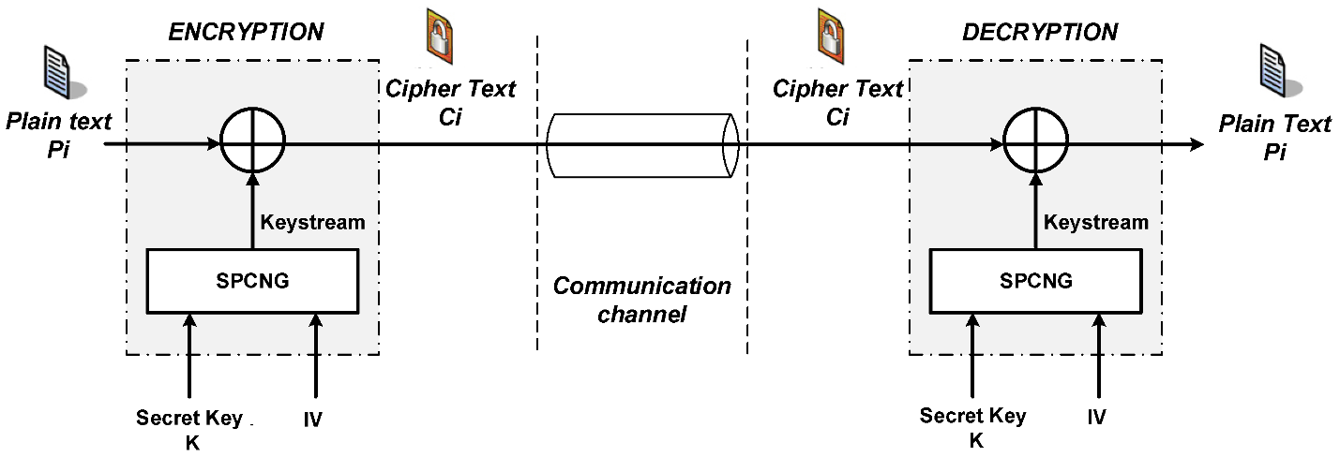

Figure 1. Block diagram of a stream encryption/decryption system.

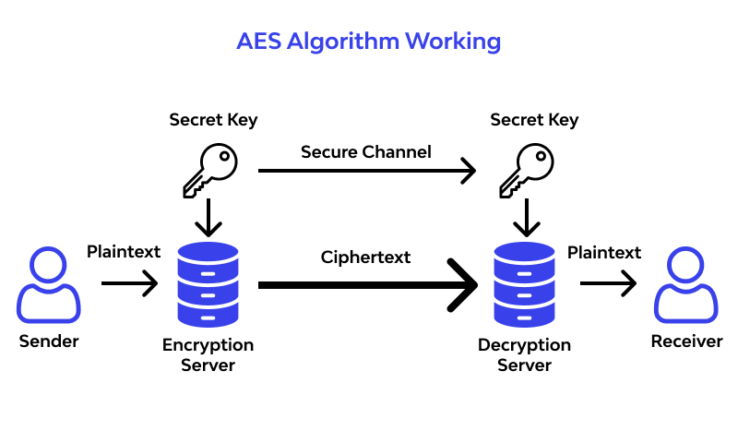

Figure 2. AES Algorithm Working.

To ensure security in the context of multimedia services such as Netflix and Spotify, we can focus on the following solutions:

+ Access Rights Management: Set up a powerful access rights management system to prevent unauthorized access and protect user privacy.

+ Multimedia Data Encryption: Use strong encryption for multimedia data storage and transmission, especially during online transmission.

+ Security Monitoring: Set up a continuous monitoring system to detect and respond to cyber threats, such as DDoS attacks or hacking.

* Research:

Concretizing security issues in the context of multimedia, you can research about:

+ Threat Analysis: Research on current and potential threats in multimedia services and develop solutions to combat them.

+ Multimedia Encoding: Research and develop advanced multimedia encoding methods, especially in online transmission environments.

+ Advanced Authentication: Research on how to improve user authentication in multimedia services to prevent fake accounts and unauthorized access.

1. **Proposed Research Directions and Expected Results**

* Application Context:

Security will be built into media services such as Netflix and Spotify as follows:

+ Data Encryption: Apply strong encryption to multimedia data to ensure security when stored and transmitted.

+ Access Control: Build a strict access management system to control users and ensure privacy .

* Suggested scenario:

+Encoding System Deployment: Integrate the new encoding solution into the multimedia infrastructure and ensure that the implementation does not significantly impact performance.

+ Safety Testing: Use safety testing tools to ensure that the system is free of security vulnerabilities and resistant to common attack scenarios.

* Test Objective:

+ Performance Evaluation: Evaluate the performance of newly deployed security systems, ensuring that there is no significant impact on user experience.

+ Threat Detection: Test the system to determine its ability to detect and respond to cyber threats.

* Conclude:

Testing and deployment are designed to ensure the effectiveness and safety of the security solution in a multimedia context. The results will provide important information about load capacity, security and threat response capabilities.