# Image List Browser Annotation Guide

# 1. Introduction

FaceMatch (FM) relies on machine learning to train its algorithms so it can properly detect and identify faces. In order for it to do so, it requires a training set of images where faces and other regions and attributes such as eyes and gender have already been identified. Using the ImageListBrowser (ILB) you can take unmarked images and identify these regions and attributes, recording them in .lst files.

## 1.1 Terms

**Annotation:**An Annotation is simply a line of information about an image. FM uses Annotations to test and train its algorithms to improve them. An Annotation usually looks something like "image.jpg f[0,0,10,10]" this example indicates that for the picture "image.jpg" there is a face in the image starting at the (0,0)th pixel of the image spanning down and to the left along the image in a 10by10 pixel box from there. To learn more about the formatting of Annotations, see the document *Manuals*/*ListFileSyntax*.

**List File and *.lst:**List files (files ending in ".lst") are plain text files that store Annotations, one Annotation per line. "*.lst" refers to any file ending in ".lst".

**Image List Browser (ILB):**ILB is a Java program used for annotating images. It lets you open up directories of images that you can annotate and then save as List Files, or else to open pre-existing List Files and edit them.

**2. Installation**

**2.1 Prerequisites**

Since the application runs on Java, the Java run time environment (JRE) is a requirement. ILB has been tested and is intended for use with Java 8.0 or greater. Please make sure this has been installed on your computer first. In order for the FaceMatch Library to be usable, the 64 bit version of the Java JRE should be installed (though most of the application will work on 32 bit Java).

Additional prerequisites for the FaceMatch Library are:

* + OpenCV: OpenCV is a Computer Vision Library originally made by Intel, now open-sourced, that FaceMatch requires.
  + Cuda: FaceMatch uses Cuda to improve its performance by using the computer’s GPU. Even if you do not have a GPU on your machine, you need to install the Cuda drivers if only so that FaceMatch can call the Cuda driver's functionality that can inform it there is no Cuda driver installed to use.
  + Visual C++ Redistributable Packages for Visual Studio (2013/2015/etc). A common Microsoft library may be required to run FaceMatch when compiled for Microsoft systems.

**2.2 Build**

To build the ILB, use an IDE like Eclipse to compile the source files and create an executable JAR file.

# 3. How to use ILB

## 3.1 Getting Started

Run the JAR file.

## 3.2 Opening an Image Directory and Selecting a List File:

The first time you run ILB you will be presented with a window containing a menu bar; the window should be otherwise empty (Figure-3.1).

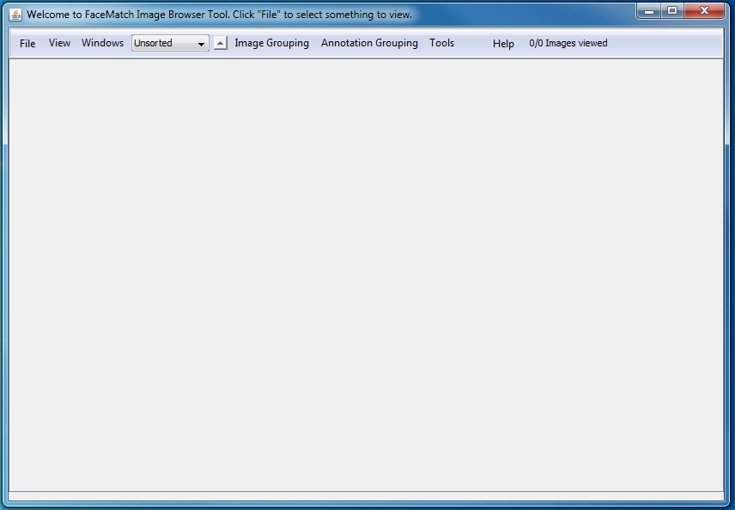

###### Figure-3.1: ILB on it's initial start-up.

To open a directory of images, click "File" in the upper left corner, and select "Open Directory" (Figure-3.2). This will open a file browser and allow you to select the directory you wish to look at images from. NOTE: when selecting a directory only images on the first level of the directory are displayed (Ie: if you select the directory "C:\images" only images from "C:\images" are displayed, and not images from child directories of it, ie no images from "C:\images\vacation2016" will display).

Notice that the "File" menu also offers the option to "Open List."

Selecting "Open List" allows you to select a list file, which then filters the directory of images you are looking at to only those images in the list file. NOTE the list file can specify images in children directories of the directory you're in and it will find them (ie: if you've opened ILB to the "C:\pictures" directory and the list file has a Annotation of "vacation2016\image1.jpg" on one line then "vacation2016\image1.jpg" will appear when you load that list).

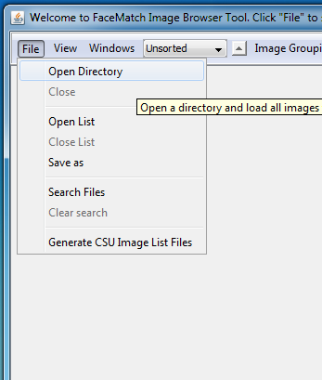

###### Figure-3.2: Opening a Directory.

## 3.3 Handling Thumbnails:

When you open a directory or list the main portion of ILB's display will fill with thumbnails of the image (Figure 3.3).

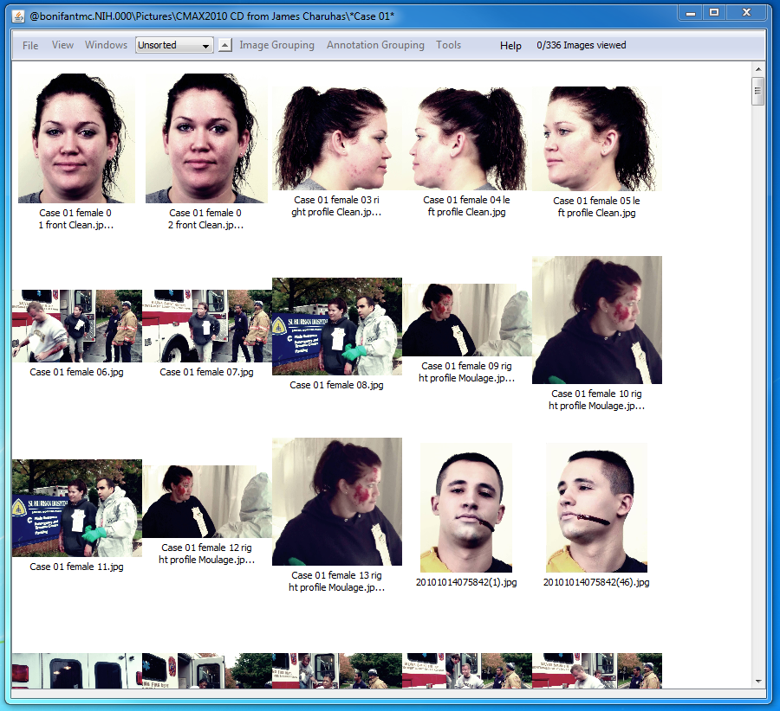

###### Figure-3.3: ILB after loading a directory of images, (these images specifically are from the CMAX2010 emergency drill, any blood you see is fake and part of the actor's moulage).

To get straight to making Annotations, either double-click on the image you want to annotate, or right click and select "open." This will open the image to its full size (or else scale it to fit your screen if it's particularly big image), section 3.4 details annotating images.

Besides opening images for annotating there are several other features of the main gallery you can utilize when looking at thumbnails. Right clicking on an image for instance lets you additionally remove the image from the list (if you have a list open), rotate an image, rename it and if FaceMatch is working on your system you can sort all the images based on their similarity to the selected image, or to a specific annotation in that image.

The menus provide several features:

* File:
  + Open Directory: open a directory of images
  + Close Directory: close the directory of images (also closes a list and clears a search if either are in use).
  + Open List: lets you open a List file, to filter a directory.
  + Close List: lets you close the List file and switches to looking at the directory (note: all annotations get saved to the list when you do this and then wipes them from the actual display, also any images that were in sub directories are removed from the display and any images in the main directory that weren't loaded will be loaded.)
  + Save as: lets you save the List file under a new name.
  + Search Files: lets you enter a search term, after which any image whose name matches the term will always float to the top of the display no matter how the images are being sorted or if you try to manually reorder the images. NOTE: The search term needs to be formatted as a "[glob](https://en.wikipedia.org/wiki/Glob_(programming))" (globs are a fancy type of text formatting used in search file systems, for more on globs see Appendix B.1).
  + Clear Search: lets you remove the search criteria, so whatever images floated at the top of the display will return to their normal location in the List file's ordering.
* View:
  + Grid View: in grid view all images are displayed as thumbnails moving horizontally and then vertically down the screen in a gird, this is the normal view ILB starts in and will be the one you're most likely to use.(Figure 3.4)
  + List View: in list view all images are displayed as thumbnails, one thumbnail per line moving vertically down the screen.
  + Image Grouping: Image grouping is a special mode that ILB can enter (see section 3.4.4.1)
  + Annotation Grouping: Annotation grouping is a special mode that ILB can enter (see section 3.4.4.2)
  + Thumbnail size: lets you adjust the size of the thumbnails in the display.
  + Manage Extra Lists: you can use this sub-menu to add additional lists to the display when in the 'List View.' This will pull the annotations from other list files up for you to compare side by side with the list you're actually editing. It includes options to add lists, remove all extra lists, remove individual extra lists, and the option to adjust a threshold value, when the disparity between the main list and the extra list is great enough the extra list's annotations will highlight in red to indicate the annotation is significantly different from the base list.

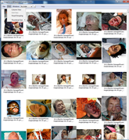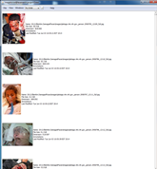

###### Figure 3.4: Grid view on the left, and List view on the right.

* Windows: control how many windows ILB produces
  + Single: When in 'single' mode ILB will open only one image to edit annotations on at a time. Trying to open a new window closes the last window open, also shifting from many to single closes all windows).
  + Many: When in 'many' mode ILB will let you open as many images to edit annotations as you want.
  + Close all: Closes all windows opened for editing annotations.
* DropDown menu/Sort
  + Unsorted: the order the images are in the list file
  + Alphabetical: sort images by their file names
  + Memory size: sort images by their file size
  + Height: sort images by their image height in pixels
  + Width: sort images by their image width in pixels
  + File Extension: sorts images into sections be file extension
  + Date Modified: sorts images by the last time you modified them (images are considered modified if you've opened and then closed the image, whether or not you actually change them).
  + Image Sort: If you searched one image against the rest of the gallery, you switch to this order. NOTE: this is order is saved until you do another such image search and can be restored by selecting this at any time (until you close the directory/list/application, after which you'll need to resort).
  + My Order: any ordering that isn't one of the above (ie: if you drag and drop the images to sort them manually or use a Search to float some images to the top)
* Arrow button:
  + Up/Down: toggling the arrow will flip the order the images are sorted in between ascending and descending order. NOTE images meeting any Search criteria imposed will remain at the top of the screen.
* Image Grouping: see section 3.4.1
* Annotation Grouping: see section 3.4.2
* Tools:
  + FaceFinder(FF): let's you adjust the parameters FaceMatch's automatic face detection uses (most features slow FF down, but give it a better chance to find faces, yet many may not be relevant like rotating images in a collection of mugshot quality pictures).
    - Rotation: FF rotates the image at 90 degree angles to look for faces it normally would miss (slows face detection, improves accuracy)
    - Multi-way Rotation: FF rotates the image at 30 degree angles to look for faces it normally would miss (slows face detection, improves accuracy)
    - Detect Landmarks: FF looks for features in a face (ie: eyes, ears, nose, mouth)
    - Histogram Equalization: FF adjusts the coloring of the image (a copy of it, not the one you see) to help find faces (slows face detection, improves accuracy)
    - Discard Featureless Faces: FF discards faces it couldn't find landmarks for (should reduce instances of FaceFinder finding faces in t-shirts and oddly textured objects).
  + FaceFinder Detect All: Calls the FaceFinder to run on all images in the list/directory
  + Statistics: displays a list of statistics about the images being viewed (number of images, annotations, landmarks, attributes, etc), the display has an option to refresh the stats if you want to leave the window open and continue making annotations, there is also an option to export the list to a text file.
* Help: opens the help menu.

Additional features:

* Images can be reordered by dragging and dropping them (by using ctrl+click you can select multiple images at once to drag them all). (In Grid and List view this is just cosmetic, in the grouping modes this lets you drag images into different groups see section 3.4 for more on grouping).
* The Display's title bar: the title bar will change, initially on a blank screen it instructs you to open a directory or list. Once you start opening things it displays what's open. in the format "<list file, if opened>@<directory>\<search terms, if any>" so you know what directory, list file, and search terms you're using.
* The Images Viewed (next to the help menu): displays how many images you've opened and then closed. This will persist for each list you work with, so when you close and open a list it will show you how many images you've already looked at roughly (it's suggested you don't open images you aren't going to annotate if you want an accurate count of how many images you have and haven't annotated yet)
* The Message bar (the gray bar at the bottom of the screen): This displays ILB's progress in loading (be that files, or running a call to FaceMatch's library), and various errors that may occur (such as not being able to detect the FaceMatch libraries on your system).

## 3.4 Annotating the Images

### 3.4.1 Annotations

Image annotation should be fairly simple. Before I explain how the actual annotation works though, let me explain what an annotation is.

An annotation is a square region on an image marking a specific feature/landmark. Textually all annotations are in the form “ ‘id'[x,y;w,l],” where ‘id’ is a single character indicating what the annotation is: f-a face, p-a profile, i-an eye, etc. x & y indicate the upper-left corner of the annotation region. Then the w & l are the dimensions of the rectangle containing the annotation. (Even when the annotation appears as a circle/ellipse, the annotation is still really a rectangle, in these cases however, they're displayed as the ellipse that the rectangle would circumscribe).

In the cases of faces, profiles, and skin patches these annotations can contain further annotations such as eyes, ears, nose, mouth, age, skin, gender, wounds, glasses, and id. In which case an annotation might be longer than the generic form given above, for instance f{[0,0;4,5] i[2,2;1,1] g[male] d[Larry]}  indicates the annotation is of 'Larry'(the d field), where 'Larry's face is(the f field), where one of his eyes is(the i field), and that Larry is in fact a male(the g field).

ILB has recently been improved to start annotating non-human entities. Mainly: pets (cats, dogs, and horses), which let's annotations become even more complicated so you can now get a{[0,0;100,100] h{[10,10;25,25] i[0,0;2,2]} k[dog] b[Bernese mountain dog]} so you have an animal, that hasa  head, that has an eye, and the animal, is a dog, specifically a berenese mountain dog, named Marie.

For more on Annotations see Appendix A.

### 3.4.2 Making the Annotations

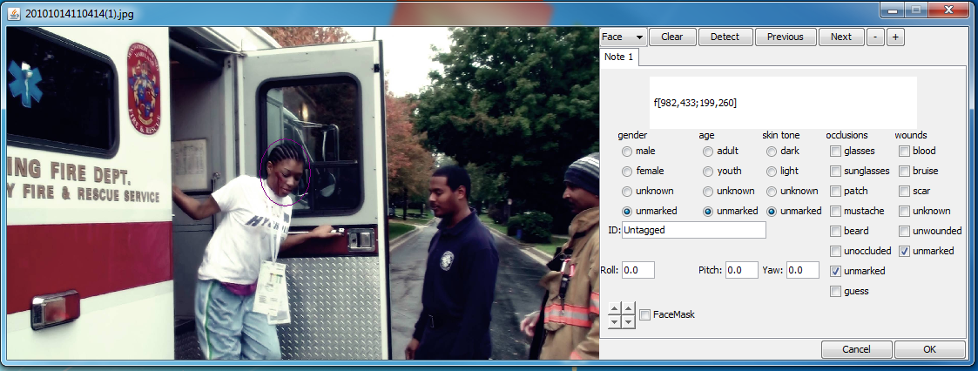

**Figure3.5 The menu for drawing/editing annotations.**

When you open an image it will display with a tabbed window to the side.

If the FaceMatch Library is available and there are not annotations on the image, then FaceMatch's FaceDetector will be called automatically to try to find faces in the image, reducing your work burden to only correcting the FaceFinder from FaceMatch.

Over the image directly you can click and drag your mouse to draw bounding boxes that segment the image producing the annotations. Then in the menu you can click on the different tabs to fill out the different information we're interested in collecting (marking the gender, age, skin tone, etc). By default you will be annotating faces, but there are many other kinds of annotations you can (and generally should) annotate. you can select different mods of annotation by using the drop down menu at the top of the menu portion of the window (in Figure 3.5, it's the button labeled 'Face' with a down arrow beside it). This will let you select the other options you can annotate (profiles, eyes, nose, mouths, skin, ears, animals, limbs, etc). You can also simply press different keys on your keyboard to shift between what you're annotating:

* f->face
* p->profile
* a->animal
* l->leg/limb
* h->head
* b->body
* t->tail
* i->eyes
* n->nose
* m->mouth
* e->ear

Pressing the keys while over an annotation will also change that annotation to the indicated type in the event that you were to say accidentally draw all features as eyes and then need to change some to noses and others to mouths, etc.

When drawing these annotations there are only 4 that can be drawn on the image directly, the face, profile, skin, and animals, all the other features are considered sub-features or 'landmarks' of the main feature. the below graphic explains which landmarks belong to which features along with some of the other different attributes you can annotate.

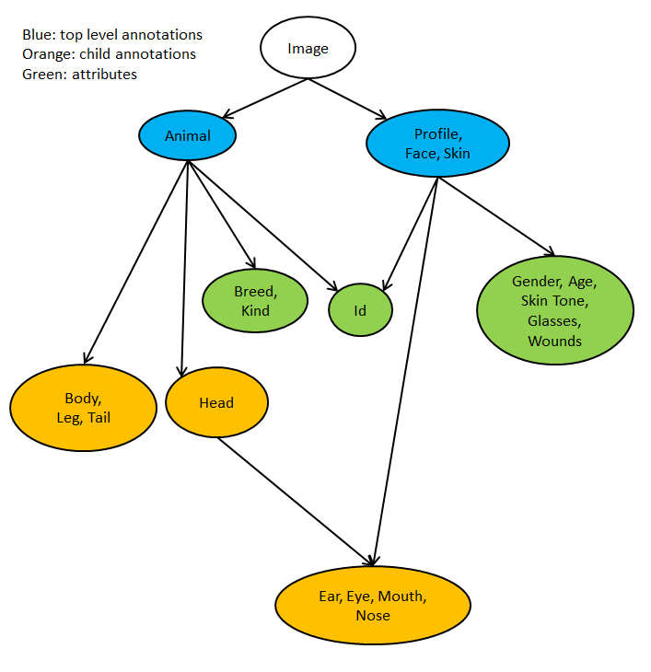

**Figure 3.6**

Double clicking an annotation will remove it from the image (doing so over an eye, ear, nose, mouth, deletes only that annotation, doing it over a face, profile, skin patch obviously removes all the annotations within it as well).

Ctrl-Z will undo the previous drawing, back until the image is as it was when you first opened it.

The plus and minus keys will shrink/grow the image to make it larger or smaller if need be (as do the plus and minus buttons on the menu).

The left and right arrow keys will move you up and down the list of images (as do the previous and next buttons on the menu).

Key-commands/short cuts:

1. If you type any individual character you will begin annotating for the type of annotation that character indicates.
2. Ctrl+Z: undoes the last annotation, holding down will continue undoing steps until all changes are removed. There is no redo.
3. Left/right arrow keys: closes the current image and opens the previous/next image on the list.

##### 3.4.3. Roll Pitch Yaw

Roll, Pitch, and Yaw together comprise a single attribute that can be annotated on images. They're used to label how an item of interest is oriented. For more on how to annotate Roll, Pitch, and Yaw, see the document *Manuals*/*RollPitchYaw*.

### 3.4.5 Grouping Images:

Images can be sorted into groups in two ways: Whole Image groups (actual Image Grouping) and Annotation Groups (grouping the specific annotations).

#### 3.4.5.1 Image Grouping

Any image can be sorted into a group. To do this you have to go to the Views menu and select "Image Grouping." This will display the images in the Image Grouping View. From there you can drag and drop images into any set of groups you want. A group is bordered by a blue line, and has the group name/id displayed in its top-left corner. You can expedite the process by using the Image Grouping Menu to select from various sorting methods to automatically group images: prefix, glob, regular expression matching, or Near Duplicate Detection. The first three are fast methods that determine what group an image should be in based on its file name.

* Prefix: groups images by their first n characters, where n is a number you supply. (eg: you can set it so all images starting with "img0001" are in a group, and "img0002" in another if the prefix is length 7, but if it were length 6, they'd all be grouped together as "img000.")
* Glob: groups images based on how they match a given glob (see Appendix A).
* Regular Expression: groups images based on how they match a given regular expression (see Appendix A).
* Near Duplicate Detection: Makes a call to FaceMatch's NearDup Detector.

#### 3.4.5.2 Annotation Grouping

Any annotation can be grouped. You can group image annotations while making the basic annotations by setting the annotation id/tag field, (right click over an annotation → Edit Tag, when annotating an image). Alternatively you can use the Annotation Grouping mode from the Views menu to group images. In this view all image are cropped to their annotations, and can be dragged and dropped into groups. A group is bordered by a blue line, and has the group name/id displayed in its top-left corner, the same as in Image Grouping. Right clicking on an image will let you change the name of the tag for all annotations in its group, or let you change the tag for that specific image.

You can also use the Annotation Grouping menu to aid in grouping images. You can group images either by comparing their names (via the prefix, glob, or regular expression matching) or by making FaceMatch calls (Near Duplicate Detection and Group by FaceMatch), in order to group with FaceMatch you have to “ingest” images which you can manually do by selecting ingest from this menu, or you can select Group by FaceMatch without ingesting, in which case Images will be ingested first and then grouped automatically. Images only need to be ingested once for each of the different method’s FaceMatch uses. FaceMatch has 6 different ways of matching images: Haar, Sift, Surf, RSILC, ORB, and LBPH. Additionally each of these different metrics for matching images can be combined and weighted to create a myriad of additional matching methods. Please NOTE that using the Near Image Duplicate Detector, prefix grouping, Regular Expression, and glob grouping methods from the Annotation Grouping menu, will still only match specific images as in the Image Grouping case, not annotations, this means if images have multiple annotations, all annotations will be assigned to the same group, which will rarely be true since it's not common that two faces in an image are the same (but there could be a mirror, or the image could be a composite of multiple pictures of the same person, so it's possible).

# Appendix A: Searching & Sorting by file name

## Globs:

Globs are specially formatted pieces of text used by computers to sort through large bodies of text

## Regex:

Regex is a common shorthand for the term "regular expression," regular expressions are used by computers to parse text into useful machine comprehensible information. Globs as a matter of course are merely dumbed down regular expressions.