LKCA User’s Manual in R
LKCA is a software toolbox for k-modes-type clustering algorithm. It provides the comprehensive open-source library for use in R that implement the clustering algorithm for categorical data. The library is designed to facilitate the development of new algorithm in this research and make comparisons between the new methods and existing ones available.

CONTENTS
1 Overview of LKCA 1
1.1 Introduction 1
1.2 Architecture of LKCA 1
1.3 Core function overview 2
2 Setup in R 2
2.1 Getting and installing 2
2.2 Data format 3
3 Core functions 5
3.1 Hard and Fuzzy k-modes clustering algorithm 5
3.1.1 K-modes-S 5
3.1.2 K-modes-M 6
3.1.3 K-modes-D 7
3.1.4 F-K-modes-S 8
3.1.5 F-K-modes-M 9
3.1.6 F-K-modes-D 10
3.2 Hard and Fuzzy SV-k modes clustering algorithm 11
3.2.1 SV-K-modes-S 11
3.2.2 SV-K-modes-M 12
3.2.3 SV-K-modes-D 13
3.2.4 F-SV-K-modes-S 14
3.2.5 F-SV-K-modes-M 15
3.2.6 F-SV-K-modes-D 16
3.3 Initial class center selection function 17
3.3.1 K-modes-k-initial-center 17
3.3.2 SV-K-modes-k-initial-center 18
3.4 Sub function 19
3.4.1 K-dis 19
3.4.2 K-center 20
3.4.3 SV-K-dis 21
3.4.4 SV-K-center 22

1 Overview of LKCA

1.1 Introduction
The k-means algorithm is well known for its efficiency in clustering large data set, however, working only on numeric data limits the use of these k-means-type algorithm. To solve this problem, Huang presented a k-modes algorithm, which extends the k-means algorithm by using a simple matching dissimilarity measure for categorical objects, modes instead of means for clusters, and a frequency-base method to update modes in the clustering process to minimize the clustering cost function.
But the limitation of k-modes algorithm is that each attribute of the objects only has a single categorical value. In real application, some objects maybe have more than one value for an attributes. For instance, many people may have several job titles and more than one hobby or email. Such data representation is very widespread in questionnaire, banking, insurance, retails, and medical databases. The capacity to deal with the categorical data with set-valued attributes is undoubtedly important for clustering algorithm. To cluster categorical data with set-values attributes, Cao proposed a SV-k-modes algorith.
As an emerging research direction, k-modes-type clustering algorithm provides a new, complementary algorithmic methodology to enrich clustering algorithm, especially clustering categorical data in big data analytics. But to the best of our knowledge, there is no comprehensive open-source packages existing for this problem. To facilitate research efforts on this research direction, we develop the open-source library called LKCA ( Library k-modes-type Clustering Algorithm ).
The main contribution of the LKCA library lies on two aspects. ( 1 ) It is the first comprehensive open-source library for clustering categorical data. ( 2 ) It is written in R and RStudio respectively, easy to use, and completely open source. We hope it will facilitate the development of clustering categorical data and encourage researchers to extend LKCA and share their algorithms through the LKCA framework.

1.2 Architecture of LKCA

The LKCA architecture is based on a separation of four modules, that is, k-modes algorithm, fuzzy k-modes algorithm, SV-k-modes algorithm, fuzzy SV-k-modes algorithm, as shown in Fig.1. The four modules in the LKCA architecture are designed independently, and all codes follow the R standards.
In each modules, LKCA provides three patterns to implement clustering algorithm, including single-threaded, multi-threaded and distributed computation. In the multi-threaded operation, it is provided with multiple CPU to execute multiple threads at the same time, which equivalently create a set of functions running in parallel. Through the multi-thread operation, it will improve the overall processing performance. In addition, by using distributed computing technology, the task will be decomposed into a number of small parts, and assigned to multiple computers for processing, which can save the overall computing time, and greatly improve the computational efficiency.
The implementation of the clustering algorithms depends on these sub functions, including the distance function, find mode function, and initial-center selection function.

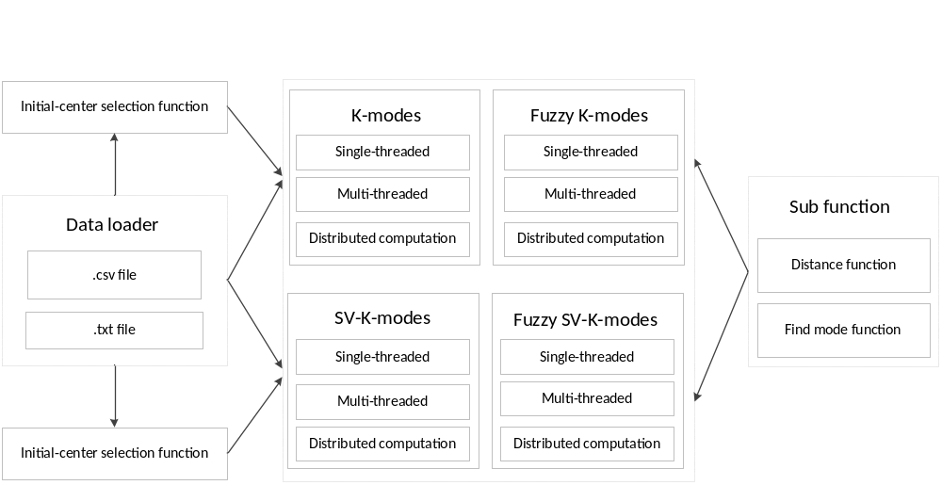

Figure 1 The architecture of LKCA

1.3 Core function overview
The core functions provided in the LKCA library are listed in Table 1.
Table 1 Core functions
R Function | Corresponding Algorithm
K-modes-S | K-modes algorithm(Single-threaded)
K-modes-M | K-modes algorithm(Multi-threaded)
K-modes-D | K-modes algorithm(Distributed Computation)
F-K-modes-S | Fuzzy K-modes algorithm(Single-threaded)
F-K-modes-M | Fuzzy K-modes algorithm(Multi-threaded)
F-K-modes-D | Fuzzy K-modes algorithm(Distributed Computation)
K-dis | Distance function of K-modes algorithm
K-center | Find mode function of K-modes algorithm
SV-K-modes-S | SV-K-modes algorithm(Single-threaded)
SV-K-modes-M | SV-K-modes algorithm(Multi-threaded)
SV-K-modes-D | SV-K-modes algorithm(Distributed Computation)
F-SV-K-modes-S | Fuzzy SV-K-modes algorithm(Single-threaded)
F-SV-K-modes-M | Fuzzy SV-K-modes algorithm(Multi -threaded)
F-SV-K-modes-D | Fuzzy SV-K-modes algorithm(Distributed Computation)
SV-K-dis | Distance function of SV-K-modes algorithm
SV-K-center | Find mode function of SV-K-modes algorithm
K-modes-k-initial-center | Initial cluster centers of k-modes
SV-K-modes-k-initial-center | Initial cluster centers of SV-k-modes

2 Setup in R

2.1 Getting and installing
To run the package, it is required that (1) Windows 7 operating system and above the version;(2) R 2.14.0, or above to be installed; (3) RStudio (4) The package should be loaded to the folder of current path, as shown in Figure 2.
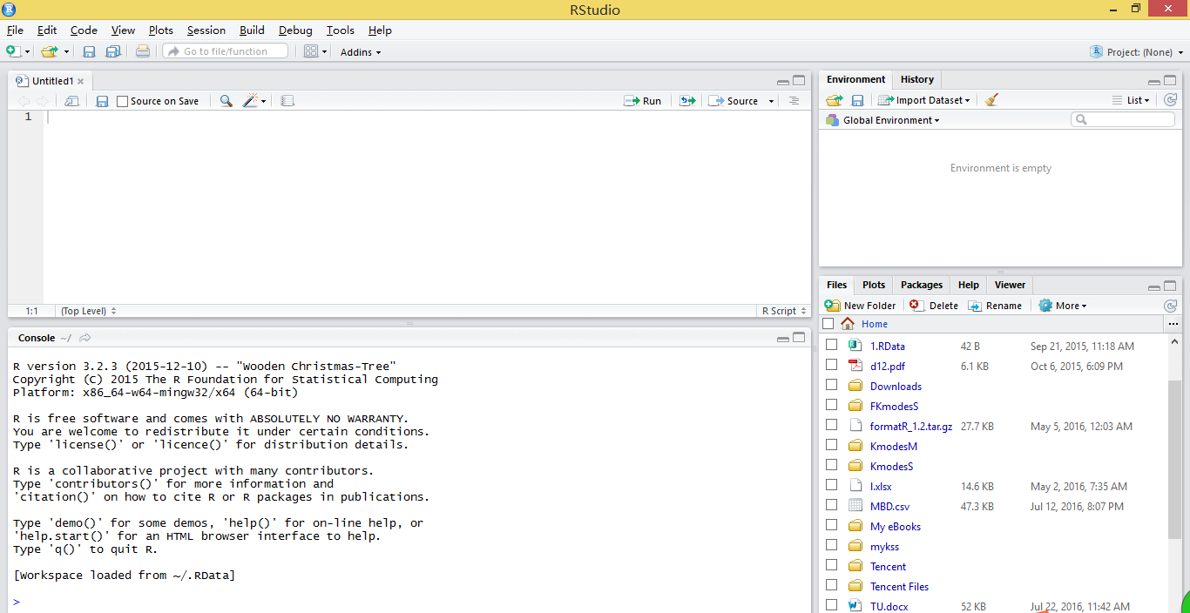
Figure 2 Loading the package
To use RStudio, you must install R in advance. Meanwhile, we can also use R to complete our work, as shown in Figure3. In this paper, we choose to use RStudio, which is a powerful and useful tool for R.
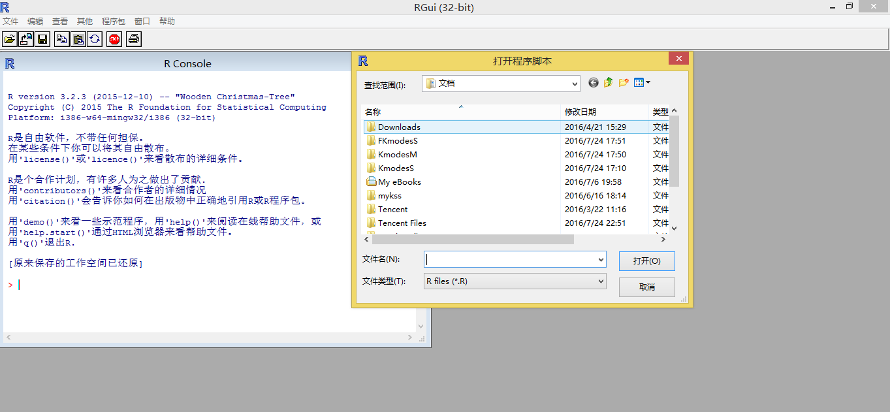
Figure 3 the Interface of R

2.2 Data format
It is required that a data set should be correctly imported to RStudio. Currently, R supports the csv file, txt file.
An example in RStudio is given in Figure 4. The lines represent the number of instances, and the columns represent the number of attributes. “header=FALSE or TRUE” represents that whether the first line is used as the column name. If the first line is used as the column name, we will input “ header=True ”. If not, input “ header=FALSE ”.
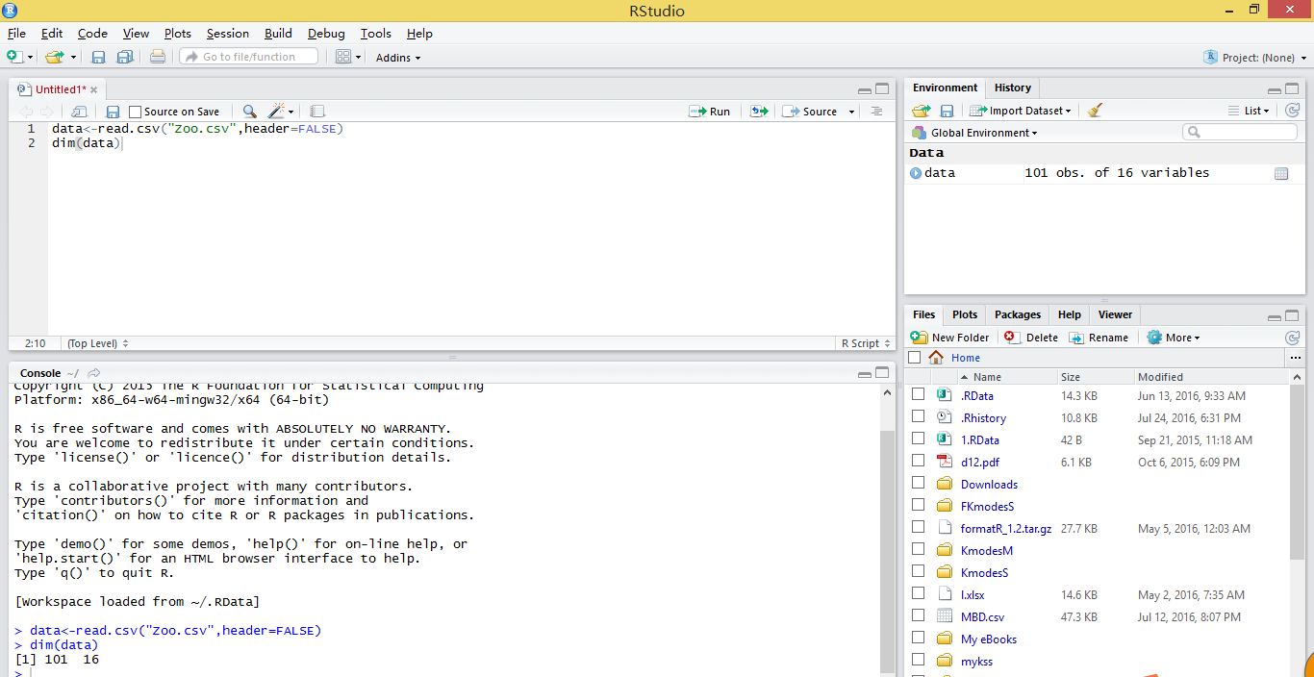
Figure 4 Example of Data format
This denotes that the data set contains 101 data instances, and the 16 columns represent the number of attributes. “header=FALSE ” represents that the first line is not used as the column name.

3 Core functions

3.1 Hard and Fuzzy k-modes clustering algorithm

3.1.1 K-modes-S
Description
Implement the K-Modes algorithm for single-threaded.
Usage
Hard-K-Mode ( data, k, InitialCenters )
return ( iter, cid, time )
Arguments
Inputs | data | Data set to be clustered
Inputs | K | Number of clusters
Inputs | InitialCenters | Initial cluster centers
Outputs | iter | Iteration number
Outputs | cid | Clustering result
Outputs | time | Computational cost
Details
The k-modes algorithm extends the k-means algorithm by using a simple matching dissimilarity measure for categorical objects, modes instead of means for clusters, and a frequency-base method to update modes in the clustering process to minimize the clustering cost function.
Reference
Z.Huang, ” Extensions to the k-means algorithm for clustering large data sets with categorical values,” Data Mining and Knowledge Discovery, vol.2, no. 3. Pp. 283 - 304, 1998
Example
>data=read.csv ( “Zoo.csv”, header=FALSE )
>K=7
>InitialCenters=NULL
>library ( KmodesS )
>Hard-K-Mode ( data, K, InitialCenters )
Results
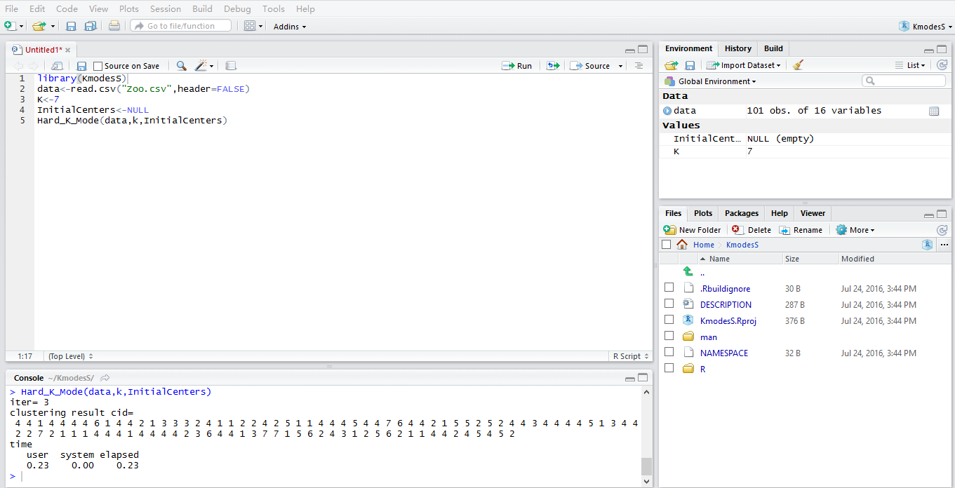
Figure 5 Example of the K-modes -S function

3.1.2 K-modes-M
Description
Implement the K-Modes algorithm for multi-thread operation.
Usage
Hard-K-Mode-M ( data, k, InitialCenters )
return ( iter, cid, time )
Arguments
Inputs | data | Data set to be clustered
Inputs | K | Number of clusters
Inputs | InitialCenters | Initial cluster centers
Outputs | iter | Iteration number
Outputs | cid | Clustering result
Outputs | time | Computational cost

Details
Multi thread operation is used to take advantage of multi-core machines and clusters of categorical data with reduce elapsed times. The operation o is provided with multiple CPU to execute multiple threads at the same time which equivalently create a set of copies of KmodesS package running in parallel .Through the multi thread operation, it will improve the overall processing performance.
Reference
Z.Huang, ” Extensions to the k-means algorithm for clustering large data sets with categorical values,” Data Mining and Knowledge Discovery, vol.2, no. 3. Pp. 283 - 304, 1998
Example
>library ( KmodesM )
>data=read.csv ( “ Zoo.csv ”, header=FALSE )
>K=7
>InitialCenters=NULL
>Hard-K-Mode-M ( data, K, InitialCenters )
Results
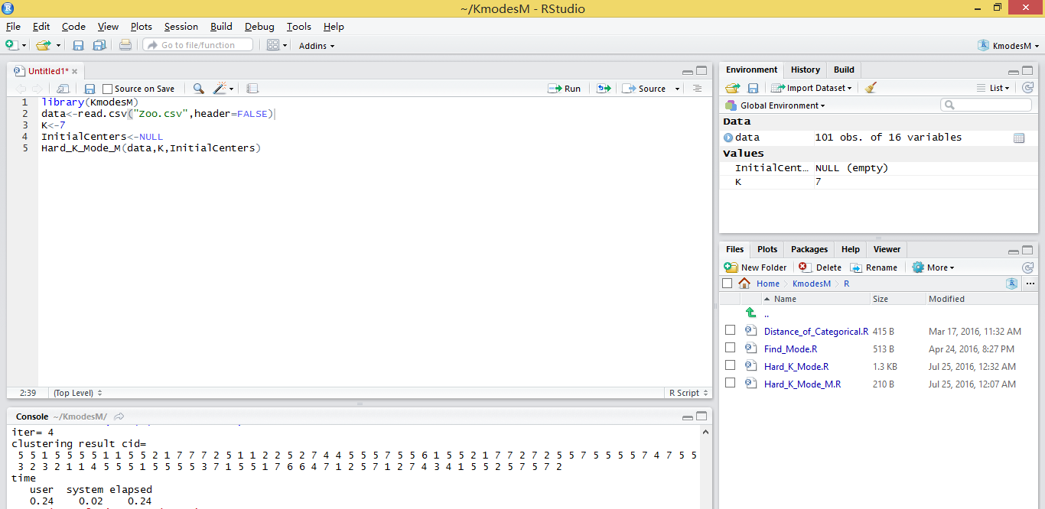
Figure 6 Example of the K-modes -M function

3.1.3 K-modes-D
Description
Implement the K-Modes algorithm for distributed computing.
Usage
Hard-K-Mode-D ( data, k, InitialCenters )
return ( nj )
Arguments
Inputs | data | Data set to be clustered
Inputs | K | Number of clusters
Inputs | InitialCenters | Initial cluster centers
Outputs | nj | Clustering result
Details
The distributed computing of the k-modes algorithm needs to rely on the RHadoop, which is a tool that connects R and Hadoop to realize the distributed computing of massive data.
Reference
Z.Huang, ” Extensions to the k-means algorithm for clustering large data sets with categorical values,”,Data Mining Knowledge Discovery, vol.2,no.3,Sept.1998
Example
>library ( KmodesD )
>data=read.csv ( “ Zoo.csv ”, header=FALSE )
>K=7
>InitialCenters=NULL
>Hard-K-Mode-D ( data, K, InitialCenters )
Results
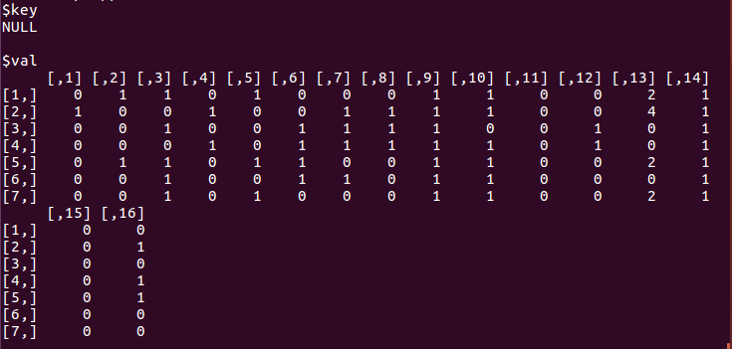
Figure 7 Example of the K-modes -D function

3.1.4 F-K-modes-S
Description
Implement the Fuzzy- K-Modes algorithm for single-threaded.
Usage
Fuzzy-K-mode-S ( data, K, InitialCenters, a )
return ( iter, cid, time )
Arguments
Inputs | data | Data set to be clustered
Inputs | K | Number of clusters
Inputs | InitialCenters | Initial cluster centers
Inputs | a | Index
Outputs | cid | Clustering result
Outputs | time | Computational cost
Outputs | iter | Iteration number

Details
The fuzzy k-modes algorithm is achieved by the development of a new procedure to generate the fuzzy partition matrix from categorical data within the framework of the fuzzy k-means algorithm. The main result of the algorithm is to find the fuzzy cluster modes when the simple matching dissimilarity measure is used for categorical objects.
Reference
Z.Huang and Michael K.Ng, ”A fuzzy k-modes algorithm for clustering categorical data,” Fuzzy System, IEEE Transaction on, vol. 7. No. 4 pp. 446-452.1999
Example
>data=read.csv ( “Zoo.csv”, header=FALSE )
>K=7
>InitialCenters=NULL
>a=1.1
>library ( FKmodesS )
>Fuzzy-K-Mode-S ( data, K, InitialCenters, a )
Results
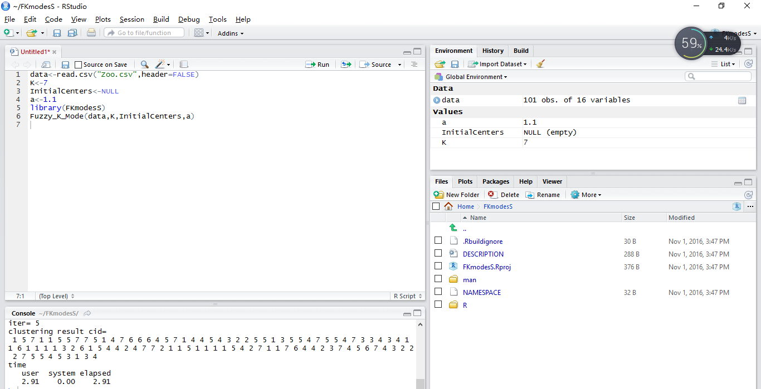
Figure 8 Example of the Fuzzy-K-Modes -S function

3.1.5 F-K-modes-M
Description
Implement the Fuzzy- K-Modes algorithm for multi-thread operation.
Usage
Fuzzy-K-Mode-M ( data, K, InitialCenters, a )
return( iter, cid, time )
Arguments
Inputs | data | Data set to be clustered
Inputs | K | Number of clusters
Inputs | InitialCenters | Initial cluster centers
Inputs | a | Index
Outputs | cid | Clustering result
Outputs | time | Computational cost
Outputs | iter | Iteration number

Details
Please refer to the details of the F-K-modes-S mentioned above.
Reference
Z.Huang and Michael K.Ng,”A fuzzy k-modes algorithm for clustering categorical data,” Fuzzy System, IEEE Transaction on, vol. 7. No. 4 pp. 446-452.1999
Example
>data=read.csv ( “Zoo.csv”, header=FALSE )
>K=7
>InitialCenters=NULL
>a=1.1
>library ( FKmodesM )
>Fuzzy-K-Mode-M ( data, K, InitialCenters, a )
Results
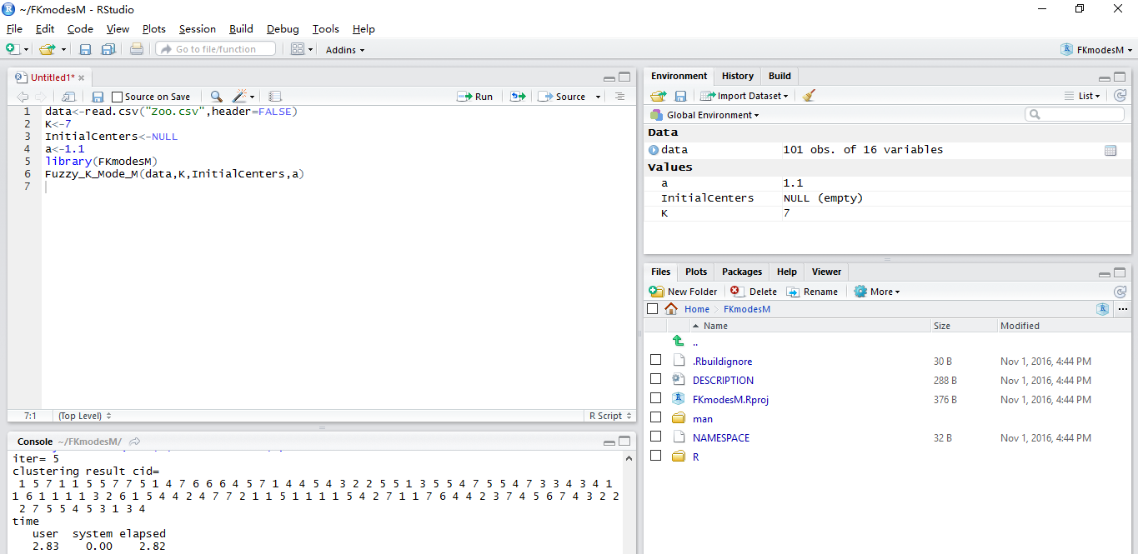
Figure 9 Example of the Fuzzy-K-modes -M function

3.1.6 F-K-modes-D
Description
Implement the Fuzzy- K-Modes algorithm for distributed computing.
Usage
Fuzzy-K-Mode-D ( data, K, InitialCenters, a )
return ( iter, cid, time )
Arguments
Inputs | data | Data set to be clustered
Inputs | K | Number of clusters
Inputs | InitialCenters | Initial cluster centers
Inputs | a | index
Outputs | nj | Clustering result
Details
Please refer to the details mentioned above.
Reference
Z.Huang and Michael K.Ng,”A fuzzy k-modes algorithm for clustering categorical data,” Fuzzy System, IEEE Transaction on, vol. 7. No. 4 pp. 446-452.1999
Example
>data=read.csv ( “ Zoo.csv ”, header=FALSE)
>K=7
>InitialCenters=NULL
>a=1.1
>library ( FKmodesD )
>Fuzzy-K-Mode-D ( data, K, InitialCenters, a)
Results
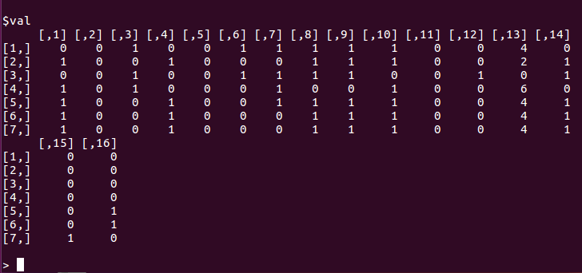
Figure 10 Example of the Fuzzy-K-modes -D function

3.2 Hard and Fuzzy SV-k modes clustering algorithm

3.2.1 SV-K-modes -S
Description
Implement the SV-K-modes algorithm for single-threaded.
Usage
New-ratio-k-multi-modes ( Data, K, InitialCenters )
return ( time )
Arguments
Inputs | Data | Data set to be clustered
Inputs | K | Number of clusters
Inputs | InitialCenters | Initial cluster centers
Outputs | Time | Computational cost

Details
The SV-k-modes clustering algorithm is designed to cluster the objects with set-valued attributes. The algorithm can partition data with mixed single-valued and set-valued attributes and the k-modes algorithm is its special case.
Reference
Fuyuan Cao, Joshua Zhexue Huang, Jiye Liang, Xingwang Zhao and Yinfeng Meng. “SV-k-modes: an Algorithm for Clustering Categorical Data with Set-valued Attributes,” Neural Networks and Learning System. IEEE Transaction, vol.13.No.9,April 2015
Example
>library ( SVKS )
>Data=read.csv ( “ MBD.csv ” , header=FALSE )
>K=10
>InitialCenters=NULL
>New-ratio-k-multi-modes ( Data, K, InitialCenters )
Results
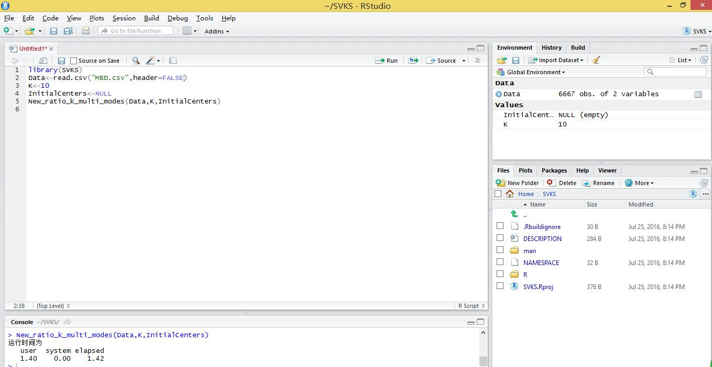
Figure 11 Example of the SV-K-modes -S function

3.2.2 SV-K-modes-M
Description
Implement the SV-K-modes algorithm for multi-threaded.
Usage
New-ratio-k-multi-modes-M ( Data, K, InitialCenters )
Return ( time )
Arguments
Inputs | Data | Data set to be clustered
Inputs | K | Number of clusters
Inputs | InitialCenters | Initial cluster centers
Outputs | time | Computational cost
Details
Please refer to the description mentioned above.
Reference
Fuyuan Cao, Joshua Zhexue Huang, Jiye Liang, Xingwang Zhao and Yinfeng Meng. “SV-k-modes: an Algorithm for Clustering Categorical Data with Set-valued Attributes,” Neural Networks and Learning System. IEEE Transaction, vol.13.No.9,April 2015
Example
>library ( SVKM )
>Data=read.csv ( “ MBD.csv ” , header=FALSE )
>K=10
>InitialCenters=NULL
>New-ratio-k-multi-modes ( Data, K, InitialCenters )
Results
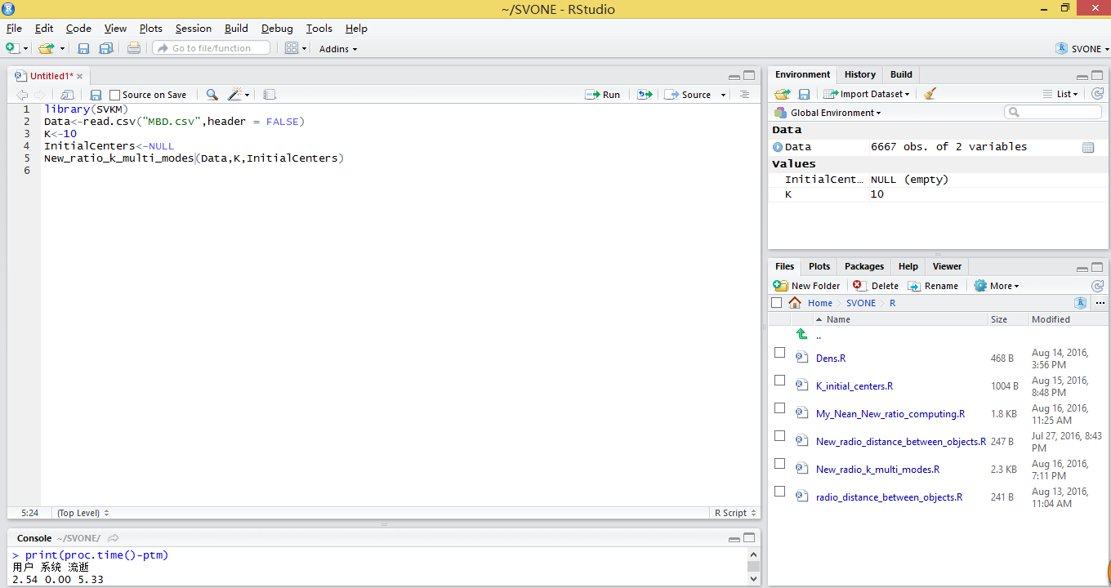
Figure 12 Example of the SV-K-modes -M function

3.2.3 SV-K-modes-D
Description
Implement the SV-K-modes algorithm for distribute computation.
Usage
New-ratio-k-multi-modes-D ( Data, K, InitialCenters )
Return ( nj )
Arguments
Inputs | Data | Data set to be clustered
Inputs | K | Number of clusters
Inputs | InitialCenters | Initial cluster centers
Outputs | nj | Clustering result
Details
Please refer to the details mentioned above.
Reference
Fuyuan Cao, Joshua Zhexue Huang, Jiye Liang, Xingwang Zhao and Yinfeng Meng. “SV-k-modes: an Algorithm for Clustering Categorical Data with Set-valued Attributes,” Neural Networks and Learning System. IEEE Transaction, vol.13.No.9,April 2015
Example
>library ( SVKD )
>Data=read.csv ( “ MBD.csv ” , header=FALSE )
>K=10
>InitialCenters=null
>New-ratio-k-multi-modes ( Data, K, InitialCenters )
Results
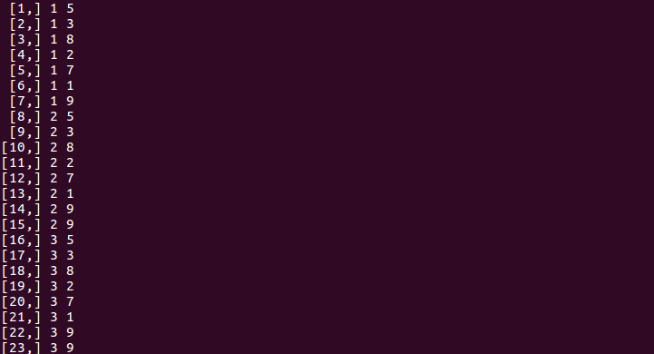

Figure 13 Example of the SV-K-modes -D function

3.2.4 F-SV-K-modes-S
Description
Implement the fuzzy SV-K-modes algorithm for single-threaded.
Usage
Fuzzy-ratio-k-multi-modes ( Data, K, InitialCenters, a )
return ( iter, cid, time )
Arguments
Inputs | data | Data set to be clustered
Inputs | K | Number of clusters
Inputs | InitialCenters | Initial cluster centers
Inputs | a | Index
Outputs | cid | Clustering result
Outputs | time | Computational cost
Outputs | iter | Iteration number
Details
Fuzzy SV-k-modes algorithm use Jaccard coefficient to compute the similarty measure between two objects and represent the center of a cluster with set-valued mode. A kind of update ways of cluster prototype is developed for the fuzzy partition matrix. These extensions made the fuzzy SV-k-modes algorithm can cluster categorical data with mixed single-valued and set-valued attributes.
Reference
Fuyuan Cao, Joshua Zhexue Huang, Xingwang Zhao and Jiye Liang, A Fuzzy SV-k-modes Algorithm for Clustering Categorical Data with Set-valued Attributes
Example
>library ( FSVKS )
>Data=read.csv ( “ MBD.csv ”, header=FALSE )
>K=10
>InitialCenters=NULL
>a=1.1
>Fuzzy-ratio-k-multi-modes ( Data, K, InitialCenters, a )
Results
Figure 14 Example of the Fuzzy-SV-K-modes -S function

3.2.5 F-SV-K-modes-M
Description
Implement the fuzzy SV-K-modes algorithm for multi-threaded.
Usage
Fuzzy-ratio-k-multi-modes-M ( Data, K, InitialCenters, a )
Return ( time )
Arguments
Inputs | data | Data set to be clustered
Inputs | K | Number of clusters
Inputs | InitialCenters | Initial cluster centers
Inputs | a | Index
Outputs | cid | Clustering result
Outputs | time | Computational cost
Outputs | iter | Iteration number
Details
Please refer to the description mentioned above.
Reference
Fuyuan Cao, Joshua Zhexue Huang, Xingwang Zhao and Jiye Liang, A Fuzzy SV-k-modes Algorithm for Clustering Categorical Data with Set-valued Attributes
Example
>library ( FSVKM )
>Data=read.csv ( “ MBD.csv ” ,header=FALSE )
>K=10
>InitialCenters=NULL
>a=1.1
Fuzzy-ratio-k-multi-modes-M ( Data, K, InitialCenters,a )
Results
Figure 15 Example of the Fuzzy-SV-K-modes-M function

3.2.6 F-SV-K-modes-D
Description
Implement the fuzzy SV-K-modes algorithm for distribute computation.
Usage
Fuzzy-ratio-k-multi-modes-D ( Data, K, InitialCenters )
Return ( nj )
Arguments
Inputs | Data | Data set to be clustered
Inputs | K | Number of clusters
Inputs | InitialCenters | Initial cluster centers
Inputs | a | index
Outputs | nj | Clustering result
Details
Please refer to the description mentioned above.
Reference
Fuyuan Cao, Joshua Zhexue Huang, Jiye Liang, Xingwang Zhao and Yinfeng Meng,SV-k-modes: an Algorithm for clustering Categorical Data with Set-Valued Attributes, IEEE Transactions on meural networks and Learning system. Vol. 13. NO. 9. April. 2015
Example
>library ( FSVKD )
>Data=read.csv ( “ MBD.csv ” , header=FALSE )
>K=10
>InitialCenters=NULL
>a==1.1
>Fuzzy-ratio-k-multi-modes-D ( Data, K, InitialCenters, a)
Results
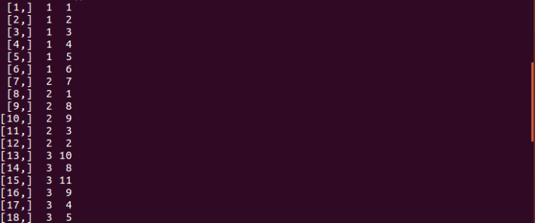
Figure 16 Example of the Fuzzy-SV-K-modes -D function

3.3 Initial class center selection function

3.3.1 K-modes-k-initial-center
Description
The initialization clustering algorithm to select the initial cluster centers for the k-modes algorithm.
Usage
k-initial-center<-function(data,K)
return(DDist)
Arguments
Input | data | A vector in data matrix
Input | K | Number of clusters
Output | DDist | Initial cluster centers

Details
The initialization clustering algorithm for categorical data is given to choose first class center by calculating the average density of the objects. If selecting more initial centers, it needs to consider the density of an object and the distance between the object and the selected initial cluster centers simultaneously.
Reference
Fuyuan Cao,Jiye Liang,Liang Bai. A new initialization method for categorical data clustering, Expert Systems with Applications, 2009, 36(7):10223-10228
Example
>Data=read.csv(“Zoo.csv”,header=FALSE)
>K=7
Result
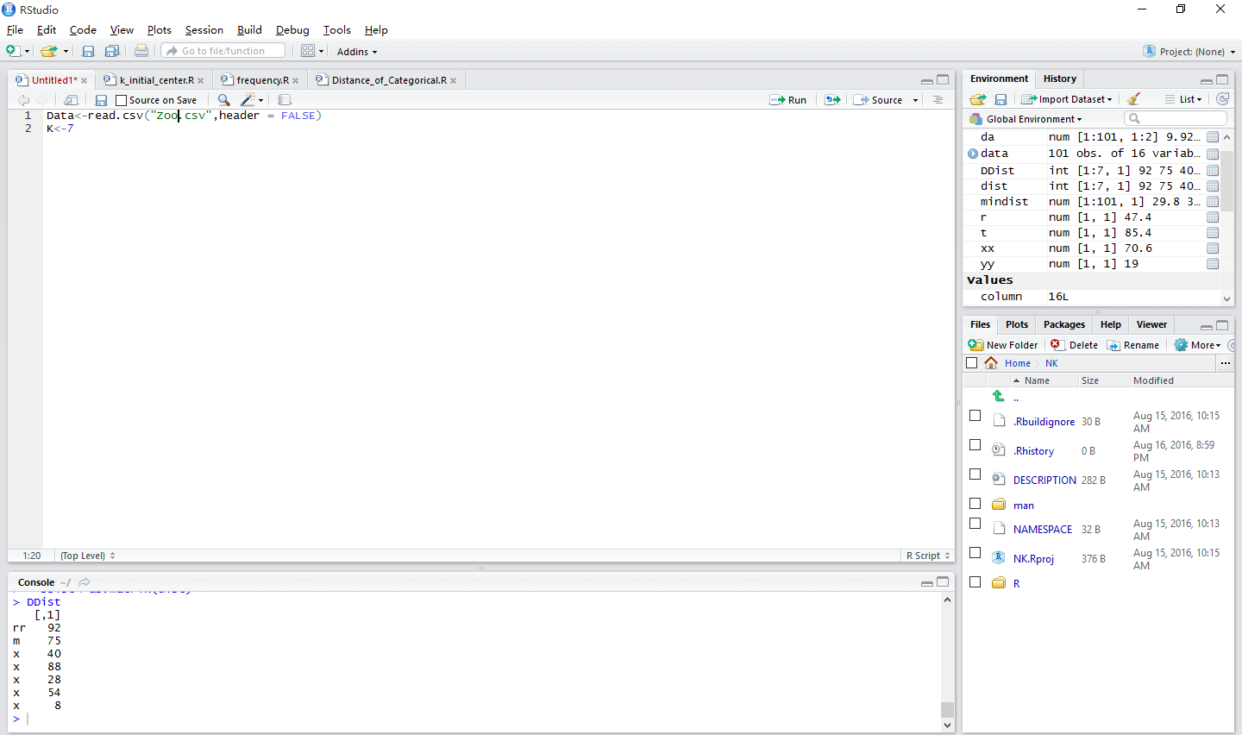
Figure 17 Example of the K-modes-k-initial-center function

3.3.2 SV-K-modes-k-initial-center
Description
The initialization algorithm to select the initial cluster centers for the SV-k-modes algorithm.
Usage
K-initial-centers<-function(Data,K)
Return(dist)
Arguments
Input | Data | A vector in data matrix
Input | K | Number of clusters
Output | dist | Initial cluster centers

Details
The initialization algorithm is to select the initial cluster centers for the SV-k-modes algorithm by extending the initialization method. If selecting more initial centers, it needs to consider the density of an object and the distance between the object and the selected initial cluster centers simultaneously.
Reference
Fuyuan Cao, Joshua Zhexue Huang, Jiye Liang, Xingwang Zhao and Yinfeng Meng,SV-k-modes: an Algorithm for clustering Categorical Data with Set-Valued Attributes, IEEE Transactions on meural networks and Learning system. Vol. 13. NO. 9. April. 2015
Example
>Data=read.csv(“MBD2.csv”, header=FALSE)
>K=3
Result
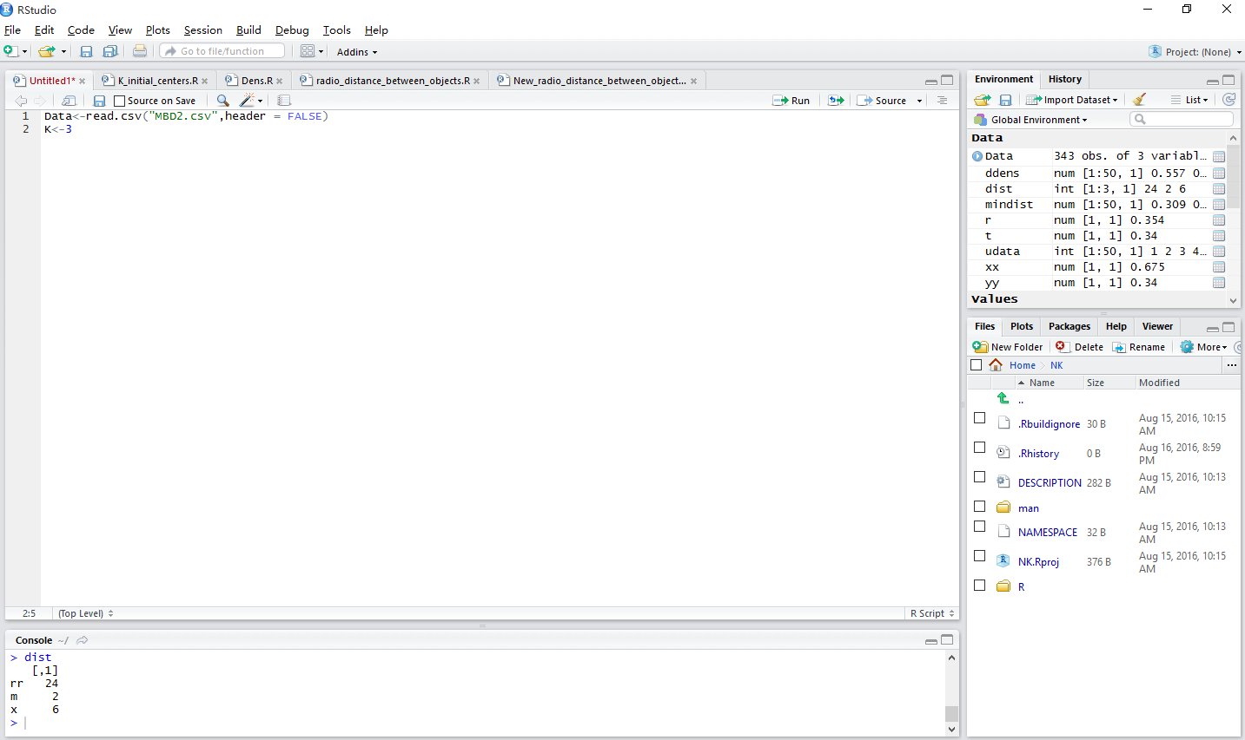
Figure 18 Example of the K-modes-k-initial-center function

3.4 Sub function

3.4.1 K-dis
Description
Calculate the distance between each object to the class center.
Usage
Distance-of-Categorical ( Data1, Data2 )
Return ( distance )
Arguments
Inputs | Data1 | A vector in data matrix
Inputs | Data2 | A vector in data matrix
Output | distance | The distance between Data1 and Data2

Details
A simple 0 - 1 matching method is used to calculate the distance between the two attributes of different objects in the same classification.
Example
>Data=read.csv ( “ Zoo.csv ” , header=FALSE )
>Distance-of-Categorical ( Data [ 1:10, ] , Data2 [10:20 , ] )
Results
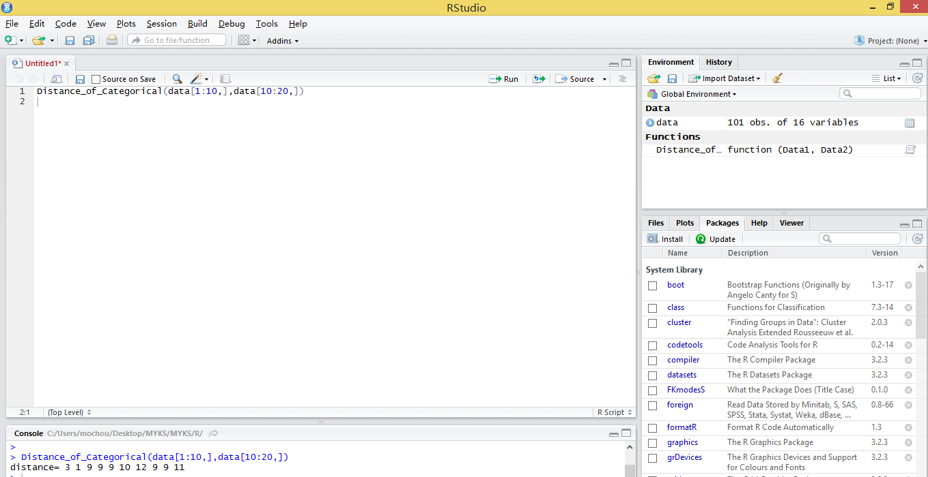
Figure 19 Example of the K-dis function

3.4.2 K-center
Description
Calculate the cluster centers for each class.
Usage
Find-Mode ( Data )
Return ( NNew-Mode )
Arguments
Input | Data | A vector in data matrix
Output | NNew-Mode | The cluster centers for Data

Details
Calculate the maximum number of frequencies in each attribute as the center of each class.
Example
>Data=read.csv ( “ Zoo.csv ”, header=FALSE )
>Find-Mode ( Data [ 1:30, ] )
Results
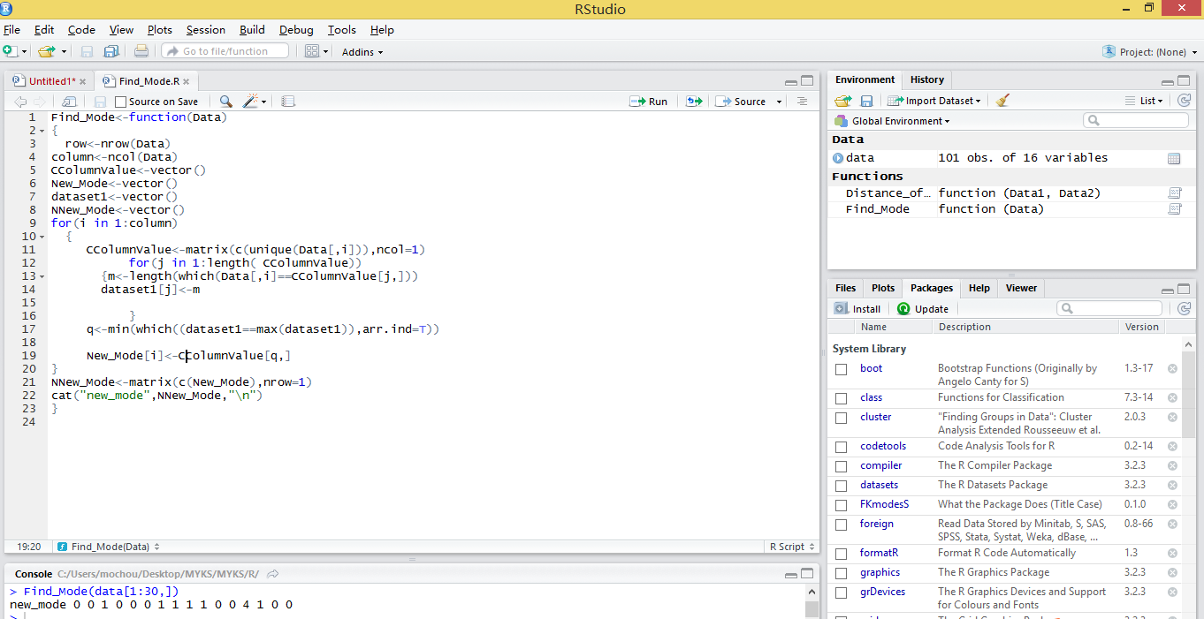
Figure 20 Example of the K-center function

3.4.3 SV-K-dis
Description
The distance function of SV-K-modes algorithm.
Usage
New-ratio-distance-between-objects ( DData1, DData2 )
Return ( distance )
Arguments
Inputs | DData1 | A vector in data matrix
Inputs | DData2 | A vector in data matrix
Output | distance | The distance between Data1 and Data2
Details
Calculate the distance between each object to the center of each class.
Reference
Fuyuan Cao, Joshua Zhexue Huang, Jiye Liang, Xingwang Zhao and Yinfeng Meng. “SV-k-modes: an Algorithm for Clustering Categorical Data with Set-valued Attributes,” Neural Networks and Learning System. IEEE Transaction, vol.13.No.9,April 2015
Example
>DData1=c(1,3,5,6,8,9,2)
>DData2=c(2,4,5,7,8,1,9)
>New-ratio-distance-between-objects(DData1,DData2)
Results
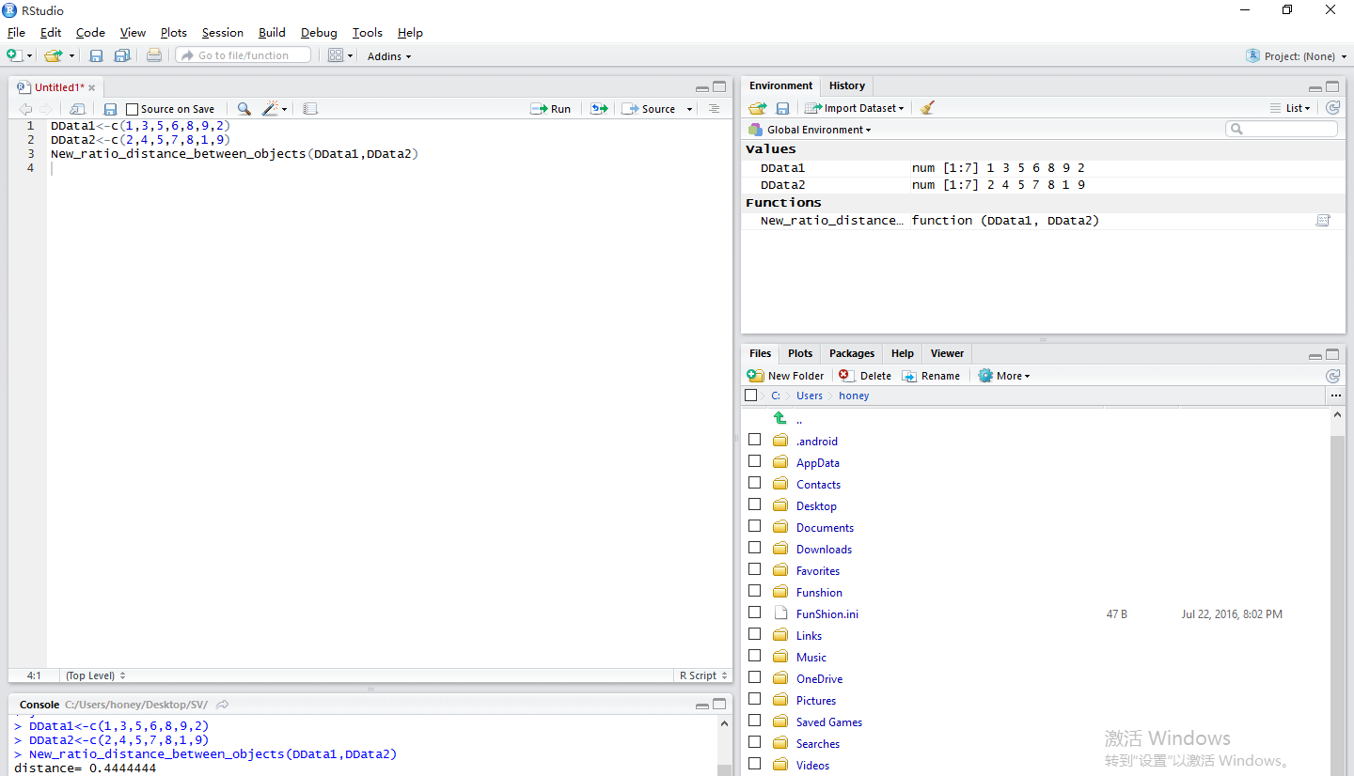
Figure 21 Example of the SV-K-dis function

3.4.4 SV-K-center
Description
The find mode function of SV-K-modes algorithm.
Usage
My-Nean-New-ratio-computing-modes(data)
return(Mode)
Arguments
Input | data | A vector in data matrix
Output | Mode | The cluster centers for data

Reference
Fuyuan Cao, Joshua Zhexue Huang, Jiye Liang, Xingwang Zhao and Yinfeng Meng,SV-k-modes: an Algorithm for clustering Categorical Data with Set-Valued Attributes, IEEE Transactions on meural networks and Learning system. Vol. 13. NO. 9. April. 2015
Example
>Data=read.csv(“MBD1.csv”,header=FALSE)
>My-Nean-New-ratio-computing-modes(data)
Results
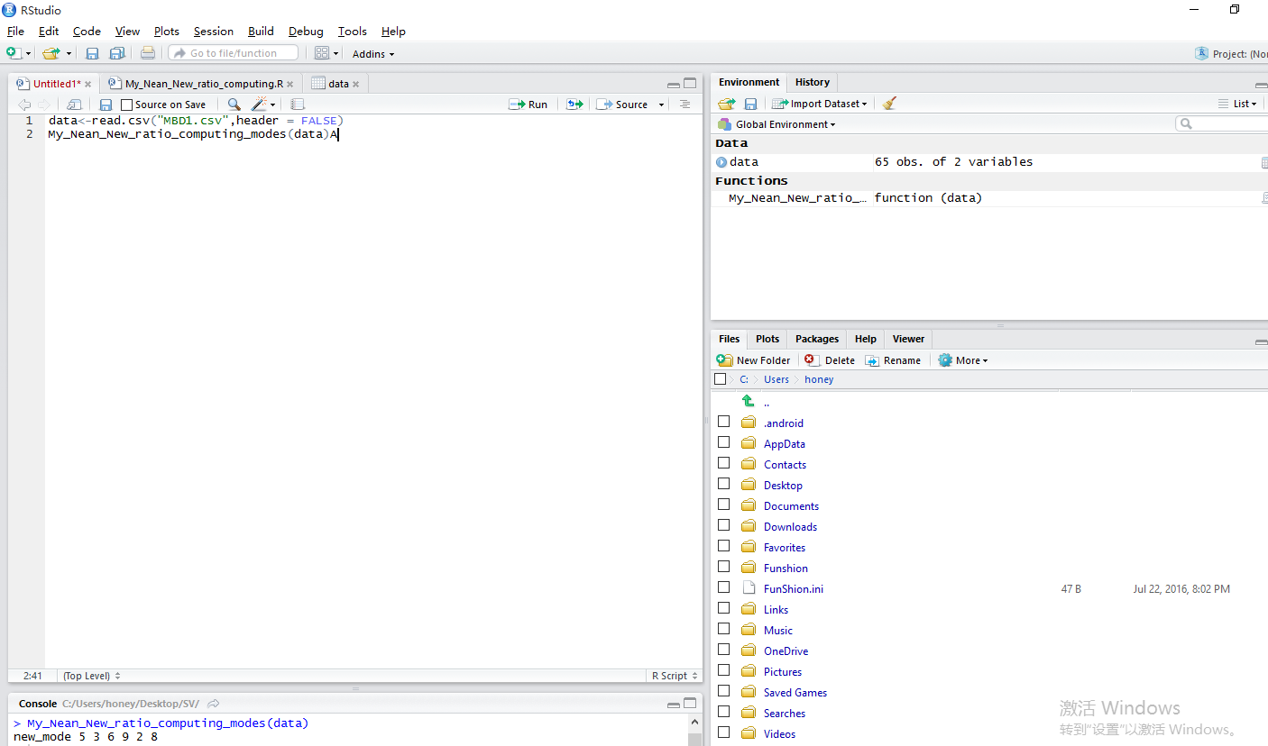
Figure 22 Example of the SV-K-center function

