学院 专业 级 学号 姓名
2016-2017 学年 2 学期
第 页 共 页
题号 | 一 | 二 | 三 | 四 | 五 | 六 | 七 | 八 | 九 | 十 | 总分 | 总分人
得分

得分 | 阅卷人

Part I. Multiple Choice Questions (5 points each)

1. Give an order of the following phases according to the rendering pipeline _cebda OR cbeda_
a) Fragment Processor
b) Clipper
c) Vertex Processor
d) Rasterizer
e) Primitive Assembler

2. Which phase (as listed above) does each of the following operations belong to?
__c__ To convert object representations from one coordinate system to another
__d__ To generate inside fragments for a polygon and calculate their colors
__b__ To determine which objects are within the view volume
__a__ To determine the color of the corresponding pixel in the frame buffer

3. Which of the following statements regarding affine transformations is(are) correct?
__abd__
a) Two translations are commutative.
b) Two rotations about the same axis are commutative.
c) A scaling and a rotation are commutative
d) A general rotation about an arbitrary line can be done with translations and rotations around the axes.

4. Which of the following statements about the homogeneous-coordinates representation is(are) correct? _ab_
a) It can be used to differentiate 3D vectors and 3D points.
b) It enables the 4x4 matrix representation for all affine transformations.
c) (0, 1, 0, 1) and (0, 3, 0, 3) refers to two different 3D points.
d) Both of the orthographic and the perspective viewing may change the value of w component of a 3D point’s homogeneous coordinates.
5. Local lighting computes the color or shade of each object independently. So it can’t deal with situations such as ____ acd _______
a) Some objects are blocked from the light.
b) Real time illumination.
c) Light can reflect from object to object.
d) Some objects might be translucent.

6. Which one of the following gives the correct steps for the normalization of an orthogonal projection defined by glOrtho(left, right, bottom, top, near, far)? _a_
a) A translation first and a scaling next.
b) A rotation first and a scaling next.
c) A shear, a translation and a scaling in order.
d) A scaling, a translation and a shear in order.

得分 | 阅卷人

Part II Free Form Questions (10 points each)

1. Given the following code fragment:
(1) Assume that the vertices of the first triangle in the above rendering of a mesh are given in clockwise order. Please draw the mesh in the following space where a, b, c, d, e, and f are the mentioned vertices.

（1） 6 分

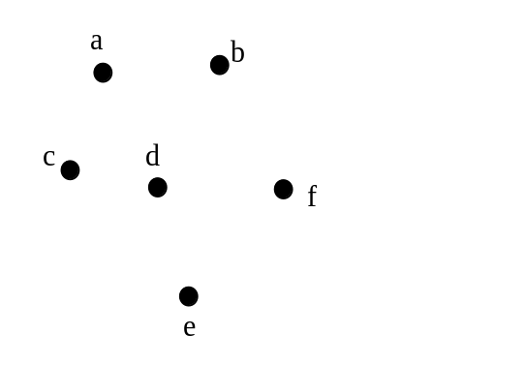

山东大学 计算机图形学 课程试卷 B
第 1 页 共 4 页
glBegin (GL_TRIANGLE_STRIP)
glVertex3fv(a);
glVertex3fv(b);
glVertex3fv(c);
glVertex3fv(d);
glVertex3fv(e);
glVertex3fv(b);
glVertex3fv(f);
glEnd ( );
……………………………………密………………………封………………………线…………………………………
学院 专业 级 学号 姓名
2016 2017 学年 2 学期
第 页 共 页
(2) Why do we often prefer triangle strips and/or triangle fans to separate triangles in representation of the same 3D object?

4分：
如果全部用三角形图元绘制的话会有许多点被重复绘制。比较而言。Triangle strips 与triangle fans 可以减少代码执行的代价与数据传输的代价.

2. Answer the following questions.
(1) Give the equation for the Phong lighting model and explain the meaning of each term in it.
(2) Describe the improvement the modified Phong model makes and give the modified lighting equation accordingly.

(1) 6 分
I=1/(a+bd+c*d^2)(Kd*Ld*Max(l*n,0)+Ks*Ls*Max((r*v)^alpha,0))+Ka*La
L:此点指向光源的向量 Ld,Ls,La:分别为漫反射，镜面反射，环境光的光强
n:此点的法向量 Kd,Ks,Ka:分别为漫反射，镜面反射，环境光的反射系数
r:此点的反射光方向的向量 alpha:镜面反射的高光系数
v:此点指向观察着的方向的向量
d:聚光源的距离
a,b,c:常数，使光照效果变化柔和
1/(a+bd+c*d^2):距离衰减因子

(2) 4分
改进的phong模型中的h,n代替r,v，其中h=(l+v)/|l+v|为向量l和v的中值向量，这
样就避免了在计算每个点的光照时计算r向量，减少了计算量
改进的phong光照模型:
I=1/(a+bd+c*d^2)(Kd*Ld*Max(l*n,0)+Ks*Ls*Max((h*n)^alpha,0))+Ka*La

3. (1) Give the OpenGL code for the view transformation as illustrated in the figure below:
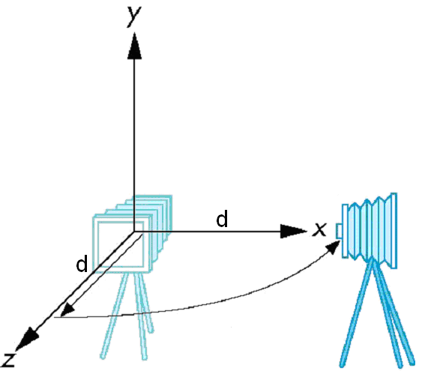

(2) Derive the view transformation matrix for gluLookAt(1, 0, 1, 0, 0, 0, 0, 1, 0).

对应代码为: (并不要求写出代码)
glMatrixMode(GL_MODELVIEW)
glLoadIdentity();
glTranslatef( 0.0, 0.0, -1.414 ); //d>0
glRotatef(-45.0, 0.0, 1.0, 0.0);

矩阵为: T(0, 0, -1.414)* R_y(-45) = [ 1, 0, 0, 0; 0, 1, 0, 0; 0, 0, 1, -1.414 ; 0, 0, 0, 1]
* [ 0.707, 0, -0.707, 0 ; 0, 1, 0, 0 ; 0.707, 0, 0.707, 0 ; 0, 0, 0, 1 ]
= [0.707, 0, -0.707, 0 ; 0, 1, 0, 0 ; 0.707, 0, 0.707, -1.414 ; 0, 0, 0, 1]
]
4. Answer the following two questions regarding clipping and rasterization -- two important steps in the vertex-to-fragment conversion.
(1) Using the Cohen-Sutherland clipping algorithm, give the steps to clip line segment AB with a square window as illustrated below:

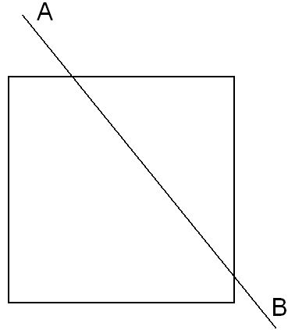
(1) 5 分
正方形的边把空间分成9个区域,各自有一个编码. 9 个区域的编码从上到下,从左到右依次是1001, 1000, 1010; 0001, 0000, 0010; 0101, 0100, 0110.

计算A, B 两点的编码, O_A = 1000, O_B=0110. O_A & O_B != 0. 所以需要求交点.
先求AB与上侧边的交点 C. 求其编码为0000, 在窗口内. 现在一点在内,一点在外.
求CB与下侧边交点D, 其编码为0010, 仍然一点在内一点在外.
求 CD与右侧边交点E, 编码为0000, 在窗口内部. 裁减完成.
山东大学 计算机图形学 课程试卷 B
第 2 页 共 4 页
5 分:

glMatrixMode(GL_MODELVIEW)
glLoadIdentity();
glTranslatef(0.0, 0.0, -d); //d>0
glRotatef(-90.0, 0.0, 1.0, 0.0);
……………………………………密………………………封………………………线…………………………………
2016-2017 学年 2 学期
第 页 共 页
(2) Using the Bresenham’s algorithm, give the rasterization result for line CD (as illustrated in the following figure) by marking out the generated fragments. Note that pixel centers locate at the crossing points of dotted lines. (5 分)

5. Given the following 2D scene with 6 objects (a, b, d, e, f and g), we have added 5 partitioning planes (A, B, C, D and E) to construct a binary space partitioning (BSP) tree. (1) Draw the BSP tree.
(2) With the viewing frustum indicated by the dotted V-shape, explain how to use the BSP tree to determine the order in which to render the 6 objects.

A
6 分
B C

g E D a

d e b f
4分: 递归地判断视点和每一个树结点的位置关系，先画离视点远的一半空间，再画离视点较近的一半空间。所以，对于此例，顺序应该是 degabf

得分阅卷人
Part III. OpenGL Application Questions (20 points)

1. The following code implements a robot arm. Please read it and answer the questions at the end.

#include <GL/glut.h>
#include <stdlib.h>
#define BASE_HEIGHT 0.2
#define BASE_WIDTH 0.2
#define LOWER_ARM_HEIGHT 0.5
#define LOWER_ARM_WIDTH 0.05
#define UPPER_ARM_HEIGHT 0.5
#define UPPER_ARM_WIDTH 0.05

GLfloat vertices[] = { -0.5,-0.5,-0.5, 0.5,-0.5,-0.5, 0.5,0.5,-0.5, -0.5,0.5,-0.5,
-0.5,-0.5,0.5, 0.5,-0.5,0.5, 0.5,0.5,0.5, -0.5,0.5,0.5};

void quad(int a, int b, int c , int d)
{
glBegin(GL_QUADS);
glVertex3f(vertices[a*3], vertices[a*3+1], vertices[a*3+2] );
glVertex3f(vertices[b*3], vertices[b*3+1], vertices[b*3+2] );
glVertex3f(vertices[c*3], vertices[c*3+1], vertices[c*3+2] );
glVertex3f(vertices[d*3], vertices[d*3+1], vertices[d*3+2] );
glEnd();
}
void cube(void)
{
quad(0,3,2,1);
quad(2,3,7,6);
quad(0,4,7,3);
quad(1,2,6,5);
quad(4,5,6,7);
quad(0,1,5,4);
}
学院 专业 级 学号 姓名
山东大学 计算机图形学 课程试卷 B
第 3 页 共 4 页
……………………………………密………………………封………………………线…………………………………
……………………………………密………………………封………………………线…………………………………
学院 专业 级 学号 姓名
2016-2017 学年 2 学期
第 页 共 页
void base()
{
glPushMatrix();
glTranslatef(0.0, 0.5*BASE_HEIGHT, 0.0);
glScalef(BASE_WIDTH, BASE_HEIGHT, BASE_WIDTH);
cube(); // Cube-A
glPopMatrix();
}
void lower_arm()
{
glPushMatrix();
glTranslatef(0.0, 0.5*LOWER_ARM_HEIGHT, 0.0);
glScalef(LOWER_ARM_WIDTH,LOWER_ARM_HEIGHT,LOWER_ARM_WIDTH);
cube(); // Cube-B
glPopMatrix();
}
void upper_arm()
{
glPushMatrix();
glTranslatef(0.0, 0.5*UPPER_ARM_HEIGHT, 0.0);
glScalef(UPPER_ARM_WIDTH,UPPER_ARM_HEIGHT, UPPER_ARM_WIDTH);
cube(); // Cube-C
glPopMatrix();
}
void display(void)
{
GLfloat theta[] = {0.0, -90.0, 45.0};
glClear(GL_COLOR_BUFFER_BIT|GL_DEPTH_BUFFER_BIT);
glMatrixMode(GL_MODELVIEW);
glLoadIdentity();

glColor3f(1.0, 0.0, 0.0);
glRotatef(theta[0], 0.0, 1.0, 0.0);
base();

glColor3f(0.0, 1.0, 0.0);
glTranslatef(0.0, BASE_HEIGHT, 0.0);
glRotatef(theta[1], 0.0, 0.0, 1.0);
lower_arm();
glColor3f(0.0, 0.0, 1.0);
glTranslatef(0.0, LOWER_ARM_HEIGHT, 0.0);
glRotatef(theta[2], 0.0, 0.0, 1.0);
upper_arm();
glFlush();
glutSwapBuffers();
}
void main(int argc, char **argv)
{
glutInit(&argc, argv);
glutInitDisplayMode(GLUT_DOUBLE | GLUT_RGB | GLUT_DEPTH);
glutInitWindowSize(500, 500);
glutCreateWindow("robot");
glEnable(GL_DEPTH_TEST);
glClearColor(1.0, 1.0, 1.0, 1.0);
glutDisplayFunc(display);
glutMainLoop();
}
- What is the screen output of this program? Please illustrate with a picture.
- Write out the affine transformation matrix applied to Cube-C.
- Try to improve the running efficiency of this code using vertex array or display list. (You may choose to use only one of them)

(1) (10 分)
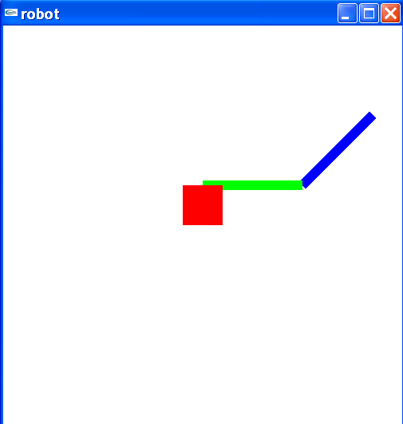

山东大学 计算机图形学 课程试卷 B
第 4 页 共 4 页
学院 专业 级 学号 姓名
2016-2017 学年 2 学期
第 页 共 页

(2) 5 分: Ry(0)*T(0,0.2,0)Rz(-90)*T(0,0.5,0)*Rz(45)*T(0,0.25,0)S(0.05,0.5,0.05)
计算得
-sqrt(2)/40 -sqrt(2)/4 0 -sqrt(2)/8 – 1/2
sqrt(2)/40 -sqrt(2)/4 0 -sqrt(2)/8 + 1/5
- 0 1/20 0
0 0 0 1

(3) 5分：
使用vertex array 和 display list 之一就算对。

使用Vertex Array：

gluByte cubeIndices[24] = {0,3,2,1, 2,3,7,6, 0,4,7,3, 1,2,6,5, 4,5,6,7, 0,1,5,4 };
glEnableClientState(GL_VERTEX_ARRAY);
glVertexPointer(3, GL_FLOAT, 0, vertices);
glDrawElements( GL_QUADS, 24, GL_UNSIGNED_BYTE, cubeIndices);

使用Dislay list:

声明一个全局变量
GLuint id;

在cube 函数里添加如下代码：
glNewList( id, GL_COMPILE );
. . . ← Original code
glEndList();

在main 函数中的glutDisplayFunc前调用 cube 函数：
id = glGenLists( 1 );
cube();

其余每次调用 cube()的地方改为 glCallList( id );

山东大学 计算机图形学 课程试卷 B
第 4 页 共 4 页

