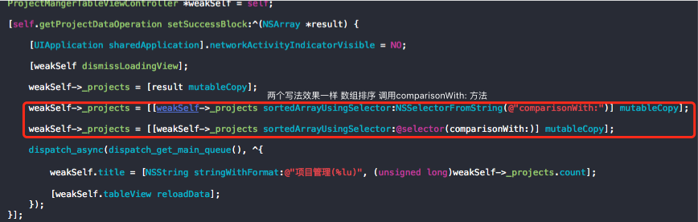

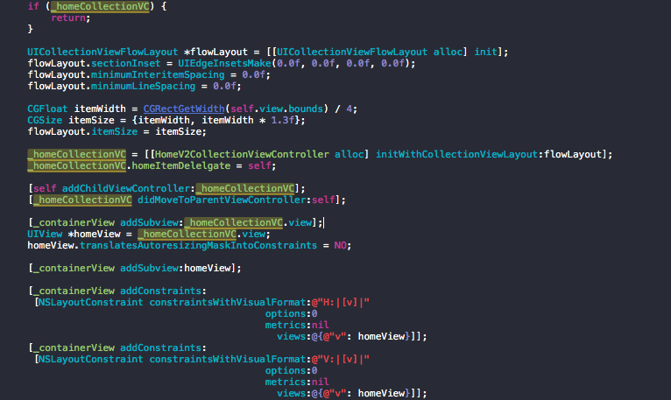

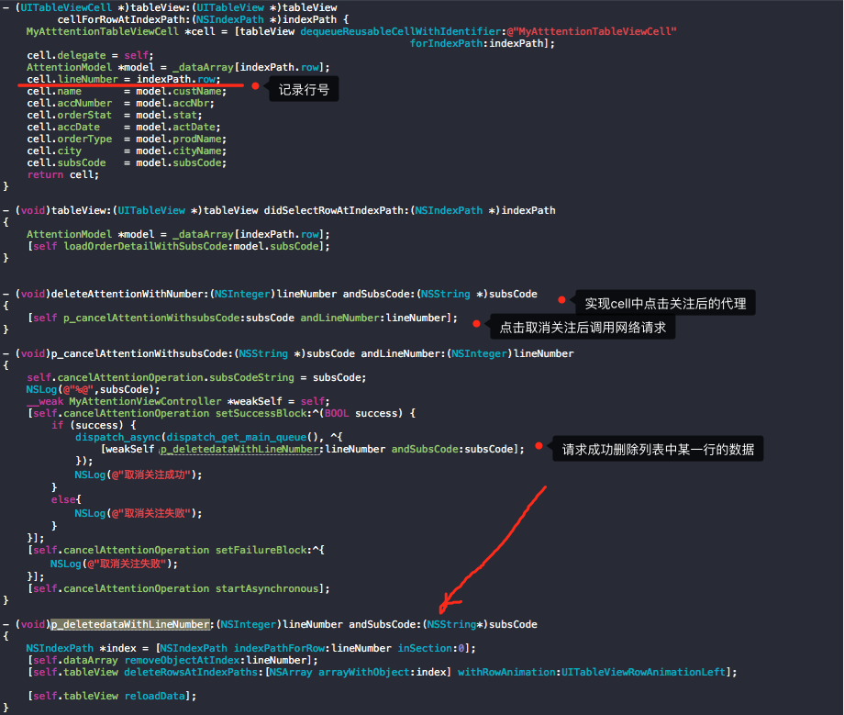

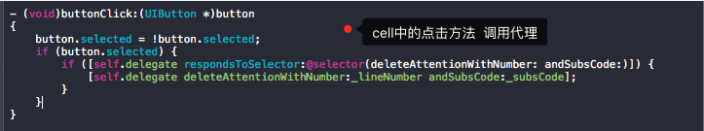

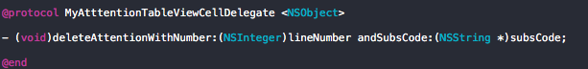



//- (void)p_setupBottomView

//{

// _bottomView = [[UIView alloc] initWithFrame:CGRectMake(0, YHScreenHeight - 44, YHScreenWidth, 44)];

// _bottomView.backgroundColor = [UIColor greenColor];

// [_bottomView addGestureRecognizer:[[UITapGestureRecognizer alloc] initWithTarget:self action:@selector(tap)]];

// [[UIApplication sharedApplication].keyWindow addSubview:_bottomView];

// [self.tableView addSubview:_bottomView];

// [self.tableView bringSubviewToFront:_bottomView];

// _bottomViewY = (int)_bottomView.frame.origin.y;

//}

//- (void)ex_scrollViewDidScroll:(UIScrollView *)scrollView

//{

// _bottomView.frame = CGRectMake(0, _bottomViewY + self.tableView.contentOffset.y, YHScreenWidth, 40);

//}

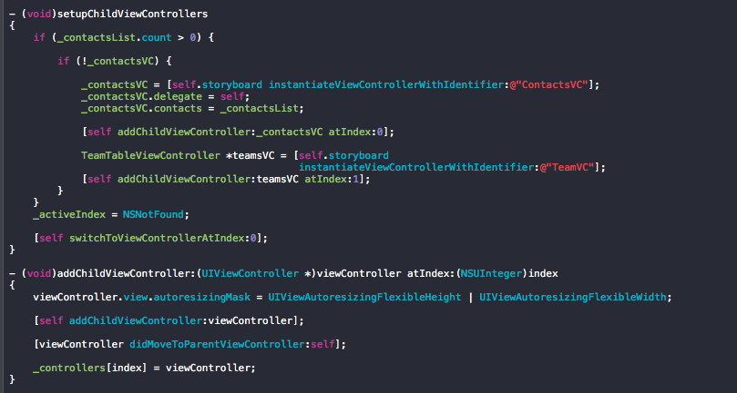

ios系统中各种设置项的url链接

在代码中调用如下代码：

NSURL*url=[NSURL URLWithString:@"prefs:root=WIFI"];

[[UIApplication sharedApplication] openURL:url];

即可跳转到设置页面的对应项。

[font=]

About — prefs:root=General&path=About

Accessibility — prefs:root=General&path=ACCESSIBILITY

Airplane Mode On — prefs:root=AIRPLANE_MODE

Auto-Lock — prefs:root=General&path=AUTOLOCK

Brightness — prefs:root=Brightness

Bluetooth — prefs:root=General&path=Bluetooth

Date & Time — prefs:root=General&path=DATE_AND_TIME

FaceTime — prefs:root=FACETIME

General — prefs:root=General

Keyboard — prefs:root=General&path=Keyboard

iCloud — prefs:root=CASTLE

iCloud Storage & Backup — prefs:root=CASTLE&path=STORAGE_AND_BACKUP

International — prefs:root=General&path=INTERNATIONAL

Location Services — prefs:root=LOCATION_SERVICES

Music — prefs:root=MUSIC

Music Equalizer — prefs:root=MUSIC&path=EQ

Music Volume Limit — prefs:root=MUSIC&path=VolumeLimit

Network — prefs:root=General&path=Network

Nike + iPod — prefs:root=NIKE_PLUS_IPOD

Notes — prefs:root=NOTES

Notification — prefs:root=NOTIFICATIONS_ID

Phone — prefs:root=Phone

Photos — prefs:root=Photos

Profile — prefs:root=General&path=ManagedConfigurationList

Reset — prefs:root=General&path=Reset

Safari — prefs:root=Safari

Siri — prefs:root=General&path=Assistant

Sounds — prefs:root=Sounds

Software Update — prefs:root=General&path=SOFTWARE_UPDATE_LINK

Store — prefs:root=STORE

Twitter — prefs:root=TWITTER

Usage — prefs:root=General&path=USAGE

VPN — prefs:root=General&path=Network/VPN

Wallpaper — prefs:root=Wallpaper

Wi-Fi — prefs:root=WIFI

if ([CLLocationManager locationServicesEnabled] &&

([CLLocationManager authorizationStatus] == kCLAuthorizationStatusAuthorized

|| [CLLocationManager authorizationStatus] == kCLAuthorizationStatusNotDetermined)) {

//定位功能可用，开始定位

NSLog(@"定位功能可用");

} else if ([CLLocationManager authorizationStatus] == kCLAuthorizationStatusDenied){

NSLog(@"定位功能不可用，提示用户开启定位");

}