1. A view is a virtual table, it does not hold any data themselves. Instead, they are definitions built on top of other tables or views, so when the underlying table or view changes, the view will change accordingly. Table is a preliminary storage for storing data and information.
2. The GROUP BY clause is used with the SELECT statement to make a group of rows based on the values of a specific column or expression.
3. It is a protocol for distributed collaborative hypermedia information systems that allows users to communicate data on the Web.

HTTP gives users a way to interact with web resources by transmitting hypertext messages between clients and servers.

1. Client-server based architecture: Server hosts and delivers resources and clients consume services.

Stateless: Once the request is served, the server does not remember if the request has arrived

Cacheable: Properly cached for scaling.

Multiple layered system: Request and response can be passed between many servers to finally supply a response back to client.

Representation of resources: It uses URI to map resources

Implementational freedom: It is an architecture style that can be implemented in multiple ways.

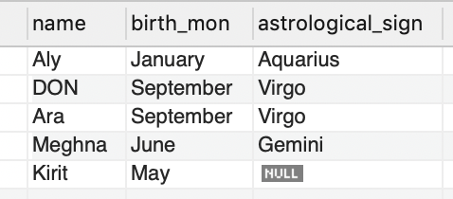

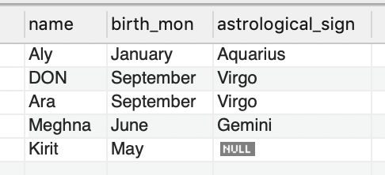

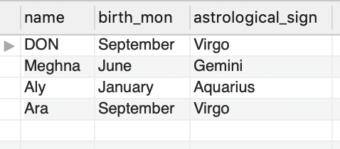

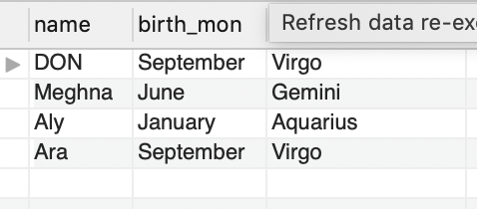

1. 201: Successfully Created

400: Client Error Bad Request

401: Client Error Unauthorized

300: Redirection Multiple choices

403: Client Error Forbidden

404: Client Error Not Found

500: Server Error Internal Server Error