Leon Hamnett – inventory forecasting assignment

Introduction:
The task was related to developing forecasting models to predict the stock level of the top 5 highest selling items upto 14 days into the future to assisst with the problem of intelligent inventory management. The data from a single store for the top 5 items could be used for both training and validation and the data from an additional store for these same 5 items could also be used for testing if desired.
The data provided comprises 3 datasets showing the following properties:
1.sales_train_validation.csv - daily sales from Walmart, spanning the item level up through product categories, departments, and stores across three U.S. regions (California, Texas, and Wisconsin).
2. sell_prices.csv Sell price per item per week per store
3. calendar.csv - Calendar details for the entire time period (for example: day of week, and major events/holidays (Super Bowl, Valentine’s Day, Orthodox Easter, etc.)
In total, there are 10 unique stores (CA_1–CA_4, TX_1–TX_3, WI_1–WI_3) and 42,840 individual time series relating to indivudal products, most of which exhibit intermittent demand patterns (some zero‐sales weeks). The time series covers dates from 2011-01-29 to 2016-06-19.

General Methodology:
- Download raw data
- Merge 3 datasets across appropiate joining columns, performing transposes and other data manipulation as required.
- Identifying global top 10 items sold, identify stores which have the most number of global top items in their local-store top 10 most sold items.
- Choose store with most top-10 global items sold, from this store choose the top 5 best selling items.
- Subset entire dataset based on stope and top 5 items of interest
- Exploratory analysis – exploring data distributions, trend, seasonality, missing vals etc
- Feature Engineering – create new features or convert some features to cyclical encoding
- Preprocess data and split into train and test sets
- Explore various potential models
- Select model and train one model per item to make 14-day ahead forecasts for that item
- Evaluate model forecasting ability per item
- Tidying code and report write up

Dataset exploration and analysis:
Firstly exploratory data anlalysis was undertaken to understand the distribution of data witthin each dataset.

Calender.csv
The calendar.csv file contains 1,969 weekly records spanning Saturday, January 29, 2011 through Sunday, June 19, 2016, with fourteen columns capturing both temporal and event information. Each row includes the date, a combined week-of-year indicator (wm_yr_wk), the weekday name and its numeric code (wday, where 1 = Saturday), month, year, and a day identifier (d). Two event name/type pairs (event_name_1, event_type_1 and event_name_2, event_type_2) annotate major holidays—162 non-null entries in the first pair and 5 in the second—such as Super Bowl, Valentine’s Day, Easter, Thanksgiving, and Christmas. Finally, three “snap” flags (snap_CA, snap_TX, snap_WI) indicate whether each of the three regions (California, Texas, and Wisconsin) was under a state-level Snap-eligible promotion that week. In total, the dataset catalogs 33 unique events across its holiday columns.

sales_train_validation.csv
The sales_train_validation.csv dataset contains 30,490 rows and 1,919 columns, providing daily unit‐sales for every item–store combination over the full training period. The first six columns give the product and location hierarchy—id, item_id, dept_id, cat_id, store_id, and state_id—followed by 1,913 day‐indexed sales columns (d_1 through d_1913) that record each a product’s daily unit sales at its specific store. In total, there are 3,049 unique items sold across 10 stores—four in California (CA_1–CA_4), three in Texas (TX_1–TX_3), and three in Wisconsin (WI_1–WI_3).
We first identified the ten most popular items across all stores for the entire period—FOODS_3_090, FOODS_3_586, FOODS_3_252, FOODS_3_555, FOODS_3_714, FOODS_3_587, FOODS_3_694, FOODS_3_226, FOODS_3_202, and FOODS_3_723. Next, we computed each store’s own top-10 best-selling items and counted how many of those matched the global top ten. The overlap by store was as follows: CA_1 (6), CA_2 (4), CA_3 (5), CA_4 (6), TX_1 (9), TX_2 (7), TX_3 (7), WI_1 (5), WI_2 (2), and WI_3 (6). From a business perspective, we selected TX_1—the store with nine global top-10 items in its local top ten—as our primary forecasting pilot, since its sales mix most closely mirrors overall trends and therefore offers the greatest leverage for a broadly applicable demand model. The top items sold from store Tx_11 were as follows: 'FOODS_3_586','FOODS_3_090','FOODS_3_555','FOODS_3_252','FOODS_3_587'.

sell_prices.csv
The pricing dataset contains 6,841,121 records and four fields: store_id and item_id (both as strings), wm_yr_wk (an integer representing the year–week), and sell_price (a floating-point value).

Analysis via merged dataset:
Once the datasets were combined and joined in an appropiate manner, we obtained the merged dataset containing the information for one specific store, and the daily sells of the top 5 products. The raw time series as well as for as rolling mean for each variable of interest was visualised. Also autocorrelation and partical autocorrelation plots were made for each target variable.
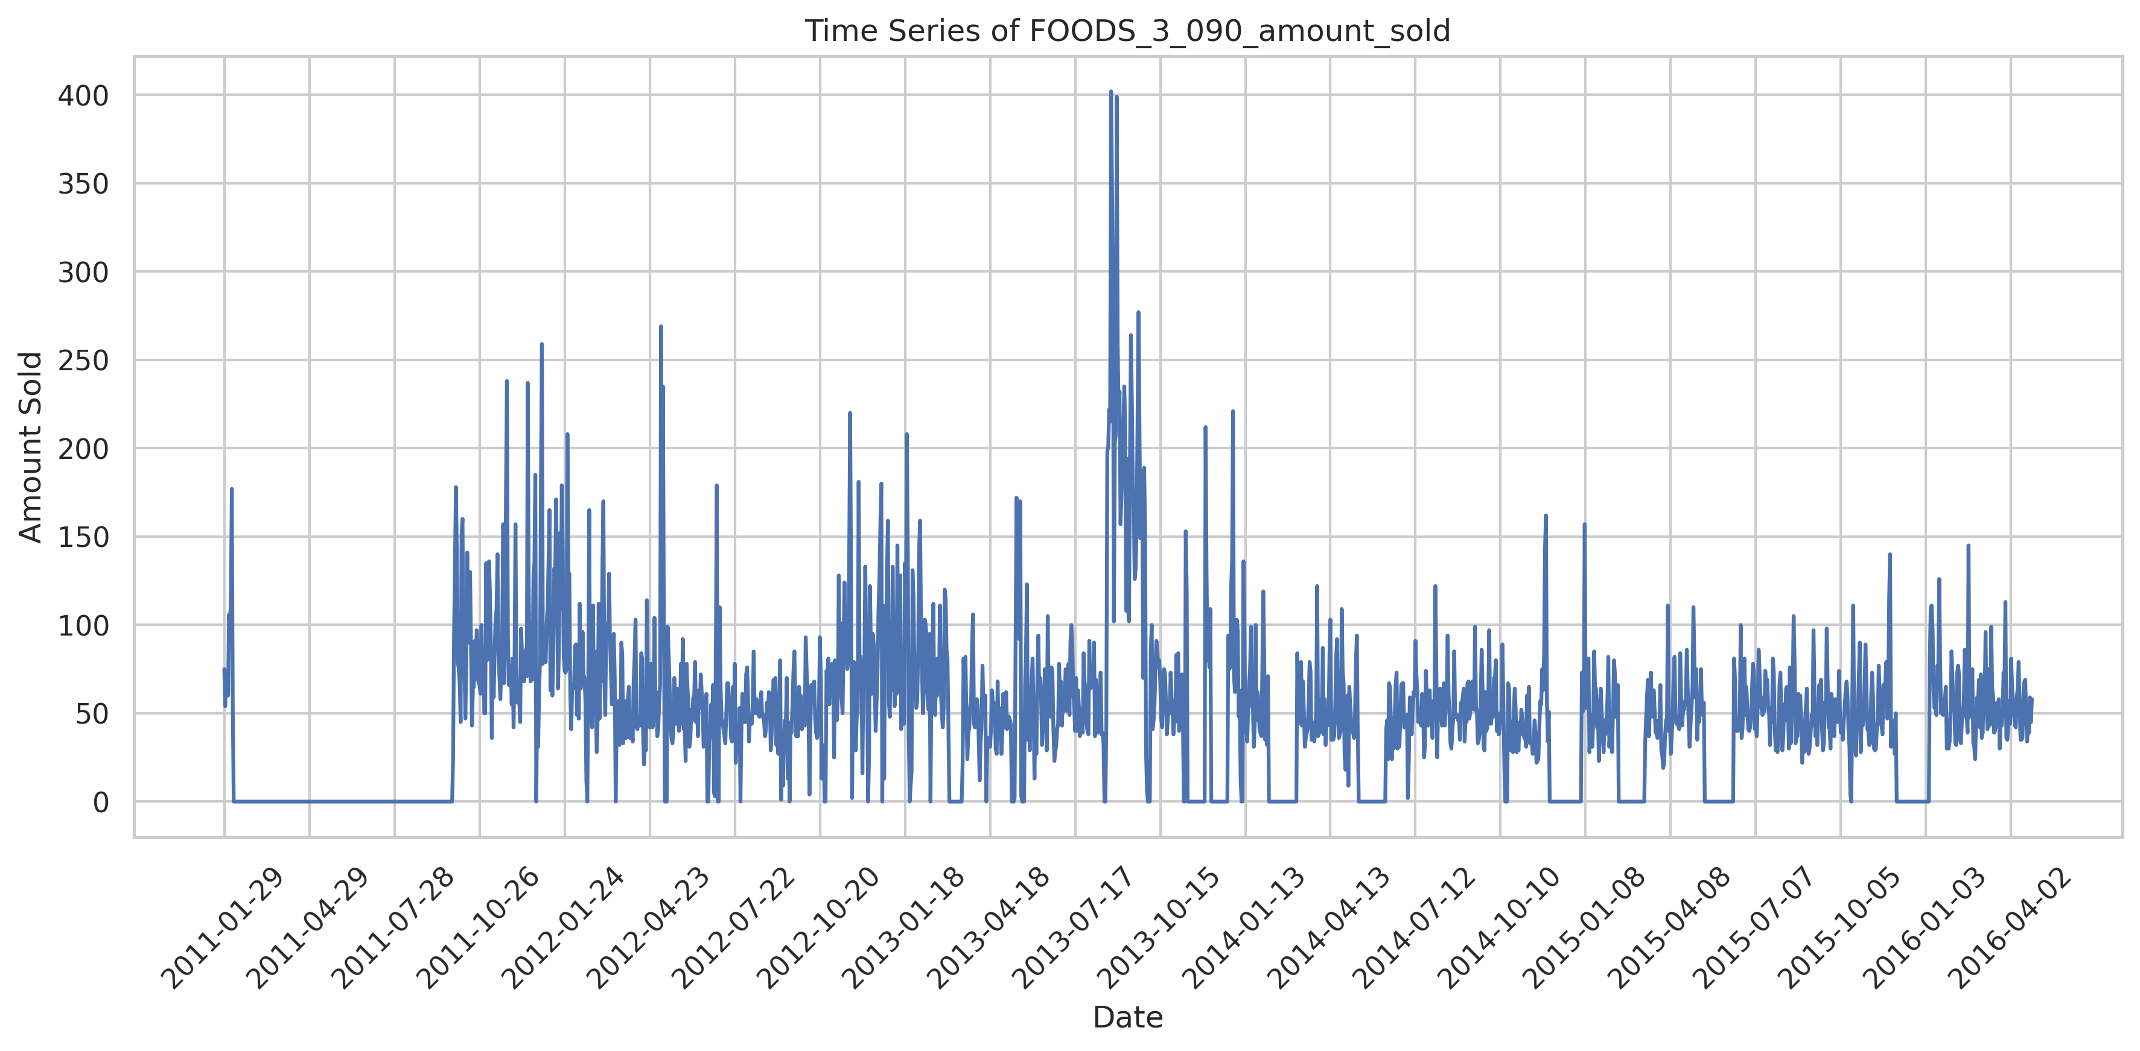Figure 1: Raw data from Item: Foods_3_090
During this initial investigation, it was realised that for some of the target features of intterest, there were large periods where the product registered only zeros. The assumption that was made during the modelling process was that these areas of zero products sold, were due to data entry errors, and that the products did actually sell items on this day. Afterwards each target variable was examined for the presence of null values, no nll values were found across all 5 target variables.
After the visual inspection, the investigation moved on to investigating the trend and seasonality present within each target feature. A basic linear regression was undertaken to estimate the trend for each target. Each target feature did not demonstrate large trend values across the entire dataset:
Trend for FOODS_3_586_amount_sold: -0.0128
Trend for FOODS_3_090_amount_sold: 0.0007
Trend for FOODS_3_555_amount_sold: -0.0198
Trend for FOODS_3_252_amount_sold: -0.0030
Trend for FOODS_3_587_amount_sold: 0.0063
Next we examined trend/seasonality/residual plots taking a seasonality assumption of 7 days, 30 days or 365 days for each target of interest. By examining the seasonality plot with the clearest oscillations, we can determine the closest seasonality assumption. For all target features, the strongest seasonality was demonstrated when the period was set to 30 (as shown in the below comparison). As such during the model training, the seasonality was set to 30 periods.
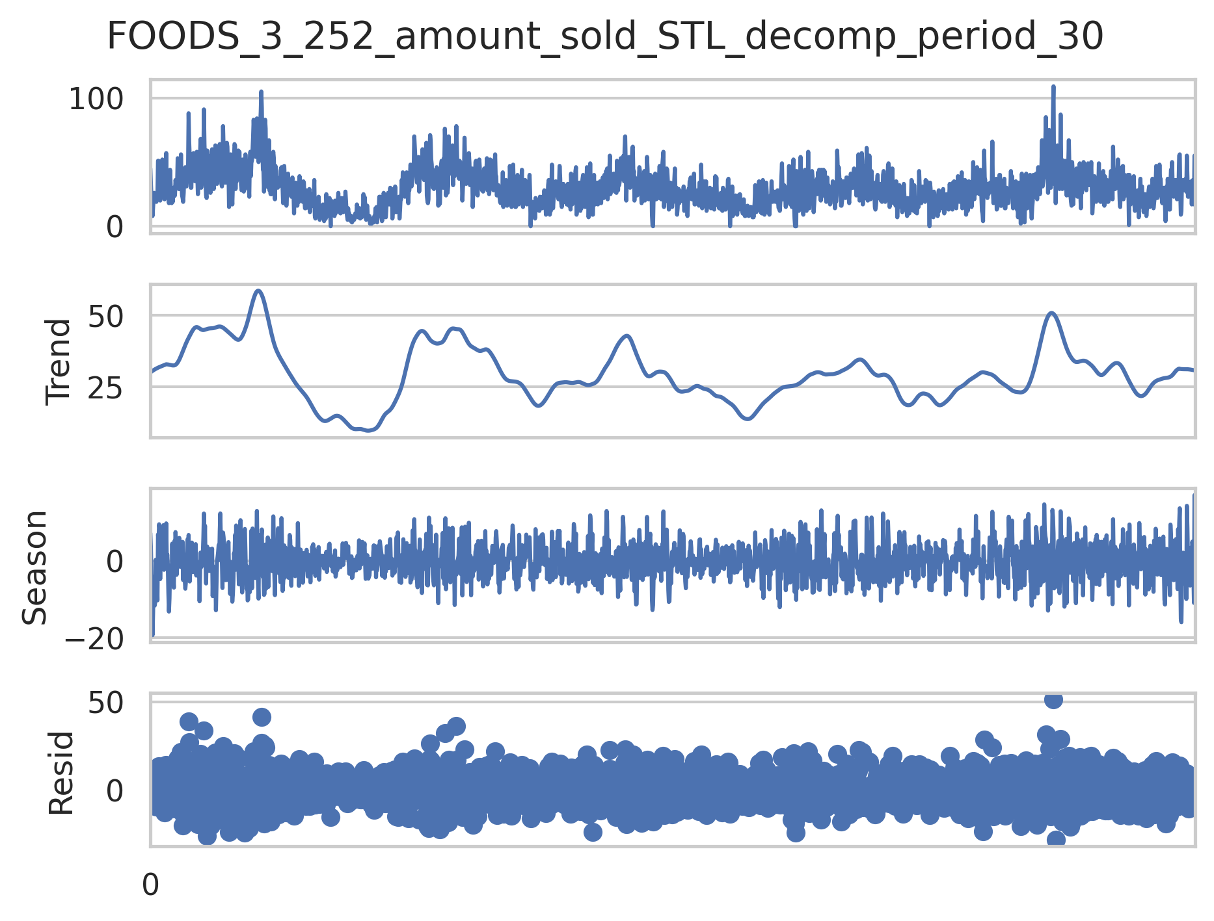
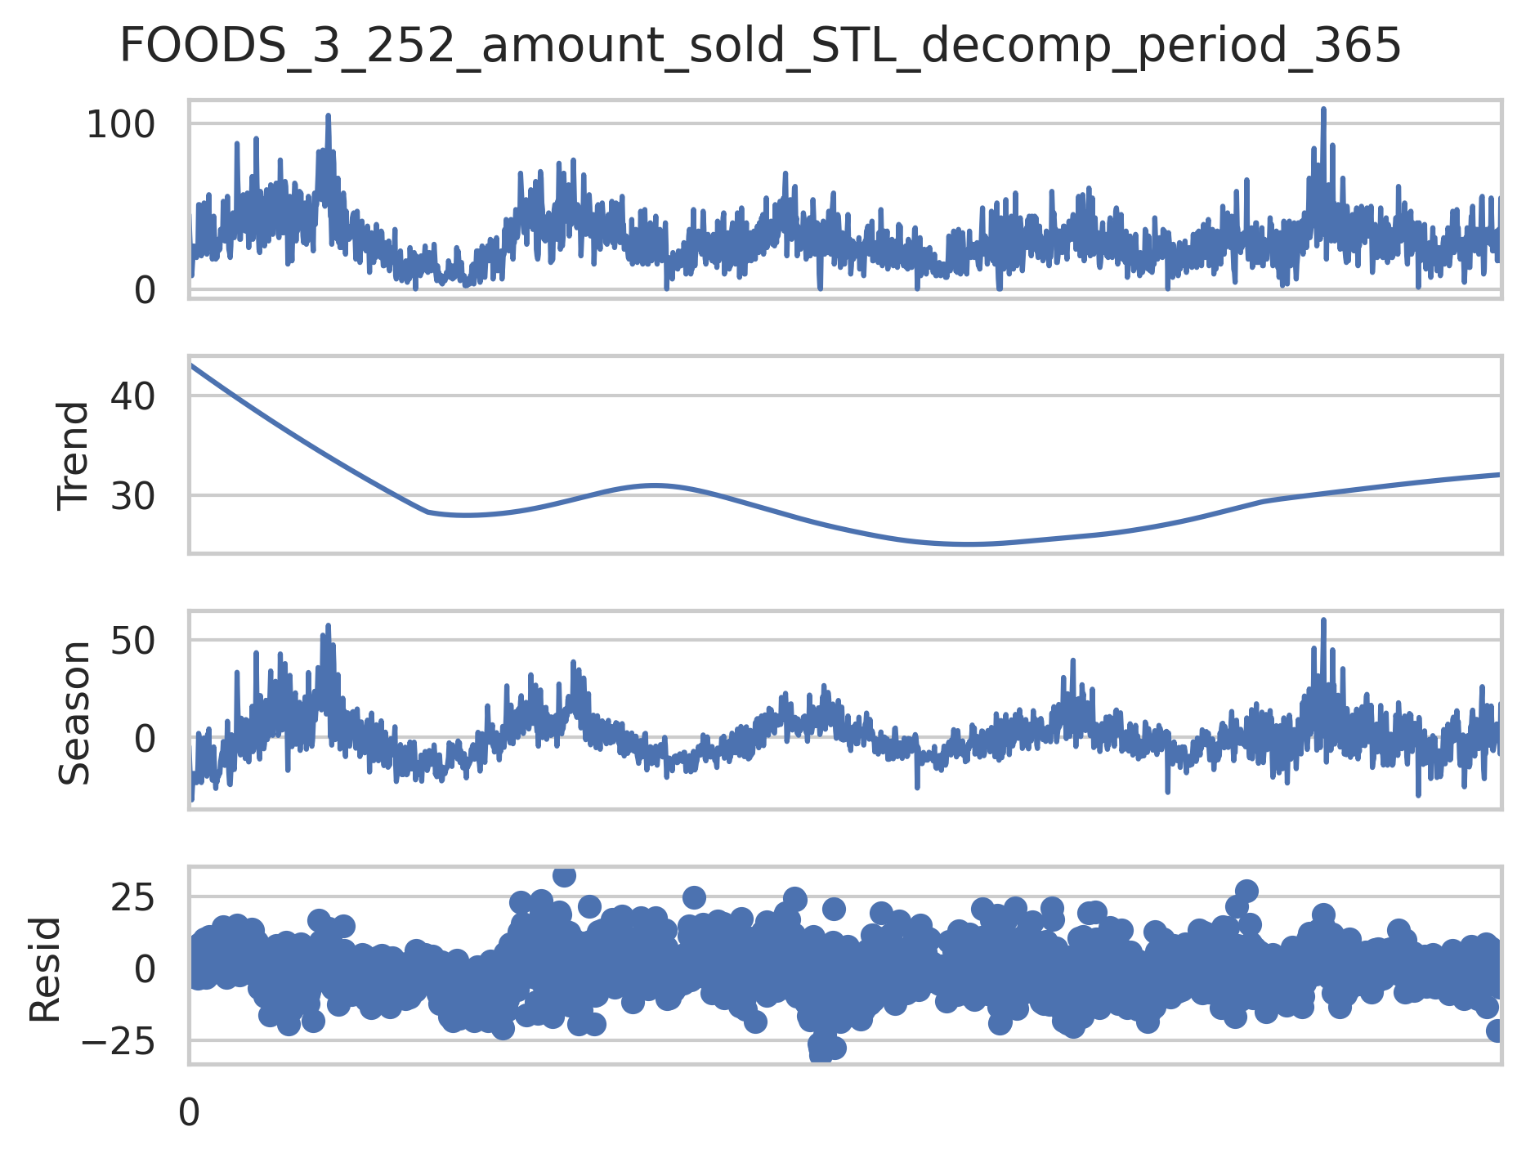
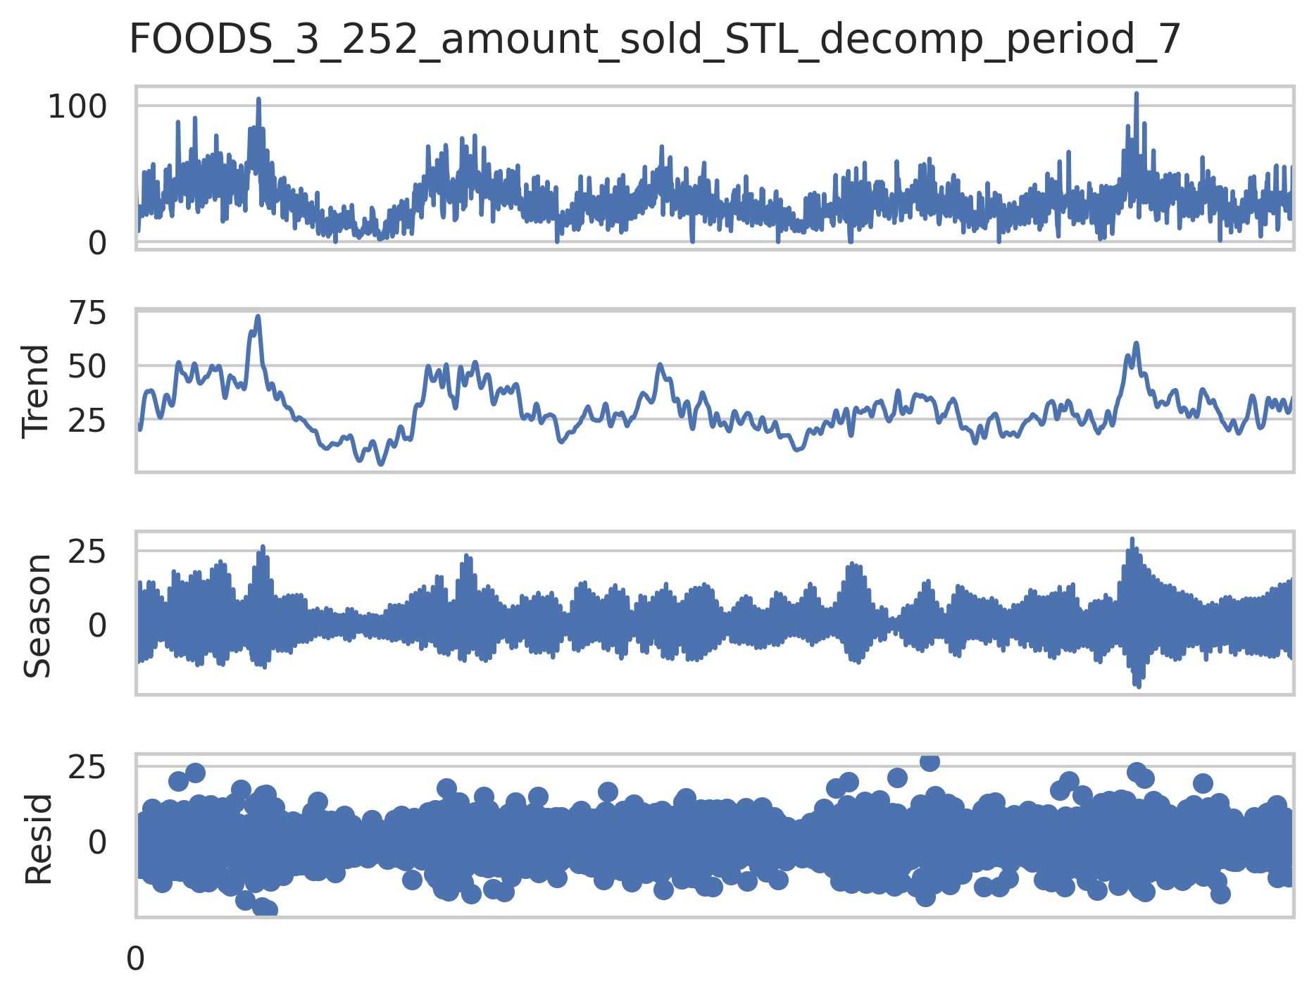Figure 2: Seasonality and trend plots with assumed period- Left: 7, Middle: 30, Right:365

Feature engineering
Several time‐based features were engineered from the merged sales–calendar–price dataset. We extracted the day of month from the date field, then flagged each row if the row is on a weekend or public holiday (is_weekend) and public holiday (is_public_holiday) based on non‐null event name.
We also computed a numerical measure counting down the days to the next public holiday, assuming that sales for certain goods would spike as holidays were approaching.
Finally, to capture cyclical patterns in the time fields, we transformed the ordinal week‐day (wday), month, and day‐of‐month into sine and cosine pairs (e.g. wday_sin, wday_cos, etc.), preserving their periodic structure for model input and helping the model to learn similarities between min and max values on a cyclical scale eg day 1 of a month is close to day 31 of the previous month

Overall Data/Model flow throughout project:

This section gives a brief summary of the data flow throughout the project and how models are trained and evaluated using this dataflow:
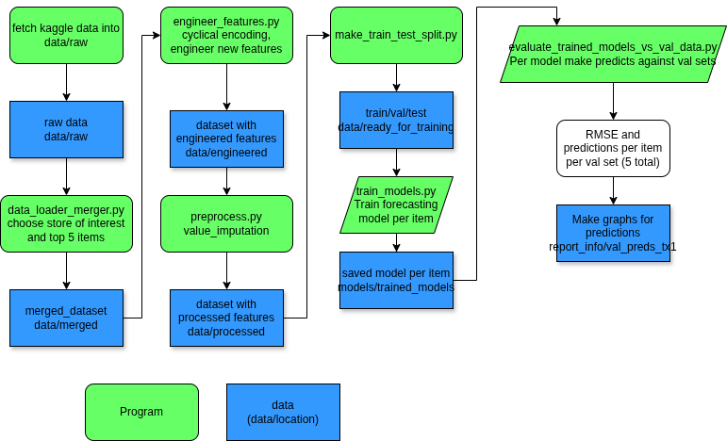

Stage 1: Combining datasets to create merged data:
Raw data to merged data (via data_loader_merger.py)
First we load each CSV into a Pandas DataFrame, filters the sales to store_id == 'TX_1' and the five selected item_ids, drops unused hierarchy columns, transposes so that each item becomes a column (with rows corresponding to day indices d_1…d_1913), and renames the first column to day_id. Next, it merges in calendar features (date, week, weekday, month, year, holiday flags, SNAP flags), drops now‐redundant columns, and then pivots the sell‐price DataFrame to align prices by wm_yr_wk for those same five items. Finally, it joins the price data to the sales + calendar table, renames columns to distinguish “_amount_sold” and “_sell_price”, converts date to a datetime index, and writes out the merged result for downstream modeling.

Stage 2: Engineering Features:
Merged data to feature engineered data (via engineer_features.py)
This script takes the previously merged sales–calendar–price dataset for TX_1’s top five items, engineers several time-based features including cycling encoding. After loading the CSV and parsing its date column, it extracts the day of month and flags weekends (Saturday/Sunday) and public holidays (any non-null event_name_1). It then computes, for each date, the number of days until the next holiday. Finally, it transforms three ordinal date fields—weekday (wday), month, and day of month—into four cyclical sine/cosine features each to preserve their periodic nature. The resulting DataFrame, now containing both raw and engineered features, is saved to an “engineered” folder for use in downstream forecasting pipelines.

Stage 3: Preprocessing Data:
Engineer data to preprocessed data (via preprocess_data.py)
This script reads in the previously engineered dataset, then applies imputation to each of the five target sales series (FOODS_3_586_amount_sold, etc.). Three imputation functions are defined—an STL‐based seasonal–trend imputer, a 5th‐order polynomial interpolator, and the imputation which was finally used a simple mean‐fill that replaces zeros with the series mean. For each output variable we use the imputation to fill values with zeroes.

Stage 4: Making train/test splits:
processed_data to ready_for_training (via make_train_test_split)
This script takes the fully processed, imputed dataset for TX_1’s top five items and partitions it into training, validation, and test sets for modeling. It first loads the combined DataFrame (with date parsed), then assigns 90% of the rows to a “train+validation” block and the remaining 10% to a hold-out test set. The train+validation block is further split by reserving the last 14 days as a true validation fold and using everything before that for training. The script reports the resulting row counts for each split and writes out four CSVs—tx1_train_val.csv, tx1_train.csv, tx1_val.csv, and tx1_test.csv—into the data/ready_for_training directory.

Stage 5: Training models:
Via train_models.py
This training script loads the pre-split TX_1 dataset, isolates ten engineered calendar features plus each of the five top-selling item series in turn, and uses PyCaret’s time-series API to fit and save an Random Forest w/ Cond. Deseasonalize & Detrending model and pipeline for generating 14-day forecasts. During experimentations comparing the performance of a large number of forrecasting models, this model was chosen as it seemed to show consistently good predictive performance andd thw lowest root mean square error (RMSE) for each target variable.
During the training process for each target series, it:
- Subsets to the relevant exogenous features plus the target column,
- Initializes a TSForecastingExperiment with sliding-window cross‐validation and linear target imputation,
- Trains the model on the training set and
- Persists the model artifact under models/trained_models.

Stage 6: Validation of trained models
Via evaluate_trained_models_vs_val_data.py
Each trained model for forecasting a specific item is used to generates 14-day forecasts against the hold-out validation window. For each item/model it reloads the pycaret experiment, loads the trained model, calls the predict function to generate predictions for the next 14 days, computes the RMSE between forecasted and actual sales, and then plots actual values vs. predicted values time and saves each chart.

Discussion of modelling results:
Models evaluated via evaluate_trained_models_vs_val_data
Now that we have a model that is trained to forecast the demand for a specific item upto 14 days in the future, we can evaluate each model against the validation data for that same item. During the training process the last 14 data points were not used to evaluate how the model would perform on unseen data.
The results for each specific item/model against the validation data are given below showing actual values in solid blue against the predicted values in dashed orange:
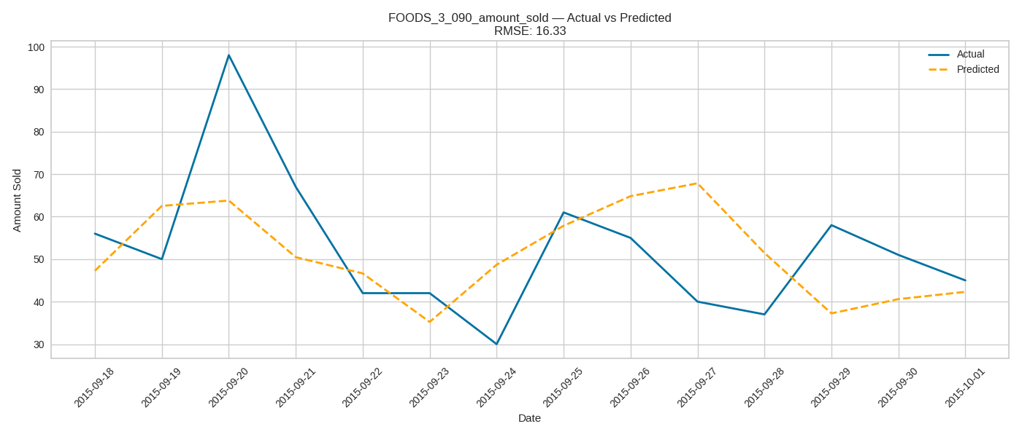
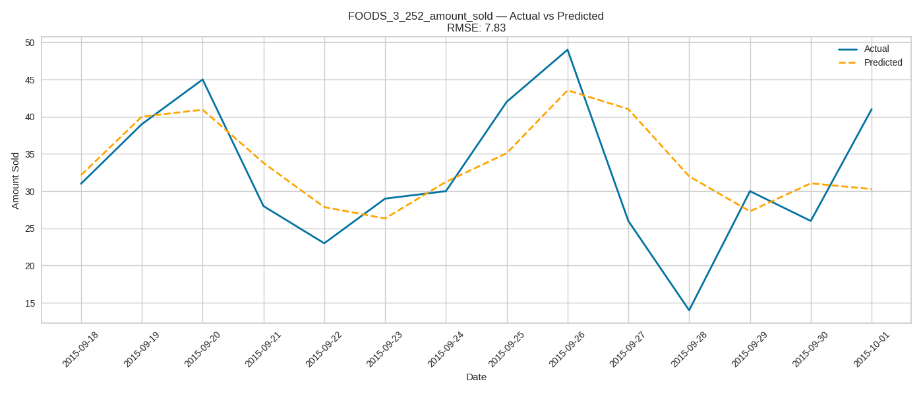
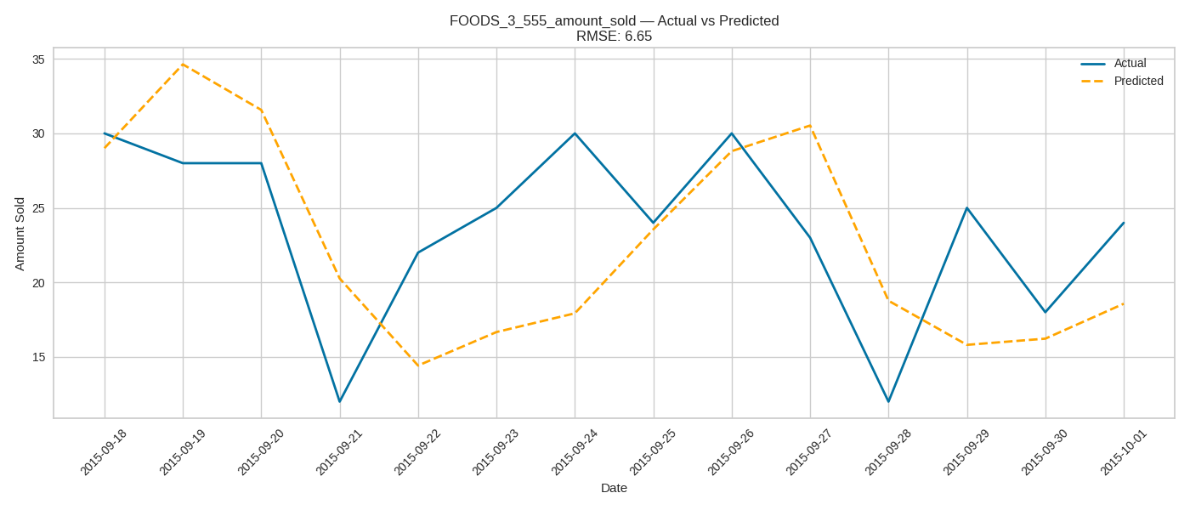

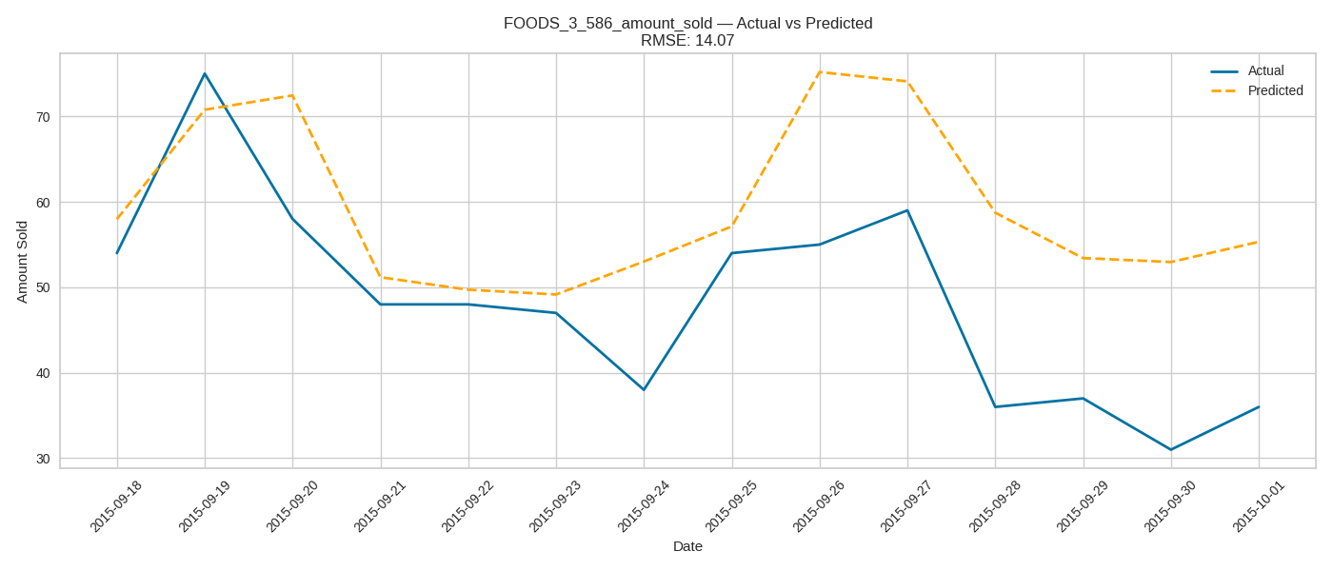
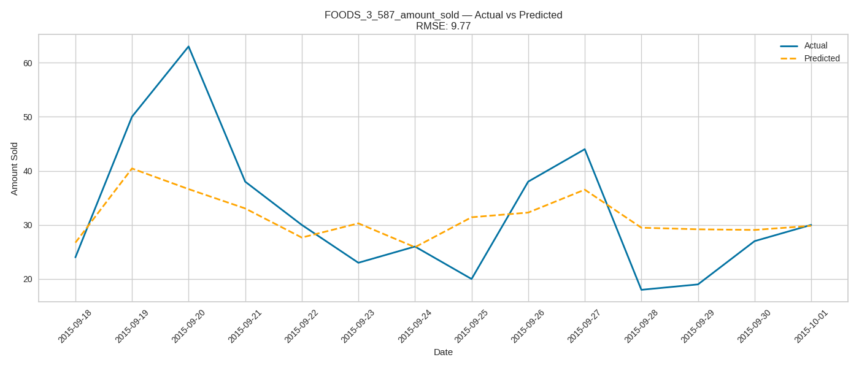
As shown in the above images, we are managing to roughly track future increases or decreases in the actual data, and obtained RMSE values ranging from 8 – 16.

Challenges Faced:
During the project I faced several technical challenges, which could be resolved if I had more time to debug and consider solutions.
- Imputation Robustness: My initial linear fills ignored seasonality and trend, and my STL‐based residual imputation were not ccorrectly returning reasonable imputations. Given more time, I’d refine the STL pipeline—tune the seasonal period, handle edge cases in residual grouping, and perhaps incorporate a multivariate imputer that borrows strength from related SKUs to fill gaps more accurately.
- Automated Model Benchmarking: I wanted to compare a number of models using pycarets automated model comparison features but I hit schema mismatches and struggled with workflow getting the model comparison to compelte correctly. To fix this, I’d build a custom sktime‐based benchmarking script: programmatic loops over forecasters (ARIMA, ETS, TCN, RF), unified train/validation splits, and saved results in a dataframe—giving me full control over inputs, horizons, and metrics.
- Rolling‐Window Validation: I wanted true sequential forecasting on a longer validation horizon but ran into prediction constraints in the pycaret package related to the training and validation data. In the end, I had to stuck to a validation period of 14 days whereas a longer validation time period may give improved knowledge of a model’s performance.
- Walk forwards prediction: with more time, I’d implement a walk‐forward routine in sktime, for example fitting on an expanding window and forecasts into the future one step at a time. This would mirror real‐world deployment. It could also be possible to implement multi-horizon forcasting to forecast multiple steps at once.

Recommendations for Future work:
For future work, I’d start by validating the zero‐sales entries. It would be prudent to investigate if these periods of 0s are true “no demand” days or data recording errors? Or perhaps the sptore ran out of stock. If they’re data collection artifacts, we could apply more robust imputation (e.g. refining the STL + residual‐imputation routine or using multivariate k-nearest imputation across related products).
In this project, univariate forecasting was used with exogenous features. However we could augment the models with cross-product signal, leveraging item‐association patterns so that sales of complimentary products inform forecasts of each other. Additionally, during this project statistical and classical ML models were used, however improved performance may be achieved with the usage of LSTM models or temporal fusion transformers.
If the ultimate goal is inventory optimization, framing the task as a reinforcement-learning problem could be a powerful approach: an agent would learn ordering policies by trading off holding, ordering, and stockout penalties against profit.
On the engineering and pipeline side, automating the full pipeline with MLflow (for data and model versioning), adding unit/integration tests, and building CI/CD alerts would improve reliability and traceability. Finally, once in production, we’d layer in MLOps best practices such as feature stores, model registries, and continuous drift monitoring to detect shifts in input data and demand patterns and trigger retraining automatically. It could also be worthwhile to dockerise the model training and validation enviroments to ensure

Appendices:

Appendix 1 – Top items sold per store across entire timeline:
Top 10 items for store CA_1:
store_id item_id total_sales
702 CA_1 FOODS_3_090 127203
1198 CA_1 FOODS_3_586 87691
864 CA_1 FOODS_3_252 74971
732 CA_1 FOODS_3_120 61899
1325 CA_1 FOODS_3_714 54080
1199 CA_1 FOODS_3_587 51717
1417 CA_1 FOODS_3_808 46094
411 CA_1 FOODS_2_197 40698
692 CA_1 FOODS_3_080 39145
1167 CA_1 FOODS_3_555 37871

Top 10 items for store CA_2:
store_id item_id total_sales
4247 CA_2 FOODS_3_586 63416
3913 CA_2 FOODS_3_252 57328
3751 CA_2 FOODS_3_090 56169
4216 CA_2 FOODS_3_555 31001
3263 CA_2 FOODS_1_218 28845
3741 CA_2 FOODS_3_080 28703
4466 CA_2 FOODS_3_808 25811
4462 CA_2 FOODS_3_804 25052
4296 CA_2 FOODS_3_635 22368
3949 CA_2 FOODS_3_288 21951

Top 10 items for store CA_3:
store_id item_id total_sales
6800 CA_3 FOODS_3_090 250502
7296 CA_3 FOODS_3_586 134386
6830 CA_3 FOODS_3_120 88795
6962 CA_3 FOODS_3_252 81456
7251 CA_3 FOODS_3_541 80491
7345 CA_3 FOODS_3_635 80222
7515 CA_3 FOODS_3_808 72591
7297 CA_3 FOODS_3_587 70324
7265 CA_3 FOODS_3_555 59092
7391 CA_3 FOODS_3_681 55537

Top 10 items for store CA_4:
store_id item_id total_sales
9849 CA_4 FOODS_3_090 52264
10345 CA_4 FOODS_3_586 32557
10346 CA_4 FOODS_3_587 24333
10011 CA_4 FOODS_3_252 23417
10564 CA_4 FOODS_3_808 21282
10394 CA_4 FOODS_3_635 20895
10472 CA_4 FOODS_3_714 19265
9961 CA_4 FOODS_3_202 18558
10250 CA_4 FOODS_3_491 18533
10300 CA_4 FOODS_3_541 17811

Top 10 items for store TX_1:
store_id item_id total_sales
13394 TX_1 FOODS_3_586 112454
12898 TX_1 FOODS_3_090 93684
13363 TX_1 FOODS_3_555 69516
13060 TX_1 FOODS_3_252 56294
13395 TX_1 FOODS_3_587 48277
13521 TX_1 FOODS_3_714 43567
13010 TX_1 FOODS_3_202 37940
13502 TX_1 FOODS_3_694 36567
13530 TX_1 FOODS_3_723 31907
13415 TX_1 FOODS_3_607 28493

Top 10 items for store TX_2:
store_id item_id total_sales
16443 TX_2 FOODS_3_586 192835
15947 TX_2 FOODS_3_090 119496
16109 TX_2 FOODS_3_252 114153
16412 TX_2 FOODS_3_555 97496
16234 TX_2 FOODS_3_377 63174
16444 TX_2 FOODS_3_587 50127
16570 TX_2 FOODS_3_714 45555
15459 TX_2 FOODS_1_218 44873
16059 TX_2 FOODS_3_202 43772
15888 TX_2 FOODS_3_030 43041

Top 10 items for store TX_3:
store_id item_id total_sales
19492 TX_3 FOODS_3_586 150122
18996 TX_3 FOODS_3_090 114854
19158 TX_3 FOODS_3_252 86632
19461 TX_3 FOODS_3_555 77673
19283 TX_3 FOODS_3_377 73797
18937 TX_3 FOODS_3_030 47976
19108 TX_3 FOODS_3_202 41551
19619 TX_3 FOODS_3_714 40650
19493 TX_3 FOODS_3_587 40306
18868 TX_3 FOODS_2_360 39026

Top 10 items for store WI_1:
store_id item_id total_sales
22181 WI_1 FOODS_3_226 78993
22649 WI_1 FOODS_3_694 41228
22045 WI_1 FOODS_3_090 34852
22541 WI_1 FOODS_3_586 32119
22668 WI_1 FOODS_3_714 30980
22446 WI_1 FOODS_3_491 26462
22623 WI_1 FOODS_3_668 25533
21998 WI_1 FOODS_3_042 25010
22035 WI_1 FOODS_3_080 24765
21426 WI_1 FOODS_1_085 21174

Top 10 items for store WI_2:
store_id item_id total_sales
25230 WI_2 FOODS_3_226 69966
25698 WI_2 FOODS_3_694 59235
25012 WI_2 FOODS_3_007 52020
25238 WI_2 FOODS_3_234 50043
24966 WI_2 FOODS_2_360 48043
25714 WI_2 FOODS_3_711 42212
25380 WI_2 FOODS_3_376 42077
25551 WI_2 FOODS_3_547 41089
25416 WI_2 FOODS_3_412 39266
25466 WI_2 FOODS_3_462 37946

Top 10 items for store WI_3:
store_id item_id total_sales
28143 WI_3 FOODS_3_090 121434
28279 WI_3 FOODS_3_226 98227
28639 WI_3 FOODS_3_586 86080
28747 WI_3 FOODS_3_694 85633
28608 WI_3 FOODS_3_555 57969
28371 WI_3 FOODS_3_318 54770
28766 WI_3 FOODS_3_714 54755
28734 WI_3 FOODS_3_681 48163
28173 WI_3 FOODS_3_120 43376
28287 WI_3 FOODS_3_234 42582

Appendix 2 – Summary statistics showing the distribution of each target of interest
ummary stats:
Summary statistics for FOODS_3_586_amount_sold:
count 1913.000000
mean 58.784109
std 19.713877
min 0.000000
25% 46.000000
50% 56.000000
75% 70.000000
max 162.000000
Name: FOODS_3_586_amount_sold, dtype: float64

Summary statistics for FOODS_3_090_amount_sold:
count 1913.000000
mean 48.972295
std 46.050259
min 0.000000
25% 0.000000
50% 46.000000
75% 67.000000
max 402.000000
Name: FOODS_3_090_amount_sold, dtype: float64

Summary statistics for FOODS_3_555_amount_sold:
count 1913.000000
mean 36.338735
std 18.448596
min 0.000000
25% 23.000000
50% 33.000000
75% 48.000000
max 135.000000
Name: FOODS_3_555_amount_sold, dtype: float64

Summary statistics for FOODS_3_252_amount_sold:
count 1913.000000
mean 29.427078
std 14.550915
min 0.000000
25% 19.000000
50% 28.000000
75% 38.000000
max 109.000000
Name: FOODS_3_252_amount_sold, dtype: float64

Summary statistics for FOODS_3_587_amount_sold:
count 1913.000000
mean 25.236278
std 15.277475
min 0.000000
25% 16.000000
50% 25.000000
75% 35.000000
max 88.000000

Appendix 3: All Seasonal/Trend/Residual graphs (per item/per period of 7/30/365
