软件无线电实验平台硬件接口

一、FPGA部分
1. FPGA型号：EP2S90F1020I4
2. 配置芯片型号：EPCS64
3. 时钟输入频率为25MHz：
set_location_assignment PIN_AM16 -to FPGA_CLK

二、AD转换部分
1. AD型号：AD9233BCPZ-125

2.采样率范围：DCS使能，20Msps——125Msps
DCS禁止，10Msps——125Msps

3. 输出数据格式：（已由硬件连接）
SCLK/DFS，AGND——偏移二进制码
AVDD——二进制补码
实验板上选择的是AVDD，故输出数据格式是二进制补码。

4. 参考电压选择：（已由硬件连接）
AD9233的SENSE引脚接到了AGND，故参考电压为1.0V，差分参考电压为2.0Vpp。

5. 时钟占空比稳定器（已由硬件连接）
SDIO/DCS，AGND——DCS禁止
AVDD——DCS使能
实验板上选择的是AGND，故DCS功能禁止。

6. power down function select（FPGA连接）
PDWN引脚，high——power down mode
Low——operational mode

7. out of range indicator（FPGA连接）
Active high

8. digital output enable（已由硬件连接）
Active low
实验板上选择的是GND，输出一直使能。

9. 采样时钟管理（FPGA连接）
AD部分的时钟通过FPGA的内部锁相环产生输出，输出引脚定义为ADC_CLOCK，经过双缓冲器NC7WV16P6X分为两路ADC_CLOCK_A，ADC_CLODK_B，
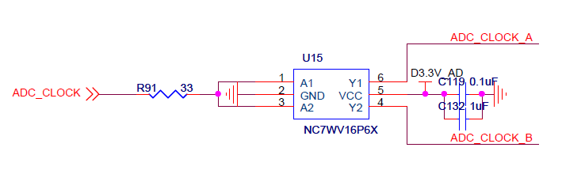
ADC_CLOCK_A，ADC_CLODK_B再分别经过单端转差分时钟缓冲器FIN1027输出供给4路AD转换器的时钟。

10. AD数据输出时钟DCO（FPGA连接）
供给FPGA捕获AD输出数据。
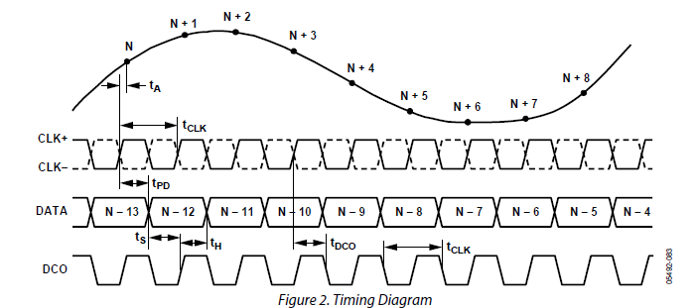
11. SPI功能（已由硬件连接）
该AD具有SPI数据读写功能，当片选端口CSB连接到AVDD，芯片SPI功能禁止。实验板上，CSB端口连接到AVDD1.8V，所以SPI功能禁止。

12. 数据端口（FPGA连接）
AD9233输出数据为12bit，实验板上端口为D13-D0，从高位开始依次对应输出数据的Data11-Data0，故实验板上的端口D1，D0不使用。

13. 端口定义
set_location_assignment PIN_T5 -to ADC_CLOCK

（1）AD转换器1
set_location_assignment PIN_R2 -to ADC1_PDWN
set_location_assignment PIN_M7 -to ADC1_OR
set_location_assignment PIN_R5 -to ADC1_CLK

set_location_assignment PIN_M8 -to ADC1_D[11]
set_location_assignment PIN_M9 -to ADC1_D[10]
set_location_assignment PIN_N2 -to ADC1_D[9]
set_location_assignment PIN_N3 -to ADC1_D[8]
set_location_assignment PIN_N4 -to ADC1_D[7]
set_location_assignment PIN_N5 -to ADC1_D[6]
set_location_assignment PIN_P1 -to ADC1_D[5]
set_location_assignment PIN_P2 -to ADC1_D[4]
set_location_assignment PIN_P4 -to ADC1_D[3]
set_location_assignment PIN_P5 -to ADC1_D[2]
set_location_assignment PIN_P6 -to ADC1_D[1]
set_location_assignment PIN_P7 -to ADC1_D[0]

（2）AD转换器2
set_location_assignment PIN_M2 -to ADC2_PDWN
set_location_assignment PIN_K6 -to ADC2_OR
set_location_assignment PIN_M6 -to ADC2_CLK

set_location_assignment PIN_K7 -to ADC2_D[11]
set_location_assignment PIN_K8 -to ADC2_D[10]
set_location_assignment PIN_K9 -to ADC2_D[9]
set_location_assignment PIN_L1 -to ADC2_D[8]
set_location_assignment PIN_L2 -to ADC2_D[7]
set_location_assignment PIN_L3 -to ADC2_D[6]
set_location_assignment PIN_L4 -to ADC2_D[5]
set_location_assignment PIN_L5 -to ADC2_D[4]
set_location_assignment PIN_L6 -to ADC2_D[3]
set_location_assignment PIN_L7 -to ADC2_D[2]
set_location_assignment PIN_L8 -to ADC2_D[1]
set_location_assignment PIN_M1 -to ADC2_D[0]

（3）AD转换器3
set_location_assignment PIN_K1 -to ADC3_PDWN
set_location_assignment PIN_H2 -to ADC3_OR
set_location_assignment PIN_K4 -to ADC3_CLK

set_location_assignment PIN_H3 -to ADC3_D[11]
set_location_assignment PIN_H4 -to ADC3_D[10]
set_location_assignment PIN_H5 -to ADC3_D[9]
set_location_assignment PIN_H6 -to ADC3_D[8]
set_location_assignment PIN_J1 -to ADC3_D[7]
set_location_assignment PIN_J2 -to ADC3_D[6]
set_location_assignment PIN_J3 -to ADC3_D[5]
set_location_assignment PIN_J4 -to ADC3_D[4]
set_location_assignment PIN_J6 -to ADC3_D[3]
set_location_assignment PIN_J7 -to ADC3_D[2]
set_location_assignment PIN_J8 -to ADC3_D[1]
set_location_assignment PIN_J9 -to ADC3_D[0]
（4）AD转换器4
set_location_assignment PIN_G4 -to ADC4_PDWN
set_location_assignment PIN_D1 -to ADC4_OR
set_location_assignment PIN_H1 -to ADC4_CLK

set_location_assignment PIN_D2 -to ADC4_D[11]
set_location_assignment PIN_E1 -to ADC4_D[10]
set_location_assignment PIN_E2 -to ADC4_D[9]
set_location_assignment PIN_E3 -to ADC4_D[8]
set_location_assignment PIN_E4 -to ADC4_D[7]
set_location_assignment PIN_F1 -to ADC4_D[6]
set_location_assignment PIN_F2 -to ADC4_D[5]
set_location_assignment PIN_F3 -to ADC4_D[4]
set_location_assignment PIN_F4 -to ADC4_D[3]
set_location_assignment PIN_G1 -to ADC4_D[2]
set_location_assignment PIN_G2 -to ADC4_D[1]
set_location_assignment PIN_G3 -to ADC4_D[0]

三、DA转换部分
1. DA转换器型号：AD9744CP

2. DA最高转换速率为210Msps，数据位数为14bit

3. SLEEP（FPGA连接）
Active high

4. 数据格式MODE（已由硬件连接）
DCOM—— binary
DVDD—— twos complement
实验板上MODE引脚连接到DVDD，故输入数据格式为二进制补码。

5. 时钟形式CMODE（已由硬件连接）
CLKCOM—— single-ended
CLKVDD—— differential
FLOAT—— PECL
实验板上CMODE引脚和CLKCOM引脚都连接到GND，故时钟输入是单端模式。

6. 时钟引脚（FPGA连接）
实验板上，4片DA转换器的时钟均直接由FPGA产生。

7. 数据端口（FPGA连接）
D0-D13为14bit数据端口，数据在上升沿更新，时序图如下图，
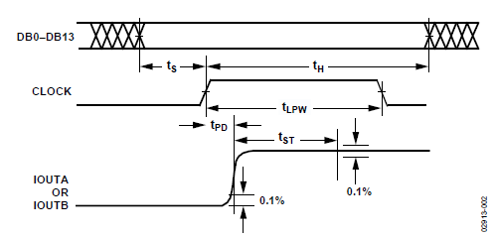

8. 端口定义

（1）DA转换器1
set_location_assignment PIN_AD8 -to DAC1_CLK
set_location_assignment PIN_AG2 -to DAC1_PDWN

set_location_assignment PIN_AG1 -to DAC1_D[13]
set_location_assignment PIN_AF6 -to DAC1_D[12]
set_location_assignment PIN_AF5 -to DAC1_D[11]
set_location_assignment PIN_AF4 -to DAC1_D[10]
set_location_assignment PIN_AF3 -to DAC1_D[9]
set_location_assignment PIN_AF2 -to DAC1_D[8]
set_location_assignment PIN_AF1 -to DAC1_D[7]
set_location_assignment PIN_AE6 -to DAC1_D[6]
set_location_assignment PIN_AE5 -to DAC1_D[5]
set_location_assignment PIN_AE4 -to DAC1_D[4]
set_location_assignment PIN_AE3 -to DAC1_D[3]
set_location_assignment PIN_AE2 -to DAC1_D[2]
set_location_assignment PIN_AE1 -to DAC1_D[1]
set_location_assignment PIN_AD9 -to DAC1_D[0]

（2）DA转换器2
set_location_assignment PIN_AB7 -to DAC2_CLK
set_location_assignment PIN_AD7 -to DAC2_PDWN

set_location_assignment PIN_AD6 -to DAC2_D[13]
set_location_assignment PIN_AD4 -to DAC2_D[12]
set_location_assignment PIN_AD3 -to DAC2_D[11]
set_location_assignment PIN_AD2 -to DAC2_D[10]
set_location_assignment PIN_AD1 -to DAC2_D[9]
set_location_assignment PIN_AC9 -to DAC2_D[8]
set_location_assignment PIN_AC8 -to DAC2_D[7]
set_location_assignment PIN_AC7 -to DAC2_D[6]
set_location_assignment PIN_AC6 -to DAC2_D[5]
set_location_assignment PIN_AC4 -to DAC2_D[4]
set_location_assignment PIN_AC3 -to DAC2_D[3]
set_location_assignment PIN_AC2 -to DAC2_D[2]
set_location_assignment PIN_AC1 -to DAC2_D[1]
set_location_assignment PIN_AB8 -to DAC2_D[0]

（3）DA转换器3
set_location_assignment PIN_Y5 -to DAC3_CLK
set_location_assignment PIN_AB6 -to DAC3_PDWN

set_location_assignment PIN_AB5 -to DAC3_D[13]
set_location_assignment PIN_AB4 -to DAC3_D[12]
set_location_assignment PIN_AB3 -to DAC3_D[11]
set_location_assignment PIN_AB2 -to DAC3_D[10]
set_location_assignment PIN_AB1 -to DAC3_D[9]
set_location_assignment PIN_AA9 -to DAC3_D[8]
set_location_assignment PIN_AA8 -to DAC3_D[7]
set_location_assignment PIN_AA7 -to DAC3_D[6]
set_location_assignment PIN_AA6 -to DAC3_D[5]
set_location_assignment PIN_AA4 -to DAC3_D[4]
set_location_assignment PIN_AA3 -to DAC3_D[3]
set_location_assignment PIN_AA2 -to DAC3_D[2]
set_location_assignment PIN_AA1 -to DAC3_D[1]
set_location_assignment PIN_Y6 -to DAC3_D[0]

（4）DA转换器4
set_location_assignment PIN_V2 -to DAC4_CLK
set_location_assignment PIN_Y4 -to DAC4_PDWN

set_location_assignment PIN_Y3 -to DAC4_D[13]
set_location_assignment PIN_Y2 -to DAC4_D[12]
set_location_assignment PIN_W8 -to DAC4_D[11]
set_location_assignment PIN_W7 -to DAC4_D[10]
set_location_assignment PIN_W6 -to DAC4_D[9]
set_location_assignment PIN_W5 -to DAC4_D[8]
set_location_assignment PIN_W4 -to DAC4_D[7]
set_location_assignment PIN_W2 -to DAC4_D[6]
set_location_assignment PIN_W1 -to DAC4_D[5]
set_location_assignment PIN_V7 -to DAC4_D[4]
set_location_assignment PIN_V6 -to DAC4_D[3]
set_location_assignment PIN_V5 -to DAC4_D[2]
set_location_assignment PIN_V4 -to DAC4_D[1]
set_location_assignment PIN_V3 -to DAC4_D[0]

