1. npm is the package manager for the Node JavaScript platform.
2. npm init - <initializer> can be used to set up a new or existing npm package.
3. npm install express nodemon - The express framework is built on top of the node.js framework and helps in fast-tracking development of server-based applications.
4. nodemon is a tool that helps develop node.js based applications by automatically restarting the node application when file changes.
5. package.json - hold our packages and details about the app.
6. package.json > "scripts":{"start":"nodemon app.js"} - script that will help us run the app using nodemon.
7. const express = require('express'); - this is how we import packages in node.js
8. const app = express(); - this is how you execute express and now you have
9. ability to create routes.
10. app.listen(3000); - this is how we start a server and listen on port number 3000.
11. req – request , res – response , first parameter is the route we wanna goto.

We use req (request) and res (response) to interact with the client(user,browser,postman etc)

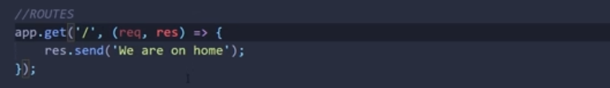

1. get(retreive), post(insert), put/patch(update), delete(remove).

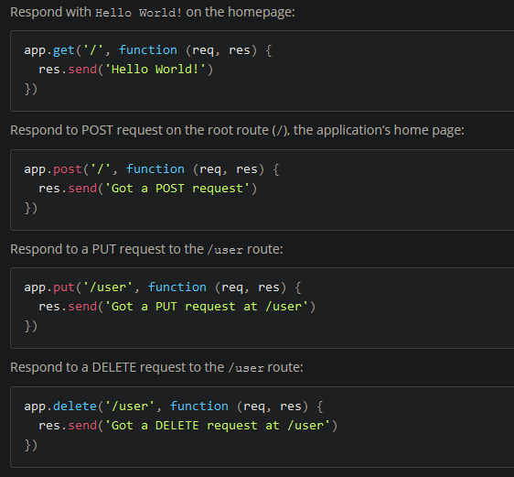

13.Middleware will execute for a specific route if it is provide and if not the it will execute for every route/request.

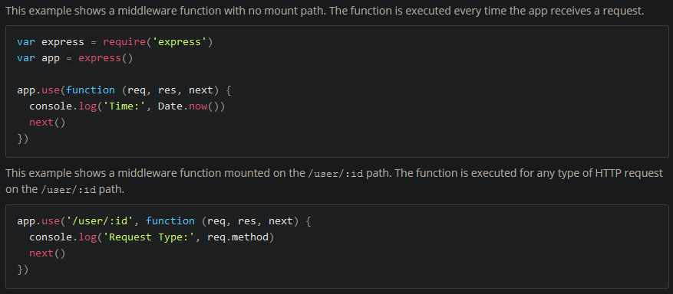

1. MongoDB – (document type) non-relational database , (node Js can also use sql database) mongoose - is an Object Data Modeling (ODM) library for MongoDB and Node. js. It manages relationships between data, provides schema validation, and is used to translate between objects in code and the representation of those objects in MongoDB.
2. npm install mongoose

importing mongoose and connecting to the database

you will need to specify username and password,

mongoose.connect(“ ”,{ },functionYouWantToExecuteIfConnected);

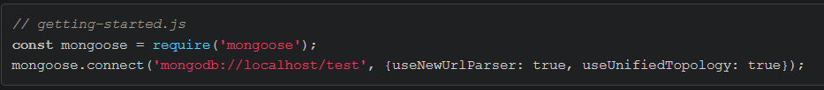

1. check out mlab.com for pseudo-database to test out your server.
2. npm install dotenv – used to hide stuff you don’t want people to see in your app.js like passwords instead you will use a variable that store the information you want to hide.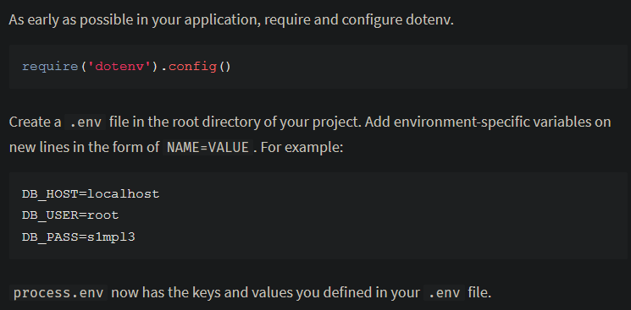



1. console.log(“message”) – prints out message to console(terminal) ,you can use this to debug.
2. You can use external files from app.js to handle certain routes using middleware function to run them and do not forget to export it so you can import in another file.

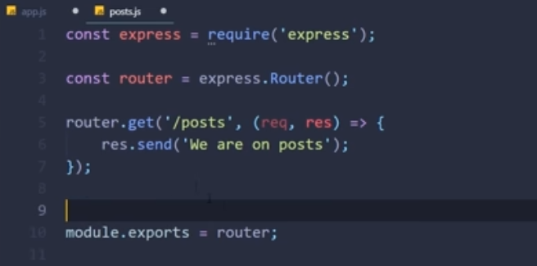

This is how you import and use it.

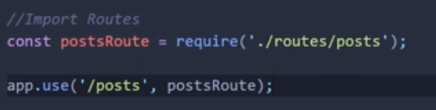

1. A Mongoose schema defines the structure of the document, default values, validators, etc., whereas a Mongoose model provides an interface to the database for creating, querying, updating, deleting records, etc.

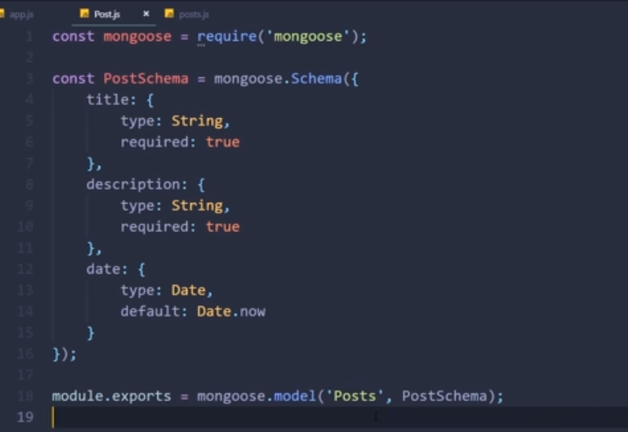

At the end you export the mongoose model and the name of the collection(table name you using MySQL_DB) which is “Posts”(it will be converted to lowercase) in this case and also provide the schema it should use.

1. We use this to interact with the database and you need to import the model you are going to use.



You can use PostMan as client.

1. install body-parser



Used so we can process the data when doing req.body



After importing it we use a middleware function to execute this every time the app.js runs before doing any request or response in the app.js.

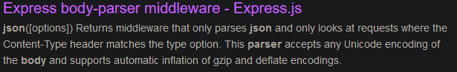

22.



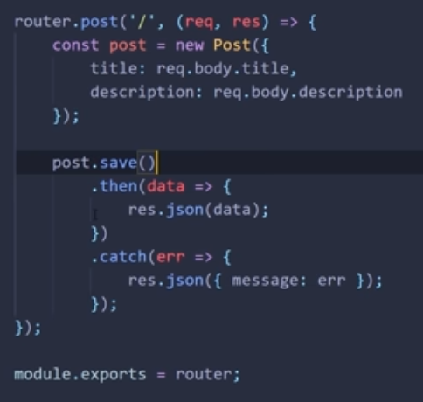

After creating the post object model you provide the data which must compile with your model schema.

Post.save(), sends the data to the database and .then is the response if these no error and .catch is the response when these an error.

You can also rewrite the above post as follows : (using async and await)

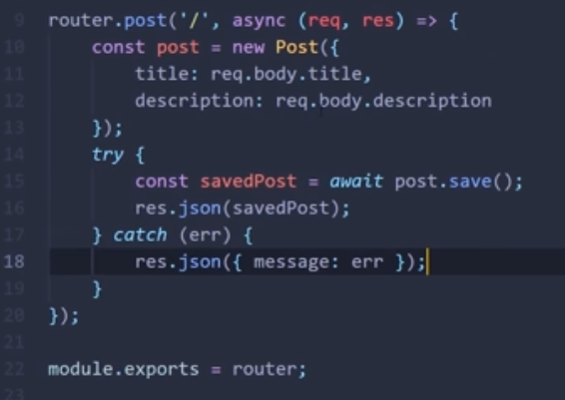

1. You can use find to also return all data from a specific collection.

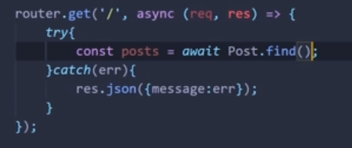

1. Mongoose functions:

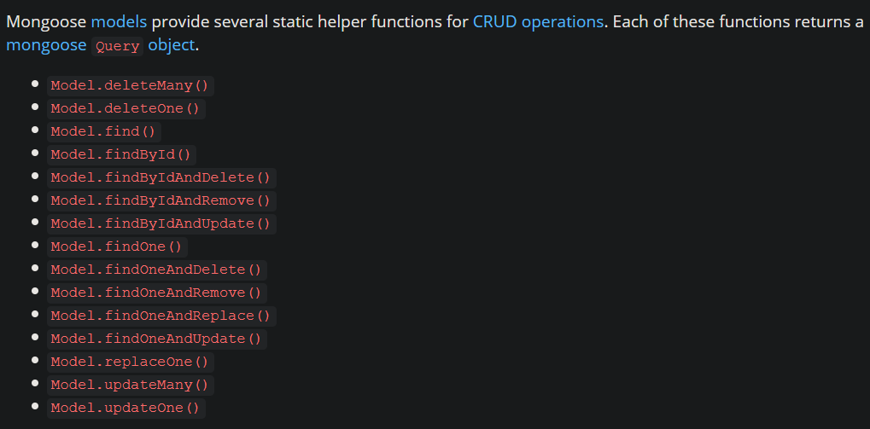

1. Get access to parameter from URL (the parameter :postId is after the ‘/’:

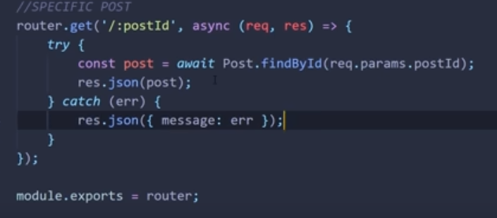

1. HTTP status codes (for REST APIs): <https://restfulapi.net/http-status-codes/>
2. npm install cors :

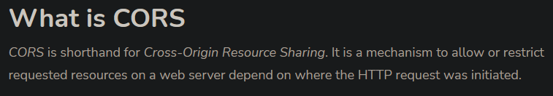

Import and add cors to middleware function.

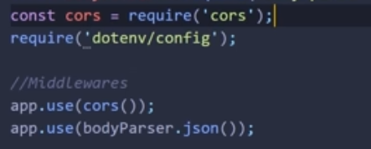

1. Check out CodePen when you have time : <https://codepen.io/about/>

For testing your server/API.